Calculation of the maximum load
The diagram shows my model of cardboard cantilever. The most stress will be experienced by the cardboard at the table edge, since it is the furthest distance from the weight that isn’t supported by the table. To calculate the maximum weight that can be supported by this cantilever, we need to calculate the stress on it and compare it to the tensile strength of cardboard. It only takes one point on the cardboard beam to break for the whole structure to fail. Thus, we need the maximum stress. Flexure (bending) stress is computed as follows:
$$σ=\frac{My}{I}$$
Where $M$ is the bending moment, $I$ is the second moment of area, or the area moment of inertia, and $y$ is the distance from the point to the neutral axis. The moment of a lever is calculated like this, force times distance:
$$M=fd$$
To maximize the moment, we need to maximize the distance from the point where force is applied. We can do this by choosing the point right at the edge of the table, since it is not supported by the table there. The distance from the load is calculated with the Pythagorean theorem we get $\sqrt{{10}^{2}+{20}^{2}}≈22.36 cm$. Thus, $M_{max}=$ $22.36f$.

To calculate $y$ we need to find the position of the neutral axis. Below is the cross-section of the beam:
tension

5.5 cm
Neutral axis
4.5cm
compression

The perimeter adds to 20cm, meaning a 20cm paper can be wrapped around it, satisfying the thickness requirement. The neutral axis is an imaginary line which divides the cardboard cross section into points of compression and tension. Thus, it experiences no stress. This is best seen in the following image:
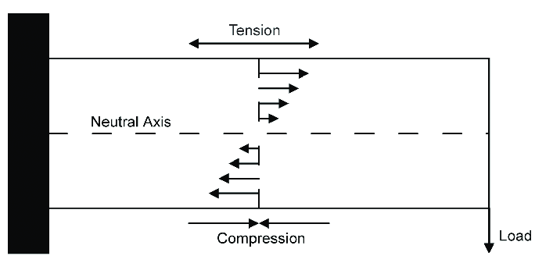
In the case of a rectangular cross-section, the neutral axis would split the area in two, as shown above. Thus, $y_{max}=\frac{5.5}{2}=2.25 cm$.
The area moment of inertia of a rectangular cross-section can be estimated as $\frac{bh^{3}}{12}$. Plugging our values in we get $\frac{4.5×{5.5}^{3}}{12}≈62.39 cm^{4}$.
The final step is to estimate the tensile strength of layered cardboard, which is what we will be using. According to this scientific paper, depending on the type of cardboard, it is around $2.5 MPa$. Let’s assume we are right at the breaking point of the cardboard, so the stress will also be $2.5 MPa$. Since we are using $cm$, we will convert $2.5 MPa$ to $250 N/cm^{2}.$ Now we can solve for the force:
$$σ=\frac{My}{I}$$
$$σ=\frac{22.36f×2.25}{4.5×{5.5}^{3}}$$
$$f=\frac{4.5×{5.5}^{3}×250}{22.36×2.25×12}≈310 N≈31 kg$$
However, this theoretical prediction is going to be much larger than the practical results. It assumes that the cardboard structure is one large block, instead of lots of layers taped together, and that it is in perfect condition, without any creases. In reality, I only managed to support a fifth of this weight, $6 kg$.
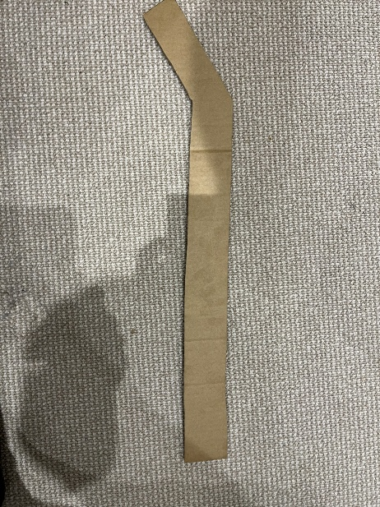
Construction process
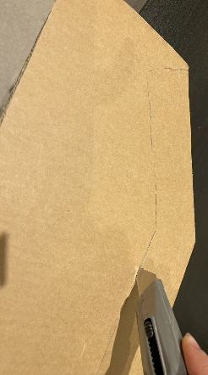
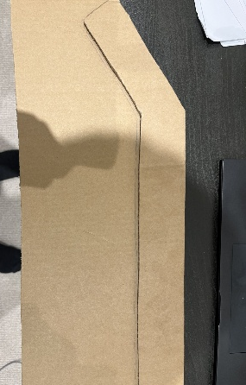
To make the structure, I cut out many shapes like the one on the right from sheets of cardboard. I did this with a cardboard cutter. I used the first shape to trace lots of copies of that shape. This made the construction process much easier. The shape consists of a long tail with a bend upward, reaching 10cm above the bottom of the tail. To increase the strength of the beam, I used different sheets of cardboard and cut them in different directions relative to the grain. This made sure that the creases in one layer of the structure didn’t line up with the other layers, creating a weak point. Then, I brought the layers together and sanded them down to make them even. Finally, I taped them together by wrapping the tape tightly around the layers. I found that this was a crucial step towards the strength of the structure.
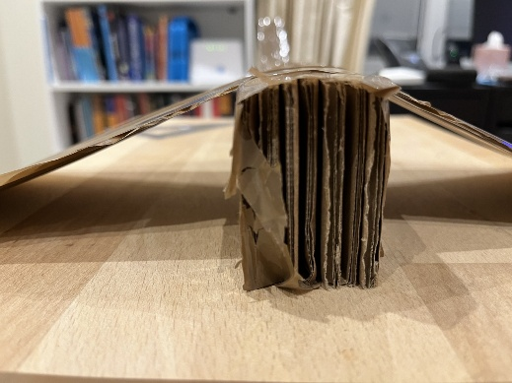
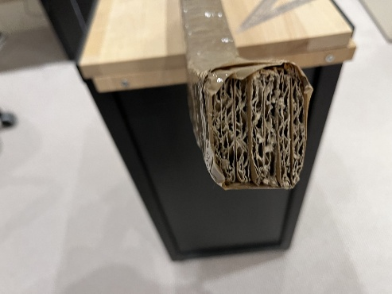
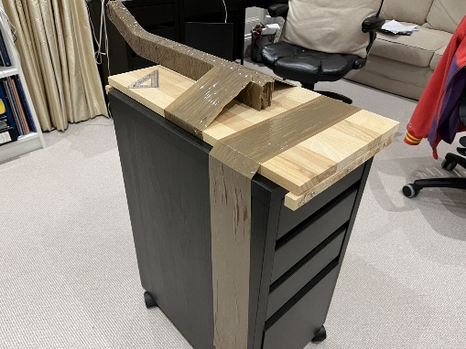
After covering the entire structure with tape, I marked a line 20cm away from where I would hang the weight. Then I positioned the beam so that this line was at the edge of a wooden board. I used a wooden board because taping the structure to a wooden board was much easier than to a table. Then I taped the wooden board to the table, ensuring the cantilever was secure.

The picture shows the final product. Although most of the structure is covered in tape, you can see the cardboard layers inside.

List of materials:
- Cardboard
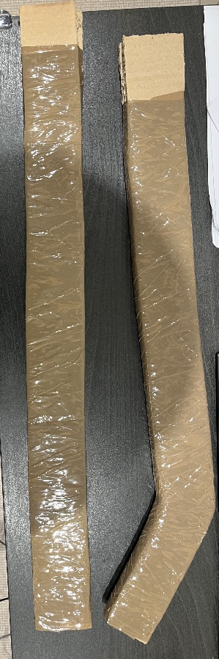
- Tape
- Wooden board
- Table
Additional experiments:
I used the structures shown on the left, which are thinner versions compared to the final version. This was to test the theoretical limit of the actual beam. I also used them to test different methods of attaching the beams to my table. Since these cardboard structures had less than half as many layers as the final version, I knew that the final version could hold approximately 2 times the maximum weight I found these experimental versions could hold. Finally, I used two different shapes to see how much the bend in the cantilever affected how much it could hold. The result was only about 500 grams less.

