M26 · Accuracy and automaticity windows in Spanish reading (SSR draft)
Nov 2, 2026 · @Abarejo

Notas para los autores
Revista objetivo: Scientific Studies of Reading (SSR), como Research Article. Es la revista de referencia para esta pregunta, publica estudios longitudinales en ortografías transparentes y no cobra por publicar. Alternativas si la rechaza: Journal of Experimental Child Psychology, Reading and Writing y Annals of Dyslexia.
Normas de SSR que condicionan el texto (instrucciones):
- Hasta 8.000 palabras sin resumen, referencias ni tablas; referencias en 10 páginas como máximo.
- Resumen estructurado (Purpose, Method, Results, Conclusion) de 200 palabras como máximo.
- Revisión doble ciego: ninguna pista de autoría; los trabajos propios se citan en tercera persona.
- APA 7, inglés americano, comité de ética nombrado y consentimiento de las familias y asentimiento de los niños.
- Declaración de disponibilidad de datos (se recomienda repositorio con DOI) y declaración de conflictos.
Estado del borrador:
Sección | Estado | Qué falta
Introducción | Borrador completo | Revisión de J. L. Luque, dueño de la idea
Método | Borrador completo | Comité de ética, ítems por lista, versión de R, repositorio
Resultados | Borrador completo con m26_articulo_v6.R (02/11/2026) | Comprobar qué cohortes tienen lectura a 9+ años; codificación del sexo
Discusión | Borrador completo | Revisión del grupo
Figuras | Definidas | Rehacerlas con calidad de imprenta desde los CSV de DIAGNOSTICO/R/M26/v6
Corrección del 02/11/2026. Las cifras de una versión anterior de este borrador (3.881 niños; AUC grave–leve de .71–.77) venían de un error en m26_ciclos_v3.R. Todas las cifras actuales salen de m26_articulo_v6.R (1.777 niños).
Decisiones abiertas para el grupo:
- Autoría. La idea es de J. L. Luque; propuesta: Luque como autor de correspondencia y orden por contribución. A acordar antes del envío.
- Preregistro. Los datos ya se han analizado, así que no cabe un Registered Report. Se recomienda depositar en OSF el código y el plan de análisis de la versión final antes de enviar, y declararlo como análisis no preregistrado.
- Incidencia de 8.2. Se excluye en todos los análisis; hay que confirmarla en el bruto y explicarla en el Método.
- Etiquetas de certeza del manual. El artículo no las usa como resultado (evita la circularidad); se mencionan solo en la discusión.

Title page
Title. When does reading become accurate, and when does it become automatic? Two developmental windows separate severe from mild reading difficulties in Spanish
Alternative title. Accuracy first, automaticity later: a longitudinal study of the two cycles of reading acquisition in Spanish from age 5 to 8
Running head. ACCURACY AND AUTOMATICITY WINDOWS IN SPANISH
Keywords. reading fluency; decoding accuracy; transparent orthography; dyslexia; early identification; word length effect
Word count. About 7,000 words planned (limit 8,000, excluding abstract, references and tables).
Author names, affiliations, acknowledgements and the correspondence address go in a separate title page file, as double-blind review requires.

Abstract
Purpose. Learning to read involves two cycles: becoming accurate and becoming automatic. We asked when each cycle is completed in Spanish, a transparent orthography, and whether children with severe and mild reading difficulties fail in different cycles.
Method. We followed 1,777 children from three birth cohorts, assessed three times per school year from age 5 on a school-based platform. Severe (≤ 10th percentile) and mild (10th–25th percentile) difficulty groups were defined only from timed reading at age 8 or later, so that all earlier measures were free of circularity.
Results. Half of typical readers mastered word and pseudoword reading accuracy (≥ 90 %) by the middle of Grade 1, mild poor readers at the start of Grade 2 and severe poor readers at its end. Accuracy, not speed, distinguished severe from mild difficulties in Grades 1 and 2 (AUC = .66–.67 vs. .44–.63), whereas speed best distinguished any difficulty from typical reading (AUC = .84 at the start of Grade 2). The word length effect shrank with age in typical readers and grew in severe poor readers.
Conclusion. Severe difficulties delay the accuracy cycle by about a school year and then the automaticity cycle; mild difficulties appear once accuracy is in place, as slow reading. Speed is the better screening measure; accuracy at the end of Grade 1 helps characterize severity.
About 190 words.

Introduction
Learning to read words can be described as two successive cycles. In the first, children learn to convert letters into sounds reliably and become accurate. In the second, repeated accurate decoding builds word-specific orthographic representations, and reading becomes fast and effortless (Ehri, 2005; LaBerge & Samuels, 1974; Share, 1995). The two cycles are hard to separate in English, where accuracy itself develops slowly. Transparent orthographies offer a cleaner view: children reach high accuracy within the first school year, and individual differences shift to speed (Seymour et al., 2003; Landerl & Wimmer, 2008).

Accuracy and speed in transparent orthographies
In Spanish, Italian, German, Finnish and Dutch, most children read words and pseudowords accurately by the end of Grade 1, while reading speed keeps growing for years (Castejón et al., 2011, 2015; Landerl & Wimmer, 2008; Zoccolotti et al., 2009). Developmental dyslexia in these languages is characterized mainly by slow, effortful reading rather than by errors (Davies et al., 2007; Serrano & Defior, 2008; Tressoldi et al., 2001; Wimmer, 1993). Its clearest marker is a word length effect that does not shrink: children with dyslexia take disproportionately longer to read long words, a sign of serial, sublexical decoding (Suárez-Coalla et al., 2014; Verhoeven & Keuning, 2018; Zoccolotti et al., 2005). Lexicality effects tell a complementary story. As children build an orthographic lexicon, familiar words are read faster than pseudowords, and this advantage grows with reading experience (Caravolas, 2018; Zoccolotti et al., 2009).
Most of this evidence comes from cross-sectional comparisons or from small longitudinal samples assessed once a year. These designs show that accuracy comes first and speed later. They cannot show when, in each child, the accuracy cycle is completed, or whether children with different outcomes diverge in different windows.

Transient and persistent difficulties
Not every child who struggles early continues to struggle. Longitudinal studies in transparent orthographies describe groups with persistent difficulties and groups whose difficulties resolve (Landerl & Wimmer, 2008; Psyridou et al., 2021). Classifications made at a single time point are unstable, partly because of measurement error and arbitrary cut-offs (Psyridou et al., 2020). This instability is a practical problem for school screening: a measure that identifies risk well at one age may do so poorly a few months later, and screening batteries rarely state when each measure is most informative (Catts et al., 2015).
A two-cycle account offers a principled answer. If severe and mild difficulties differ in which cycle fails, they should diverge from typical development at different times and on different measures: on accuracy early, on speed later.

The present study
We used a school-based platform that assessed children three times per school year, from age 5 to age 8 or older, across three birth cohorts. This temporal resolution allows the timing of each cycle to be estimated in individual children. To avoid circularity, difficulty groups were defined only from reading at age 8 or later; every measure before that age was therefore independent of group membership. We asked four questions:
- When is accuracy mastered? We expected most typical readers to reach 90 % accuracy in word and pseudoword reading during Grade 1 (H1).
- When does reading become automatic? We expected the word length effect to shrink gradually in typical readers and to persist in children with difficulties (H2).
- What distinguishes severe from mild difficulties? We expected children with severe difficulties to still make accuracy errors at the end of Grade 1 and the start of Grade 2, and children with mild difficulties to be accurate by then but slow, so that accuracy would separate the two groups and speed would separate both from typical readers (H3).
- Do severe and mild difficulties fail in different cycles? We expected severe difficulties to delay both cycles, and mild difficulties to affect mainly the automaticity cycle (H4).
The development of the lexicality effect was examined as an exploratory question.

Method

Participants
Participants were children born in 2010, 2011 and 2012 who attended public schools in the province of Málaga (Spain) taking part in a school-wide reading assessment program. All were native or fluent Spanish speakers in Spanish-medium classrooms. Of 5,495 children with any data, 1,777 had timed reading data at age 8 or later and form the analytic sample (2010: 783; 2011: 603; 2012: 391). Children born in 2013 were assessed only up to age 7 and contribute only to the analysis of transitions. Table 1 describes the sample by group; attrition is analysed in the Results.
Most schools also implemented a classroom phonological awareness and letter knowledge program in kindergarten. Program status was assigned only to children in the term-by-term follow-up of each school (1,212 children of the analytic sample), of whom 76–80 % in each group attended program schools (Table 1).

Procedure
Children were assessed individually at school three times per school year (late November, mid-February and late May) in sessions of no more than 15 minutes. Tasks were presented on a computer by a web-based platform; the examiner, a trained school speech and language teacher or a supervised trainee, scored each response with the mouse, and the platform recorded response times. Assessment points are labelled age.term, so that 6.1 is the first term of Grade 1 and 7.3 the last term of Grade 2.
[Completar: comité de ética que aprobó el estudio, convenio con la administración educativa, consentimiento de las familias y asentimiento de los niños.]

Measures
Word and pseudoword reading. Children read aloud lists of disyllabic words, trisyllabic words and disyllabic pseudowords [completar: número de ítems por lista y por sesión; listas iguales o distintas entre cursos]. Accuracy was the proportion of items read correctly. Time was the total reading time of the list, converted to time per item.
Reading outcome at age 8 or later. Reading efficiency and time in word, pseudoword and text reading at every assessment from 8.1 onwards were converted to percentiles within cohort and assessment and averaged within child. Besides the term-by-term assessments on the platform (8.1 and 8.3), this outcome includes two wider assessments of the 2020–21 and 2021–22 school years: a paper-and-pencil reading efficiency battery (February 2021) and a tablet version of the platform with time-limited lists (2021–22). Because percentiles were computed within each assessment, format differences do not shift group means, and a sensitivity analysis defined groups from the term-by-term assessments only. The 8.2 assessment was excluded because all groups showed a simultaneous drop in accuracy [confirmar si 8.2 de 2012 corresponde a la evaluación en papel de 2021].

Group definition
Within each cohort, children with an average reading percentile at age 8 or later at or below the 10th percentile formed the severe group (n = 177), those between the 10th and 25th percentiles the mild group (n = 268), and the rest the typical group (n = 1,332). Only children with at least one timed reading measure (time or efficiency) at age 8 or later were classified. Because groups were defined from later reading only, all measures taken before age 8 are free of circularity. These groups were not used for any clinical decision.

Analysis
All analyses were run in R [versión] with data.table, lme4 and pROC. Response times of zero were treated as missing. Speed measures were analysed as percentiles within cohort and session, or as ratios within the same child and session, so that differences in time units between platform versions did not affect results.
- Accuracy mastery. Mastery was the first assessment with at least 90 % mean accuracy in disyllabic word and pseudoword reading, maintained at the next assessment. We estimated the cumulative proportion of children reaching mastery at each assessment with a discrete-time Kaplan–Meier estimator, treating children who left before mastery as censored. Confidence intervals come from 500 bootstrap resamples of children.
- Automaticity markers. The length effect was the ratio of time per item in trisyllabic to disyllabic words; the lexicality effect was the ratio of time per item in disyllabic pseudowords to words. Both ratios were computed within child and session. Log ratios were modelled with linear mixed models including group, assessment and their interaction, with random intercepts for child and school; the interaction was tested with a likelihood ratio test, and marginal means were back-transformed to ratios.
- Transitions out of risk. At each assessment, all children from the 2010–2013 cohorts were classified by their word and pseudoword reading percentile (≤ 10th, 10th–25th, > 25th). We estimated the probability of moving above the 25th percentile, or of staying at or below the 10th, at the next assessment within the same school year.
- Early identification. Logistic models with accuracy, speed or both at 6.2, 6.3 and 7.1 predicted group membership (severe vs. mild; any difficulty vs. typical). Models were trained on two cohorts and tested on the third, rotating the held-out cohort. We report the area under the ROC curve (AUC) of the held-out predictions, with 95 % confidence intervals from 500 bootstrap resamples, and calibration as the intercept and slope of a logistic recalibration model.
- Sensitivity. We repeated the mastery analysis with groups defined by the 15th and 30th percentiles, with groups defined from reading at age 9 or later, with mastery thresholds of 85 % and 95 %, and restricted to children in schools without the kindergarten program.
Only aggregated results leave the project computer; every cell with fewer than 10 children is suppressed. [Completar: repositorio con DOI para el código y los datos agregados.]

Results

Sample and attrition
The three groups were similar in age at the first Grade 1 assessment (Table 1). The severe and mild groups had a lower mean school socioeconomic index than the typical group, and a slightly higher proportion of girls [verificar la codificación del sexo: lo esperable es más niños en los grupos con dificultad].
Table 1. Sample by group.
 | Severe | Mild | Typical
n | 177 | 268 | 1,332
Schools | 35 | 38 | 48
Girls, n (%) | 93 (53) | 133 (51) | 602 (46)
Age at 6.1, months, M (SD) | 78.2 (5.9) | 78.0 (5.8) | 77.2 (4.6)
School socioeconomic index, M | 5.31 | 5.14 | 5.66
Kindergarten program, % of known (n known) | 75.6 (86) | 80.2 (187) | 79.6 (939)
[Completar: escala del índice socioeconómico y número total de colegios.]
Children who remained in the program until age 8 read in Grade 1 much like those who left. Their mean Grade 1 word and pseudoword reading percentile was 47.8 vs. 53.0 in the 2010 cohort, 49.2 vs. 49.8 in 2011 and 52.7 vs. 48.2 in 2012, and the proportion below the 25th percentile was 15.2 vs. 12.1 %, 14.8 vs. 19.0 % and 15.3 vs. 21.5 %, respectively. Attrition was therefore not systematically related to early reading.

When is accuracy mastered?
Accuracy data before age 8 were available for 1,093 children (71 severe, 161 mild, 861 typical). Half of typical readers had mastered word and pseudoword reading accuracy by 6.2, the middle of Grade 1; two thirds by the end of Grade 1 and almost all by the end of Grade 2 (Table 2, Figure 1). Mild poor readers reached the same point two assessments later, at the start of Grade 2, and severe poor readers four assessments later, at the end of Grade 2. At the end of Grade 2, one in five mild and one in three severe poor readers had not yet mastered accuracy. H1 was supported, and the timing of mastery ordered the groups as H4 predicted.
Table 2. Cumulative percentage of children who had mastered accuracy (95 % CI).
Assessment | Severe (n = 71) | Mild (n = 161) | Typical (n = 861)
6.1 | 6 (1–11) | 16 (10–21) | 40 (37–43)
6.2 | 15 (7–23) | 21 (15–28) | 53 (49–56)
6.3 | 17 (10–26) | 28 (21–36) | 66 (63–69)
7.1 | 24 (15–34) | 50 (42–58) | 82 (79–85)
7.2 | 47 (34–63) | 68 (60–76) | 91 (89–93)
7.3 | 64 (47–82) | 80 (72–88) | 98 (96–99)
Median assessment (95 % CI) | 7.3 (7.2–7.3) | 7.1 (7.1–7.2) | 6.2 (6.2–6.3)

When does reading become automatic?
The length effect changed differently with age in the three groups (group × assessment, χ²(12) = 315.3, p < .001; 4,056 observations from 1,094 children). In typical readers, trisyllabic words took 1.34 times as long per item as disyllabic words at 6.2 (95 % CI 1.31–1.38), and the ratio fell steadily to 1.10 (1.07–1.12) at 8.3 (Figure 2A). In severe poor readers there was no length effect at 6.3 (1.01, 0.96–1.07), when most of them were still inaccurate; it appeared at 7.1 (1.29) and kept growing to 1.51 (1.39–1.64) at 8.3. Mild poor readers showed an intermediate pattern: the ratio peaked at 7.2 (1.48) and was still 1.30 (1.24–1.36) at 8.3. H2 was supported: the length effect shrank only in typical readers.
The lexicality effect also differed by group (χ²(16) = 67.4, p < .001; 5,433 observations). In typical readers, pseudowords took 1.11 times as long per item as words at 6.1 and 1.48 times at 7.1, after which the advantage for words grew slowly to 1.66 at 8.3 (Figure 2B). Mild poor readers followed the same curve with a delay of about one term. Severe poor readers read words no faster than pseudowords until the end of Grade 1 (0.99–1.03 from 6.1 to 6.3); the word advantage appeared at 7.1 (1.16) and at 8.3 (1.53) reached the level typical readers had shown at 7.1.

Transitions out of risk
Risk status was volatile in Grade 1 and more stable from Grade 2 (Figure 3). Of children at or below the 10th percentile in word and pseudoword reading, 56 % were still there at the next assessment at 6.1, 33 % at 6.2 and 62 % at 7.1. Of children at or below the 25th percentile, the proportion who moved above it at the next assessment was 58 % at 5.2, 33 % at 6.1, 50 % at 6.2, 36 % at 7.1, 35 % at 7.2 and 31 % at 8.1.

Early identification
Speed and accuracy both identified children with any later difficulty in Grade 1, and speed did better from Grade 2 (Table 3). At 7.1, speed alone reached an AUC of .84, and adding accuracy did not improve it. These models were well calibrated in the held-out cohorts (calibration slopes 0.97–1.04), except accuracy alone at 7.1 (0.59).
In line with H3, only accuracy separated severe from mild difficulties at 6.3 and 7.1 (AUC = .66 and .67); speed did not (.48 and .44), and adding speed to accuracy did not help. Discrimination between severe and mild difficulties was modest, and calibration slopes well below 1 (0.10–0.71) indicate that these models would not transfer reliably to a new cohort.
Table 3. Area under the ROC curve in held-out cohorts (95 % CI).
Assessment | Comparison | Accuracy | Speed | Both
6.2 | Any difficulty vs. typical (180 / 958) | .74 (.70–.79) | .77 (.73–.81) | .80 (.76–.83)
6.3 | Any difficulty vs. typical (183 / 959) | .76 (.72–.81) | .77 (.73–.81) | .81 (.78–.85)
7.1 | Any difficulty vs. typical (202 / 986) | .71 (.67–.76) | .84 (.81–.87) | .84 (.81–.87)
6.2 | Severe vs. mild (49 / 180) | .60 (.49–.70) | .63 (.53–.73) | .63 (.53–.73)
6.3 | Severe vs. mild (52 / 183) | .66 (.56–.75) | .48 (.38–.57) | .66 (.57–.75)
7.1 | Severe vs. mild (59 / 202) | .67 (.59–.75) | .44 (.35–.53) | .65 (.57–.74)
Cases / total in parentheses after each comparison.

Sensitivity analyses
The order of mastery was unchanged with groups defined by the 15th and 30th percentiles (median mastery at 7.2, 7.1 and 6.2 for severe, mild and typical readers) and with an 85 % accuracy threshold (7.2, 7.1 and 6.1). With a 95 % threshold all groups were later and severe and mild readers had the same median (7.3), although fewer severe readers had mastered accuracy by 7.3 (56 vs. 65 %). When groups were defined from reading at age 9 or later, the typical and mild groups were unchanged (6.2 and 7.1), but the smaller severe group (n = 50) mastered accuracy at 6.3, like typical readers [comprobar qué cohortes y niños tienen lectura a 9+ años].
Term-by-term assessments only. Defining groups only from the term-by-term platform assessments at age 8 (cohorts 2010 and 2011; 100 severe, 148 mild and 744 typical readers) reproduced every main result. Median mastery was at 6.2, 7.2 and 7.3 for typical, mild and severe readers. Accuracy separated severe from mild difficulties (AUC = .67 at 6.2 and 6.3, .70 at 7.1) and speed did not (.36–.59), whereas speed best identified any difficulty at 7.1 (AUC = .88, 95 % CI .85–.91, calibration slope 1.00). In schools known to have no kindergarten program (19 severe, 34 mild and 188 typical readers) the medians were also 7.3, 7.1 and 6.2.

Discussion
We asked when Spanish-speaking children complete the two cycles of word reading, becoming accurate and becoming automatic, and whether children with severe and mild reading difficulties fail in different cycles. Typical readers became accurate by the middle of Grade 1. Children with mild difficulties became accurate two assessments later, at the start of Grade 2, and children with severe difficulties about a school year later; a third of them were still inaccurate at the end of Grade 2. Once accurate, the groups diverged in automaticity: the length effect faded in typical readers and grew in severe poor readers, and the advantage of words over pseudowords appeared about a year and a half later in severe poor readers than in typical readers.

Two cycles, two kinds of difficulty
The results fit a two-cycle account of word reading (Ehri, 2005; Share, 1995). The automaticity markers changed only after accuracy was in place. Severe poor readers showed no length effect while they were still inaccurate, presumably because every item was read slowly and with effort; the effect appeared once they decoded accurately and then grew, the signature of accurate but serial, letter-by-letter decoding described in Italian and Spanish dyslexia (Suárez-Coalla et al., 2014; Zoccolotti et al., 2005). Their lexicality effect was absent in Grade 1 and caught up only at age 8, consistent with a delayed build-up of word-specific orthographic representations.
Children with mild difficulties took a different path. They were accurate by the start of Grade 2, and accuracy did not distinguish them from typical readers as well as speed did. Their difficulty belongs to the automaticity cycle, the slow but accurate reading that characterizes most poor readers in transparent orthographies (Serrano & Defior, 2008; Tressoldi et al., 2001; Wimmer, 1993). On this account, severe and mild difficulties are not only two degrees of the same problem: severe difficulties begin in the accuracy cycle and carry over into the automaticity cycle, whereas mild difficulties begin in the automaticity cycle.
The distinction should not be overstated. Accuracy separated severe from mild difficulties only modestly (AUC = .66–.67), the groups overlap, and the severe group's delay in accuracy was not replicated when groups were defined from reading at age 9 or later. Children with severe difficulties may be better described as a group in which an accuracy delay is more frequent than as a group defined by it.

Implications for screening
Three practical implications follow. First, speed is the better general screening measure in Spanish. From the middle of Grade 1 it identified later difficulties at least as well as accuracy, and at the start of Grade 2 it reached an AUC of .84 with good calibration in a new cohort. Second, accuracy is informative at a specific window. A child who is still inaccurate in word and pseudoword reading at the end of Grade 1 or the start of Grade 2 is more likely to have a severe difficulty, and the window coincides with the point at which most typical readers have already mastered accuracy. Third, decisions should not rest on a single assessment in Grade 1. About half of the children at risk in Grade 1 moved out of risk at the next assessment, whereas risk status was more stable from Grade 2, in line with evidence that single-point classifications are unstable (Psyridou et al., 2020). Repeated brief assessments, with decisions based on two consecutive results, match the timing we observed.

Limitations
First, groups were defined from timed reading at age 8 or later, so only 1,777 of the 5,495 children could be classified, and only 71 severe poor readers had accuracy data before age 8. Attrition was unrelated to Grade 1 reading, but the small severe group limits precision, and its accuracy delay did not hold with groups defined at age 9 or later. Second, the outcome was defined from reading speed and efficiency, partly in a paper battery and a tablet version administered during the pandemic years. This shared method may favour speed as an early marker of later difficulty, although every result held when groups were defined from the term-by-term platform assessments only. Third, about four in five children with known status attended schools with a kindergarten phonological awareness program, so the timing of mastery may be earlier than in schools without it; the small group of schools without the program showed the same medians. Fourth, lists changed across sessions; ratios computed within session control for list difficulty at each assessment but not across assessments, and list times include errors and self-corrections. Fifth, the 10th and 25th percentile cut-offs are conventional, although the sensitivity analyses suggest that the main pattern does not depend on them. Finally, all children came from one Spanish province.

Conclusion
In Spanish, the accuracy cycle of word reading is completed for most children during Grade 1, and difficulties that persist to age 8 differ in when they become visible. Severe difficulties are more often preceded by an accuracy delay that lasts into Grade 2, followed by a growing length effect; mild difficulties appear as slow but accurate reading. Screening that measures speed repeatedly from the middle of Grade 1, and checks accuracy at the end of Grade 1, follows these two windows.

Declarations
Ethics approval. [Completar: comité de ética, número de aprobación y fecha; convenio con la administración educativa.]
Consent. [Completar: consentimiento informado por escrito de las familias y asentimiento verbal de los niños.]
Data availability. Aggregated data (every cell with at least 10 children) and the analysis code are available at [OSF, DOI]. Individual data cannot be shared because they concern minors and are covered by an agreement with the education administration; requests can be addressed to the research group.
Disclosure statement. [Confirmar.] Some of the authors developed the assessment platform and the kindergarten program used in the participating schools. They receive no income from either.
Funding. [Completar: proyectos y convocatorias.]
En el manuscrito anónimo, ética y disponibilidad de datos van en el texto sin nombres; financiación y conflictos, en la portada aparte.

References
Caravolas, M. (2018). Growth of word and pseudoword reading efficiency in alphabetic orthographies: Impact of consistency. Journal of Learning Disabilities, 51(5), 422–433. https://doi.org/10.1177/0022219417718197
Castejón, L., González-Pumariega, S., & Cuetos, F. (2011). Adquisición de la fluidez en la lectura de palabras en una muestra de niños españoles: Un estudio longitudinal. Infancia y Aprendizaje, 34(1), 19–30. https://doi.org/10.1174/021037011794390139
Castejón, L., González-Pumariega, S., & Cuetos, F. (2015). Development of word reading fluency along primary education: A six-year follow-up. Infancia y Aprendizaje, 38(3), 504–530. https://doi.org/10.1080/02103702.2015.1076266
Catts, H. W., Nielsen, D. C., Bridges, M. S., Liu, Y. S., & Bontempo, D. E. (2015). Early identification of reading disabilities within an RTI framework. Journal of Learning Disabilities, 48(3), 281–297. https://doi.org/10.1177/0022219413498115
Davies, R., Cuetos, F., & Glez-Seijas, R. M. (2007). Reading development and dyslexia in a transparent orthography: A survey of Spanish children. Annals of Dyslexia, 57(2), 179–198. https://doi.org/10.1007/s11881-007-0010-2
Ehri, L. C. (2005). Learning to read words: Theory, findings, and issues. Scientific Studies of Reading, 9(2), 167–188. https://doi.org/10.1207/s1532799xssr0902_4
LaBerge, D., & Samuels, S. J. (1974). Toward a theory of automatic information processing in reading. Cognitive Psychology, 6(2), 293–323. https://doi.org/10.1016/0010-0285(74)90015-2
Landerl, K., & Wimmer, H. (2008). Development of word reading fluency and spelling in a consistent orthography: An 8-year follow-up. Journal of Educational Psychology, 100(1), 150–161. https://doi.org/10.1037/0022-0663.100.1.150
Psyridou, M., Tolvanen, A., Lerkkanen, M.-K., Poikkeus, A.-M., & Torppa, M. (2020). Longitudinal stability of reading difficulties: Examining the effects of measurement error, cut-offs, and buffer zones in identification. Frontiers in Psychology, 10, Article 2841. https://doi.org/10.3389/fpsyg.2019.02841
Psyridou, M., Tolvanen, A., Lerkkanen, M.-K., Poikkeus, A.-M., & Torppa, M. (2021). Developmental profiles of reading fluency and reading comprehension from grades 1 to 9 and their early identification. Developmental Psychology, 57(11), 1840–1854. https://doi.org/10.1037/dev0000976
Serrano, F., & Defior, S. (2008). Dyslexia speed problems in a transparent orthography. Annals of Dyslexia, 58(1), 81–95. https://doi.org/10.1007/s11881-008-0013-6
Seymour, P. H. K., Aro, M., & Erskine, J. M. (2003). Foundation literacy acquisition in European orthographies. British Journal of Psychology, 94(2), 143–174. https://doi.org/10.1348/000712603321661859
Share, D. L. (1995). Phonological recoding and self-teaching: Sine qua non of reading acquisition. Cognition, 55(2), 151–218. https://doi.org/10.1016/0010-0277(94)00645-2
Suárez-Coalla, P., Ramos, S., Álvarez-Cañizo, M., & Cuetos, F. (2014). Orthographic learning in dyslexic Spanish children. Annals of Dyslexia, 64(2), 166–181. https://doi.org/10.1007/s11881-014-0092-5
Tressoldi, P. E., Stella, G., & Faggella, M. (2001). The development of reading speed in Italians with dyslexia: A longitudinal study. Journal of Learning Disabilities, 34(5), 414–417. https://doi.org/10.1177/002221940103400503
Verhoeven, L., & Keuning, J. (2018). The nature of developmental dyslexia in a transparent orthography. Scientific Studies of Reading, 22(1), 7–23. https://doi.org/10.1080/10888438.2017.1317780
Wimmer, H. (1993). Characteristics of developmental dyslexia in a regular writing system. Applied Psycholinguistics, 14(1), 1–33. https://doi.org/10.1017/S0142716400010122
Zoccolotti, P., De Luca, M., Di Filippo, G., Judica, A., & Martelli, M. (2009). Reading development in an orthographically regular language: Effects of length, frequency, lexicality and global processing ability. Reading and Writing, 22(9), 1053–1079. https://doi.org/10.1007/s11145-008-9144-8
Zoccolotti, P., De Luca, M., Di Pace, E., Gasperini, F., Judica, A., & Spinelli, D. (2005). Word length effect in early reading and in developmental dyslexia. Brain and Language, 93(3), 369–373. https://doi.org/10.1016/j.bandl.2004.10.010
Verificados con SciSpace: Castejón 2011 y 2015, Psyridou 2020 y 2021, Tressoldi 2001. Antes de enviar, comprobar páginas y DOI de las demás en la web de cada revista. Se han retirado De Luca (2010) y Furnes y Elwér (2025), que no se pudieron localizar.

Tables and figures
Elemento | Contenido | Fuente | Estado
Table 1 | Muestra por grupo | R0b, R0c | En el texto
Table 2 | Dominio acumulado de la exactitud con IC 95 % | R2, R2b | En el texto
Table 3 | AUC en cohortes de validación | R4 | En el texto
Figure 1 | Curvas de Kaplan–Meier del dominio de la exactitud por grupo, con bandas del IC 95 %, de 5.2 a 7.3 | R2 | Dibujada (paleta del grupo; figuras_m26.py v2)
Figure 2 | Cocientes de longitud (A) y lexicalidad (B) por grupo y momento, medias marginales con IC 95 % | R3 | Dibujada (paleta del grupo; figuras_m26.py v2)
Figure 3 | Transiciones entre estados de riesgo de un trimestre al siguiente (gráfico de líneas) | Q3, Q3b (todas las cohortes) | Dibujada (paleta del grupo; figuras_m26.py v2)
Supplementary S1 | Análisis de sensibilidad | R5 | Tabla
Supplementary S2 | Abandono por cohorte | R1 | Tabla
Supplementary S3 | Coeficientes de los modelos mixtos y calibración | R3p, R4 | Tabla
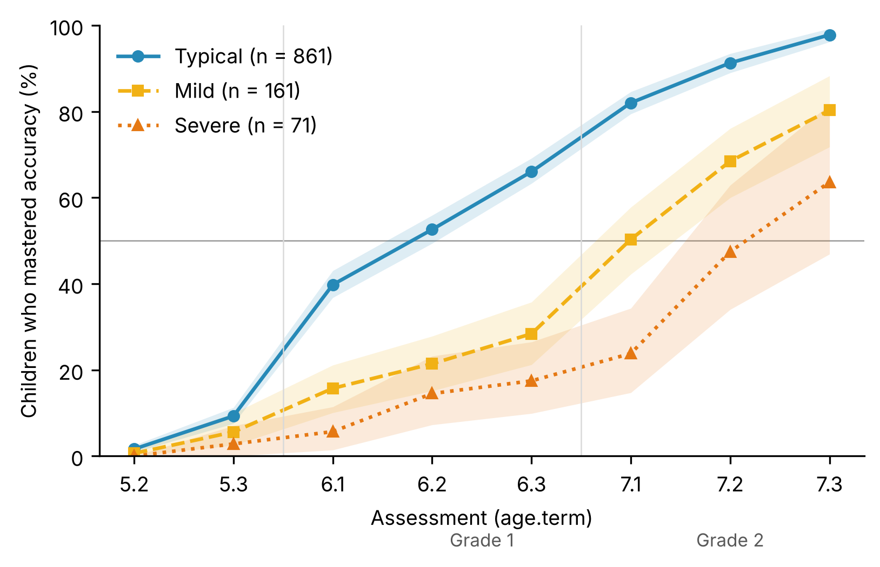
Figure 1. Cumulative percentage of children who mastered word and pseudoword reading accuracy (≥ 90 %, maintained at the next assessment), by later reading group. Shaded bands are 95 % bootstrap confidence intervals.
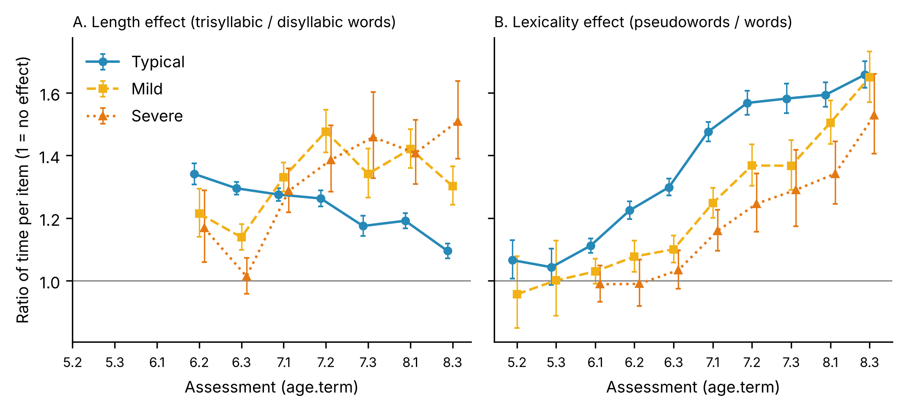
Figure 2. Length (A: trisyllabic / disyllabic words) and lexicality (B: pseudowords / words) effects as ratios of time per item, by group and assessment. Points are marginal means from linear mixed models; bars are 95 % confidence intervals. A ratio of 1 means no effect.
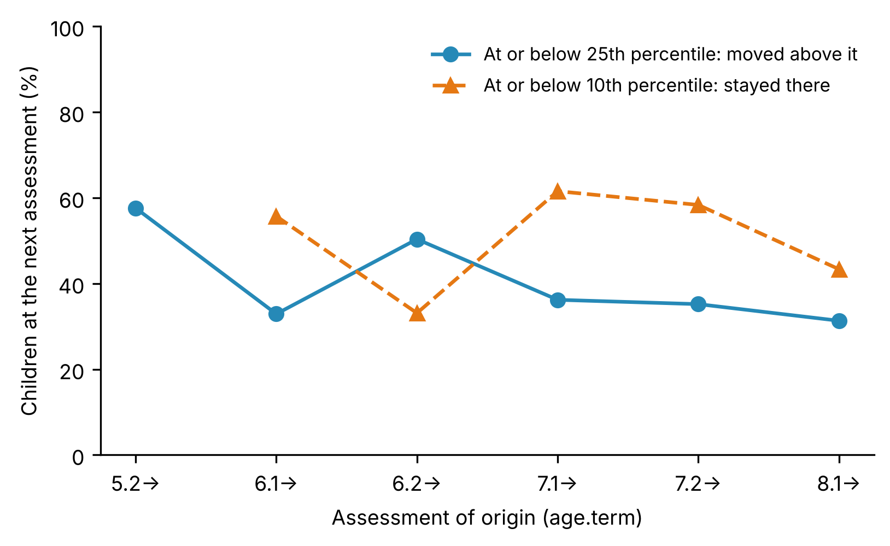
Figure 3. Stability of reading risk from one assessment to the next within the same school year (8.1 → 8.3 across the excluded 8.2 assessment). Circles: percentage of children at or below the 25th percentile in word and pseudoword reading who moved above it. Triangles: percentage of children at or below the 10th percentile who stayed there. All children from the 2010–2013 cohorts.

Lista de comprobación de envío a Scientific Studies of Reading
- ☐ J. L. Luque revisa la introducción, las hipótesis y la discusión (la idea es suya).
- ☐ Acordar la autoría, el orden y el autor de correspondencia.
- ☐ Completar ética, consentimiento, financiación y conflictos.
- ☐ Completar el Método: ítems por lista y sesión, listas iguales o distintas entre cursos, versión de R, número total de colegios, escala del índice socioeconómico.
- ☐ Confirmar en los datos brutos la incidencia de 8.2.
- ☐ Comprobar la codificación del sexo.
- ☐ Comprobar qué cohortes tienen lectura a 9+ años y explicar el análisis de sensibilidad del grupo grave.
- ☐ Dibujar las figuras 1–3 con calidad de imprenta desde los CSV de DIAGNOSTICO/R/M26/v6.
- ☐ Depositar en OSF el código y los datos agregados y poner el DOI.
- ☐ Verificar páginas y DOI de todas las referencias.
- ☐ Anonimizar: sin nombres de la plataforma, del programa, del grupo ni de la universidad; trabajos propios en tercera persona.
- ☐ Contar palabras (límite 8.000 sin resumen, referencias ni tablas) y resumen de 200 palabras como máximo.
- ☐ Inglés americano y APA 7; revisión del inglés por un nativo.
- ☐ Portada aparte con autores, afiliaciones, agradecimientos y correspondencia.
- ☐ Carta de presentación (cover letter).

