Solution of Homework 4

Kálmán Abari

# Introduction

To solve homework 4, I chose a great article (Campagna, 2016), which of course refers to other articles in the bibliography (Amerigo & Aragones, 1997; Pedersen, 1999; Scopelliti & Giuliani, 2004).

# Questions

## Question 1

**What is the distribution of variable *Gender*?**

The *Gender* variable is named f1m0 in the database, and 0 stands for Male and 1 stands for Female. As a first step, let's do the necessary transformations in the jamovi.

Figure 1

Renaming the name of the variable f1m0 and renaming its levels

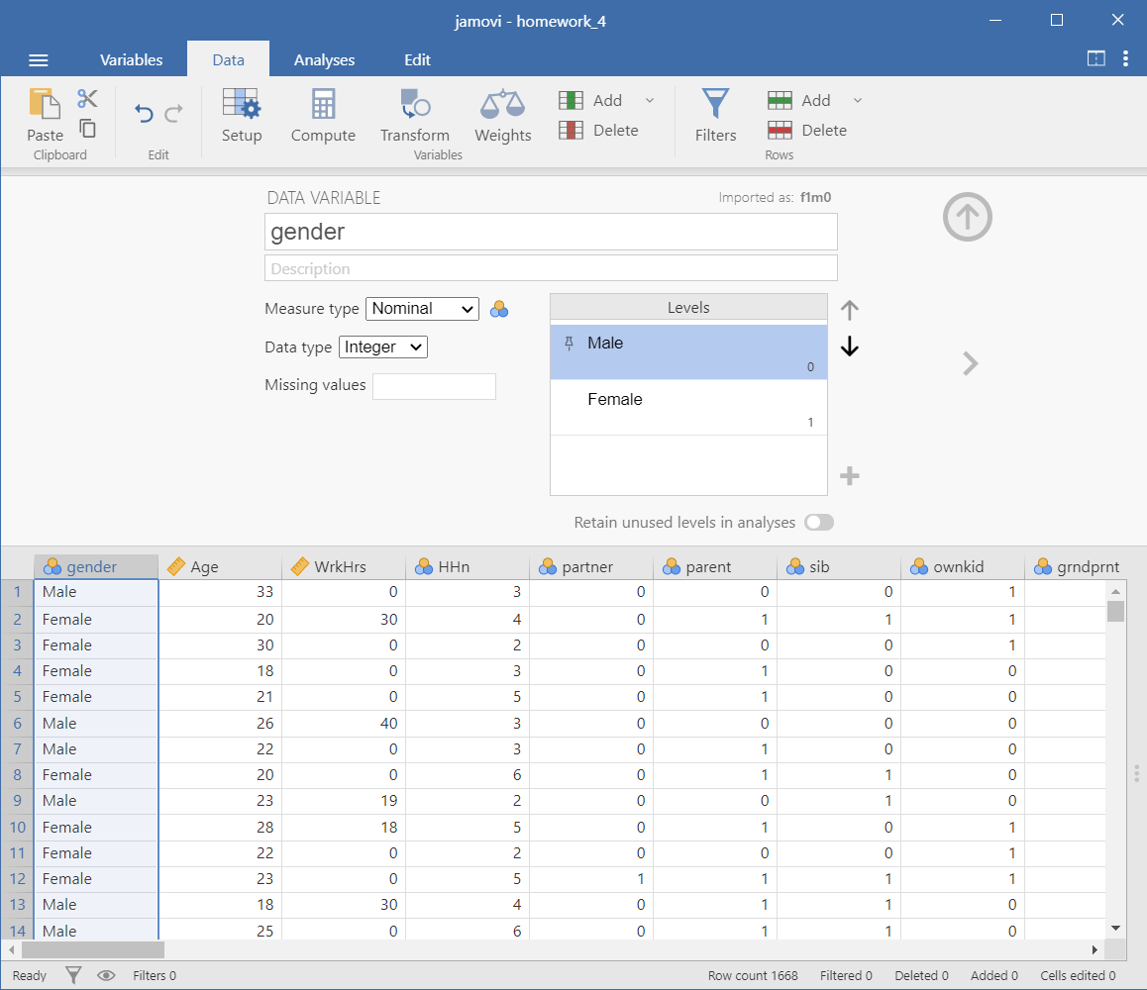

The next step is to create a frequency table and draw a bar plot.

Figure 2

Distribution of variable Gender

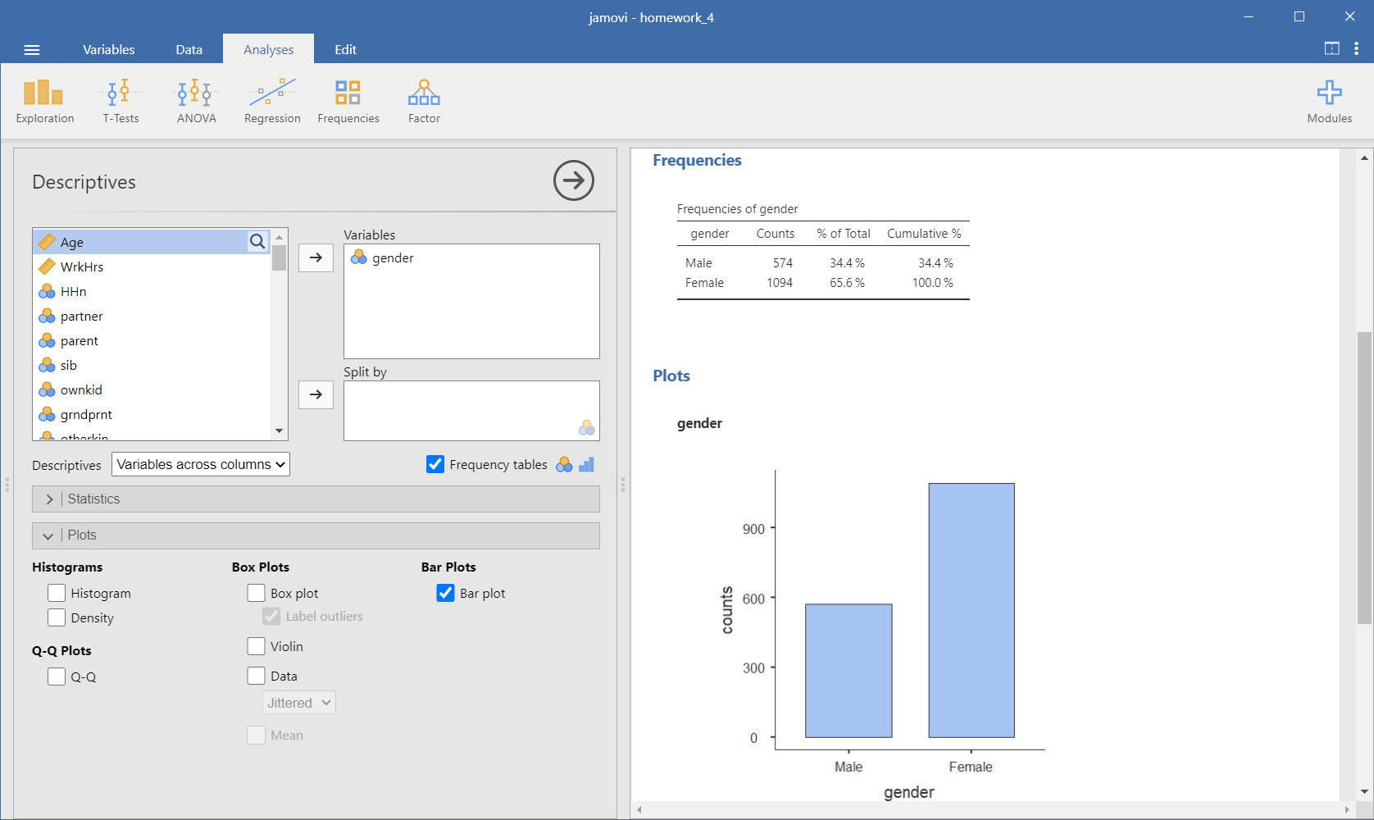

It can be seen that there are twice as many female respondents as male respondents.

## Question 2

**What is the distribution of variable *Hours worked per week*?**

The variable '*Hours worked per week*' is stored in the column WrkHrs. The variable is set to 0 if the respondent has no steady job. Since we are only interested in the number of hours worked for persons who work at all, zero values are set to missing values. We create the variable *WrkHrs_fixed*.

Figure 3

Compute a new variable. Removing zero values we create the variable ‘WrkHrs_fixed’

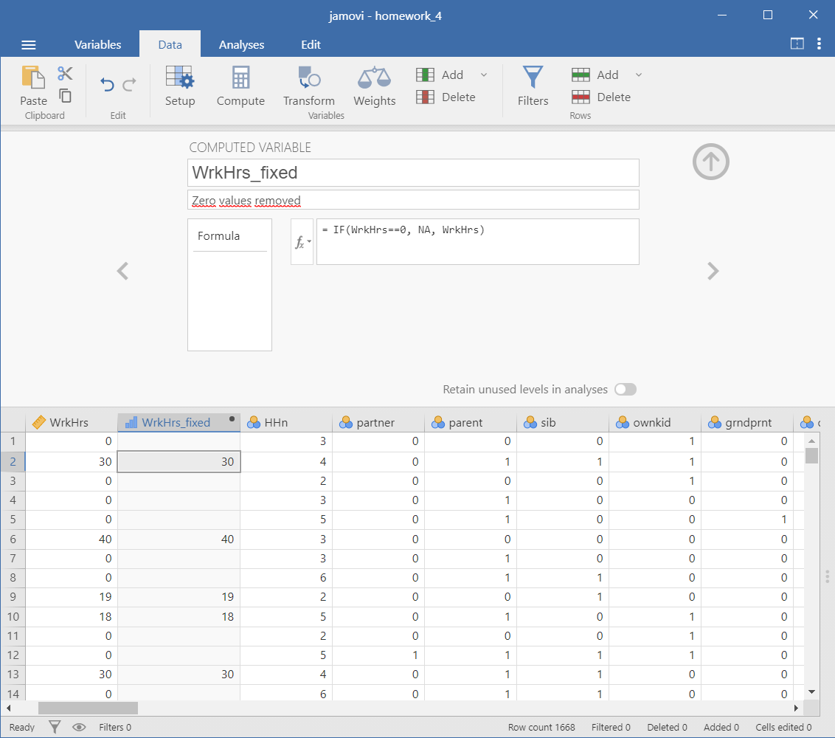

Figure 4

Analysis of the distribution of the variable "WrkHrs_fixed"

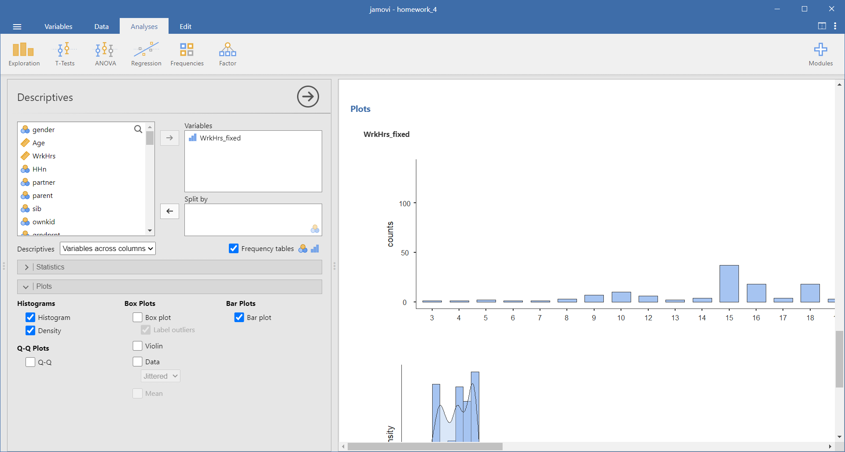

The frequency table, the barplot and the histogram are highlighted separately from the results of the analysis.

Table 1

Frequency table for the variable ‘WrkHrs_fixed’

| Frequencies of WrkHrs_fixed | | | | | | | |
| --- | --- | --- | --- | --- | --- | --- | --- |
| **WrkHrs_fixed** | | **Counts** | | **% of Total** | | **Cumulative %** | |
| 3 |  | 1 |  | 0.1 % |  | 0.1 % |  |
| 4 |  | 1 |  | 0.1 % |  | 0.3 % |  |
| 5 |  | 2 |  | 0.3 % |  | 0.5 % |  |
| 6 |  | 1 |  | 0.1 % |  | 0.7 % |  |
| 7 |  | 1 |  | 0.1 % |  | 0.8 % |  |
| 8 |  | 3 |  | 0.4 % |  | 1.2 % |  |
| 9 |  | 7 |  | 0.9 % |  | 2.1 % |  |
| 10 |  | 10 |  | 1.3 % |  | 3.4 % |  |
| 12 |  | 6 |  | 0.8 % |  | 4.2 % |  |
| 13 |  | 2 |  | 0.3 % |  | 4.5 % |  |
| 14 |  | 4 |  | 0.5 % |  | 5.0 % |  |
| 15 |  | 37 |  | 4.9 % |  | 9.9 % |  |
| 16 |  | 18 |  | 2.4 % |  | 12.3 % |  |
| 17 |  | 4 |  | 0.5 % |  | 12.8 % |  |
| 18 |  | 18 |  | 2.4 % |  | 15.2 % |  |
| 19 |  | 3 |  | 0.4 % |  | 15.5 % |  |
| 20 |  | 87 |  | 11.5 % |  | 27.0 % |  |
| 21 |  | 13 |  | 1.7 % |  | 28.7 % |  |
| 22 |  | 9 |  | 1.2 % |  | 29.9 % |  |
| 23 |  | 8 |  | 1.1 % |  | 31.0 % |  |
| 24 |  | 25 |  | 3.3 % |  | 34.3 % |  |
| 25 |  | 46 |  | 6.1 % |  | 40.3 % |  |
| 26 |  | 6 |  | 0.8 % |  | 41.1 % |  |
| 27 |  | 5 |  | 0.7 % |  | 41.8 % |  |
| 28 |  | 11 |  | 1.4 % |  | 43.2 % |  |
| 29 |  | 2 |  | 0.3 % |  | 43.5 % |  |
| 30 |  | 101 |  | 13.3 % |  | 56.8 % |  |
| 31 |  | 1 |  | 0.1 % |  | 56.9 % |  |
| 32 |  | 18 |  | 2.4 % |  | 59.3 % |  |
| 33 |  | 7 |  | 0.9 % |  | 60.2 % |  |
| 34 |  | 7 |  | 0.9 % |  | 61.1 % |  |
| 35 |  | 56 |  | 7.4 % |  | 68.5 % |  |
| 36 |  | 18 |  | 2.4 % |  | 70.9 % |  |
| 37 |  | 4 |  | 0.5 % |  | 71.4 % |  |
| 38 |  | 27 |  | 3.6 % |  | 75.0 % |  |
| 39 |  | 1 |  | 0.1 % |  | 75.1 % |  |
| 40 |  | 137 |  | 18.1 % |  | 93.1 % |  |
| 42 |  | 5 |  | 0.7 % |  | 93.8 % |  |
| 43 |  | 3 |  | 0.4 % |  | 94.2 % |  |
| 44 |  | 2 |  | 0.3 % |  | 94.5 % |  |
| 45 |  | 10 |  | 1.3 % |  | 95.8 % |  |
| 47 |  | 1 |  | 0.1 % |  | 95.9 % |  |
| 48 |  | 4 |  | 0.5 % |  | 96.4 % |  |
| 50 |  | 13 |  | 1.7 % |  | 98.2 % |  |
| 52 |  | 3 |  | 0.4 % |  | 98.6 % |  |
| 60 |  | 4 |  | 0.5 % |  | 99.1 % |  |
| 64 |  | 1 |  | 0.1 % |  | 99.2 % |  |
| 70 |  | 2 |  | 0.3 % |  | 99.5 % |  |
| 72 |  | 2 |  | 0.3 % |  | 99.7 % |  |
| 75 |  | 1 |  | 0.1 % |  | 99.9 % |  |
| 84 |  | 1 |  | 0.1 % |  | 100.0 % |  |
|  | | | | | | | |

Figure 5

Barplot for variable ‘WrkHrs_fixed’

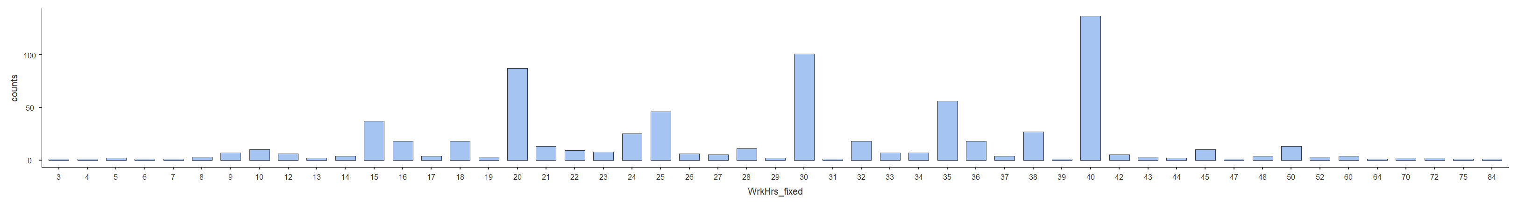

Figure 6

Histogram for the variable ‘WrkHrs_fixed’

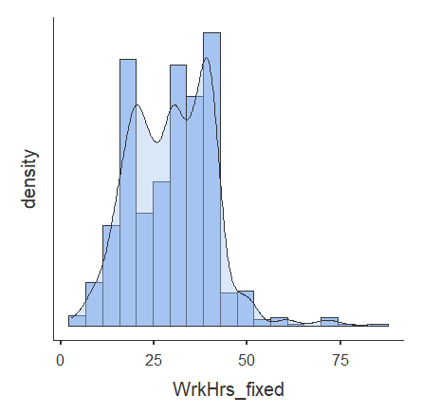

As the graphs and table show, the most common weekly working hours are 20, 30, 35, and 40.

## Question 3

**Calculate all central tendency values for the variable *Age*. Interpret them.**

Calculating the Measures of Central Tendency in jamovi is an easy process.

Figure 7

Calculating the Measures of Central Tendency for the variable ‘Age’

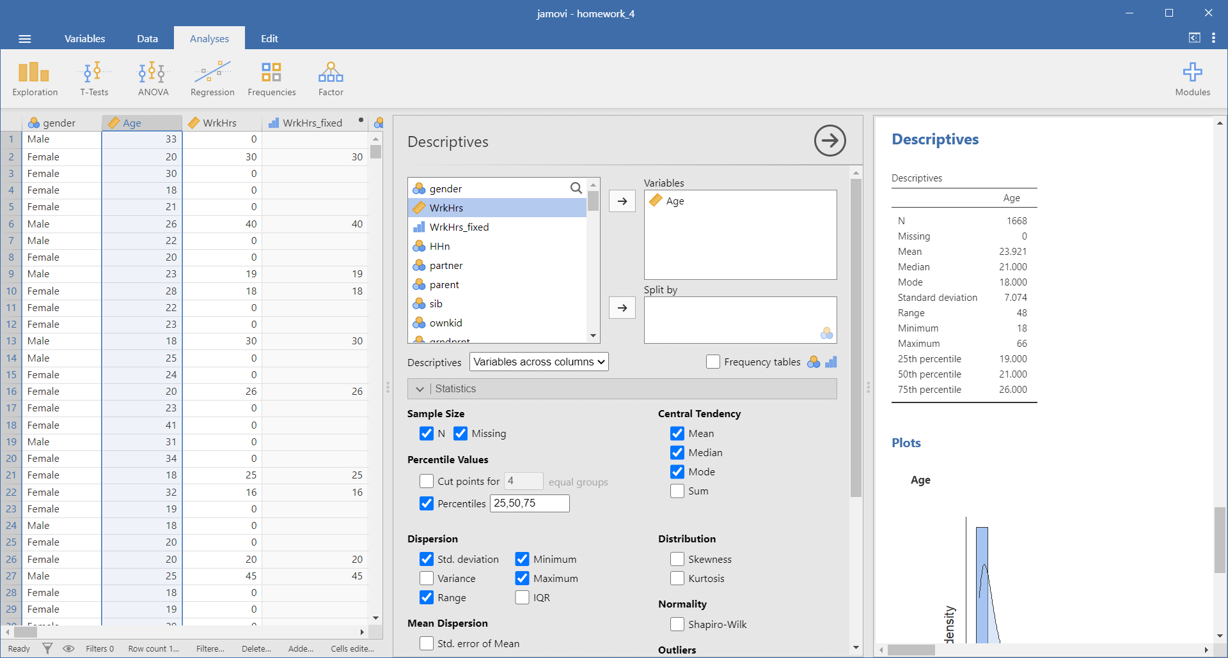

We highlight the main points in a table.

Table 2

Measures of Central Tendency for the variable ‘Age’

| Descriptives | | | |
| --- | --- | --- | --- |
|  | | **Age** | |
| N |  | 1668 |  |
| Missing |  | 0 |  |
| Mean |  | 23.921 |  |
| Median |  | 21.000 |  |
| Mode |  | 18.000 |  |
| Standard deviation |  | 7.074 |  |
| Range |  | 48 |  |
| Minimum |  | 18 |  |
| Maximum |  | 66 |  |
| 25th percentile |  | 19.000 |  |
| 50th percentile |  | 21.000 |  |
| 75th percentile |  | 26.000 |  |
|  | | | |

The mode (18) is the most frequent value, i.e. 18 is the most frequent value in the sample, i.e. most people are 18 years old.

The median (21) is the middle number in an ordered data set, i.e. the sample has the same proportion of people aged under 21 and over 21.

The mean (23.92) is the sum of all values divided by the total number of values. It’s the most commonly used measure of central tendency because all values are used in the calculation. An important property of the mean: the algebraic sum of the deviations from the arithmetic mean of the values is zero.

# References

Amerigo, M., & Aragones, J. I. (1997). A theoretical and methodological approach to the study of residential satisfaction. *Journal of Environmental Psychology, 17*, 47–57. doi:10.1006/jevp.1996.0038

Campagna, G. (2016). Survey data on household spatial quality and experiences of stress. *Data in Brief, 7*, 509–513. doi:10.1016/j.dib.2016.03.010

Pedersen, D. M. (1999). Model for types of privacy by privacy functions. *Journal of Environmental Psychology, 19*, 397–405. doi:10.1006/jevp.1999.0140

Scopelliti, M., & Giuliani, M. V. (2004). Choosing restorative environments across the lifespan: A matter of place experience. *Journal of Environmental Psychology, 24*, 423–437. doi:10.1016/j.jenvp.2004.11.002