The structure of the Hungarian Parallel Precision Speech Database
The database contains nearly 2,000 sentences read by 5 male and 5 female speakers stored in an ordered directory structure. Every library typically contain 36-36 sentences in an audible form (wav) and six additional parallel representations. These are the following: orthographic text (txt), phonetic transcription supplemented with word boundaries (gph), sound and word boundaries with time markers (TextGrid), waveform markers (pit), word stress marks in every word of the sentence (hgs), formant data for every voiced high energy speech sound of the sentence at 10%, 25%, 50%, 75%, and 90% points. All seven types of files of the given sentence have the same identifier, only the file extensions are different (see below the part of the structure of the library 01).

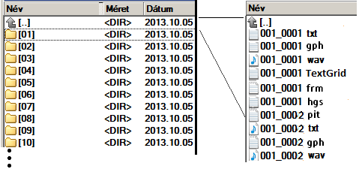

Example sentence: Ebben a pillanatban rájött, hogy hol van.

txt file: | ebben a pillanatban rájött, hogy hol van.
gph file: | e b: e n < sil | > a < sil | > p i l: a n a d b a n < sil | > r a1 j o2 < t: sil | t > h o < gy sil | ty > h o l < sil | > v a n
TextGrid file: | sound and word boundaries start-end time markers
pit file: | start-end time markers of voiced sound periods for F0 calculation
hgs file: | [:F]ebben [:N]a [:N]pillanatban [:F]rájött, [:N]hogy [:F]hol [:N]van.
frm file: | example of the four forms of the first vowel in the 001_0001.frm file at 5 points of the sound:  file hang time pos F1 F2 F3 F4  f_bm_0103 E 0.1321 10 571 1596 2435 3607  f_bm_0103 E 0.1443 25 570 1610 2509 3631  f_bm_0103 E 0.1648 50 570 1628 2593 3615  f_bm_0103 E 0.1853 75 541 1532 2518 3566  f_bm_0103 E 0.1976 90 446 1427 2406 3505

