Structure of the Hungarian stress database
The database contains 1866 declarative sentences from works of literature in 56 libraries. The libraries typically contain 36-36 sentences in audible form (wav) and in text (txt) with the same identifier, only the extension of the files is different.
For example, the first sentence in directory 1 has the following file name:
001_0001.txt and 001_0001.wav

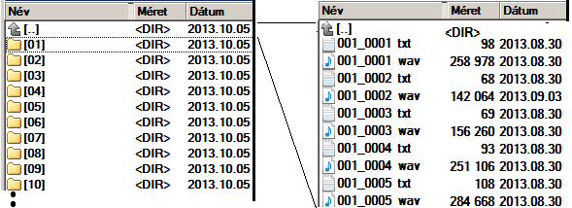

Text part (txt files)
Each word of each sentence is marked with stress mark. We use two types of stress marks: the word is accented: F / not accented: N. (subdegrees of accentuation are not marked within the sentences).
Attention! In the text of the sentences, we use only small letters. So we do not enforce Hungarian spelling rules here!
For example, the first sentence of library 1 has nine words and 9 stress marks. The following textual content is in the file:
[:N]a [:F]világosság [:N]felé [:N]fordult, [:N]és [:F]belebámult [:N]az [:F]üveg [:N]papírnyomóba.

Sound files (wav)
The sentences of the database were produced by the ProfiVox-triad male voice speech synthesizer in audible form from the written form including the F and N stress marks in the tex. Emphasis was created only by changing the fundamental frequency up and down. We performed a strong fundamental frequency (F0) increase on the first vowel of the word, and then controlled the fundamental frequency back till the beginning point of the second vowel to the base melodic line level.

Evaluation of the stress database
The stress marks in the sentences of the database can be used as a reference. No labeling error is in the text files. It means that where emphasis has been marked on the given word, the accented pronunciation does not cause unacceptable or strange sounding. There are sentences that can be pronounced with different types of emphasis depending on the interpretation and the intended communication. For these sentences, one of the correct forms is given by the stress marks before the words. The developers proved the correctness of the database with a listening test in 2013. See the technical article.

