Personal Budget Management System Report
Budgetwise
Aaine Barintuma
UI/UX Design individual practical assignment
31 October 2026

Project overview
Budgetwise helps a user record income and expenses and see the remaining monthly balance. The project includes mobile Figma designs and a responsive website built with HTML, CSS and JavaScript. This report explains the research, requirements, design and implementation in simple terms.
Required journey: Login → Budget dashboard → Add transaction → Updated summary. The summary is the saved state of the third required interface, shown separately for clarity.

Basic user research
The research method was a review of the assignment, existing code, Figma screen structure and a walkthrough of the working website. No participant interviews or survey results were supplied. Proposed users and likely difficulties below are assumptions to validate with users.
Proposed users | Likely need
Students | Record allowances, meals and transport
Salaried workers | Compare income with monthly bills
People with irregular income | Record several payments as they arrive

The brief requires income and expense entry, so the design has a type switch. Its required journey ends with an updated summary, so saving shows confirmation and recalculated totals. The mobile Figma frames support a phone layout with scrolling content.

Simple research questions
How do you track spending now? What is difficult? What should appear first in a budget app? Would you use a phone or computer? What was difficult when you tried this demo? Record actual answers separately in RESEARCH.md; do not invent results.

Problem requirements and sketches

Problem statement
Users need one simple place to record income and expenses and see what remains for the month. Budgetwise reduces the need to add totals manually. This problem framing comes from the assignment and needs participant feedback.

Main requirements
Provide a login interface, a monthly dashboard, an income and expense form, clear validation, an updated summary and easy navigation. The layout should work on phones and computers. Sample entries should remain after reloading the browser.

Ideas considered
A long transaction list makes individual records easy to inspect. A dashboard makes the overall monthly position easier to see. The dashboard idea was selected, with a separate Transactions view for detail. This explains the existing design; it is not a participant voting result.
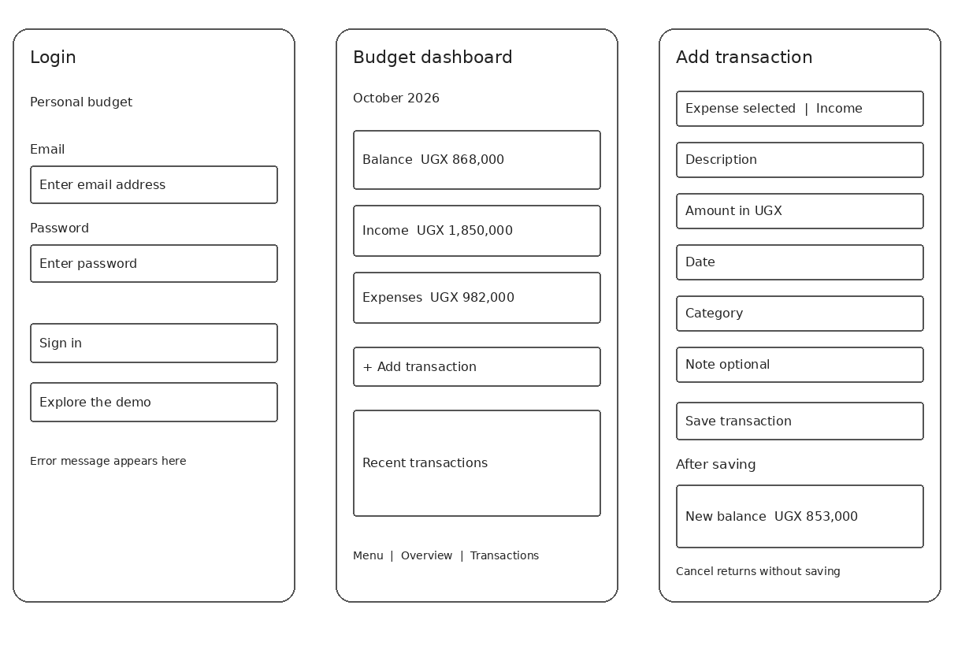
Figure 1 Digital wireframes for the three required interfaces
These are digital drawing guides created for the documentation. The third sketch includes the form and its saved summary. To meet a paper-sketch requirement, draw these layouts on paper, label the buttons and photograph the drawings. No paper sketch photographs were supplied.

High fidelity mobile design
The existing Figma file was inspected on 31 October 2026. Its four main phone frames are 390 × 844 pixels. Login, Overview, Add transaction and Updated summary were verified in the file structure. The file also includes Reports, Transactions, Budgets and Settings.
Screen | Verified frame
Login | 15:157
Budget dashboard | 15:158
Add transaction | 15:159
Updated summary | 15:160

Figma file: https://www.figma.com/design/FQLOMqCsZITyL52DR6MInm
Direct links to each screen are in submission/figma/README.md.
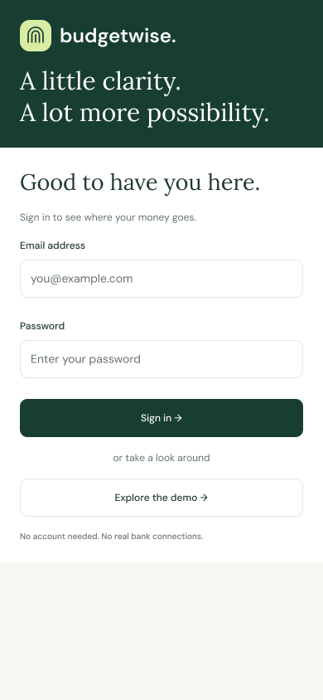
Figure 2 Login design exported directly from Figma

Design choices
The web code uses dark green #183e32, light green #d8eca4 and a light background #f7f8f2. DM Sans is used for body text and Lora for main headings. Consistent cards, visible labels and a clear Add transaction action help users find the main tasks.
Figma is the mobile design artefact. The implementation also adapts to desktop. Further Figma image exports were stopped by the plan usage limit; the remaining frames are linked, not presented as exported screenshots. Prototype connections were not tested in this pass.

Working login and dashboard
HTML loads the interface, CSS controls its layout, and JavaScript handles navigation, validation and calculations. These screenshots were captured from the deployed website using fictional sample data on 31 October 2026. They show the desktop implementation.
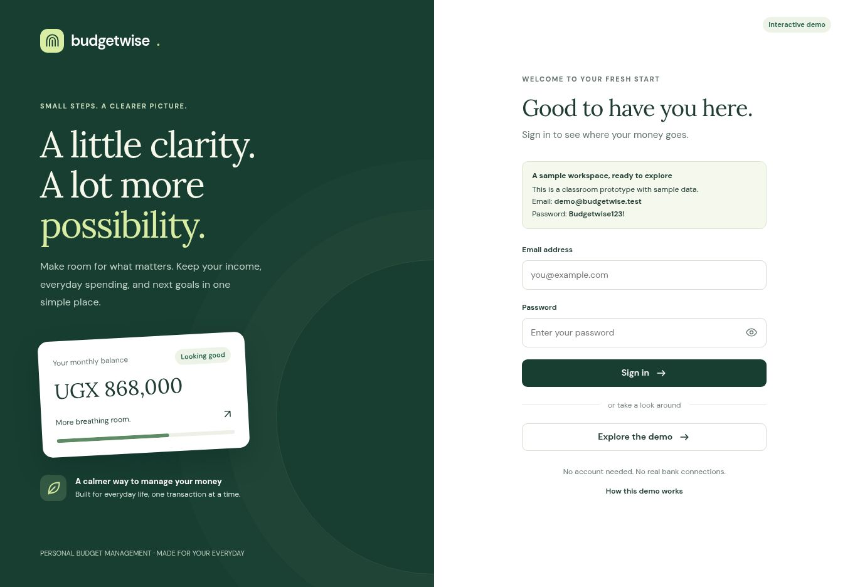
Figure 3 Login with labelled fields and a public demo option
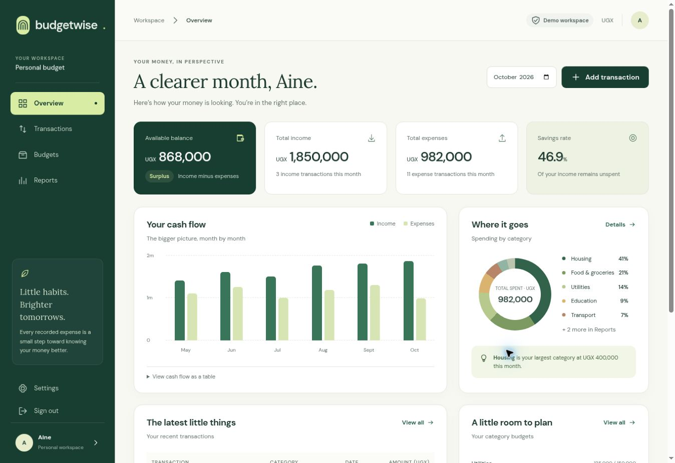
Figure 4 Dashboard before adding the sample expense
October starts with income of 1,850,000 UGX, expenses of 982,000 UGX and a remaining balance of 868,000 UGX. The dashboard provides a month selector and Add transaction action.

Adding a transaction and seeing the result
The form records type, description, amount, date and category. Notes are optional. It rejects incomplete entries and shows a preview before saving. Balance equals total income minus total expenses for the selected month.
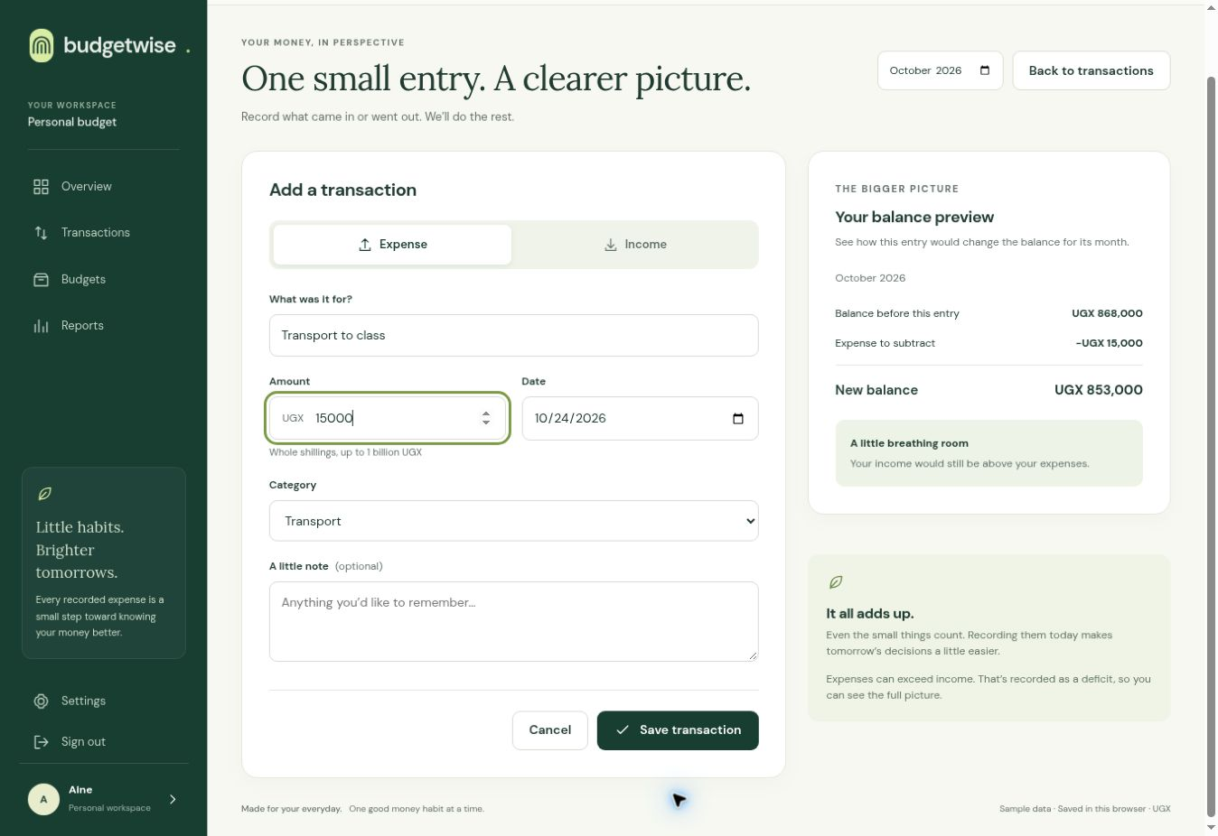
Figure 5 Entering a 15,000 UGX transport expense
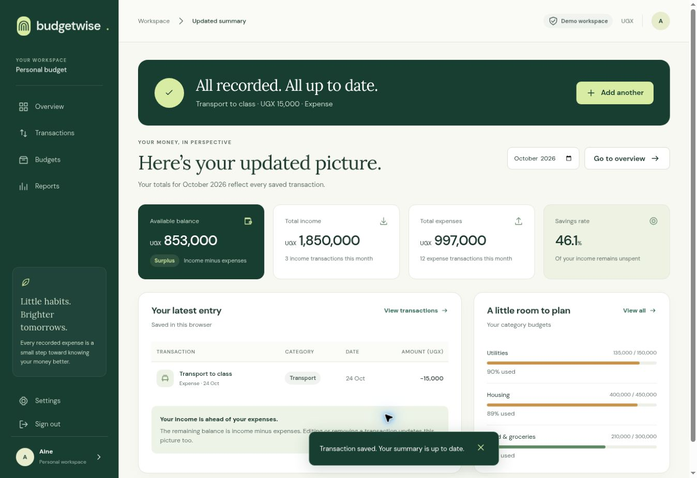
Figure 6 Saved entry with recalculated monthly totals
After saving, income stays at 1,850,000 UGX, expenses increase to 997,000 UGX and balance falls to 853,000 UGX. Reloading retains the saved entry in the same browser.

Checks and demonstration

Checks performed
All 18 existing model tests passed on 31 October 2026. They cover totals, deficits, validation, dates, filters, category totals, saved-state checks and CSV handling. Both JavaScript files passed syntax checks.
Browser action | Observed result
Submit empty login | Requests email and password
Open the demo | Shows October dashboard
Submit empty transaction | Shows required-field errors
Enter 15,000 UGX expense | Preview balance is 853,000 UGX
Save the expense | Expenses 997,000 and balance 853,000 UGX
Reload the summary | Saved entry and totals remain

These are developer checks of the live desktop journey. They are not participant usability results or a full accessibility audit. A fresh mobile browser check was not performed in this pass.

Simple demonstration
1. Open Login and demonstrate an empty-form error, then choose Explore the demo.
2. Show the October dashboard and starting balance of 868,000 UGX.
3. Add an Expense called Transport to class, amount 15000, date 24 October 2026, category Transport.
4. Show the 853,000 UGX preview, save, and explain the updated summary.
5. Reload to show that the sample entry remains in this browser.

Limitations and next step
This is a classroom prototype with simulated login and fictional data. Records stay in browser local storage; there is no bank connection or server backup. Collect real participant feedback and add personal paper sketch photos where required, then use the presentation guide to demonstrate the interface.

Project references
Assignment brief: the two images supplied by the student.
Source: https://github.com/abarintuma/ui-ux
Website: https://ui-ux-ivory.vercel.app/
Designs: https://www.figma.com/design/FQLOMqCsZITyL52DR6MInm
Inspected application revision: ae70b9d. Supporting notes are in submission/.

