**The initial setup visualization**

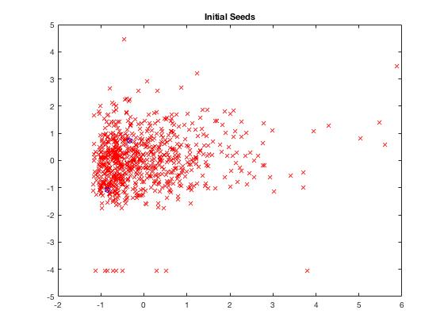

Figure 1: Seeds

**The initial cluster assignment visualization**

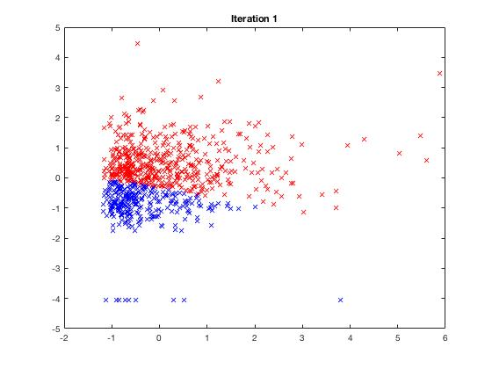

Figure 2: Initial Clustering

**The final cluster assignment visualization**

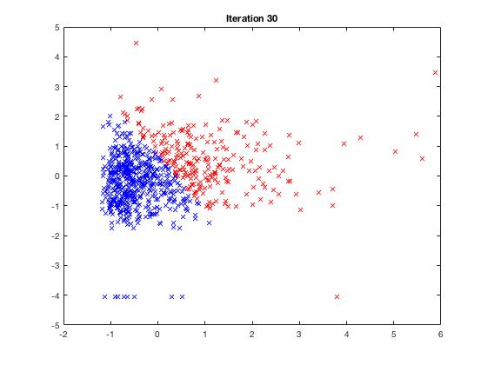

Figure 3: Final Clustering after 30 iterations