The final model in the form is

$$y=3.4256×{10}^{3}+846.9474x_{:,1}-369.2202x_{:,2}$$

The graph of the RMSE.

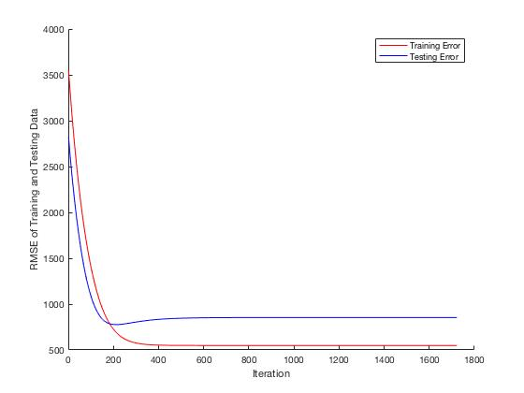

The root mean squared error.

|  |  |
| --- | --- |
| RMSE: | 853.380586 |