**Theory Question 1**

$$H\left(\frac{12}{21},\frac{9}{21}\right)=-\frac{12}{21}\log_{2}{\frac{12}{21}}-\frac{9}{21}\log_{2}{\frac{9}{21}}≈0.9852$$

$$remainder\left(x_{1}\right)=\frac{8}{21}H\left(\frac{7}{8},\frac{1}{8}\right)+\frac{13}{21}H\left(\frac{5}{13},\frac{8}{13}\right)=0.8021$$

$$remainder\left(x_{2}\right)=\frac{10}{21}H\left(\frac{7}{10},\frac{3}{10}\right)+\frac{11}{21}H\left(\frac{5}{11},\frac{6}{11}\right)=0.9403$$

$$IG\left(x_{1}\right)=H\left(\frac{12}{21},\frac{9}{21}\right)-remainder\left(x_{1}\right)=0.1831$$

$$IG\left(x_{2}\right)=H\left(\frac{12}{21},\frac{9}{21}\right)-remainder\left(x_{2}\right)=0.0449$$

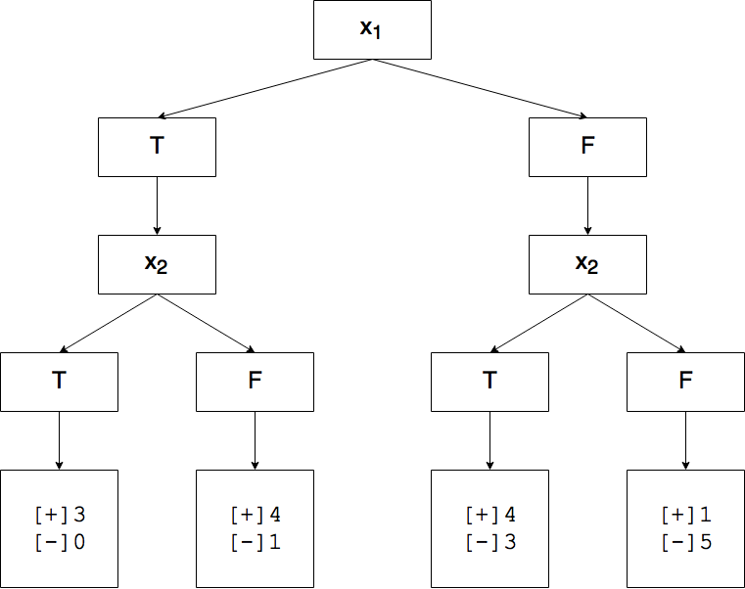

**Theory Question 2**

$$P\left(A=Yes\right)=\frac{3}{5}$$

$$P\left(A=No\right)=\frac{2}{5}$$

Standardized feature, $μ_{1}=208.0000$, $μ_{2}=4.0260$, $σ_{1}=145.2154$, $σ_{2}=1.3256$

$$data=\left[\begin{aligned}\begin{matrix}+0.0551 & +1.2477\end{matrix} \\ \begin{matrix}-0.9572 & +0.5688\end{matrix} \\ \begin{matrix}+0.6473 & -1.2945\end{matrix} \\ \begin{matrix}-1.0192 & -0.6533\end{matrix} \\ \begin{matrix}+1.2740 & +0.1313\end{matrix}\end{aligned}\right]$$

For Given A = Yes:

$$data=\left[\begin{matrix}\begin{matrix}+0.0551 & +1.2477\end{matrix} \\ \begin{matrix}-0.9572 & +0.5688\end{matrix} \\ \begin{matrix}-1.0192 & -0.6533\end{matrix}\end{matrix}\right]$$

$μ_{1}=-0.6404$, $μ_{2}=0.3877$, $σ_{1}=0.6031$, $σ_{2}=0.9633$

For Given A = No:

$$data=\left[\begin{aligned}\begin{matrix}+0.6473 & -1.2945\end{matrix} \\ \begin{matrix}+1.2740 & +0.1313\end{matrix}\end{aligned}\right]$$

$μ_{1}=0.9607$, $μ_{2}=-0.5816$, $σ_{1}=0.4431$, $σ_{2}=1.0082$

Using normal PDF. Standardize data first, it becomes to $0.2341$ and 0.4028.

$$P\left(GetA | R\right)∝P\left(GetA\right)×P\left(f_{1} | GetA\right)×P\left(f_{2} | GetA\right)=\frac{3}{5}×0.2312×0.4141=0.0574$$

$$P\left(NotA | R\right)∝P\left(NotA\right)×P\left(f_{1} | NotA\right)×P\left(f_{2} | NotA\right)=\frac{2}{5}×0.2347×0.2457=0.0232$$

$0.0574>0.0232$, so that it should get an A.

**k-Nearest Neighbors (KNN)**

|  |  |
| --- | --- |
| Precision | 0.925234 |
| Recall | 0.841837 |
| F-Measure | 0.881567 |
| Accuracy | 0.913242 |