Artificial Neural Networks

(a) Requested Statistical Information

|  |  |
| --- | --- |
| Testing Error | 0.060665 |

(b) Plot of training error vs iteration.

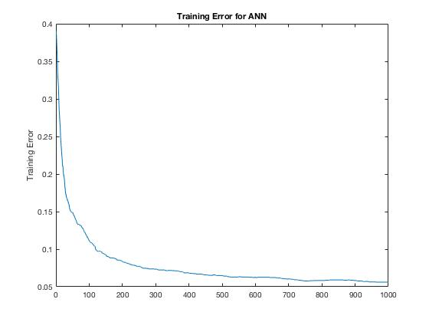

The Precision-Recall Tradeoff

(a) Precision-Recall plot.

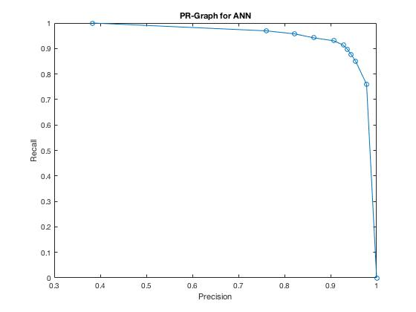

Multi-Class Artificial Neural Networks

(a) Requested Statistical Information

|  |  |
| --- | --- |
| Testing Error | 0.097458 |

(b) Plot of training error vs iteration.

