
GOVERNMENT ARTS AND SCIENCE COLLEGE
WIMCO NAGAR, THIRUVOTTIYUR,
CHENNAI-19
MICRO GOAL

Team ID: SWTID-2026-3099
Team Size:5

Team Leader : ABARNA S
Team Member : ASWINI T
Team Member : BAKKIYALAKSHMI B
Team Member : BHUVANSURYA D
Team Member : GNANA PRIYA V

MICROGOALS – SECURE GOAL MANAGEMENT BACKEND API

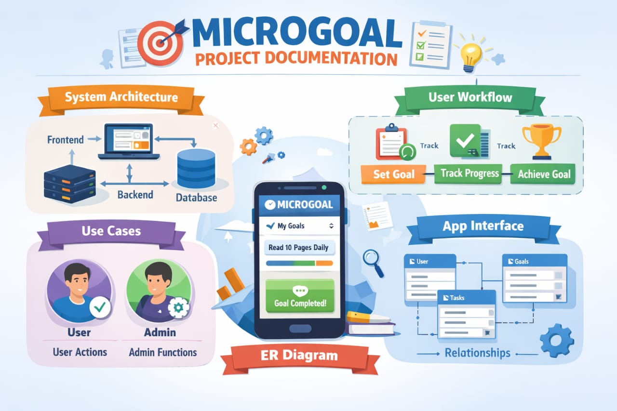

TITLE OF CONTENTS

1. INTRODUCTION

2. PROJECT OVERVIEW

3. PROJECT INSTRUCTION

4. PROJECT RE-QUISITIES

5. PROJECT ARCHITECTURE

6. FEATURES

7. USER FLOW

8. PROJECT SETUP AND CONFIGURATION

9. MONGODB EXECUTION

10. CONCLUSION

- INTRODUCTION:
Microgoal are small and simple goal that help a person achieve a bigger goal step by
step. Instead of focusing on one large task, microgoals break the task into smaller and
manageable parts. This makes the work easier and helps people stay motivated. By completing
small goals regularly, a person can make steady progress and successfully reach their main
objective. Microgoals are often used in studying, project work, personal development, and time
management to improve productivity and focus.

- PROJECT OVERVIEW:
MicroGoals is a secure backend RESTful API developed using Node.js, Express.js,
and MongoDB. It enables users to register, log in, and manage their personal goals through
CRUD operations. The system uses JWT authentication and middleware to ensure data security
and user-specific access control.

The system includes:
● User Registration &amp; Login
● JWT-based Authentication
● CRUD Operations for Goals
● Protected Routes
● Centralized Error Handling

The main objective is to provide a secure and scalable backend system for digital goal
management.

3.PROJECT INSTRUCTION:
● The project follows REST API principles.
● Authentication is handled using JWT.
● MongoDB is used as the database.
● APIs are tested using Thunder Client.
● The project follows MVC architecture.

4.PRE-REQUISITES:
Before running the project, the following tools are required:
● Node.js (v18 or higher)
● Express.js
● MongoDB (Local / Atlas)
● VS Code
● Thunder Client (Extension)
● Basic knowledge of JavaScript &amp; REST API

5.PROJECT ARCHITECTURE:
TECHNICAL ARCHITECTURE:
● Runtime: Node.js
● Framework: Express.js
● Database: MongoDB
● Authentication: JWT
● Architecture Pattern: MVC

6.FEATURES:
    - User Registration
    - Secure login with JWT
    - Create Goal
    - Update Goal
    - Delete Goal
    - View User-specific Goals
    - Protected Routes

7. USER FLOW:
1. User registers
2. User logs in
3. JWT token generated
4. User sends token in header
5. Access protected routes
6. Perform CRUD operatios

8. PROJECT SETUP AND CONFIGURATION:

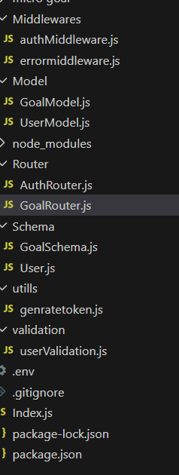

9. Project setup
npm init -y
- install dependencies:
npm install express mongoose jsonwebtoken bcryptjs dotenv
- start server:
node server.js

- BACKEND DEVELOPMENT
- Created Express 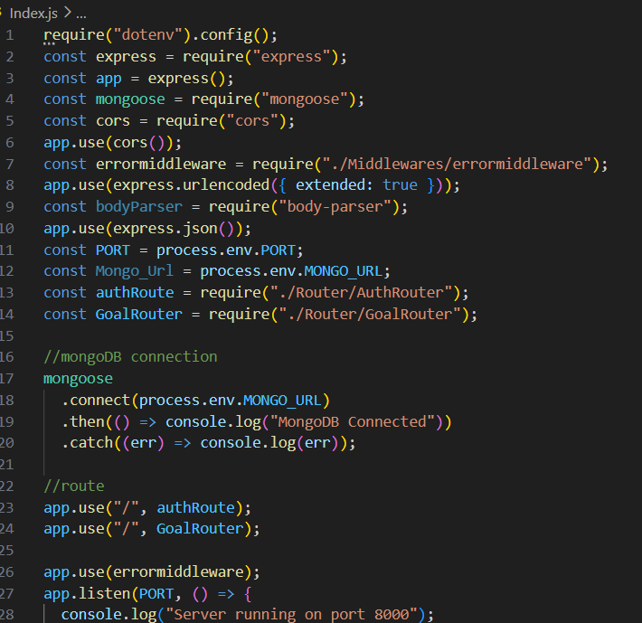

- Connected MongoDB

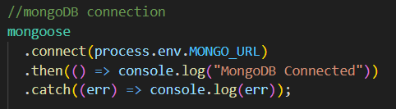

- Implemented Authentication APIs
.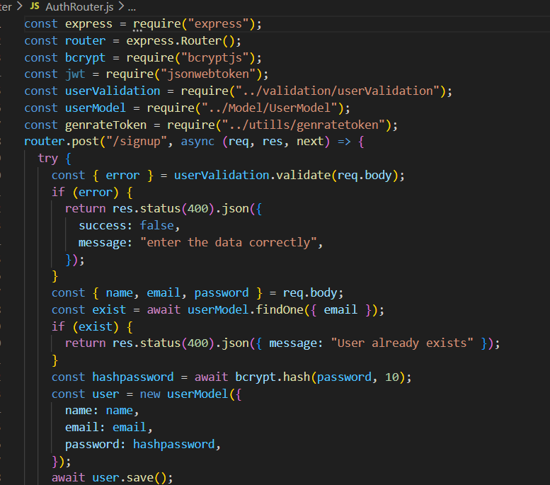

- Implemented Goal CRUD APIs

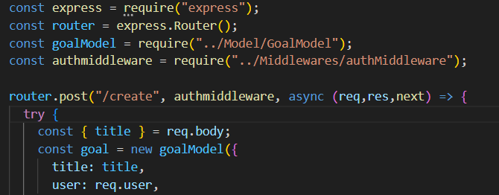

- DATABASE DEVELOPMENT

- CONFIGURE MONGODB

- Use mongodb atlas or local MongoDB
- Store connection string in.env

- CREATE DATABASE CONNECTION
Index.js file:
- Use mongoose.connect()
- Handle connection errors

Create schema and models:

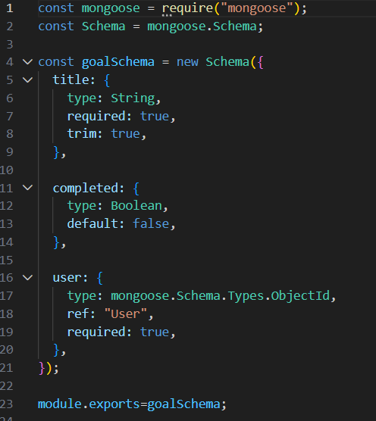

PROJECT EXECUTION:
Project Execution steps:
- Start MongoDB
- Run server
- Test APIs in thunder client
- Register user
- Login and get JWT
- Perform CRUD operations

10.PROJECT OUTPUT SCREENSHOTS:

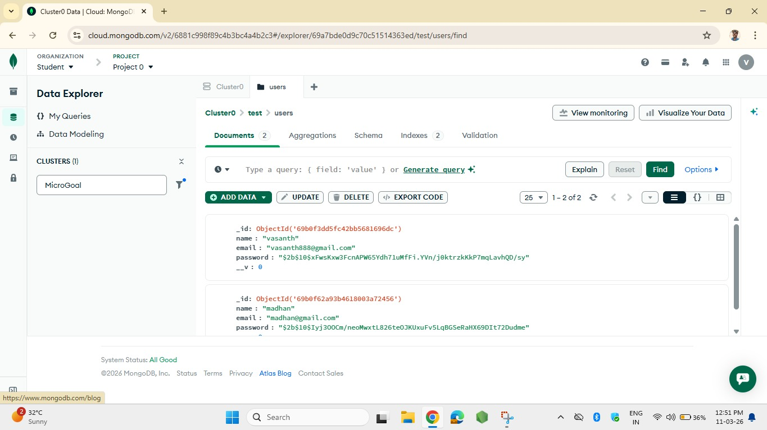

11. CONCLUSION:
Microgoals are very useful for achieving big goals easily. When a big task is divided into many small goals, it becomes simple to understand and complete. Microgoals help people stay focused, motivated, and organized while working on a task.
Instead of trying to finish everything at once, completing one small step at a time reduces stress and increases confidence. Each microgoal gives a sense of progress, which encourages us to continue working towards the final goal.
For example, if a student wants to complete a project, they can set microgoals like researching the topic, writing the introduction, preparing slides, and practicing the presentation. By completing each step one by one, the whole project becomes easier to finish.
In conclusion, microgoals make big tasks manageable and improve productivity. They help us plan our work better, maintain motivation, and successfully achieve our main objectives.

