* Due by EOD 1/30/2021
  + Business Question
  + Slack repo location to Eric+Eric+Cas
* Project due date: 2/10/2021 (Wednesday)
* Business question ideas
  + Which city in the US has the best job market for data analysts?
    - Refine “best”. ie: number of jobs, average salary, etc.
* Project Info
  + Track two: a combination of web-scraping and Leaflet (or Plotly)
  + Overview: pull job data from bls.gov and deploy to map visualization (leaflet)
  + Map ideas
    - Map layers for number of jobs, average salary, etc.
    - Geographic Map of skills (ie: Python vs. Java across US)

**PARKING LOT**

* + layer for “quality of life”, ie: proximity to ski areas, etc.

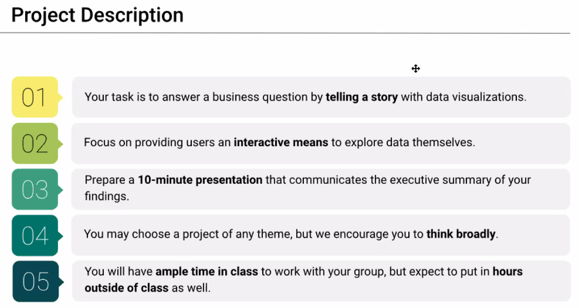

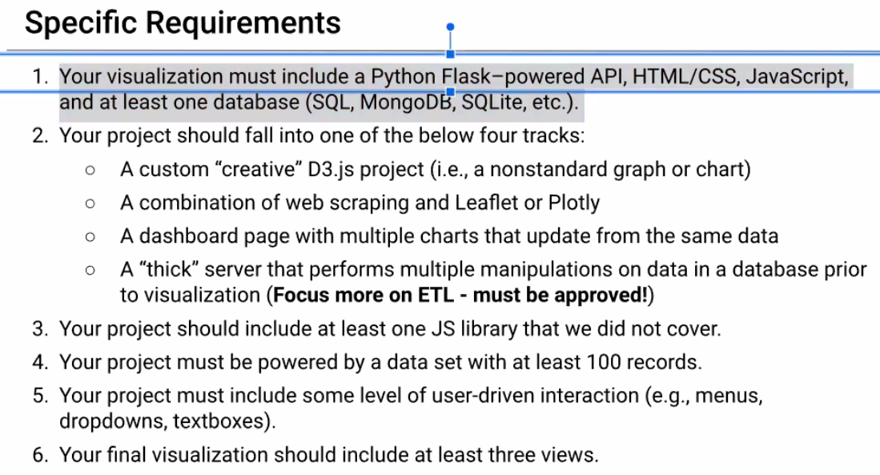

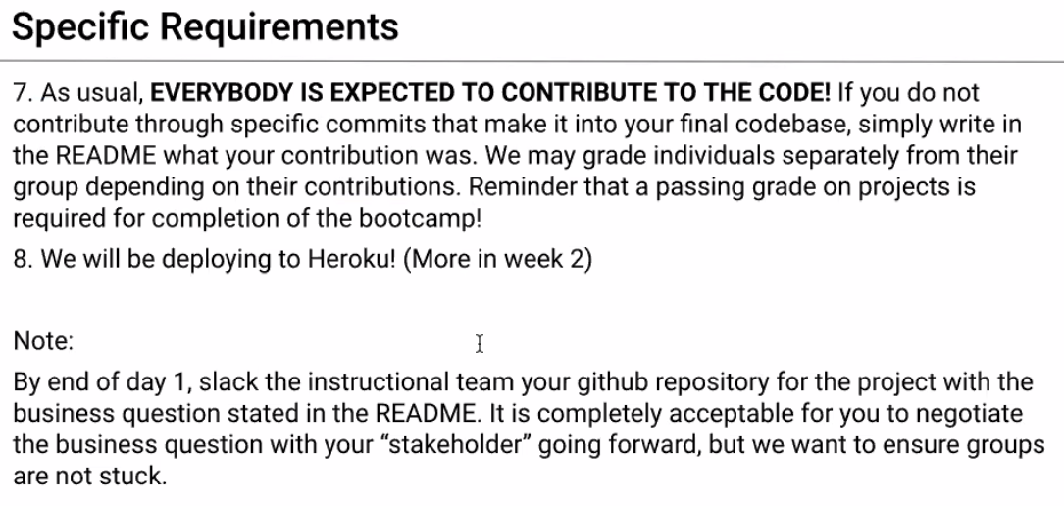

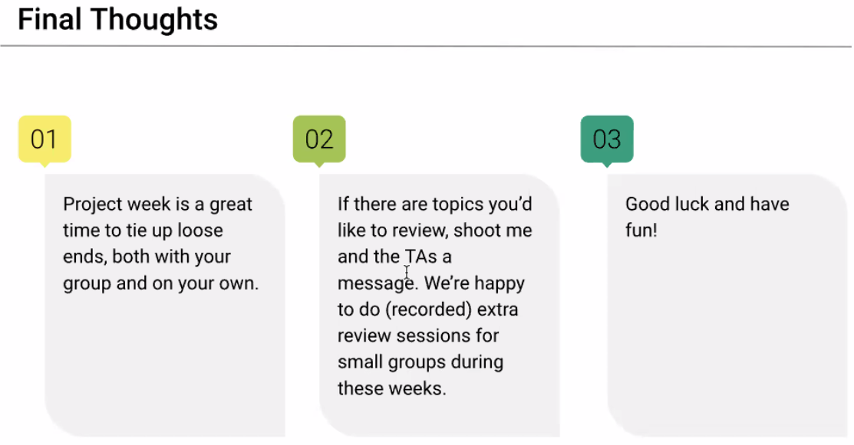

**DATA SOURCES**

* LinkedIn – paywall (Aaron)
* Glassdoor – paywall (Sung)
* Ziprecruiter – paywall (Sung)
* Monster – maybe? (Aaron found something)
  + Brett: XML file challenge