**Capstone Project**

Barou Anna

11/1/2018

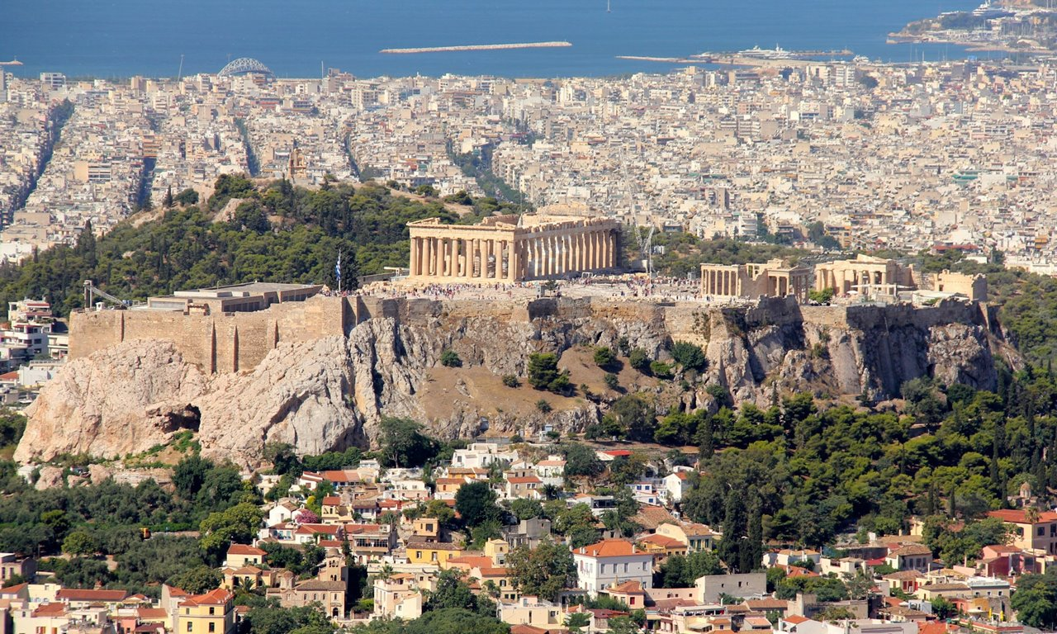

**“The Battle of Athens’s Neighborhoods, Greece”**

**Table of Contents**

Introduction/Business Problem 2

Data section 3

# **Introduction/Business Problem**

**A Friend of mine which is Pharmacist is looking to set up new “Pharmacy” store in a neighborhood of Athens, Greece.**

**He needs his pharmacy’s location to be near his home location, so specific municipalities of Athens (24 different municipalities of Athens) are investigated.**

**To be sure that his new pharmacy store will have good profit, he requires to:**

* **set up his business to a municipality that live lot of people (so, we examine each municipality population)**
* **to be as near as possible to a Hospital or Medical Center**
* **to be as far as possible to other competitors’ Pharmacy stores**

**This report is focused to propose the better location for my friend Pharmacist to set up a new “Pharmacy” store, according to above requirements.**

# **Data section**

**Below data are used to examine this case:**

**First of all, I need a list of Athens (Attica, Greece) Municipalities with their population figure. According to “**General Secretariat of National Statistical Service of Greece**” there is a table that shows population (latest figures from year 2011) per Municipality. So, I use below page to extract required information:**

<http://www.citypopulation.de/php/greece-attiki.php>

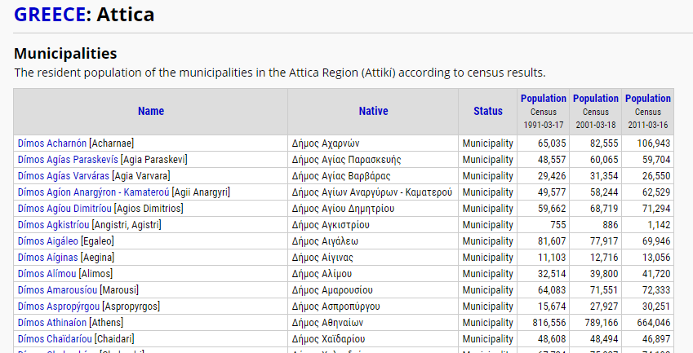

**As we can see, this table has 6 columns:**

* **first column “Name”, list all names of Athens (Attica) Municipalities**
* **second column “Native” has its municipality name in Greek**
* **third column “Status” states that each name corresponds to Municipality**
* **fourth column shows each municipality Population figure from year 1991**
* **fifth column shows each municipality Population figure from year 2001**
* **sixth column shows each municipality Population figure from year 2011**

**From above table, first and last column have the information we need.**

**Then, to continue my investigation I ask my friend Pharmacist to provide me with name of municipalities that is interested to set up his business. He is only interesting to specific 26 municipalities: Agia Paraskevi, Agios Dimitrios, Alimos, Marousi, Chalandri, Dafni-Ymittos, Elliniko-Argyroupoli, Filothei-Psychiko, Galatsi, Glyfada, Ilioupoli, Irakleio, Kessariani, Kallithea, Kifisia, Lykovrysi-Pefki, Metamorfosi, Nea Ionia, Nea Smyrni, Palaio Faliro, Papagou-Cholargos, Penteliri-Voula-Vouliagmeni, Vrilissia, Vyronas, Zografos.**

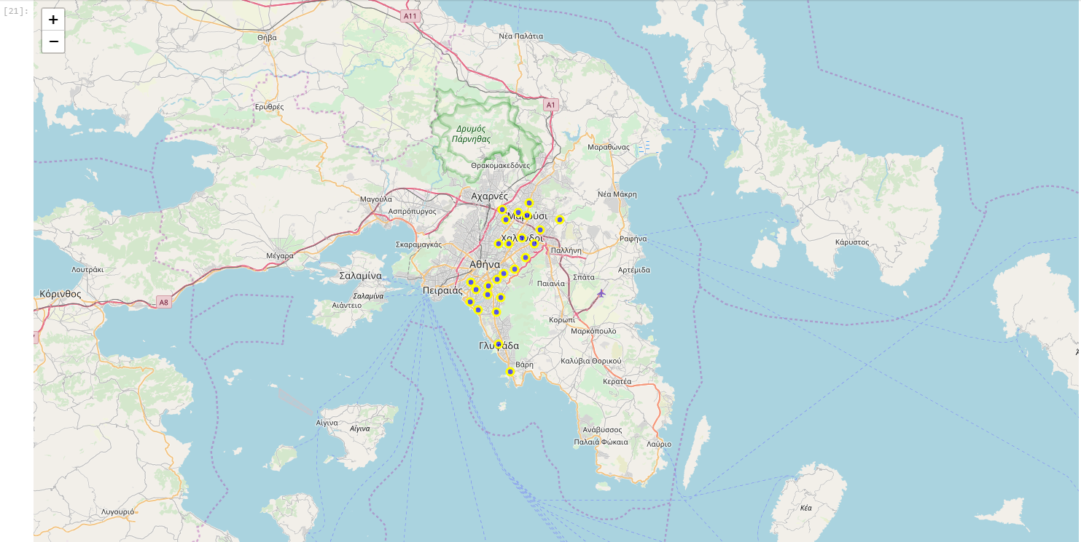

**Then, I prepared a csv (coordinates.csv) file that lists all above municipalities and their coordination:**

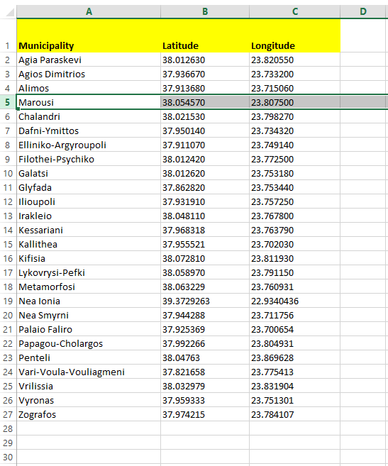

**To continue, I use Foursquare.com (**<https://foursquare.com/>**) to fetch**

* **all other competitor’s Pharmacy with their coordinates and distance from center of each Municipality**
* **all Medical centers and Hospital for each interested Municipality.**

**Using Folium (**<https://pypi.org/project/folium/> **), I create relative maps to view interested results: e.g. for municipality named “Marousi”, a map is created that shows competitors’ Pharmacy (red cicles) and Medical Centers/Hospitals (blue cicles)**

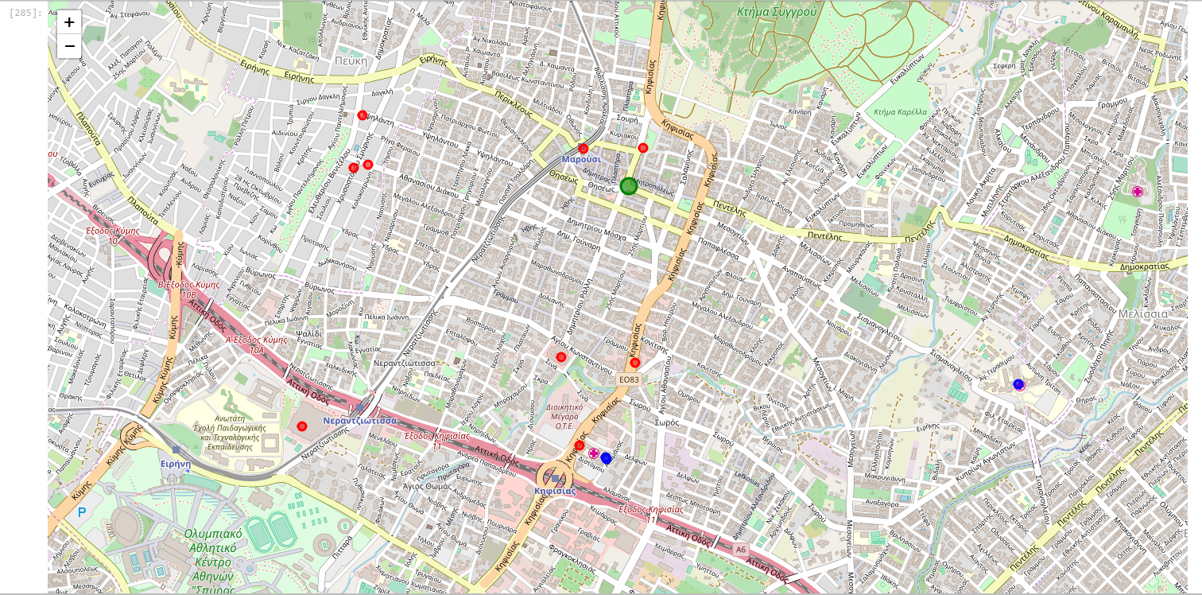

With above data, I will examine and compare all 26 municipalities and using K-means algorithm, I propose the best location for new “Pharmacy” to be set up.