Example of Report Generation from Matlab

This is a simple example created by Andreas Karlsson, Sweden.
Updated a cloudy day, in October 2016, with 7 °C.
The script will just insert a table and two figures into this document. Last section is a short introduction for the interested users out there.
My intention with this demo is to encourage you to let your powerful computer do the "monkey-job" such as inserting figures into MS-Word and writing standard reports. Hopefully these simple lines will help you getting more time for funny coding and problem solving, increasing productivity in other words by spending less time in Microsoft Office programs.
Happy coding!

Table of Contents
Example of Report Generation from Matlab 1
Table of Contents 2
Example of Report Generation from Matlab 2
Table of Contents 3
Data From Matlab 4
The Self-Explaining Table 4
First figure 4
Second figure 5
Flying Start 6
Selection-methods 6

Data From Matlab

The Self-Explaining Table

Test 1 | 0.3 | Pass
Test 2 | 1.8 | Fail

Example of ReFirst figure

port Generation from Matlab

This is a simple example created by Andreas Karlsson, Sweden.
Updated a cloudy day, in October 2016, with 7 °C.
The script will just insert a table and two figures into this document. Last section is a short introduction for the interested users out there.
My intention with this demo is to encourage you to let your powerful computer do the "monkey-job" such as inserting figures into MS-Word and writing standard reports. Hopefully these simple lines will help you getting more time for funny coding and problem solving, increasing productivity in other words by spending less time in Microsoft Office programs.
Happy coding!

Table of Contents
Example of Report Generation from Matlab 1
Table of Contents 2
Data From Matlab 3
The Self-Explaining Table 3
Test 2 3
Example of ReFirst figure 3
port Generation from Matlab 3
Table of Contents 4
Data From Matlab 5
The Self-Explaining Table 5
First figure 5
Second figure 6
Flying Start 7
Selection-methods 7
Second figure 13
Flying Start 14
Selection-methods 14

Data From Matlab

The Self-Explaining Table

Test 1 | 0.3 | Pass
Test 2 | 1.8 | Fail

First figure
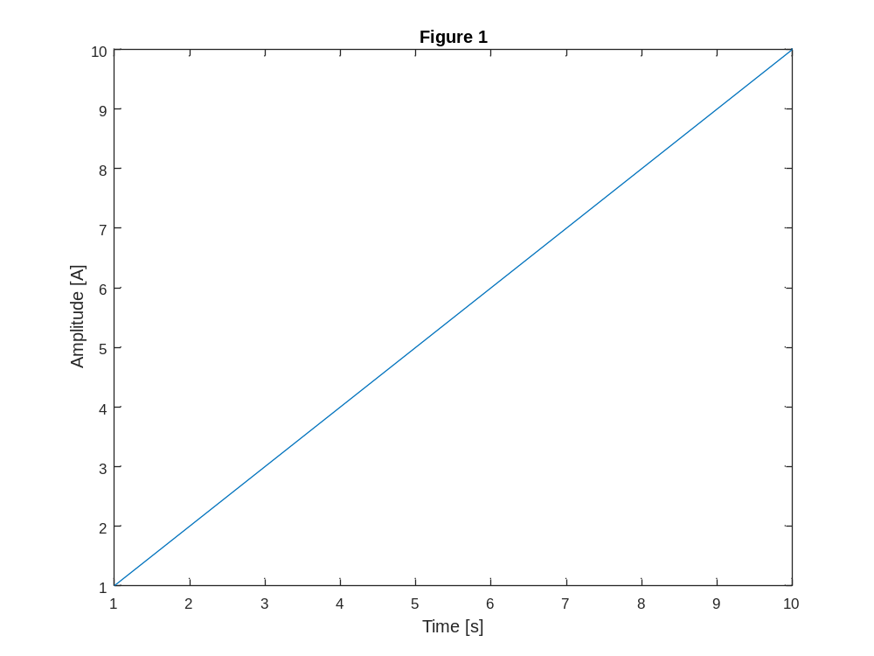

Second figure
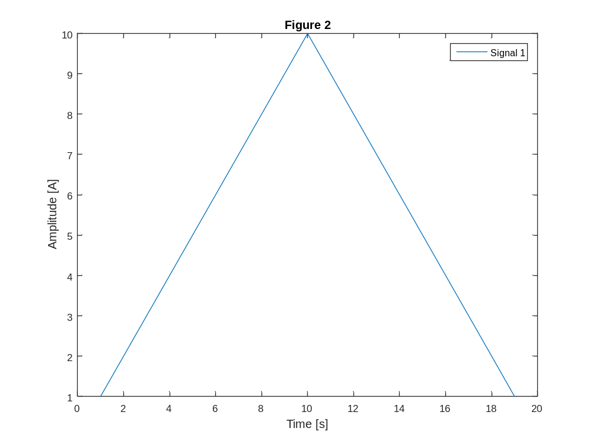

Flying Start
Find out how to do new things in MS-Word by using the "Record Macro"-function and look at the Visual Basic commands used.
In Matlab you find the available properties by using get(ActXWord), for top interface, and further on with for example get(ActXWord.Selection).
Then find the methods usable from Matlab by using the invoke-function in Matlab e.g. invoke(ActXWord.Selection). See the output of that call below.
Set a breakpoint here and play around with these commands...

Selection-methods
Methods called from Matlab as: ActXWord.Selection.MethodName(xxx)
Ignore the first parameter "handle".

Variant Information(handle, WdInformation)
void Select(handle)
void SetRange(handle, int32, int32)
void Collapse(handle, Variant(Optional))
void InsertBefore(handle, string)
void InsertAfter(handle, string)
handle Next(handle, Variant(Optional))
handle Previous(handle, Variant(Optional))
int32 StartOf(handle, Variant(Optional))
int32 EndOf(handle, Variant(Optional))
int32 Move(handle, Variant(Optional))
int32 MoveStart(handle, Variant(Optional))
int32 MoveEnd(handle, Variant(Optional))
int32 MoveWhile(handle, Variant, Variant(Optional))
int32 MoveStartWhile(handle, Variant, Variant(Optional))
int32 MoveEndWhile(handle, Variant, Variant(Optional))
int32 MoveUntil(handle, Variant, Variant(Optional))
int32 MoveStartUntil(handle, Variant, Variant(Optional))
int32 MoveEndUntil(handle, Variant, Variant(Optional))
void Cut(handle)
void Copy(handle)
void Paste(handle)
void InsertBreak(handle, Variant(Optional))
void InsertFile(handle, string, Variant(Optional))
bool InStory(handle, handle)
bool InRange(handle, handle)
int32 Delete(handle, Variant(Optional))
int32 Expand(handle, Variant(Optional))
void InsertParagraph(handle)
void InsertParagraphAfter(handle)
void InsertSymbol(handle, int32, Variant(Optional))
void CopyAsPicture(handle)
void SortAscending(handle)
void SortDescending(handle)
bool IsEqual(handle, handle)
single Calculate(handle)
handle GoTo(handle, Variant(Optional))
handle GoToNext(handle, WdGoToItem)
handle GoToPrevious(handle, WdGoToItem)
void PasteSpecial(handle, Variant(Optional))
handle PreviousField(handle)
handle NextField(handle)
void InsertParagraphBefore(handle)
void InsertCells(handle, Variant(Optional))
void Extend(handle, Variant(Optional))
void Shrink(handle)
int32 MoveLeft(handle, Variant(Optional))
int32 MoveRight(handle, Variant(Optional))
int32 MoveUp(handle, Variant(Optional))
int32 MoveDown(handle, Variant(Optional))
int32 HomeKey(handle, Variant(Optional))
int32 EndKey(handle, Variant(Optional))
void EscapeKey(handle)
void TypeText(handle, string)
void CopyFormat(handle)
void PasteFormat(handle)
void TypeParagraph(handle)
void TypeBackspace(handle)
void NextSubdocument(handle)
void PreviousSubdocument(handle)
void SelectColumn(handle)
void SelectCurrentFont(handle)
void SelectCurrentAlignment(handle)
void SelectCurrentSpacing(handle)
void SelectCurrentIndent(handle)
void SelectCurrentTabs(handle)
void SelectCurrentColor(handle)
void CreateTextbox(handle)
void WholeStory(handle)
void SelectRow(handle)
void SplitTable(handle)
void InsertRows(handle, Variant(Optional))
void InsertColumns(handle)
void InsertFormula(handle, Variant(Optional))
handle NextRevision(handle, Variant(Optional))
handle PreviousRevision(handle, Variant(Optional))
void PasteAsNestedTable(handle)
handle CreateAutoTextEntry(handle, string, string)
void DetectLanguage(handle)
void SelectCell(handle)
void InsertRowsBelow(handle, Variant(Optional))
void InsertColumnsRight(handle)
void InsertRowsAbove(handle, Variant(Optional))
void RtlRun(handle)
void LtrRun(handle)
void BoldRun(handle)
void ItalicRun(handle)
void RtlPara(handle)
void LtrPara(handle)
void InsertDateTime(handle, Variant(Optional))
handle ConvertToTable(handle, Variant(Optional))
void ClearFormatting(handle)
void PasteAppendTable(handle)
void ToggleCharacterCode(handle)
void PasteAndFormat(handle, WdRecoveryType)
void PasteExcelTable(handle, bool, bool, bool)
void ShrinkDiscontiguousSelection(handle)
void InsertStyleSeparator(handle)
void Sort(handle, Variant(Optional))
handle GoToEditableRange(handle, Variant(Optional))
void InsertXML(handle, string, Variant(Optional))
void InsertCaption(handle, Variant, Variant(Optional))
void InsertCrossReference(handle, Variant, WdReferenceKind, Variant, Variant(Optional))
void ClearParagraphStyle(handle)
void ClearCharacterAllFormatting(handle)
void ClearCharacterStyle(handle)
void ClearCharacterDirectFormatting(handle)
void ExportAsFixedFormat(handle, string, WdExportFormat, Variant(Optional))
void ReadingModeGrowFont(handle)
void ReadingModeShrinkFont(handle)
void ClearParagraphAllFormatting(handle)
void ClearParagraphDirectFormatting(handle)
void InsertNewPage(handle)

Second figure

Flying Start
Find out how to do new things in MS-Word by using the "Record Macro"-function and look at the Visual Basic commands used.
In Matlab you find the available properties by using get(ActXWord), for top interface, and further on with for example get(ActXWord.Selection).
Then find the methods usable from Matlab by using the invoke-function in Matlab e.g. invoke(ActXWord.Selection). See the output of that call below.
Set a breakpoint here and play around with these commands...

Selection-methods
Methods called from Matlab as: ActXWord.Selection.MethodName(xxx)
Ignore the first parameter "handle".

Variant Information(handle, WdInformation)
void Select(handle)
void SetRange(handle, int32, int32)
void Collapse(handle, Variant(Optional))
void InsertBefore(handle, string)
void InsertAfter(handle, string)
handle Next(handle, Variant(Optional))
handle Previous(handle, Variant(Optional))
int32 StartOf(handle, Variant(Optional))
int32 EndOf(handle, Variant(Optional))
int32 Move(handle, Variant(Optional))
int32 MoveStart(handle, Variant(Optional))
int32 MoveEnd(handle, Variant(Optional))
int32 MoveWhile(handle, Variant, Variant(Optional))
int32 MoveStartWhile(handle, Variant, Variant(Optional))
int32 MoveEndWhile(handle, Variant, Variant(Optional))
int32 MoveUntil(handle, Variant, Variant(Optional))
int32 MoveStartUntil(handle, Variant, Variant(Optional))
int32 MoveEndUntil(handle, Variant, Variant(Optional))
void Cut(handle)
void Copy(handle)
void Paste(handle)
void InsertBreak(handle, Variant(Optional))
void InsertFile(handle, string, Variant(Optional))
bool InStory(handle, handle)
bool InRange(handle, handle)
int32 Delete(handle, Variant(Optional))
int32 Expand(handle, Variant(Optional))
void InsertParagraph(handle)
void InsertParagraphAfter(handle)
void InsertSymbol(handle, int32, Variant(Optional))
void CopyAsPicture(handle)
void SortAscending(handle)
void SortDescending(handle)
bool IsEqual(handle, handle)
single Calculate(handle)
handle GoTo(handle, Variant(Optional))
handle GoToNext(handle, WdGoToItem)
handle GoToPrevious(handle, WdGoToItem)
void PasteSpecial(handle, Variant(Optional))
handle PreviousField(handle)
handle NextField(handle)
void InsertParagraphBefore(handle)
void InsertCells(handle, Variant(Optional))
void Extend(handle, Variant(Optional))
void Shrink(handle)
int32 MoveLeft(handle, Variant(Optional))
int32 MoveRight(handle, Variant(Optional))
int32 MoveUp(handle, Variant(Optional))
int32 MoveDown(handle, Variant(Optional))
int32 HomeKey(handle, Variant(Optional))
int32 EndKey(handle, Variant(Optional))
void EscapeKey(handle)
void TypeText(handle, string)
void CopyFormat(handle)
void PasteFormat(handle)
void TypeParagraph(handle)
void TypeBackspace(handle)
void NextSubdocument(handle)
void PreviousSubdocument(handle)
void SelectColumn(handle)
void SelectCurrentFont(handle)
void SelectCurrentAlignment(handle)
void SelectCurrentSpacing(handle)
void SelectCurrentIndent(handle)
void SelectCurrentTabs(handle)
void SelectCurrentColor(handle)
void CreateTextbox(handle)
void WholeStory(handle)
void SelectRow(handle)
void SplitTable(handle)
void InsertRows(handle, Variant(Optional))
void InsertColumns(handle)
void InsertFormula(handle, Variant(Optional))
handle NextRevision(handle, Variant(Optional))
handle PreviousRevision(handle, Variant(Optional))
void PasteAsNestedTable(handle)
handle CreateAutoTextEntry(handle, string, string)
void DetectLanguage(handle)
void SelectCell(handle)
void InsertRowsBelow(handle, Variant(Optional))
void InsertColumnsRight(handle)
void InsertRowsAbove(handle, Variant(Optional))
void RtlRun(handle)
void LtrRun(handle)
void BoldRun(handle)
void ItalicRun(handle)
void RtlPara(handle)
void LtrPara(handle)
void InsertDateTime(handle, Variant(Optional))
handle ConvertToTable(handle, Variant(Optional))
void ClearFormatting(handle)
void PasteAppendTable(handle)
void ToggleCharacterCode(handle)
void PasteAndFormat(handle, WdRecoveryType)
void PasteExcelTable(handle, bool, bool, bool)
void ShrinkDiscontiguousSelection(handle)
void InsertStyleSeparator(handle)
void Sort(handle, Variant(Optional))
handle GoToEditableRange(handle, Variant(Optional))
void InsertXML(handle, string, Variant(Optional))
void InsertCaption(handle, Variant, Variant(Optional))
void InsertCrossReference(handle, Variant, WdReferenceKind, Variant, Variant(Optional))
void ClearParagraphStyle(handle)
void ClearCharacterAllFormatting(handle)
void ClearCharacterStyle(handle)
void ClearCharacterDirectFormatting(handle)
void ExportAsFixedFormat(handle, string, WdExportFormat, Variant(Optional))
void ReadingModeGrowFont(handle)
void ReadingModeShrinkFont(handle)
void ClearParagraphAllFormatting(handle)
void ClearParagraphDirectFormatting(handle)
void InsertNewPage(handle)

