**Configuration of Northwind sample Database from Git-Hup repository to Local machine steps Documentation**

This is the link from GitHub from where I configured database to my local machine.

<https://github.com/microsoft/sql-server-samples.git>

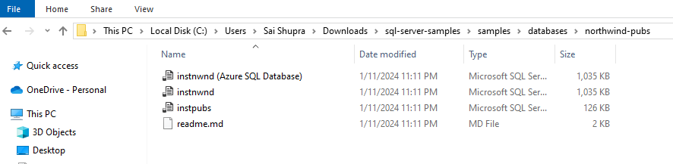

Another way to fetch databases from GitHub repository is I generated one of the python script to fetch databases as below and configured in my local

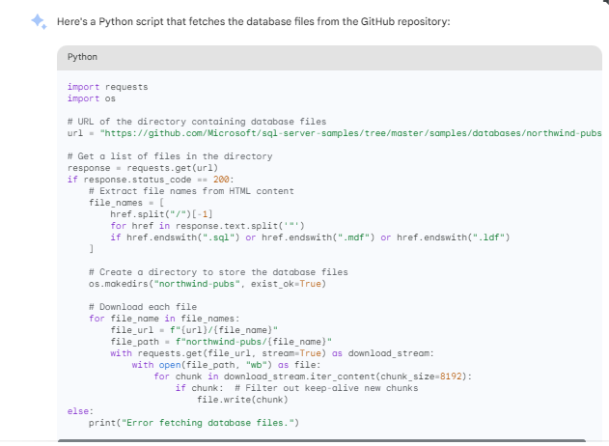

SOLUTION First Approach: Using AWS Schema conversion tool.

Manually created a database named Northwind-pubs and created Tables using the scripts.

And created views using scripts.

Now my recommendation to use AWS SCT tool to transfer data from SQL server to PostgreSQL this is possible when all environment in one place I don’t have some access so unable to do it properly below are some issues I faced when doing connection, but it is executable when all environment is at one place

This can be eliminated by using required drivers when all compatible software used, I have some Limitation so facing issue.

**SECOND APPROACH AWS CLOUD SOLUTION:**

Architecture DIAGRAM is not created due to some restrictions.

Approach 1: Using S3 and Lambda for Incremental Data

Workflow:

SQL Server data is transferred to S3.

Lambda function triggers new data in S3.

Lambda processes the incremental data and updates the PostgreSQL database.

Pros:

Serverless architecture for cost efficiency.

Incremental processing can reduce the load on the database.

Cons:

Complexity in handling incremental data processing.

Potential delays in data propagation.

Considerations:

Ensure Lambda function scalability and error handling.

Monitor and manage S3 costs based on data storage and transfer.

Approach 2: Using AWS Glue and Athena

Workflow:

AWS Glue Crawler fetches data from SQL Server and catalogs it.

Use Athena for querying data in the Glue catalog.

Load data from Athena to Amazon RDS for PostgreSQL.

Pros:

Simplifies ETL (Extract, Transform, Load) processes using Glue.

Athena enables SQL queries directly on data in S3.

Cons:

AWS Glue may have associated costs.

Additional considerations for managing schema changes.

Considerations:

Regularly update Glue crawlers to reflect changes in SQL Server schema.

Optimize Athena queries for performance.

Common Considerations for Both Approaches:

High Availability (HA):

Replicating data to multiple availability zones (AZs) is a good practice for minimizing downtime. Ensure PostgreSQL in RDS is configured for multi-AZ deployment.

Security:

Implement appropriate security measures, such as encryption in transit and at rest, to protect sensitive data.

Monitoring and Logging:

Set up CloudWatch logs and metrics for Lambda, Glue, and RDS to monitor performance and detect issues.

Testing:

Conduct thorough testing, including performance testing and data consistency checks, before and after the cutover.

Cost Management:

Regularly review and optimize costs associated with Lambda, Glue, S3 storage, and RDS.

Documentation:

Document the entire process, including configurations, for reference and future troubleshooting.

Resources used to develop this document.

1. SSMS- from Microsoft documentation
2. PostgreSQL- EBD PostgreSQL documentation
3. AWS Schema conversion tool -AWS documentation
4. AWS cloud services -AWS documentation
5. ChatGPT – For Information structure

**Approach 1: Using S3 and Lambda for Incremental Data**

**Terraform configuration (main.tf):**

provider "aws" {

region = "your-region"

}

# S3 bucket for data transfer

resource "aws_s3_bucket" "data_bucket" {

bucket = "your-bucket-name"

}

# Lambda function to process incremental data

resource "aws_lambda_function" "data_processor" {

filename = "lambda_function.zip" # Replace with your code file

source_code_hash = filebase64sha256("lambda_function.zip")

handler = "your.handler"

runtime = "python3.9" # Adjust as needed

role = aws_iam_role.lambda_role.arn

}

# IAM role for Lambda function

resource "aws_iam_role" "lambda_role" {

assume_role_policy = <<EOF

{

"Version": "2012-10-17",

"Statement": [

{

"Action": "sts:AssumeRole",

"Principal": {

"Service": "lambda.amazonaws.com"

},

"Effect": "Allow",

"Sid": ""

}

]

}

EOF

}

# S3 event trigger for Lambda function

resource "aws_s3_bucket_notification" "data trigger" {

bucket = aws_s3_bucket.data_bucket.id

lambda function {

lambda_function_arn = aws_lambda_function.data_processor.arn

events = ["s3:ObjectCreated:*"]

}

}

# PostgreSQL database in RDS

resource "aws_db_instance" "postgres_db" {

# ... database configuration details ...

}

**Approach 2: Using AWS Glue and Athena**

**Terraform configuration (main.tf):**

# ... S3 bucket resource from Approach 1 ...

# Glue crawler to catalog SQL Server data

resource "aws_glue_crawler" "data_crawler" {

database_name = "your-database-name"

name = "your-crawler-name"

role = aws_iam_role.glue_role.arn

s3_target {

path = "s3://your-bucket-name/data"

}

}

# IAM role for Glue crawler

resource "aws_iam_role" "glue_role" {

# ... role policy for Glue access ...

}

# Athena database for querying data

resource "aws_athena_database" "data_database" {

name = "your-database-name"

}

# PostgreSQL database in RDS (same as Approach 1)