# DAT 223 Module Four Assignment Email Template

**To:** La Banca Central Bank (supervisor@fraudulenttransactions.net)

**From:** Alyssa Basile

**Date:** November 20, 2021

**Subject:** Plans for Gathering Data

Hello,

As you requested, I have outlined a plan for gathering data in order to address your organizational problem. Please see below for more information:

**La Banca Central Bank**

**La Banca Central Bank is dealing with fraudulent transactions, and it had led to customers’ personal information and financial accounts being compromised.**

**Types of Data**

* Qualitative
* Quantitative

**Plan for Gathering Data**

* I need to use the data the bank already has and possibly gather new data by doing naturalistic (unstructured) observation and use a “bait”.
* The department I would need to gather data from is the IT department. I would also need to gather data from the management/upper-level department. If they have a security, specifically for information systems, department, I will gather data from them as well.
* Confidentiality/privacy may be an issue. I may be exposed to customers’ financial and personal information.

**Tools, Techniques, and Methods for Analysis**

* MySQL
* QDA Miner
* Tableau
* Semi-structured interviews
* Expert panel

**Rationale**

* To solve this problem, I need to use data to figure out why is this problem happening, how it is happening, what is causing it, and those kinds of questions will help us figure out the next step to take to solve it. Using quantitative data will show us the numbers, whether it is repetitive or whether the numbers look high comparing to usual spending numbers. Qualitative data will help us figure out what kind of actions are being taken and what’s not (such as, are there a cybersecurity team? If no, then that kind of action needs to be taken. It also would help figure out how do we know fraudulent transactions are happening.

Please reach out with any questions.

Thank you,

Alyssa Basile

**Consultant**

Attachments (if any)

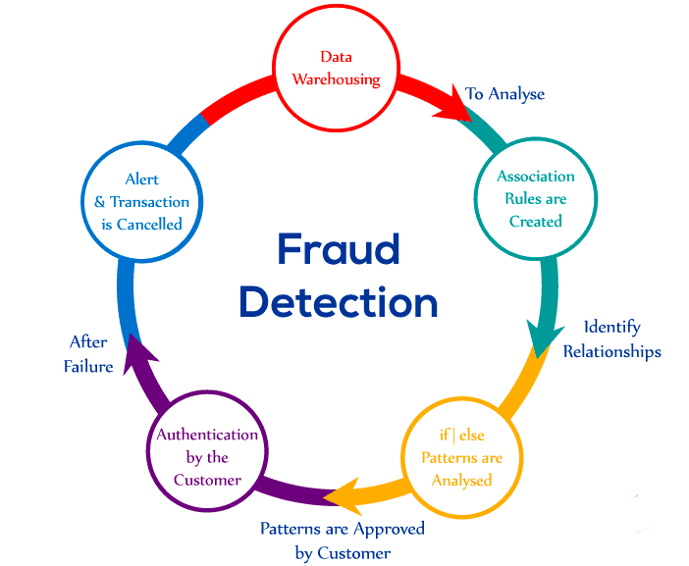

*Fraud Detection and Prevention*. OmniSci. From <https://www.omnisci.com/technical-glossary/fraud-detection-and-prevention>.