# Who Earns What? A Look at PhD Stipends Across Top Departments

Preprocessing:

* Data source: [https://www.kaggle.com/paultimothymooney/phd-stipends/data#](https://www.kaggle.com/paultimothymooney/phd-stipends/data)
* Initial sample size
  + observations: 8625 - lots of missing data
  + after removing outliers: 8297
  + after removing NA from department and overall pay: 2477
* Dropped rows with NAs in Department (can’t impute) and Overall Pay (did not impute)
* There were some extreme outliers (I would’ve loved to make a six-figure stipend!), but of course, this is highly unlikely. Outliers were removed.
* Filter out rows where Department was a non-word string, cleaned up text (using *tm*, *qdapRegex* packages)
* Obtained list of most frequently represented departments (using *wordcloud*)
* Grouped sample by these top departments (using *stringr*)
* Explored Overall Pay x Department, investigated relationship between LW-Ratio and Overall Pay
* Additional focus on first 4 years of study (under assumption that at minimum, people are at least in a PhD program for 4 years) (n=1830)

Report:

**What are the reporting departments?**

The majority of represented departments included the following: general sciences, engineering, chemistry, psychology, biomedical sciences, computer sciences, English, political studies, chemistry, and materials science. Wage is inspected across the first four years of the PhD program (N=1830)



**How much are PhD students earning?**

Stipends range by department, on average, ranging from $19,436 (English) to $29,911.55 (Biomedical Sciences).

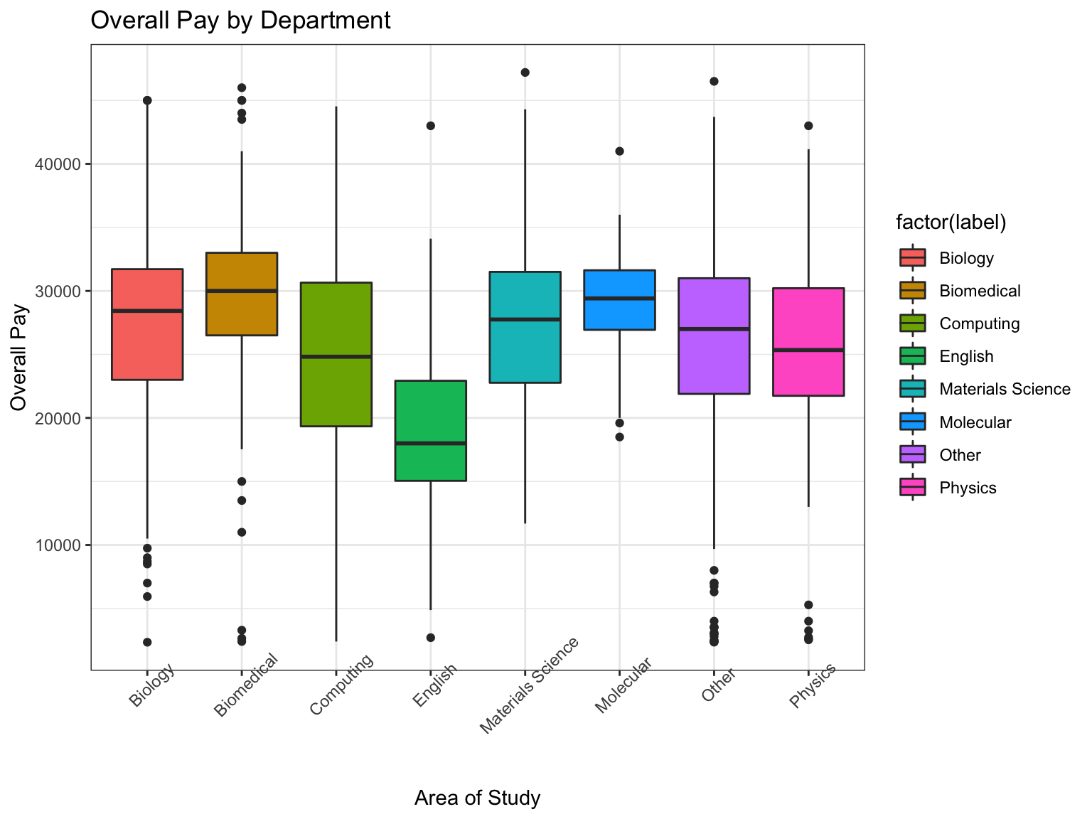**How do PhD stipends vary by department?**

A look at overall pay by department reveals within- and between-department variability, but generally, those in English PhD programs earn significantly less than those in other departments.

*Left: Overall PhD student stipends across top academic departments.*

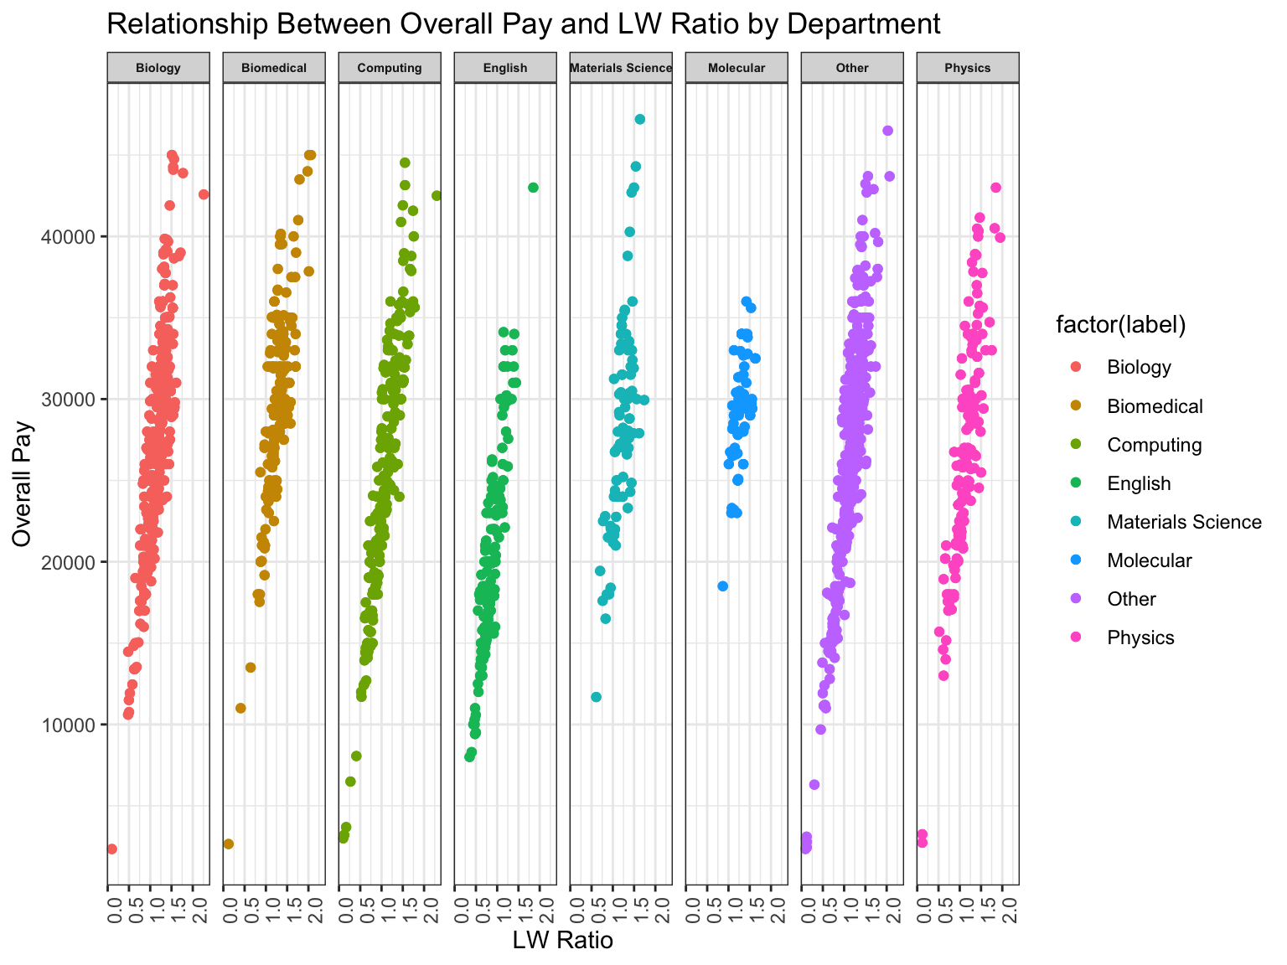**Is pay explained by the living wage ratio?**

The living wage ratio is a good predictor of overall pay, accounting for almost 80% of the variance in earnings. Additional factors, such as university type (public v. private), geographical region, and Carnegie classification may additionally explain overall pay, and should be explored.

*Right: PhD student stipends in top departments by living-wage (LW) ratio.*