UNIVERSITY OF ENGINEERING AND TECHNOLOGY MARDAN

ASSIGNMENT#02

NAME: BASIT AFRIDI

REG NO: 21MDBCS174

SUBJECT: HCI

DEPARTMENT: COMPUTER SCIENCE

SUBMITTED TO: HAMID-ULLAH

Task #1: Design a PSD Mockup Create a PSD (Photoshop Document) mockup for the user interface of your Final Year Project using any free online design tool. The tools below are recommended, but you can use others as well:

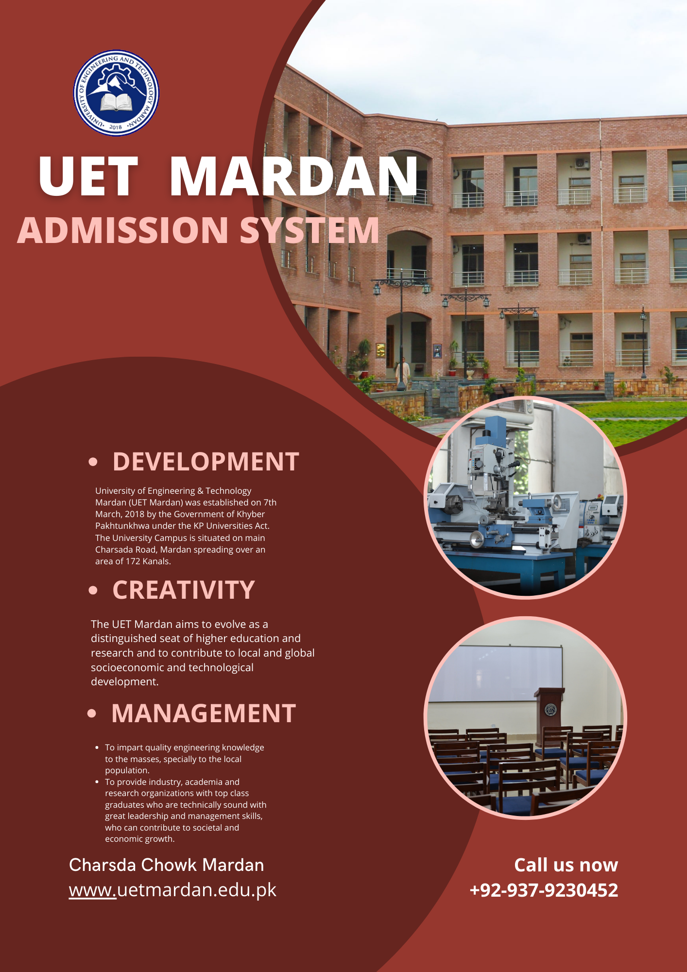

Task #2: Convert PSD to HTML/CSS Convert your PSD mockup from Task #1 into a functional webpage using HTML and CSS. Make sure to structure your code well and apply appropriate styling.

HTML CODE:

|  |  |
| --- | --- |
|  | <!DOCTYPE html> |
|  | <html lang="en"> |
|  | <head> |
|  | <meta charset="UTF-8"> |
|  | <meta name="viewport" content="width=device-width, initial-scale=1.0"> |
|  | <title>UET Mardan Admission System</title> |
|  | <link rel="stylesheet" href="styles.css"> |
|  | </head> |
|  | <body> |
|  | <header class="header"> |
|  | <div class="container"> |
|  | <img src="uet-logo.png" alt="UET Mardan Logo" class="logo"> |
|  | <h1>UET Mardan</h1> |
|  | <h2>Admission System</h2> |
|  | </div> |
|  | </header> |
|  |  |
|  | <section class="content"> |
|  | <div class="info"> |
|  | <h3>Development</h3> |
|  | <p>University of Engineering & Technology Mardan (UET Mardan) was established on 7th March, 2018 by the Government of Khyber Pakhtunkhwa under the KP Universities Act. The University Campus is situated on main Charsada Road, Mardan spreading over an area of 172 Kanals.</p> |
|  |  |
|  | <h3>Creativity</h3> |
|  | <p>The UET Mardan aims to evolve as a distinguished seat of higher education and research and to contribute to local and global socioeconomic and technological development.</p> |
|  |  |
|  | <h3>Management</h3> |
|  | <ul> |
|  | <li>To impart quality engineering knowledge to the masses, especially to the local population.</li> |
|  | <li>To provide industry, academia, and research organizations with top-class graduates who are technically sound with great leadership and management skills.</li> |
|  | </ul> |
|  | </div> |
|  |  |
|  | <div class="images"> |
|  | <img src="building.jpg" alt="UET Mardan Building" class="main-img"> |
|  | <div class="circle-img"> |
|  | <img src="lab.jpg" alt="Lab Image"> |
|  | <img src="classroom.jpg" alt="Classroom Image"> |
|  | </div> |
|  | </div> |
|  | </section> |
|  |  |
|  | <footer class="footer"> |
|  | <div class="contact-info"> |
|  | <p>Charsada Chowk Mardan</p> |
|  | <p><a href="<https://www.uetmardan.edu.pk>">www.uetmardan.edu.pk</a></p> |
|  | <p>Call us now: +92-937-9230452</p> |
|  | </div> |
|  | </footer> |
|  | </body> |
|  | </html> |
|  |  |

CSS Code:

/* Basic reset */

* {

    margin: 0;

    padding: 0;

    box-sizing: border-box;

}

/* Body styling */

body {

    font-family: 'Arial', sans-serif;

    background-color: #f9f9f9;

}

/* Header section */

.header {

    background-color: #792b24;

    color: white;

    text-align: center;

    padding: 20px 0;

}

.header .logo {

    width: 80px;

}

.header h1 {

    font-size: 48px;

    margin-top: 10px;

    font-weight: bold;

}

.header h2 {

    font-size: 24px;

    font-weight: 300;

    color: #f7b0a5;

}

/* Main content section */

.content {

    display: flex;

    padding: 20px;

    justify-content: space-between;

}

.info {

    width: 60%;

    padding: 20px;

}

.info h3 {

    font-size: 24px;

    color: #f7b0a5;

    margin-bottom: 10px;

}

.info p, .info ul {

    font-size: 16px;

    color: #333;

    margin-bottom: 20px;

}

.info ul {

    list-style-type: disc;

    padding-left: 20px;

}

.images {

    width: 35%;

    position: relative;

}

.main-img {

    width: 100%;

    border-radius: 5px;

}

.circle-img {

    display: flex;

    flex-direction: column;

    gap: 15px;

    margin-top: 20px;

}

.circle-img img {

    width: 100px;

    height: 100px;

    border-radius: 50%;

}

/* Footer section */

.footer {

    background-color: #792b24;

    color: white;

    padding: 20px;

    text-align: center;

    margin-top: 20px;

}

.footer p, .footer a {

    font-size: 16px;

    color: white;

}

.footer a {

    text-decoration: none;

    color: #f7b0a5;

}

Task #3: Upload to GitHub Upload both Task #1 (PSD/mockup design) and Task #2 (HTML/CSS implementation) to a GitHub repository. Ensure your repository is organized and includes all necessary files.

Here is the Link:

<https://github.com/abasit23/UET-Admission-System.git>