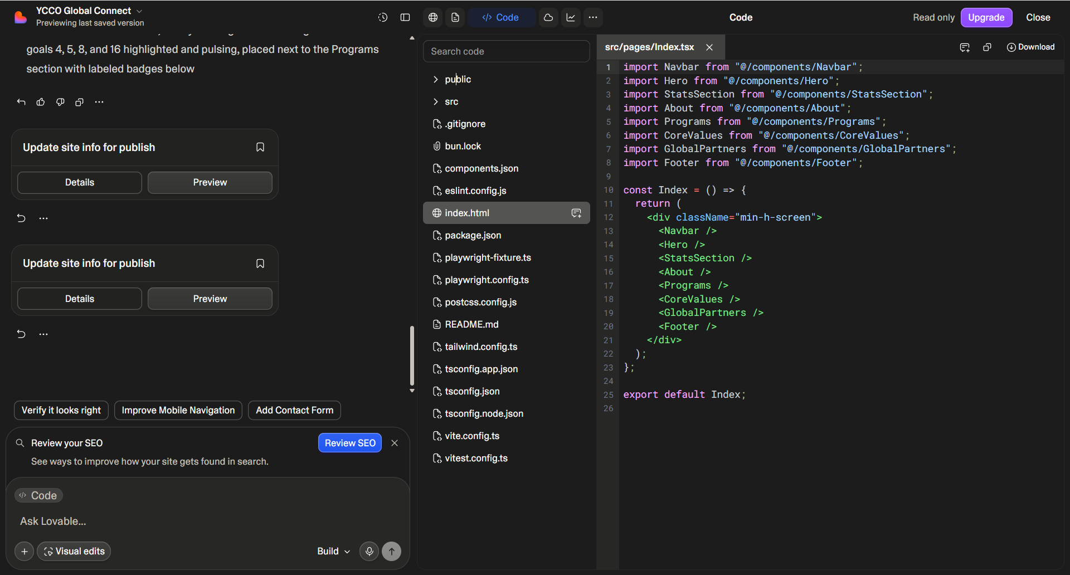
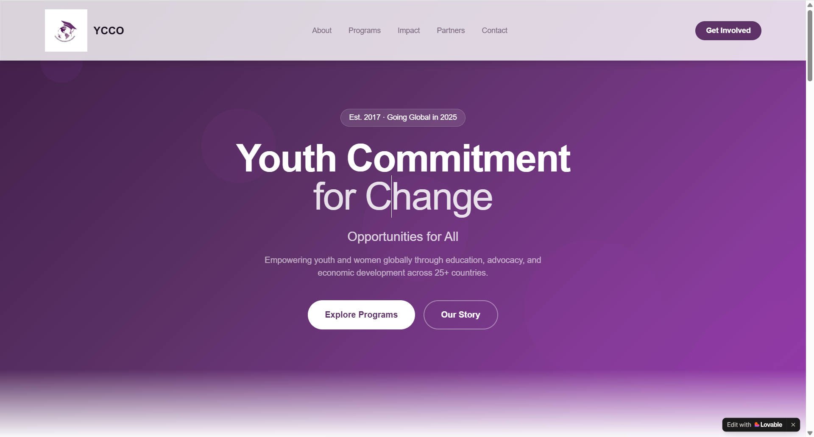
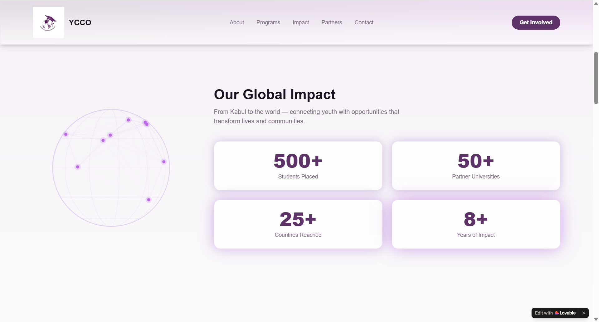
The Globe moving, rotating (find out how is really works)
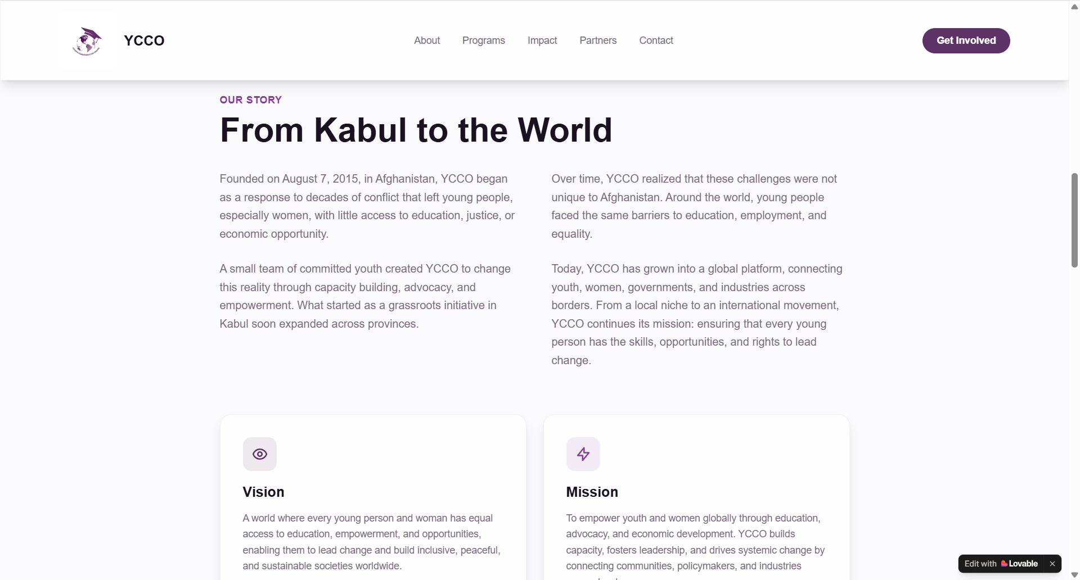
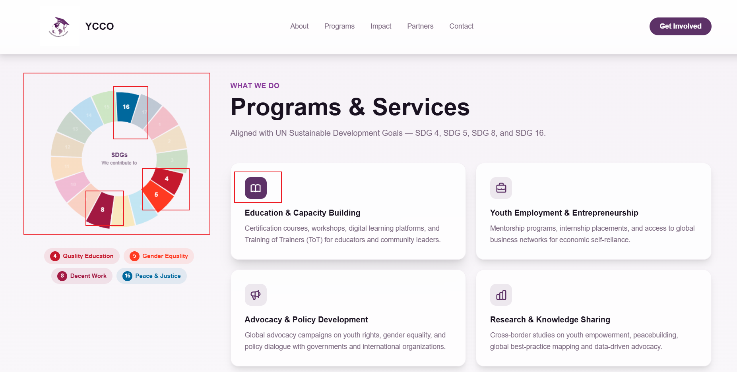
Also rotating but also the numbers changing their Size? HOW?
Going on ICON on Programs and the Color becomes darker

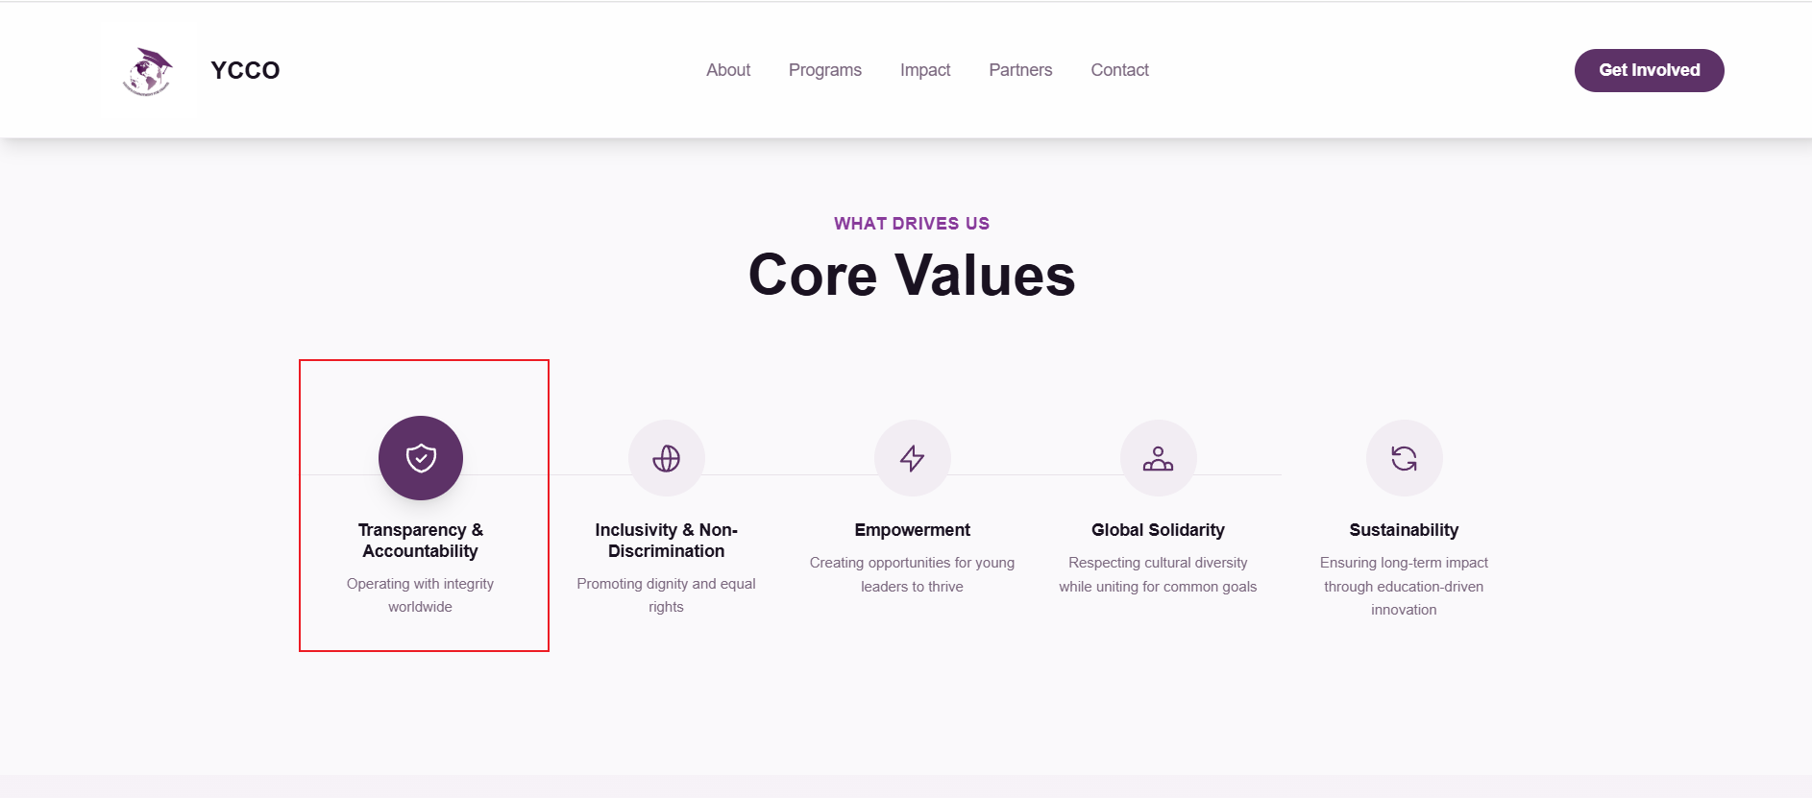
Here the same color changing
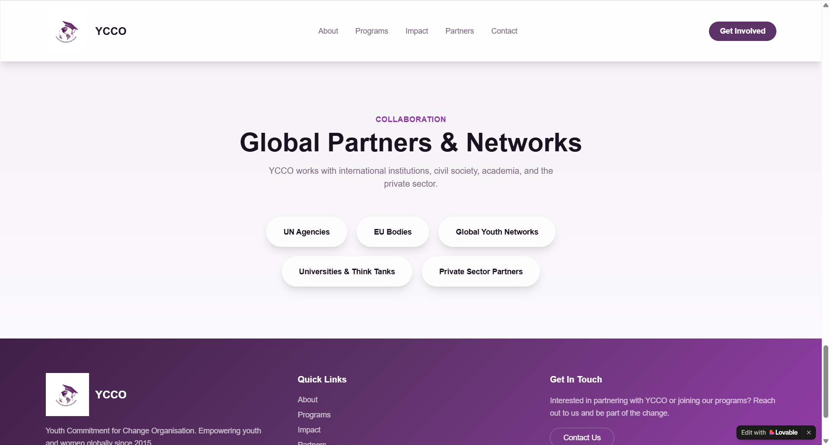

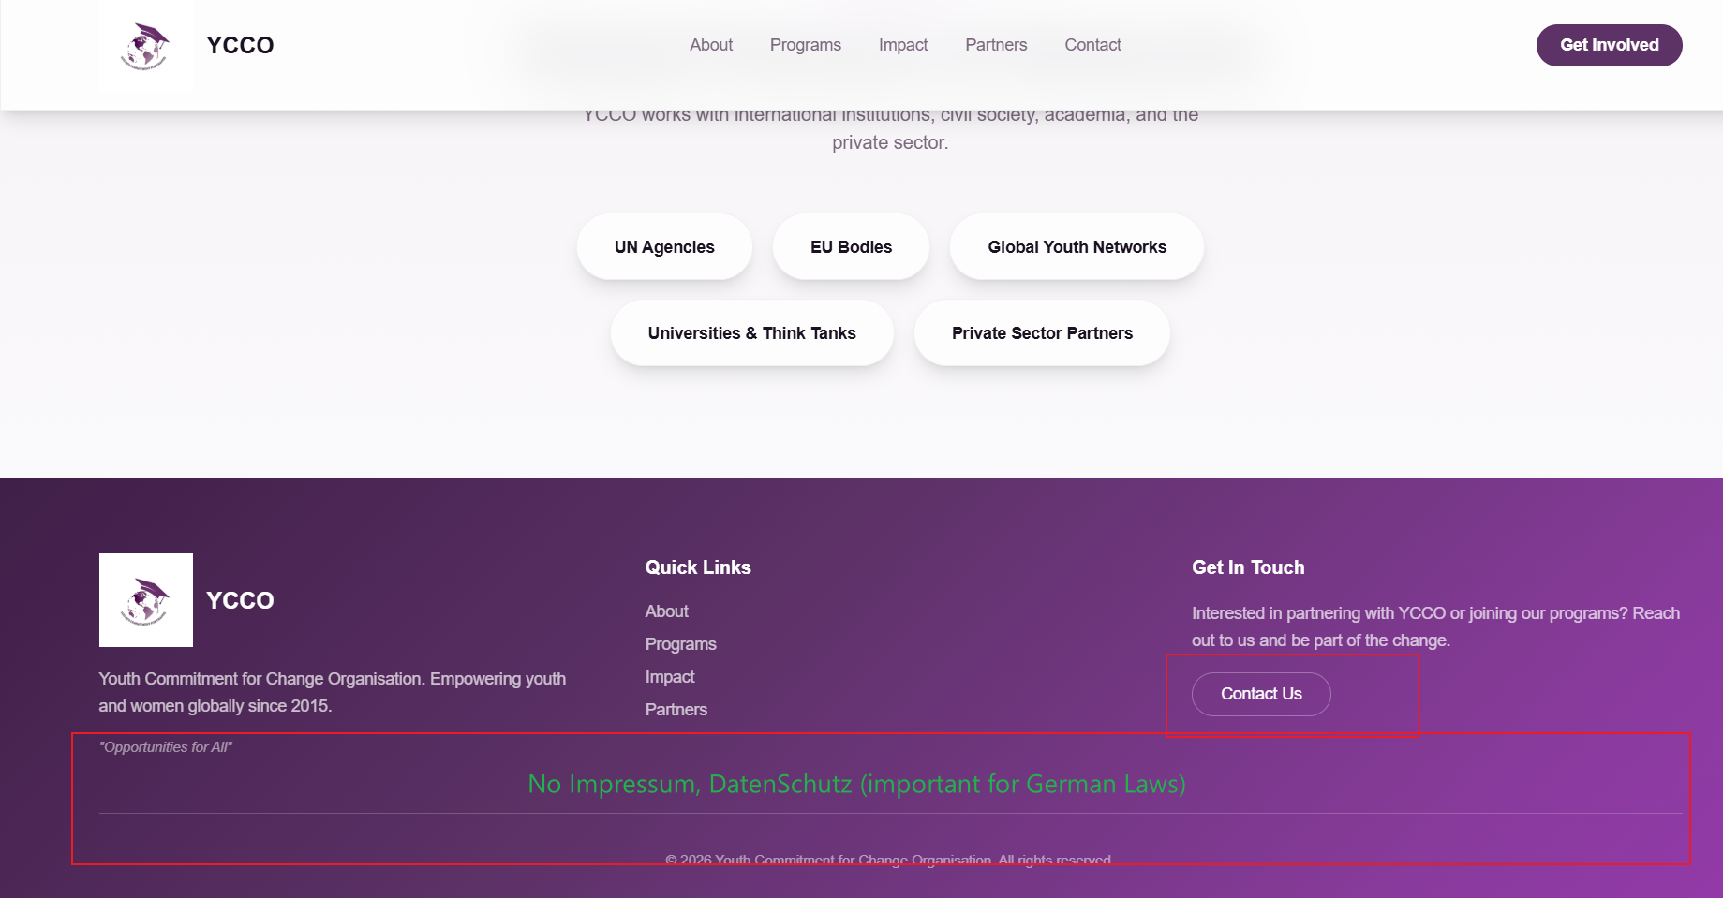
Linking: Only Contact
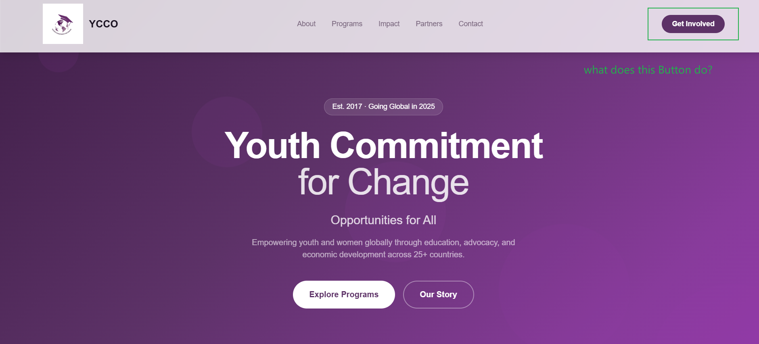

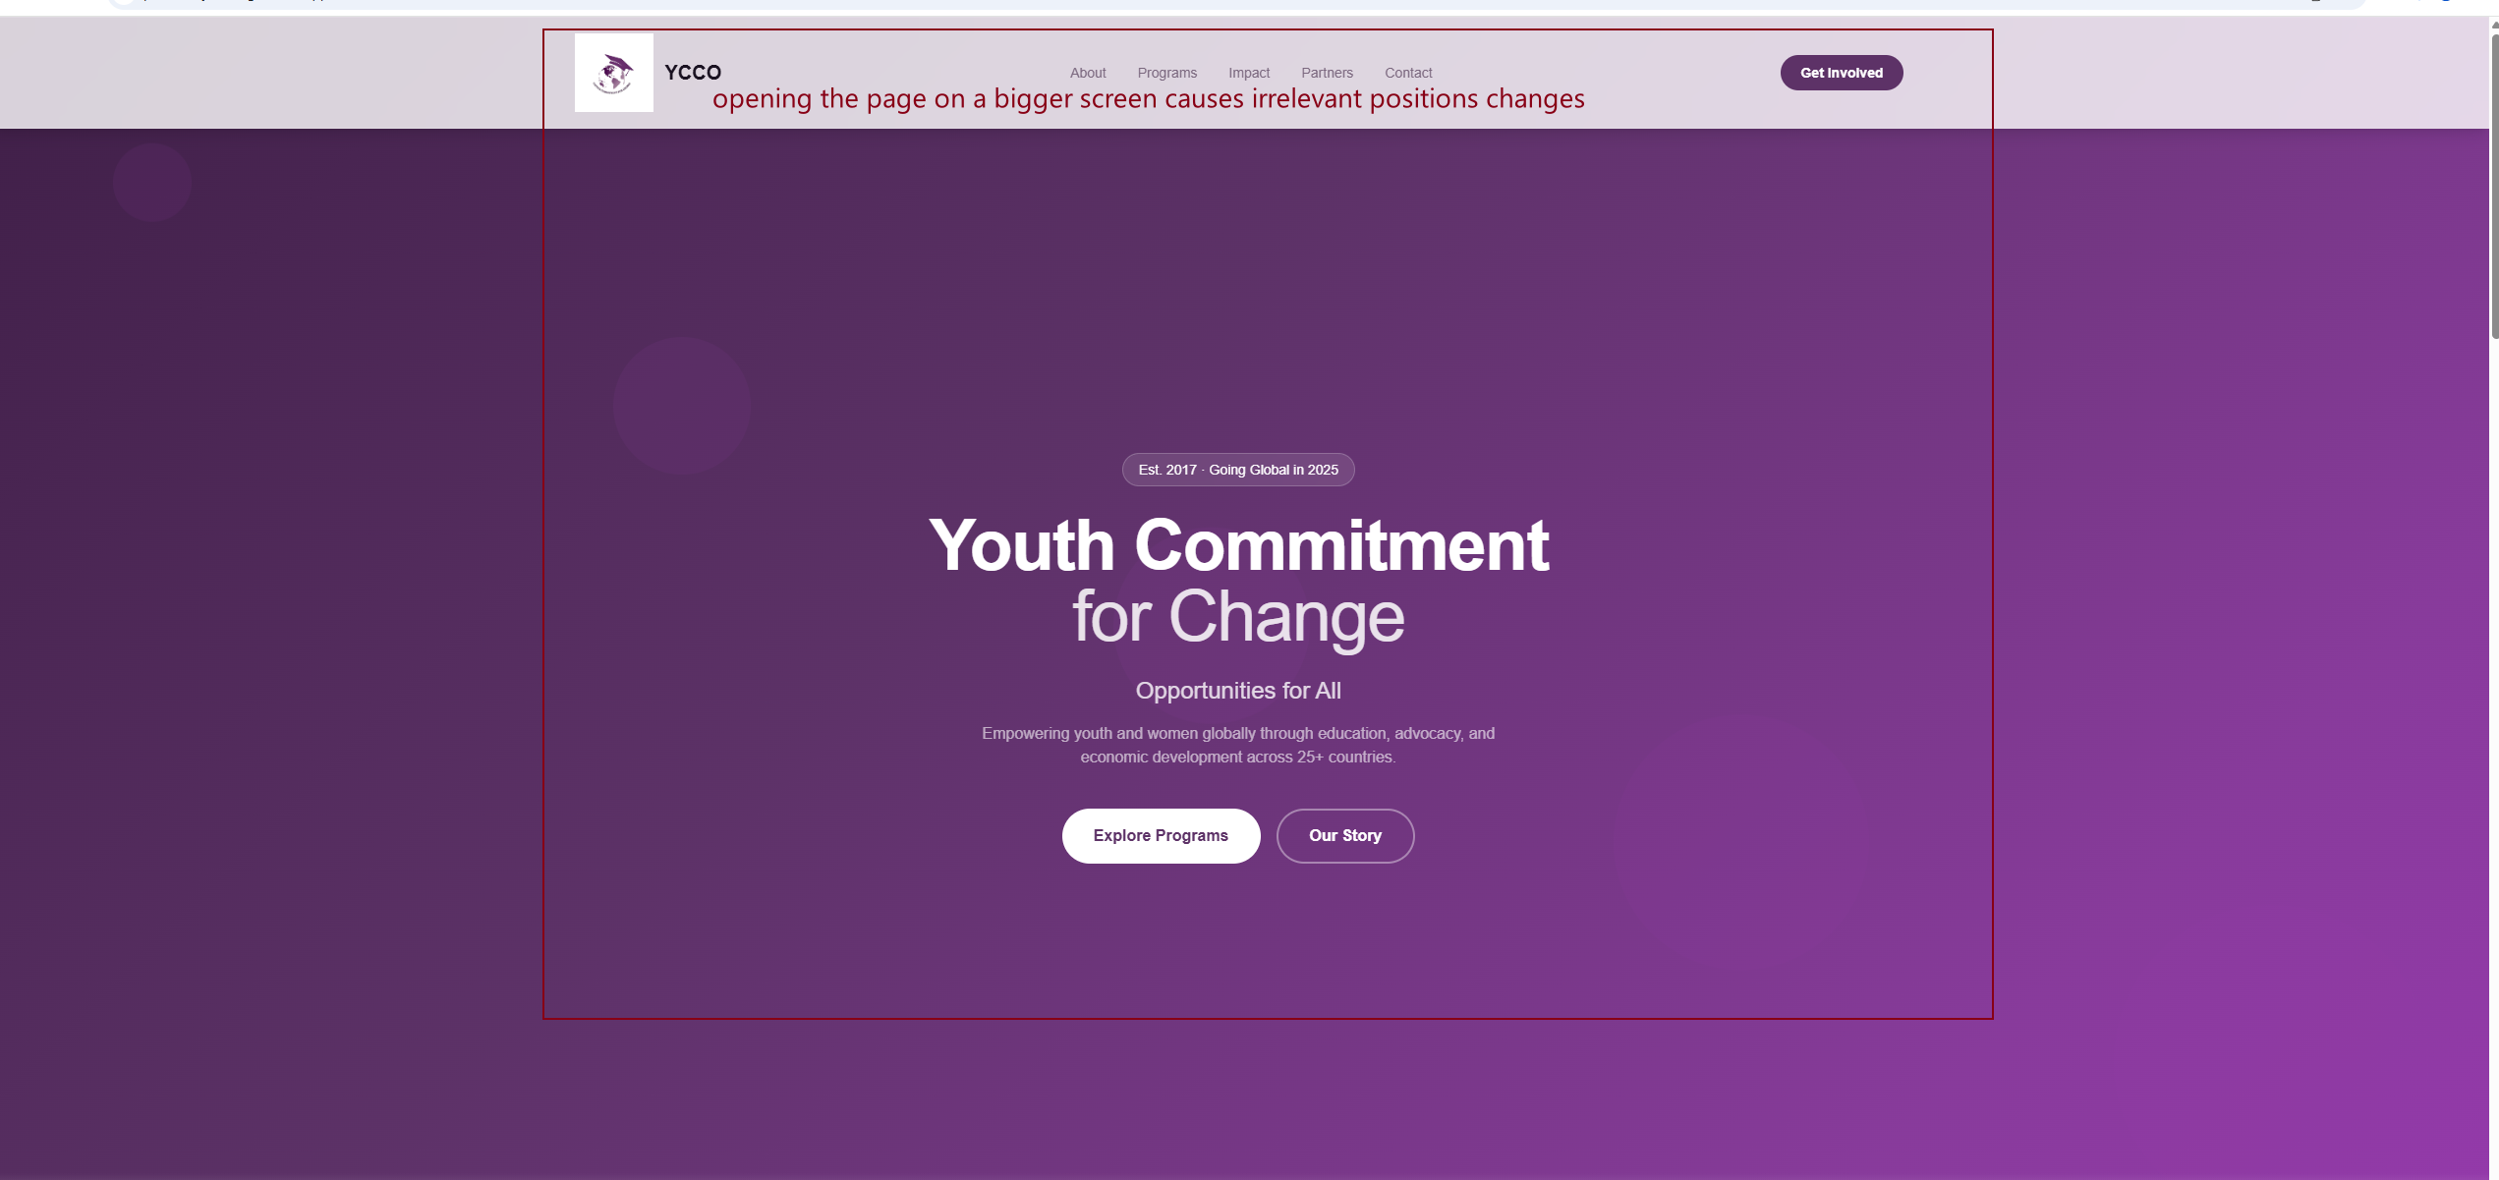
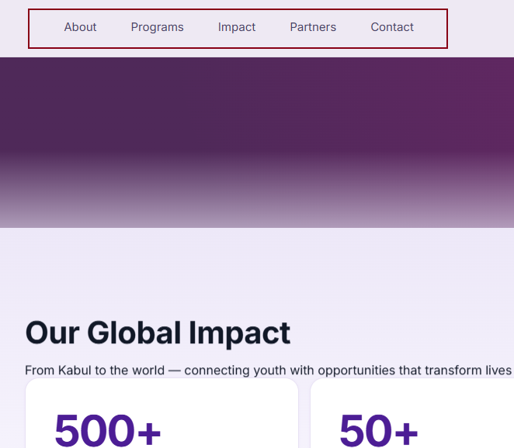

1: Complicated JS Code which is actually not needed for the case now
2: Change the website from complicated js code into normal HTML and CSS.
3: Implementing will be done with AI, but needs hours to customize the Structure and Design to the wish of Customer. (AI can not do all alone)
4:
Sprint 1: Structure, Design, Edit and Customize
Sprint 2: Bug Fix and publish on GitLab
Sprint 3: Domain, Hosting and launch, Release 1 Test Phase
Sprint 4: Website delivered

5:

