Professor David Branning, Alex Bellas, Aashwin Basnet

Summer 2017

7/26/2017

Summer Research Report:

1. The JAVA GUI: Some inconsistency in registering the counts.

Problems noticed: On July 25, 2017, I ran the GUI and started taking counts and writing it to file at 15:58 PM. It was all fine until 15:27, when the GUI started showing 0 counts on windows A, B, and AB. It kept on showing 0 for a while before it momentarily switches back to working in a normal mode again, but after a while showed 0 again. The GUI had inconsistency like this for a while and after some time, it went to 0 for good.

On July 26, 2017, I ran the GUI again (this time I prioritized the GUI from normal to high mode) and started taking counts and writing to file again; right now, it is 2:17 PM of July 27, 2017 and it is still working well and showing correct counts. The GUI ran properly until 23:18:50 of July 27, 2017 and it went to flat 0.

On July 28, 2017, Prof. Branning noticed that the power plug in the CCM was loose and hence, faulty power supply could have been the source of the problem all these times. Hence, on July 28, 2017, testGUI6 was run at around 11 AM (exact time can be found by referring to file testGUI6). The test is still running and going good so far (exactly 3 PM).

**SETTING GUI ON HIGH PRIORITY MODE**

Steps

1. Open **task manager**
2. Go to **Applications** and right click **COINCIDE** and then click “**Go to process**”
3. Right click on javaw.exe and set priority to high

Note: I really do not know if the trick with the GUI was to just set it to high priority mode but it seems to be working so far. (UPDATED AT 2:27 PM 7/27/17)

**RUNNING CONFIGURATIONS FOR CoincideGUI.Java**

Sometimes, when you try to run Java, it says there is no launch history as shown in pic 1. In that case, you cannot run the application inside JAVA and cannot export it as a runnable jar file. In that case, take following steps.

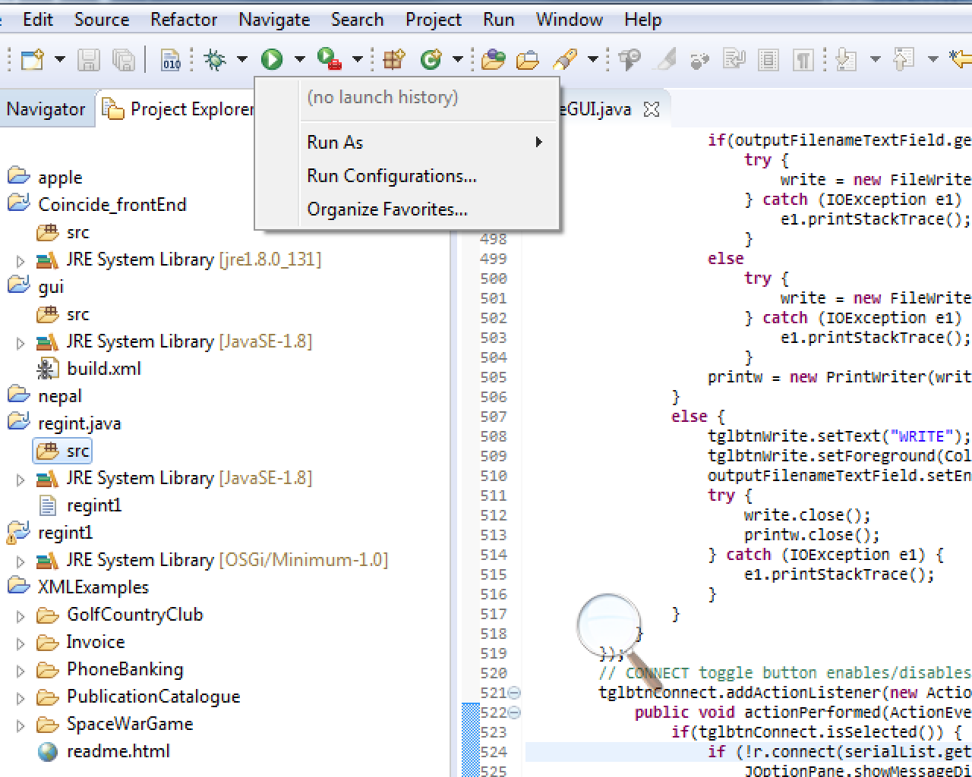

Fig 1: By clicking on the small downward arrow on Run, you will see these options.

Steps:

1. In Eclipse, in the project explorer pane (you can see that on the figure above on left side), right click and choose **Import** and then do either of the following:
2. Choose **Projects from folder or archive**. Then, just type this on **“Import Source”**: C:\Users\trinlab\git\javaproject

Note: At this point, this folder has the most updated version of Java files from the entire research work we have done up to today. And this already has the configuration that we need to run for this GUI. If you have a separate folder for your project, this method will not work.

1. Instead of step a), directly choose Git>Projects from Git. Again, I assume that Git has been installed in the computer and you can easily find techniques to do so in the internet in case it is not installed. Then, click Clone URI and then copy and paste [**git@github.com:abasnet1/javaproject.git**](mailto:git@github.com:abasnet1/javaproject.git)on URI and for protocol (shown in figure below), choose https. Then click Next and you should be all set after few more easy steps.

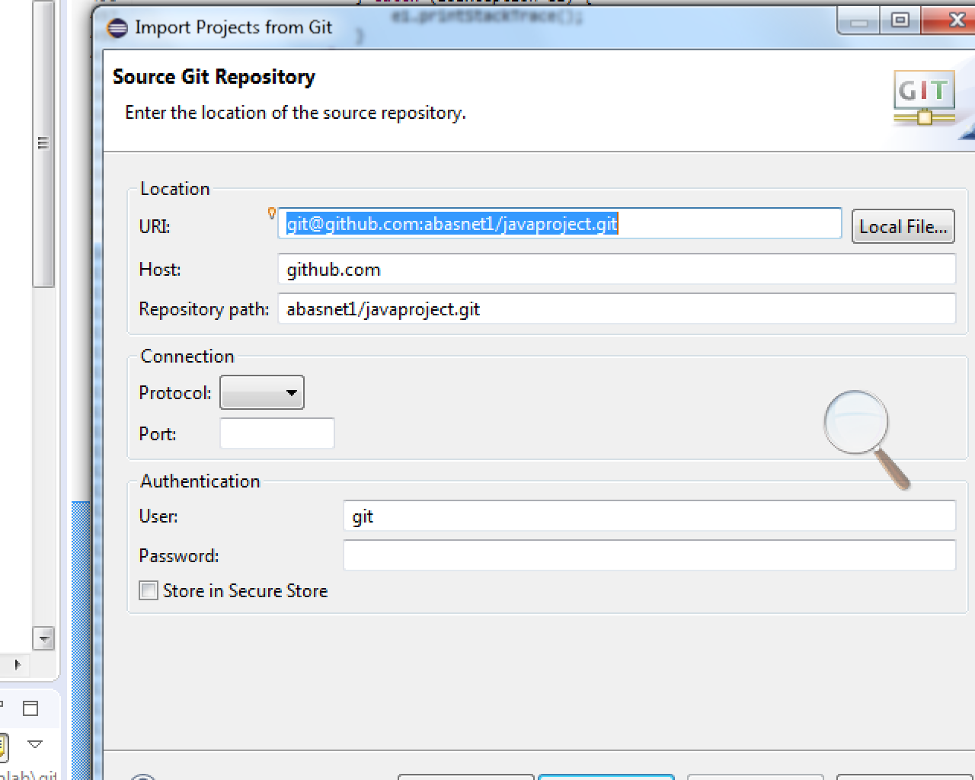

After following one of these steps, you should see your project in the project explorer windows. Mine looks something like this:

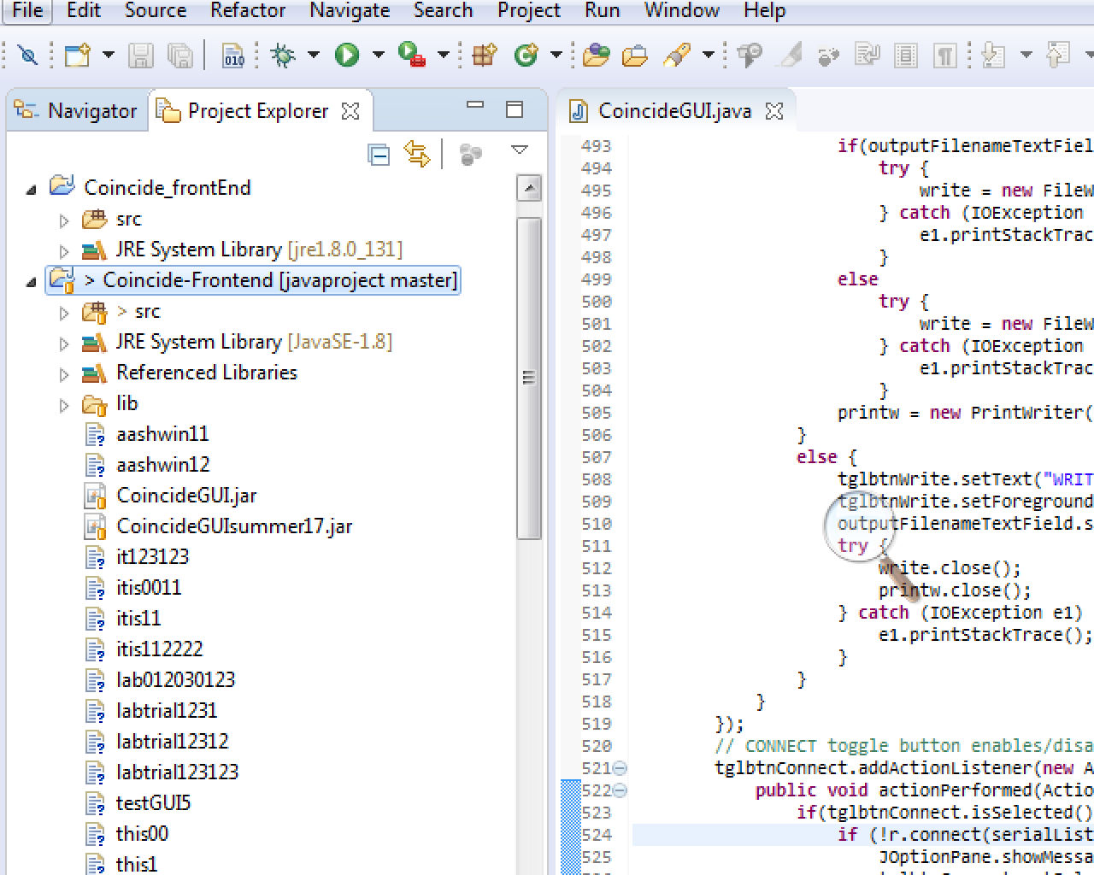

So the red underlined project is the one I just imported and if you open its sub folders, you will see src and then double click on coincide_front_end_master and choose coincideGUI. You are all set.

Now, once you do that, if you try to run this program, you will see something like this:

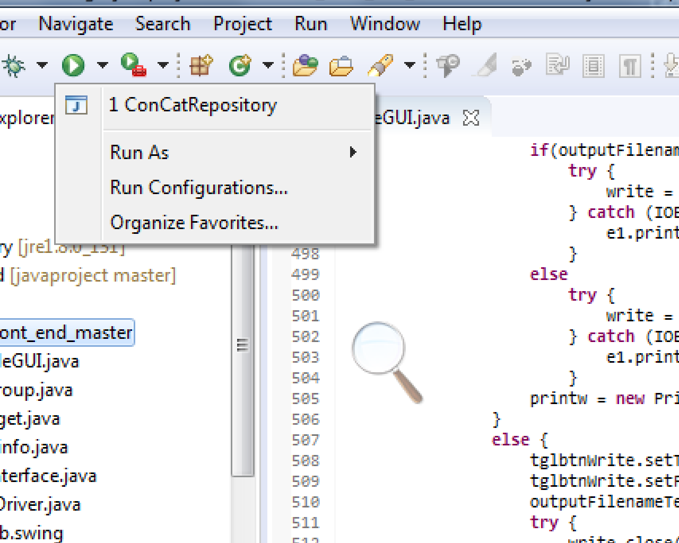

In order to run the GUI, just click on *concat repository* and you should be all set.

How to **use the write to file function** in GUI?

Steps:

1. Open the GUI.
2. Go to Settings tab.
3. First make sure that the mojo is connected to your computer or pi by choosing appropriate ports from *Serial Port* option.
4. Before start writing, I recommend just clicking *connect* on bottom left side side of GUI under settings tab to make sure the mojo is connected. Also, go to data tab and check if it actually shows some counts. If you want a fresh set of data, make sure you unselected all the windows, go back to settings tab and then Disconnect the mojo.
5. Go back to settings tab and write a file name under *Output Filename* option.
6. Then click *Connect* and then *Write.*
7. Go back to data tab and choose any windows or combination of windows you want to take counts from and click *Go.*
8. Once you are done, press *Stop* on bottom left of data tab.
9. Go back to settings tab and click *Don’t Write*.
10. You should be all set! Your file should be in the folder where your project folder is. If you do not know that, just use windows explorer and search for your file.