**Resort Booking System (Project Resort)**

**Software Requirements Specification**

**Software Engineering Fundamentals, Fall 2019**

**Modification history:**

|  |  |  |  |
| --- | --- | --- | --- |
| Version | Date | Who | Comment |
| v1.0 | 9/29/19 | Chase Canales | Implemented general information, first draft of introduction, Use Case diagram, and initial shall statements. |
| v1.1 | 10/3/19 | Brandon Baker | Changed Email address, Assumptions |

**Team Name:** import team_name;

**Team Members:**

* Cristian Mendoza [cemendoza0611@eagle.fgcu.edu](mailto:cemendoza0611@eagle.fgcu.edu)
* Chase Canales [ccanales5383@eagle.fgcu.edu](mailto:ccanales5383@eagle.fgcu.edu)
* Todd Bauer [twbauer8220@eagle.fgcu.edu](mailto:twbauer8220@eagle.fgcu.edu)
* Brandon Baker [babaker5755@eagle.fgcu.edu](mailto:babaker@eagle.fgcu.edu)
* Jose Sinestre [jsilvestre1169@eagle.fgcu.edu](mailto:jsilvestre1169@eagle.fgcu.edu)
* Gerardo Ortiz [gortiz7941@eagle.fgcu.edu](mailto:gortiz7941@eagle.fgcu.edu)

**Contents of this Document**

Introduction

* Software to be Produced
* Definition, Acronyms, and Abbreviations

Product Overview

* Assumptions
* Use Case Diagram
* Use Case Descriptions

Specific Requirements

**SECTION 1: Introduction**

Software to be Produced:

* The intent of our software is to provide clients an easy-to-use interface that allows users to preview, browse and book rooms at a hotel, along with giving them the ability to cancel any reservations they may place. In addition, the software will allow hotel staff to access specialized reports that display booking information and client transactions.

Definitions, Acronyms, and Abbreviations:

* <include any that are needed to read this document (or "None" if document is self-explanatory and no acronyms or abbreviations will be used>

**SECTION 2:** **Product Overview**

Assumptions:

* We are assuming that hotel customers and hotel staff will be able to run Java programs on their computer.
* We are assuming that the customer will feel comfortable entering their credit card information into a system that has no encryption.
* We are assuming the user has an email address to receive their booking confirmation number.
* We are assuming that our offline database will be accessible to both the hotel staff and hotel customers.
* We are assuming that the hotel has a variety of rooms to offer hotel customers to stay in.

Use Case Diagram:

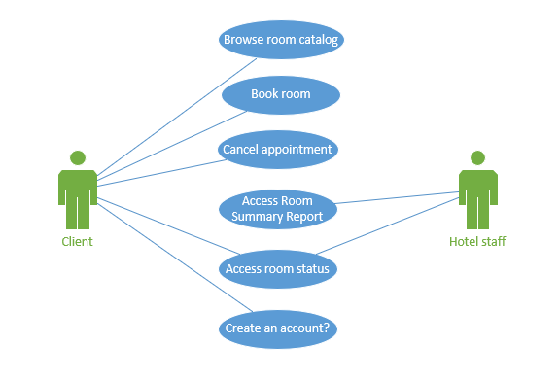

Use Case Descriptions:

* <Briefly describe each use case included in the above diagram. Please make sure you describe the main steps of each use case, making sure that exceptions are considered. For reference, see materials presented in class and textbook >

**SECTION 3: Specific Requirements**

**< The following template must be used for each requirement; you should have about 15 requirements total: >**

|  |
| --- |
|  |
| 1. The system shall allow authorized users to access the Detailed Resort Summary Report, which describes booking status for each room and any confirmations/cancellations based on a given date range. 2. The system shall allow users to browse a catalog of all types of rooms that are available at the resort. 3. The system shall allow users to narrow down their booking criteria via filtering their selection based on room availability, price, suite size, and sleeping accommodations. 4. The system shall allow users to cancel their appointment through the use of a booking confirmation number. 5. The system shall allow users to enter credit card payment information to book a room after selecting their choice of room. 6. The system shall send the user an email of the booking confirmation with a link to cancel the appointment. 7. The system shall display a list of rooms and their booked status. 8. The system shall generate a unique confirmation number for every booking. 9. The system shall allow hotel staff to display the booking status of hotel rooms. 10. The system shall store current and past occupancy information and associated confirmation numbers on a SQL database. |

Template created by G. Walton ([GWalton@mail.ucf.edu](mailto:GWalton@mail.ucf.edu)) on Aug 30, 1999 and last updated Aug 15, 2000; updated by A. Koufakou, Aug 2014

This page last modified by <your name here> (<your e-mail address text and link here> ) on <modification date here>