**Resort Booking System (Project Resort)**

**Software Requirements Specification**

**Software Engineering Fundamentals, Fall 2019**

**Modification history:**

|  |  |  |  |
| --- | --- | --- | --- |
| Version | Date | Who | Comment |
| v1.0 | 9/29/19 | Chase Canales | Implemented general information, first draft of introduction, Use Case diagram, and initial shall statements. |
| v1.1 | 10/3/19 | Brandon Baker | Changed Email address, Assumptions |
| v1.2 | 10/8/19 | Chase Canales | Created Use Case descriptions, Report Summary definition, and cleaned up organization. |
| v1.3 | 10/8/19 | Todd Bauer | Added assumptions, reformatted requirements table, updated use case diagram |

**Team Name:** import team_name;

**Team Members:**

* Cristian Mendoza [cemendoza0611@eagle.fgcu.edu](mailto:cemendoza0611@eagle.fgcu.edu)
* Chase Canales [ccanales5383@eagle.fgcu.edu](mailto:ccanales5383@eagle.fgcu.edu)
* Todd Bauer [twbauer8220@eagle.fgcu.edu](mailto:twbauer8220@eagle.fgcu.edu)
* Brandon Baker [babaker5755@eagle.fgcu.edu](mailto:babaker@eagle.fgcu.edu)
* Jose Sinestre [jsilvestre1169@eagle.fgcu.edu](mailto:jsilvestre1169@eagle.fgcu.edu)
* Gerardo Ortiz [gortiz7941@eagle.fgcu.edu](mailto:gortiz7941@eagle.fgcu.edu)

**Contents of this Document**

Introduction

* Software to be Produced
* Definition, Acronyms, and Abbreviations

Product Overview

* Assumptions
* Use Case Diagram
* Use Case Descriptions

Specific Requirements

**SECTION 1: Introduction**

Software to be Produced:

* The intent of our software is to provide clients an easy-to-use interface that allows users to preview, browse and book rooms at a hotel, along with giving them the ability to cancel any reservations they may place. In addition, the software will allow hotel staff to access specialized reports that display booking information and client transactions.

Definitions, Acronyms, and Abbreviations:

* Summary Report – A document accessible by staff members only that displays information based on client reservations, cancellations, payment confirmations, reservation numbers, and booking status on rooms. This report can be filtered by a date range given by the hotel staff.

**SECTION 2:** **Product Overview**

Assumptions:

* We are assuming that hotel customers and hotel staff will be able to run Java programs on their computer.
* We are assuming that the customer will feel comfortable entering their credit card information into a system that has no encryption.
* We are assuming that the customer’s credit card is not declined.
* We are assuming the user has an email address to receive their booking confirmation number.
* We are assuming that our offline database will be accessible to both the hotel staff and hotel customers.
* We are assuming that the hotel has a variety of rooms to offer hotel customers to stay in.

Use Case Diagram:

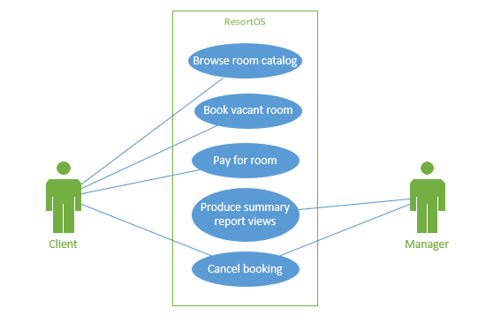

Use Case Descriptions:

1. **Browse room catalog**: The client will click on a “browse rooms” section from the main page and will be given a list of rooms and the ability to filter their selection, based on number of beds, room price, and date range. Before they are able to book the room, they must submit a date range that they will be staying at the resort. *Actor - Client*
2. **Book room:** The client, after selecting a room from the catalog, will confirm their room by selecting a “Book room” button, which will then prompt them to submit their personal details, which include their name, number of people who will be staying in the room, an email address, and payment information (credit card information and billing address). After the room is booked, the client will receive a confirmation number in their email. After this is complete, documentation of this action will be sent to the staff report. *Actor - Client*
3. **Cancel appointment:** The client will select a “Cancel Appointment” option from the main page and will be navigated to the cancellation page, which will prompt them to submit their confirmation number from the email they received after confirming their room. Once submitted, their booking selection will be taken off reservation and they will be removed from booking records. After this is complete, documentation of this action will be sent to the staff report. *Actor – Client*
4. **Access Room Summary Report:** Once a client has submitted a room booking or cancellation, the system will keep records of each event and store them for documentation. The staff member will click on a button on the main page labeled “Staff Login” and submit their access ID when prompted, navigating them to a hidden staff-only page and view the Summary Report. *Actor – Hotel Staff*

**SECTION 3: Specific Requirements**

**< The following template must be used for each requirement; you should have about 15 requirements total: >**

|  |  |
| --- | --- |
| 1 | The system shall allow users to browse a catalog of all types of rooms that are available at the resort. |
| 2 | The system shall allow users to narrow down their booking criteria via filtering their selection based on room availability, price, suite size, and sleeping accommodations. |
| 3 | The system shall allow users to cancel their appointment by entering their booking confirmation number. |
| 4 | The system shall allow users to enter credit card payment information to book a room after selecting their choice of room. |
| 5 | The system shall send the user an email of the booking confirmation with a link to cancel the appointment. |
| 6 | The system shall display a list of rooms and their booked status. |
| 7 | The system shall generate a unique confirmation number for every booking. |
| 8 | The system shall allow hotel staff to display the booking status of hotel rooms. |
| 9 | The system shall store current and past occupancy information and associated confirmation numbers in a database. |
| 10 | The system shall generate a Detailed Resort Summary Report that contains (…) |
| 11 | The system shall allow managers to access the Detailed Resort Summary Report, which describes booking status for each room and any confirmations/cancellations based on a given date range. |

Template created by G. Walton ([GWalton@mail.ucf.edu](mailto:GWalton@mail.ucf.edu)) on Aug 30, 1999 and last updated Aug 15, 2000; updated by A. Koufakou, Aug 2014

This page last modified by Todd Bauer ([twbauer8220@eagle.fgcu.edu](mailto:twbauer8220@eagle.fgcu.edu)) on Oct 6, 2019