**Resort Booking System (Project Resort)**

**Software Requirements Specification**

**Software Engineering Fundamentals, Fall 2019**

**Modification history:**

|  |  |  |  |
| --- | --- | --- | --- |
| Version | Date | Who | Comment |
| v1.0 | 9/29/19 | Chase Canales | Implemented general information, first draft of introduction, Use Case diagram, and initial shall statements. |
| v1.1 | 10/3/19 | Brandon Baker | Changed Email address, Assumptions |
| v1.2 | 10/8/19 | Chase Canales | Created Use Case descriptions, Report Summary definition, and cleaned up organization. |
| v1.3 | 10/8/19 | Todd Bauer | Added assumptions, reformatted requirements table, updated use case diagram |
| v1.4 | 10/8/19 | Brandon Baker  Chase Canales  Cristian Mendoza  Gerardo Ortiz  Jose Silvestre  Todd Bauer | Refined definitions. Updated use case diagram according to updated shall statements. Reformatted shall statement list. Removed shall statements 1, 3, 7, and 9 (from v1.1). Added shall statements 2, 8, 9, 11, 13, 15, 16. |
| v1.5 | 10/10/19 | Todd Bauer | Updated shall statement 1 and 15 (is now 17). Added shall statements 3 and 12. Removed shall statement 16 (from v1.4). |

**Team Name:** import team_name;

**Team Members:**

* Cristian Mendoza [cemendoza0611@eagle.fgcu.edu](mailto:cemendoza0611@eagle.fgcu.edu)
* Chase Canales [ccanales5383@eagle.fgcu.edu](mailto:ccanales5383@eagle.fgcu.edu)
* Todd Bauer [twbauer8220@eagle.fgcu.edu](mailto:twbauer8220@eagle.fgcu.edu)
* Brandon Baker [babaker5755@eagle.fgcu.edu](mailto:babaker@eagle.fgcu.edu)
* Jose Sinestre [jsilvestre1169@eagle.fgcu.edu](mailto:jsilvestre1169@eagle.fgcu.edu)
* Gerardo Ortiz [gortiz7941@eagle.fgcu.edu](mailto:gortiz7941@eagle.fgcu.edu)

**Contents of this Document**

Introduction

* Software to be Produced
* Definition, Acronyms, and Abbreviations

Product Overview

* Assumptions
* Use Case Diagram
* Use Case Descriptions

Specific Requirements

**SECTION 1: Introduction**

Software to be Produced:

* The intent of our software is to provide clients an easy-to-use interface that allows users to preview, browse and book rooms at a hotel, along with giving them the ability to cancel any reservations they may place. In addition, the software will allow hotel staff to access specialized reports that display booking information and client transactions.

Definitions, Acronyms, and Abbreviations:

* Detailed Resort Summary Report – A document accessible by staff members only that displays reservations, cancellations, payment confirmations, reservation numbers, room charges, and booking status on rooms. This report can be filtered by a date range given by the hotel staff.

**SECTION 2:** **Product Overview**

Assumptions:

* We are assuming that hotel customers and staff will be able to run Java programs on their computer.
* We are assuming that the customer will feel comfortable entering their credit card information into a system that has no encryption.
* We are assuming that the customer’s credit card is not declined.
* We are assuming the user has an email address to receive their booking confirmation number.
* We are assuming that our offline database will be accessible to both the hotel staff and hotel customers.
* We are assuming that the hotel has a variety of rooms to offer hotel customers to stay in.

Use Case Diagram:

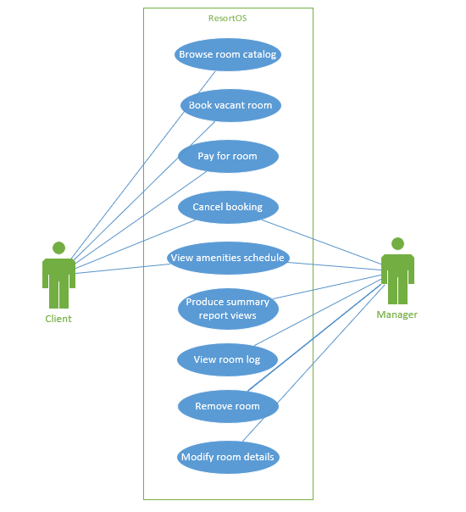

Use Case Descriptions:

1. **Browse room catalog**: The client will click on a “browse rooms” section from the main page and will be given a list of rooms and the ability to filter their selection, based on number of beds, room price, and date range. Before they are able to book the room, they must submit a date range that they will be staying at the resort. *Actor - Client*
2. **Book vacant room:** The client, after selecting a room from the catalog, will confirm their room by selecting a “Book room” button, which will then prompt them to submit their personal details, which include their name, number of people who will be staying in the room, an email address, and payment information (credit card information and billing address). After the room is booked, the client will receive a confirmation number in their email. After this is complete, documentation of this action will be sent to the staff report. *Actor – Client*
3. **Cancel appointment:** The client will select a “Cancel Appointment” option from the main page and will be navigated to the cancellation page, which will prompt them to submit their confirmation number from the email they received after confirming their room. Once submitted, their booking selection will be taken off reservation and they will be removed from booking records. After this is complete, documentation of this action will be sent to the staff report. *Actor – Client*
4. **Access Room Summary Report:** Once a client has submitted a room booking or cancellation, the system will keep records of each event and store them for documentation. The staff member will click on a button on the main page labeled “Staff Login” and submit their access ID when prompted, navigating them to a hidden staff-only page and view the Summary Report. *Actor – Hotel Staff*

**SECTION 3: Specific Requirements**

|  |  |
| --- | --- |
| 1 | The system shall allow customers to browse a catalog of all types of rooms, as defined by the manager. See shall statements 2 and 3. |
| 2 | The system shall allow the manager to add new rooms while specifying room size, bed size(s), and number of beds, as well as custom room details of their choosing. |
| 3 | The system shall allow the manager to remove and modify existing rooms based on their room size, bed size(s), and number of beds, as well as custom room details. |
| 4 | The system shall allow customers to cancel their reservation by entering their booking confirmation number. |
| 5 | The system shall allow customers to enter credit card payment information to book a room after selecting their choice of room. |
| 6 | The system shall send the customer an email of the booking confirmation with a link to cancel the appointment. |
| 7 | The system shall allow the managers to view a live log of rooms and their booked status. |
| 8 | The system shall generate a unique confirmation number for every booking. |
| 9 | The system shall allow the user to view closing and opening times for the gym, laundry room, restaurants, and pool. |
| 10 | The system shall allow customers to view the following details of each room: room type, room size in square feet, number of beds, smoking or non-smoking, number of phones, access to Wi-Fi, and room service availability. |
| 11 | The system shall generate a Detailed Resort Summary Report as outlined in the definition section above. |
| 12 | The system shall automatically save every Detailed Resort Summary Report that is produced by the manager. |
| 13 | The system shall send the customer an email upon reserving a room that contains the room type, room amenities, and room number. |
| 14 | The system shall store current and past occupants’ names, addresses, phone numbers, and booking confirmation numbers in a database. |
| 15 | The system shall store invoices containing items charged to the room and their prices. |
| 16 | The system shall allow managers to narrow down their search criteria by date when accessing the Detailed Resort Summary Reports. |
| 17 | The system shall only allow managers to access Detailed Resort Summary Reports with their sixteen characters long password. |

Template created by G. Walton ([GWalton@mail.ucf.edu](mailto:GWalton@mail.ucf.edu)) on Aug 30, 1999 and last updated Aug 15, 2000; updated by A. Koufakou, Aug 2014

This page last modified by Todd Bauer ([twbauer8220@eagle.fgcu.edu](mailto:twbauer8220@eagle.fgcu.edu)) on Oct 10, 2019