**Resort Booking System (Project Resort)**

**Software Requirements Specification**

**Software Engineering Fundamentals, Fall 2019**

**Modification history:**

|  |  |  |  |
| --- | --- | --- | --- |
| Version | Date | Who | Comment |
| v1.0 | 9/29/19 | Chase Canales | Implemented general information, first draft of introduction, Use Case diagram, and initial shall statements. |
| v1.1 | 10/3/19 | Brandon Baker | Changed Email address, Assumptions |
| v1.2 | 10/8/19 | Chase Canales | Created Use Case descriptions, Report Summary definition, and cleaned up organization. |
| v1.3 | 10/8/19 | Todd Bauer | Added assumptions, reformatted requirements table, updated use case diagram |
| v1.4 | 10/8/19 | Brandon Baker  Chase Canales  Cristian Mendoza  Gerardo Ortiz  Jose Silvestre  Todd Bauer | Refined definitions. Updated use case diagram according to updated shall statements. Reformatted shall statement list. Removed shall statements 1, 3, 7, and 9 (from v1.1). Added shall statements 2, 8, 9, 11, 13, 15, 16. |
| v1.5 | 10/10/19 | Todd Bauer | Updated shall statement 1 and 15 (is now 17). Added shall statements 3 and 12. Removed shall statement 16 (from v1.4). |
| v1.6 | 10/11/19 | Todd Bauer  Cristian Mendoza  Jose Silvestre | Updated assumptions section and added new assumption statements. |
| v1.7 | 11/12/19 | Todd Bauer  Cristian Mendoza | Updated the shall statements format. |
| v1.8 | 12/1/19 | Chase Canales | Updated shall statements, use case diagram, use case descriptions, and DRSR definition. Reformatted shall statement list in order of tab view functionality. Updated shall statements 1, 4, 9, 11, (from v1.7). Removed shall statements 2, 3, 6, 10, 12 (from v1.7). Added shall statements 1, 4, 7, 10, 11, 12, 13, 14, 15, 16 (from v1.8). |

**Team Name:** import team_name;

**Team Members:**

* Cristian Mendoza [cemendoza0611@eagle.fgcu.edu](mailto:cemendoza0611@eagle.fgcu.edu)
* Chase Canales [ccanales5383@eagle.fgcu.edu](mailto:ccanales5383@eagle.fgcu.edu)
* Todd Bauer [twbauer8220@eagle.fgcu.edu](mailto:twbauer8220@eagle.fgcu.edu)
* Brandon Baker [babaker5755@eagle.fgcu.edu](mailto:babaker@eagle.fgcu.edu)
* Jose Silvestre [jsilvestre1169@eagle.fgcu.edu](mailto:jsilvestre1169@eagle.fgcu.edu)
* Gerardo Ortiz [gortiz7941@eagle.fgcu.edu](mailto:gortiz7941@eagle.fgcu.edu)

**Contents of this Document**

Introduction

* Software to be Produced
* Definition, Acronyms, and Abbreviations

Product Overview

* Assumptions
* Use Case Diagram
* Use Case Descriptions

Specific Requirements

**SECTION 1: Introduction**

Software to be Produced:

* The intent of our software is to provide clients an easy-to-use interface that allows users to preview, browse and book rooms at a resort, along with giving them the ability to cancel any reservations they may place. In addition, the software will allow managers to access specialized reports that display booking information and client transactions.

Definitions, Acronyms, and Abbreviations:

* Detailed Resort Summary Report (DRSR) – A document accessible by managers only that displays booking confirmation numbers, the room that was booked, check-in dates, check-out dates, client names, client addresses, client credit card information, client email address, and the price they will be charged. This information can be narrowed down by date when the DRSR is generated.

**SECTION 2:** **Product Overview**

Assumptions:

* We are assuming that all computers that have installed this software product have also installed Java SE Runtime Environment 8 and meet the requirements to run Java programs as well.
* We are assuming that our database will be accessible to both the hotel staff and hotel customers.
* We are assuming this in-house software product will not be available commercially and will be exclusive only to this establishment.
* We are assuming this software product will be capable of running 24/7 with minimal to no downtime apart from maintenance.
* We are assuming the emails our system will be sending to our customers will reach them virtually 100% of the time with no errors in communication between our system and their email provider.

Use Case Diagram:

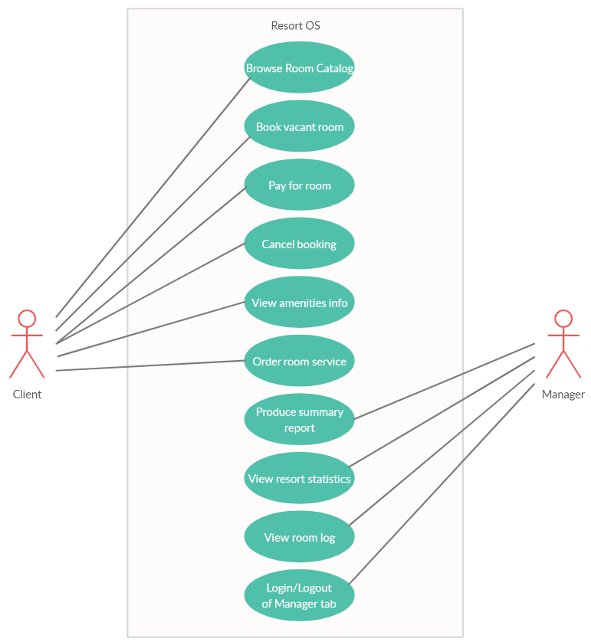

Use Case Descriptions:

1. **Browse room catalog**: The client will click on a “browse rooms” section from the main page and will be given a list of rooms and the ability to filter their selection, based on number of beds, room price, and date range. Before they are able to book the room, they must submit a date range that they will be staying at the resort. *Actor - Client*
2. **Book vacant room:** The client, after selecting a room from the catalog, will confirm their room by selecting a “Book room” button, which will then prompt them to submit their personal details, which include their name, number of people who will be staying in the room, an email address, and payment information (credit card information and billing address). After the room is booked, the client will receive a confirmation number in their email. After this is complete, documentation of this action will be sent to the staff report. *Actor – Client*
3. **Pay for room:** Allows the client to enter their credit card information to pay for their booking.Can be considered a sub-process of the “book vacant room” use case. *Actor - Client*
4. **Cancel booking:** The client will select a “Cancel Appointment” option from the main page and will be navigated to the cancellation page, which will prompt them to submit their confirmation number from the email they received after confirming their room. Once submitted, their booking selection will be taken off reservation and they will be removed from booking records. After this is complete, documentation of this action will be sent to the staff report. *Actor – Client*
5. **View amenities info:** The client will select the “Amenities” tab to view the list of amenities available at the resort. Once they select an amenity, the system will display the hours of operation and a general description for the selected amenity. *Actor – Client*
6. **Order room service:** The client will select the “Amenities” tab, and after selecting the “Order Room Service” panel, the client can choose a single food item from a supplied list (or multiple food items), and input their room name and credit card number for purchasing the food item. *Actor - Client*
7. **Produce summary report views:** Once a client has submitted a room booking or cancellation, the system will keep records of each event and store them for documentation. The staff member will click on a button on the main page labeled “Staff Login” and submit their access ID when prompted, navigating them to a hidden staff-only page and view the Summary Report. *Actor – Manager*
8. **View resort statistics:** Once a manager has logged into the manager tab, they can select the “Resort Statistics” button and choose to view either booking information or revenue information, split up between each month. *Actor - Manager*
9. **View room log:** This will display a live log of rooms and their booked status for a quick overview of what rooms are occupied and which are available. *Actor - Manager*
10. **Login/Logout of Manager Tab:** The system shall allow a manager to login with their supplied credentials in order to view secure information, along with logging out of the view as well.

**SECTION 3: Specific Requirements**

|  |  |
| --- | --- |
| 1 | The system shall supply the user with a description on how to use the application that is viewable on the home page. |
| 2 | The system shall allow users to browse a variety of rooms that are different based on theme, price, and number of beds. |
| 3 | The system shall allow users to enter their personal information, such as name, address, phone number, email, and credit card information when booking a room. |
| 4 | The system shall supply not allow users to book an incorrect date range when reserving a room, such as attempting to book a date that is in the past. |
| 5 | The system shall supply the user a unique reservation confirmation number after they have booked a room. |
| 6 | The system shall allow the user to cancel a reservation by inputting a reservation number that is supplied after they have booked a reservation. |
| 7 | The system shall allow resort managers to log into a secure tab that is only viewable after inputting the correct credentials. |
| 8 | The system shall allow resort managers to view the Detailed Room Summary Report |
| 9 | The system shall store current and past occupants’ names, addresses, phone numbers, and booking confirmation numbers in a database. |
| 10 | The system shall allow managers to log out of their account from the manager tab. |
| 11 | The system shall allow managers to view the vacancy status of each room based on a date range supplied by the manager. |
| 12 | The system shall allow managers to filter the vacancy status of each room based on a date range supplied by the manager. |
| 13 | If a room has been reserved, the system shall allow managers to directly view the client’s information from the manager tab. |
| 14 | The system shall allow managers to view each month’s booking statistics, displaying how many rooms have been booked each month. |
| 15 | The system shall allow managers to view the amount of revenue generated each month by the resort. |
| 16 | The system shall allow users to order room service to their room by supplying their room name, credit card number, and requested meal choice. |
| 17 | The system shall allow users to view information regarding resort amenities, displaying a general description, along with opening and closing times, of each amenity. |

Template created by G. Walton ([GWalton@mail.ucf.edu](mailto:GWalton@mail.ucf.edu)) on Aug 30, 1999 and last updated Aug 15, 2000; updated by A. Koufakou, Aug 2014