# Machine Learning: Assignment 1

import numpy as np  
import pandas as pd  
import time  
import gc  
import random  
from sklearn.model_selection import cross_val_score, GridSearchCV, cross_validate, train_test_split  
from sklearn.metrics import accuracy_score, classification_report, confusion_matrix, f1_score  
from sklearn.datasets import make_classification  
from sklearn.svm import SVC  
from sklearn.tree import DecisionTreeClassifier  
from sklearn.neural_network import MLPClassifier  
from sklearn.ensemble import GradientBoostingClassifier  
from sklearn.preprocessing import StandardScaler, normalize  
from sklearn.decomposition import PCA  
from sklearn.impute import SimpleImputer  
from sklearn.neighbors import KNeighborsClassifier  
from sklearn.model_selection import validation_curve  
from sklearn.neural_network import MLPClassifier  
import seaborn as sns  
import matplotlib.pyplot as plt  
from yellowbrick.model_selection import LearningCurve, ValidationCurve  
from sklearn.preprocessing import OneHotEncoder

# 1. Data Import, leansing Setup and helper functions

class Data():  
 def dataAllocation(self,path):  
 # df = pd.read_csv(path)  
 # x_data = df.iloc[:, :-1]  
 # y_data = df.iloc[:, -1 ]  
 # return x_data,y_data  
 X, y = make_classification(n_samples=2000, n_features=20, n_informative=10, n_redundant=0, random_state=rs)  
 return X, y  
 def trainSets(self,x_data,y_data):  
 x_train, x_test, y_train, y_test = train_test_split(x_data, y_data, test_size = 0.3, random_state = rs, shuffle = True)  
 return x_train, x_test, y_train, y_test  
  
data = 'data/pima-indians-diabetes.csv'  
rs = 614  
dataset = Data()  
x_data,y_data = dataset.dataAllocation(data)  
x_train, x_test, y_train, y_test = dataset.trainSets(x_data,y_data)  
# print("Heatmap for Features")  
# data_corr = sns.heatmap(pd.DataFrame(x_train).corr(), cmap='Blues')

# 2. Decision Tree Classifier

class DTClassifier():  
  
 def trainTest(self,x_train,x_test, y_train):  
 df = []  
 for i in range(16):  
 for j in range(20):  
 dt_clf = DecisionTreeClassifier(max_depth=i+1, min_samples_leaf=j+1)  
 dt_clf.fit(x_train, y_train)  
   
 y_predict_train = dt_clf.predict(x_train)  
 y_predict_test = dt_clf.predict(x_test)  
 df.append([i+1, j+1, "Train", f1_score(y_train, y_predict_train)])  
 df.append([i+1, j+1, "Test", f1_score(y_test, y_predict_test)])  
  
 return pd.DataFrame(df, columns=["Depth", "Leaf Size", "Sample Type", "F1 Score" ])  
   
 def hyperParameterTuning(self,x_train,y_train):  
 param_grid = {'max_depth': range(1, 21), 'min_samples_leaf': range(1, 20)}  
 tuned = GridSearchCV(estimator = DecisionTreeClassifier(random_state = rs), param_grid = param_grid, cv=10)  
 tuned.fit(x_train, y_train)  
 print(tuned.best_params_)  
 return tuned.best_score_, tuned.best_params_

dt = DTClassifier()  
df = dt.trainTest(x_train, x_test, y_train)  
g = sns.FacetGrid(df, hue="Sample Type", col="Depth", height=4, col_wrap=4)  
g.map(sns.pointplot, "Leaf Size", "F1 Score" )

<seaborn.axisgrid.FacetGrid at 0x7fdc5b22b430>

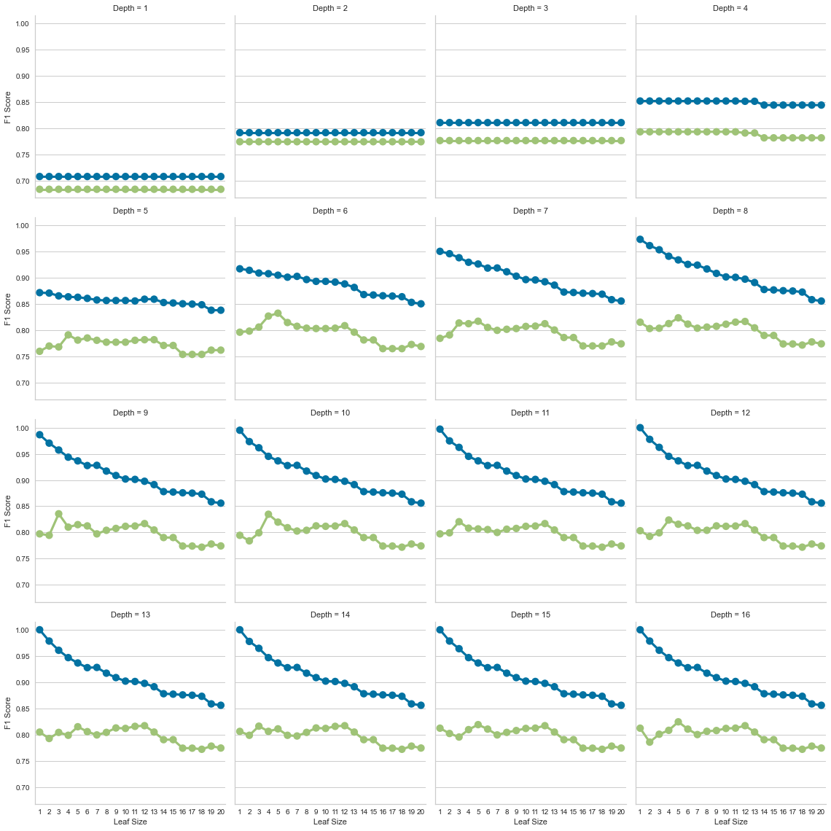

best_score, best_params = dt.hyperParameterTuning(x_train,y_train)  
print(best_score)

{'max_depth': 10, 'min_samples_leaf': 5}  
0.8150000000000001

dt_tuned = DecisionTreeClassifier(max_depth=best_params['max_depth'], min_samples_leaf=best_params['min_samples_leaf'], random_state=rs)  
  
sizes = np.linspace(0.3, 1.0, 10)  
  
# Instantiate the classification model and visualizer  
visualizer = LearningCurve(  
 dt_tuned, scoring='f1_weighted', train_sizes=sizes, n_jobs=4  
)  
  
visualizer.fit(x_data,y_data) # Fit the data to the visualizer  
visualizer.show()

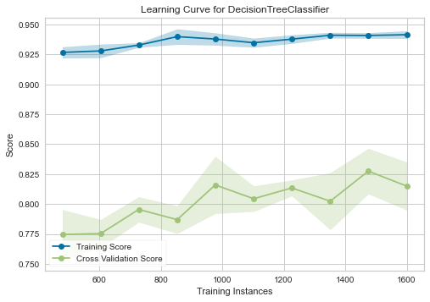

<matplotlib.axes._subplots.AxesSubplot at 0x7fdc5fa11940>

# 3. Support Vector Machine

class SupportVectorMachine():  
 def dataPreProcess(self,x_train,x_test):  
 scaler = StandardScaler()  
 scaled_x_train = scaler.fit_transform(x_train)  
 scaled_x_test = scaler.transform(x_test)  
 return scaled_x_train, scaled_x_test  
   
 def trainTest(self,scaled_x_train,scaled_x_test, y_train, y_test):  
 cs = [x/10000 for x in [1, 10, 100, 1000, 10000, 100000, 1000000]]  
 df = []  
 for c in cs:  
 for k in ["linear", "sigmoid"]:  
 model = SVC(kernel = k, C=c)  
 model.fit(scaled_x_train,y_train)  
 y_predict_train = model.predict(scaled_x_train)  
 y_predict_test = model.predict(scaled_x_test)  
 df.append([k, c, accuracy_score(y_predict_test, y_test)])  
 return pd.DataFrame(df, columns=["Kernel", "C", "Accuracy"])  
   
 def hyperParameterTuning(self,scaled_x_train, y_train):  
 param_grid = {'C': [x/10000 for x in [1, 10, 100, 1000, 10000, 100000, 1000000]],   
 'kernel': ["linear", "sigmoid"]}   
 svm_tune = SVC(gamma = "auto")  
 svm_cv = GridSearchCV(estimator = svm_tune, param_grid = param_grid, n_jobs=5, return_train_score=True)  
 svm_cv.fit(scaled_x_train, y_train)  
 best_score = svm_cv.best_score_  
 return best_score, svm_cv.best_params_

svm = SupportVectorMachine()  
scaled_x_train, scaled_x_test = svm.dataPreProcess(x_train,x_test)  
df = svm.trainTest(scaled_x_train,scaled_x_test, y_train, y_test)  
best_score, best_params = svm.hyperParameterTuning(scaled_x_train, y_train)  
print(best_score, best_params)

0.8614285714285714 {'C': 0.01, 'kernel': 'linear'}

g = sns.FacetGrid(df, col="Kernel", height=4)  
g.map(sns.pointplot, "C", "Accuracy")

<seaborn.axisgrid.FacetGrid at 0x7fdc5fa514f0>

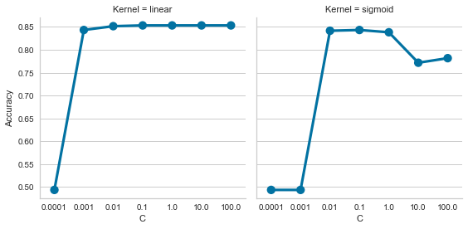

dt_tuned = SVC(kernel=best_params['kernel'], C=best_params['C'])  
  
sizes = np.linspace(0.3, 1.0, 10)  
  
# Instantiate the classification model and visualizer  
visualizer = LearningCurve(  
 dt_tuned, scoring='f1_weighted', train_sizes=sizes, n_jobs=4  
)  
  
visualizer.fit(x_data,y_data) # Fit the data to the visualizer  
visualizer.show()

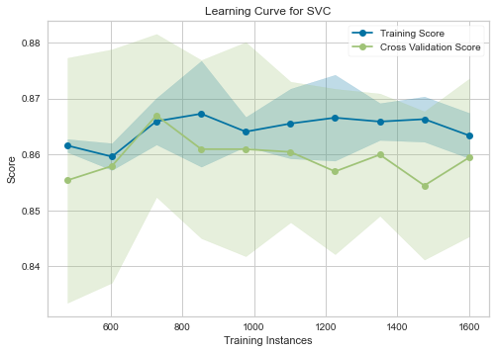

<matplotlib.axes._subplots.AxesSubplot at 0x7fdc5fbd3910>

# 4. KNN

class KNN():  
 def testTrain(self,x_train,x_test, y_train):  
 df = []  
 for i in range(20):  
 model = KNeighborsClassifier(n_neighbors= i+1)  
 model.fit(x_train, y_train)  
 y_predict_test = model.predict(x_test)  
 df.append([i+1, accuracy_score(y_predict_test, y_test)])  
 return pd.DataFrame(df, columns= ["Neighbors", "Accuracy"])  
   
 def hyperParameterTuning(self,x_train,y_train):  
 tuned = GridSearchCV(KNeighborsClassifier(), {"n_neighbors" : range(1, 21)})  
 tuned.fit(x_train, y_train)  
 return tuned.best_score_, tuned.best_params_

knn = KNN()  
df = knn.testTrain(x_train,x_test, y_train)  
best_score, best_params = knn.hyperParameterTuning(x_train,y_train)  
print(best_score, best_params)

0.9242857142857142 {'n_neighbors': 10}

sns.lineplot(data=df, x="Neighbors", y="Accuracy")

<matplotlib.axes._subplots.AxesSubplot at 0x7fdc602e4e20>

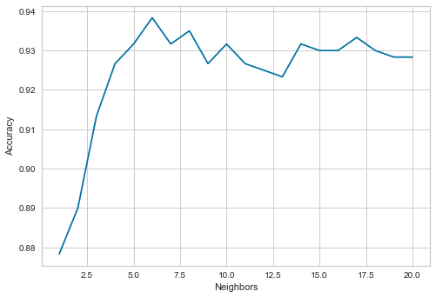

knn_tuned = KNeighborsClassifier(n_neighbors=best_params['n_neighbors'])  
  
sizes = np.linspace(0.3, 1.0, 10)  
  
# Instantiate the classification model and visualizer  
visualizer = LearningCurve(  
 knn_tuned, scoring='f1_weighted', train_sizes=sizes, n_jobs=4  
)  
  
visualizer.fit(x_data,y_data) # Fit the data to the visualizer  
visualizer.show()

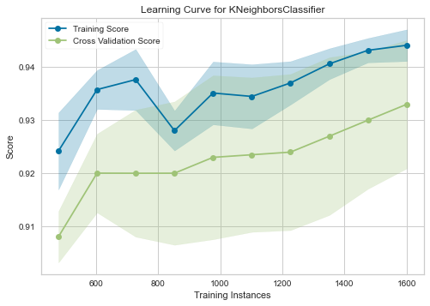

<matplotlib.axes._subplots.AxesSubplot at 0x7fdc601763d0>

# 5. Neural Network

np.linspace(1,150,30).astype('int')

array([ 1, 6, 11, 16, 21, 26, 31, 36, 42, 47, 52, 57, 62,  
 67, 72, 78, 83, 88, 93, 98, 103, 108, 114, 119, 124, 129,  
 134, 139, 144, 150])

class NN():  
 def dataPreProcess(self,x_train,x_test):  
 scaler = StandardScaler()  
 scaled_x_train = scaler.fit_transform(x_train)  
 scaled_x_test = scaler.transform(x_test)  
 return scaled_x_train, scaled_x_test  
  
 def trainTest(self,scaled_x_train,scaled_x_test, y_train, y_test):  
 df = []  
 for i in [0.01, 0.02, 0.04, 0.08, 0.1]:  
 model = MLPClassifier(max_iter=300, learning_rate_init=i)  
 model.fit(scaled_x_train,y_train)  
 y_predict_train = model.predict(scaled_x_train)  
 y_predict_test = model.predict(scaled_x_test)  
 df.append([i, accuracy_score(y_predict_test, y_test)])  
 return pd.DataFrame(df, columns=["Learning Rate", "Accuracy"])  
   
 def hyperParameterTuning(self,scaled_x_train, y_train):  
 param_grid = {  
 'hidden_layer_sizes': [x**2 for x in range(2, 11)],  
 'learning_rate_init': [0.01, 0.02, 0.04, 0.08, 0.1],  
 }  
 tuned = GridSearchCV(MLPClassifier(max_iter=300), param_grid = param_grid, cv=10)  
 tuned.fit(scaled_x_train, y_train)  
 return tuned.best_score_, tuned.best_params_

nn = NN()  
scaled_x_train, scaled_x_test = nn.dataPreProcess(x_train,x_test)  
df = nn.trainTest(scaled_x_train,scaled_x_test, y_train, y_test)  
sns.lineplot(data=df, x="Learning Rate", y="Accuracy")

<matplotlib.axes._subplots.AxesSubplot at 0x7fdc6062df40>

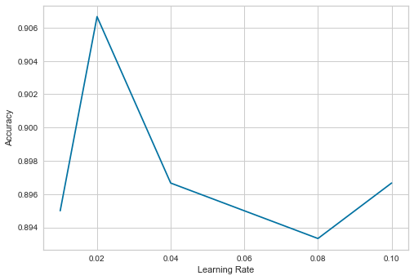

best_score, best_params = nn.hyperParameterTuning(scaled_x_train, y_train)  
print(best_score, best_params)

0.9099999999999999 {'hidden_layer_sizes': 81, 'learning_rate_init': 0.04}

boost_tuned = MLPClassifier(max_iter=300, learning_rate_init=best_params['learning_rate_init'], hidden_layer_sizes=best_params['hidden_layer_sizes'])  
  
sizes = np.linspace(0.3, 1.0, 10)  
  
# Instantiate the classification model and visualizer  
visualizer = LearningCurve(  
 boost_tuned, scoring='f1_weighted', train_sizes=sizes, n_jobs=4  
)  
  
visualizer.fit(x_data,y_data) # Fit the data to the visualizer  
visualizer.show()

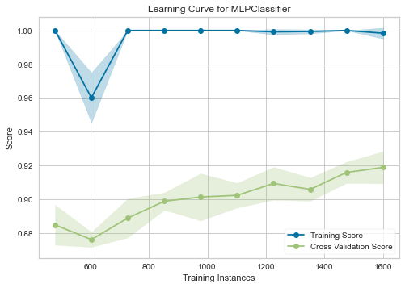

<matplotlib.axes._subplots.AxesSubplot at 0x7fdc606049a0>

# 6. Boost

class Boost():  
 def dataPreProcess(self,x_train,x_test):  
 scaler = StandardScaler()  
 scaled_x_train = scaler.fit_transform(x_train)  
 scaled_x_test = scaler.transform(x_test)  
 return scaled_x_train, scaled_x_test  
  
  
 def trainTest(self,scaled_x_train,scaled_x_test, y_train, y_test):  
 df = []  
 for i in range(50, 251, 5):  
 model = GradientBoostingClassifier(n_estimators=i, max_depth=3, min_samples_leaf=10)  
 model.fit(scaled_x_train,y_train)  
 y_predict_train = model.predict(scaled_x_train)  
 y_predict_test = model.predict(scaled_x_test)  
 df.append([i, accuracy_score(y_predict_test, y_test)])  
 return pd.DataFrame(df, columns=["Estimators", "Accuracy"])  
   
 def hyperParameterTuning(self,scaled_x_train, y_train):  
 param_grid = {'n_estimators': range(50, 151, 40), 'max_depth': range(2, 4)}  
 tuned = GridSearchCV(GradientBoostingClassifier(), param_grid, cv=10)  
 tuned.fit(scaled_x_train, y_train)  
 return tuned.best_score_, tuned.best_params_

boost = Boost()  
scaled_x_train, scaled_x_test = boost.dataPreProcess(x_train,x_test)  
df = boost.trainTest(scaled_x_train,scaled_x_test, y_train, y_test)  
sns.lineplot(data=df, x="Estimators", y="Accuracy")

<matplotlib.axes._subplots.AxesSubplot at 0x7fdc42cd11c0>

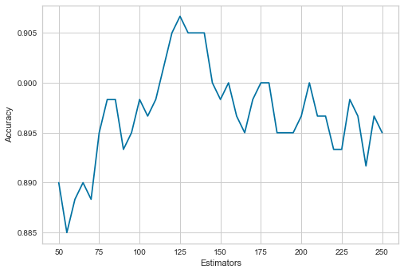

best_score, best_params = boost.hyperParameterTuning(scaled_x_train, y_train)  
print(best_score, best_params)

0.8742857142857142 {'max_depth': 3, 'n_estimators': 130}

boost_tuned = GradientBoostingClassifier(n_estimators=best_params['n_estimators'], max_depth=best_params['max_depth'], min_samples_leaf=100)  
  
sizes = np.linspace(0.3, 1.0, 10)  
  
# Instantiate the classification model and visualizer  
visualizer = LearningCurve(  
 boost_tuned, scoring='f1_weighted', train_sizes=sizes, n_jobs=4  
)  
  
visualizer.fit(x_data,y_data) # Fit the data to the visualizer  
visualizer.show()

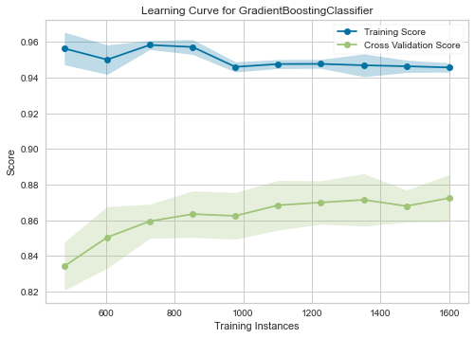

<matplotlib.axes._subplots.AxesSubplot at 0x7fdc42fa68b0>