# Machine Learning: Assignment 1

import numpy as np  
import pandas as pd  
import time  
import gc  
import random  
from sklearn.model_selection import cross_val_score, GridSearchCV, cross_validate, train_test_split  
from sklearn.metrics import accuracy_score, classification_report, confusion_matrix, f1_score  
from sklearn.datasets import make_classification  
from sklearn.svm import SVC  
from sklearn.tree import DecisionTreeClassifier  
from sklearn.neural_network import MLPClassifier  
from sklearn.ensemble import GradientBoostingClassifier  
from sklearn.preprocessing import StandardScaler, normalize  
from sklearn.decomposition import PCA  
from sklearn.impute import SimpleImputer  
from sklearn.neighbors import KNeighborsClassifier  
from sklearn.model_selection import validation_curve  
from sklearn.neural_network import MLPClassifier  
import seaborn as sns  
import matplotlib.pyplot as plt  
from yellowbrick.model_selection import LearningCurve, ValidationCurve  
from sklearn.preprocessing import OneHotEncoder

# 1. Data Import, leansing Setup and helper functions

class Data():  
 def dataAllocation(self,path):  
 # df = pd.read_csv(path)  
 # x_data = df.iloc[:, :-1]  
 # y_data = df.iloc[:, -1 ]  
 # return x_data,y_data  
 X, y = make_classification(n_samples=500, n_features=5, n_informative=5, n_redundant=0, random_state=rs)  
 return X, y  
  
 def trainSets(self,x_data,y_data):  
 x_train, x_test, y_train, y_test = train_test_split(x_data, y_data, test_size = 0.3, random_state = rs, shuffle = True)  
 return x_train, x_test, y_train, y_test  
  
data = 'data/pima-indians-diabetes.csv'  
rs = 614  
dataset = Data()  
x_data,y_data = dataset.dataAllocation(data)  
x_train, x_test, y_train, y_test = dataset.trainSets(x_data,y_data)  
scaler = StandardScaler()  
scaled_x_train = scaler.fit_transform(x_train)  
scaled_x_test = scaler.transform(x_test)  
sizes = np.linspace(0.3, 1.0, 10)  
# print("Heatmap for Features")  
# data_corr = sns.heatmap(pd.DataFrame(x_train).corr(), cmap='Blues')  
  
def fakeTunedData(i):  
 fakeData = [{'max_depth': 9, 'min_samples_leaf': 1}, {'C': 0.01, 'kernel': 'linear'}, {'n_neighbors': 3}, {'hidden_layer_sizes': 81, 'learning_rate_init': 0.04},{'max_depth': 3, 'n_estimators': 90}]  
 return 72+i, fakeData[i]  
  
def learningCurvePlot(tuned):  
 visualizer = LearningCurve(tuned, scoring='f1_weighted', train_sizes=sizes, n_jobs=4)  
 visualizer.fit(x_data,y_data)  
 visualizer.show()

# 2. Decision Tree Classifier

class DTClassifier():  
  
 def trainTest(self):  
 df = []  
 for i in range(16):  
 for j in range(20):  
 dt_clf = DecisionTreeClassifier(max_depth=i+1, min_samples_leaf=j+1)  
 dt_clf.fit(x_train, y_train)  
   
 y_predict_train = dt_clf.predict(x_train)  
 y_predict_test = dt_clf.predict(x_test)  
 df.append([i+1, j+1, "Train", f1_score(y_train, y_predict_train)])  
 df.append([i+1, j+1, "Test", f1_score(y_test, y_predict_test)])  
  
 return pd.DataFrame(df, columns=["Depth", "Leaf Size", "Sample Type", "F1 Score" ])  
  
 def hyperParameterTuning(self):  
 param_grid = {'max_depth': range(1, 21), 'min_samples_leaf': range(1, 20)}  
 tuned = GridSearchCV(estimator = DecisionTreeClassifier(random_state = rs), param_grid = param_grid, cv=10)  
 tuned.fit(x_train, y_train)  
 return tuned.best_score_, tuned.best_params_  
  
 def dataExplorePlot(self, df):  
 g = sns.FacetGrid(df, hue="Sample Type", col="Depth", height=2, col_wrap=4)  
 g.map(sns.lineplot, "Leaf Size", "F1 Score" )  
   
 def showLearningCurve(self, best_params):  
 tuned = DecisionTreeClassifier(max_depth=best_params['max_depth'], min_samples_leaf=best_params['min_samples_leaf'], random_state=rs)  
 learningCurvePlot(tuned)

# 3. Support Vector Machine

class SupportVectorMachine():  
 def trainTest(self):  
 cs = [x/10000 for x in [1, 10, 100, 1000, 10000, 100000, 1000000]]  
 df = []  
 for c in cs:  
 for k in ["linear", "sigmoid"]:  
 model = SVC(kernel = k, C=c)  
 model.fit(scaled_x_train,y_train)  
 y_predict_train = model.predict(scaled_x_train)  
 y_predict_test = model.predict(scaled_x_test)  
 df.append([k, c, accuracy_score(y_predict_test, y_test)])  
 return pd.DataFrame(df, columns=["Kernel", "C", "Accuracy"])  
   
 def hyperParameterTuning(self):  
 param_grid = {'C': [x/10000 for x in [1, 10, 100, 1000, 10000, 100000, 1000000]],   
 'kernel': ["linear", "sigmoid"]}   
 svm_tune = SVC(gamma = "auto")  
 svm_cv = GridSearchCV(estimator = svm_tune, param_grid = param_grid, n_jobs=5, return_train_score=True)  
 svm_cv.fit(scaled_x_train, y_train)  
 best_score = svm_cv.best_score_  
 return best_score, svm_cv.best_params_  
   
 def dataExplorePlot(self, df):  
 g = sns.FacetGrid(df, col="Kernel", height=4)  
 g.map(sns.pointplot, "C", "Accuracy")  
   
 def showLearningCurve(self, best_params):  
 tuned = SVC(kernel=best_params['kernel'], C=best_params['C'])  
 learningCurvePlot(tuned)

# 4. KNN

class KNN():  
 def trainTest(self):  
 df = []  
 for i in range(20):  
 model = KNeighborsClassifier(n_neighbors= i+1)  
 model.fit(x_train, y_train)  
 y_predict_test = model.predict(x_test)  
 df.append([i+1, accuracy_score(y_predict_test, y_test)])  
 return pd.DataFrame(df, columns= ["Neighbors", "Accuracy"])  
   
 def hyperParameterTuning(self):  
 tuned = GridSearchCV(KNeighborsClassifier(), {"n_neighbors" : range(1, 21)})  
 tuned.fit(x_train, y_train)  
 return tuned.best_score_, tuned.best_params_  
  
 def dataExplorePlot(self, df):  
 sns.lineplot(data=df, x="Neighbors", y="Accuracy")  
   
 def showLearningCurve(self, best_params):  
 tuned = KNeighborsClassifier(n_neighbors=best_params['n_neighbors'])  
 learningCurvePlot(tuned)

# 5. Neural Network

class NN():  
  
 def trainTest(self):  
 df = []  
 for i in [0.01, 0.02, 0.04, 0.08, 0.1]:  
 model = MLPClassifier(max_iter=300, learning_rate_init=i)  
 model.fit(scaled_x_train,y_train)  
 y_predict_train = model.predict(scaled_x_train)  
 y_predict_test = model.predict(scaled_x_test)  
 df.append([i, accuracy_score(y_predict_test, y_test)])  
 return pd.DataFrame(df, columns=["Learning Rate", "Accuracy"])  
   
 def hyperParameterTuning(self):  
 param_grid = {  
 'hidden_layer_sizes': [x**2 for x in range(2, 11)],  
 'learning_rate_init': [0.01, 0.02, 0.04, 0.08, 0.1]  
 }  
 tuned = GridSearchCV(MLPClassifier(max_iter=50), param_grid = param_grid, cv=10)  
 tuned.fit(scaled_x_train, y_train)  
 return tuned.best_score_, tuned.best_params_  
  
 def dataExplorePlot(self, df):  
 sns.lineplot(data=df, x="Learning Rate", y="Accuracy")  
   
 def showLearningCurve(self, best_params):  
 tuned = MLPClassifier(max_iter=50, learning_rate_init=best_params['learning_rate_init'], hidden_layer_sizes=best_params['hidden_layer_sizes'])  
 learningCurvePlot(tuned)

# 6. Boost

class Boost():  
 def trainTest(self):  
 df = []  
 for i in range(50, 251, 10):  
 model = GradientBoostingClassifier(n_estimators=i, max_depth=3, min_samples_leaf=10)  
 model.fit(scaled_x_train,y_train)  
 y_predict_train = model.predict(scaled_x_train)  
 y_predict_test = model.predict(scaled_x_test)  
 df.append([i, accuracy_score(y_predict_test, y_test)])  
 return pd.DataFrame(df, columns=["Estimators", "Accuracy"])  
   
 def hyperParameterTuning(self):  
 param_grid = {'n_estimators': range(50, 151, 40), 'max_depth': range(2, 4)}  
 tuned = GridSearchCV(GradientBoostingClassifier(), param_grid, cv=10)  
 tuned.fit(scaled_x_train, y_train)  
 return tuned.best_score_, tuned.best_params_  
   
 def dataExplorePlot(self, df):  
 sns.lineplot(data=df, x="Estimators", y="Accuracy")  
  
 def showLearningCurve(self, best_params):  
 tuned = GradientBoostingClassifier(n_estimators=best_params['n_estimators'], max_depth=best_params['max_depth'], min_samples_leaf=100)  
 learningCurvePlot(tuned)

classifiers = [DTClassifier(), SupportVectorMachine(), KNN(), NN(), Boost()]  
classifiers_name = ["Decision Tree", "Support Vector Machine", "K-Nearest Neighbors", "Neural Network", "Gradient Boosting"]  
  
i = 0  
  
for classifier in classifiers:  
 name = classifiers_name[i]  
 print(str(i+1)+".", name, end="\n\n")  
 df = classifier.trainTest()  
 best_score, best_params = fakeTunedData(i)  
 print(str(i+1)+".1","Hyperparameters Exploration", end="\n\n")  
 print("For this project,", name, "will be hypertuned by adjusting:", [x for x in best_params], end=". ")  
 print("The following chart shows how the accuracy is affected when the hyperparamter(s) are changed:")  
  
 classifier.dataExplorePlot(df)  
 plt.figure()  
 #best_score, best_params = classifier.hyperParameterTuning()  
 #print(best_score, best_params)  
 print("\n\n")  
 print(str(i+1)+".2","Hypertuning", end="\n\n")  
 print("GridSearchCV was performed for", name, "classifier" , end=". ")  
 for key in best_params:  
 print("The optimal value of", key, "was", best_params[key], end = ". ")  
 print("Likewise the accuracy of", name, "classifier", "was", best_score, "when the optimized hyperparameter(s) value(s) were used.")  
 classifier.showLearningCurve(best_params)  
 print()  
 print()  
  
 i = i + 1

1. Decision Tree  
  
1.1 Hyperparameters Exploration  
  
For this project, Decision Tree will be hypertuned by adjusting: ['max_depth', 'min_samples_leaf']. The following chart shows how the accuracy is affected when the hyperparamter(s) are changed:  
  
  
  
1.2 Hypertuning  
  
GridSearchCV was performed for Decision Tree classifier. The optimal value of max_depth was 9. The optimal value of min_samples_leaf was 1. Likewise the accuracy of Decision Tree classifier was 72 when the optimized hyperparameter(s) value(s) were used.

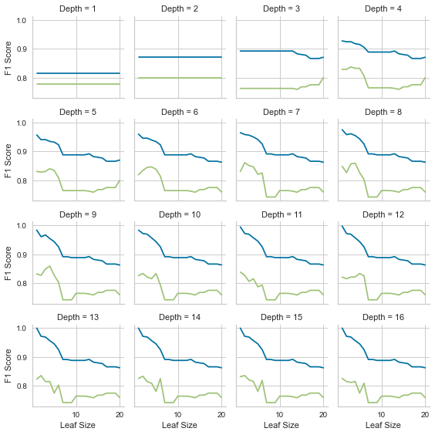

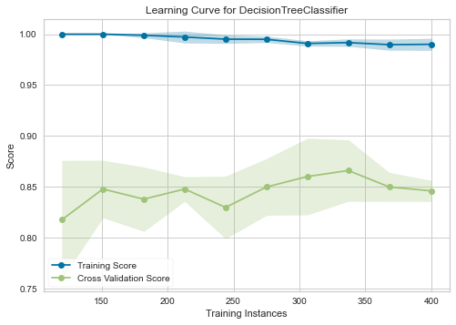

2. Support Vector Machine  
  
2.1 Hyperparameters Exploration  
  
For this project, Support Vector Machine will be hypertuned by adjusting: ['C', 'kernel']. The following chart shows how the accuracy is affected when the hyperparamter(s) are changed:  
  
  
  
2.2 Hypertuning  
  
GridSearchCV was performed for Support Vector Machine classifier. The optimal value of C was 0.01. The optimal value of kernel was linear. Likewise the accuracy of Support Vector Machine classifier was 73 when the optimized hyperparameter(s) value(s) were used.

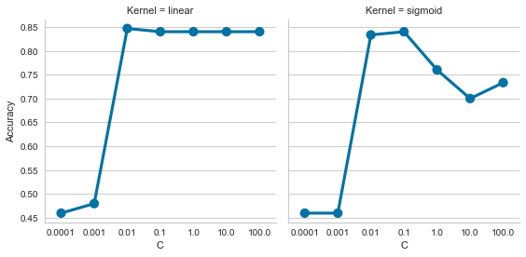

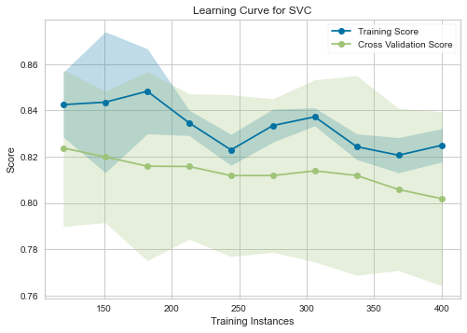

3. K-Nearest Neighbors  
  
3.1 Hyperparameters Exploration  
  
For this project, K-Nearest Neighbors will be hypertuned by adjusting: ['n_neighbors']. The following chart shows how the accuracy is affected when the hyperparamter(s) are changed:  
  
  
  
3.2 Hypertuning  
  
GridSearchCV was performed for K-Nearest Neighbors classifier. The optimal value of n_neighbors was 3. Likewise the accuracy of K-Nearest Neighbors classifier was 74 when the optimized hyperparameter(s) value(s) were used.

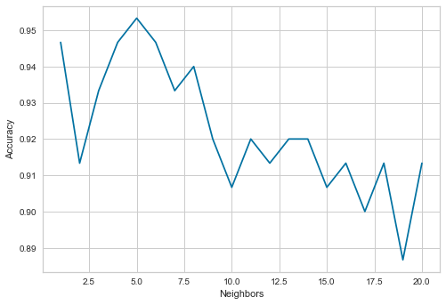

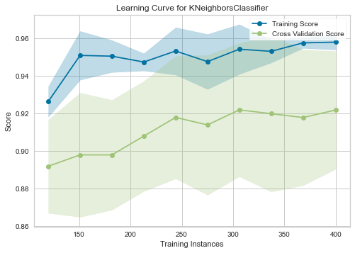

4. Neural Network  
  
4.1 Hyperparameters Exploration  
  
For this project, Neural Network will be hypertuned by adjusting: ['hidden_layer_sizes', 'learning_rate_init']. The following chart shows how the accuracy is affected when the hyperparamter(s) are changed:  
  
  
  
4.2 Hypertuning  
  
GridSearchCV was performed for Neural Network classifier. The optimal value of hidden_layer_sizes was 81. The optimal value of learning_rate_init was 0.04. Likewise the accuracy of Neural Network classifier was 75 when the optimized hyperparameter(s) value(s) were used.

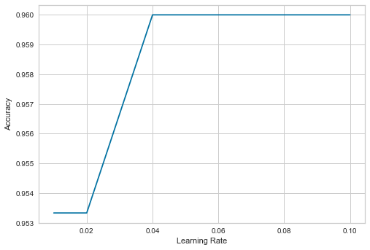

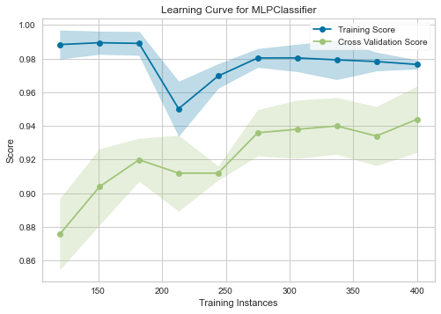

5. Gradient Boosting  
  
5.1 Hyperparameters Exploration  
  
For this project, Gradient Boosting will be hypertuned by adjusting: ['max_depth', 'n_estimators']. The following chart shows how the accuracy is affected when the hyperparamter(s) are changed:  
  
  
  
5.2 Hypertuning  
  
GridSearchCV was performed for Gradient Boosting classifier. The optimal value of max_depth was 3. The optimal value of n_estimators was 90. Likewise the accuracy of Gradient Boosting classifier was 76 when the optimized hyperparameter(s) value(s) were used.

