Heatmap for Features

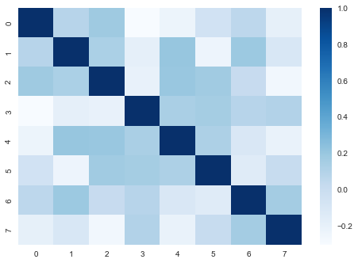

1. Decision Tree  
  
1.1 Hyperparameters Exploration  
  
For this project, Decision Tree will be hypertuned by adjusting: ['max_depth', 'min_samples_leaf']. The following charts show how the accuracy is affected when the hyperparamter(s) are changed for both dataset 1 and dataset 2:  
  
  
  
1.2 Hypertuning  
  
GridSearchCV was performed for Decision Tree classifier.  
  
Dataset 1 Results:  
The optimal value of max_depth was 9. The optimal value of min_samples_leaf was 1. Likewise the accuracy of Decision Tree classifier was 0.8828571428571429 when the optimized hyperparameter(s) value(s) were used.

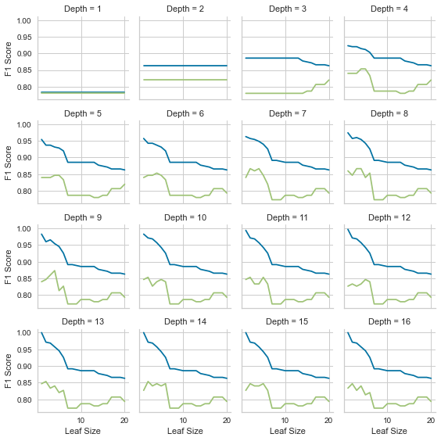

<Figure size 576x396 with 0 Axes>

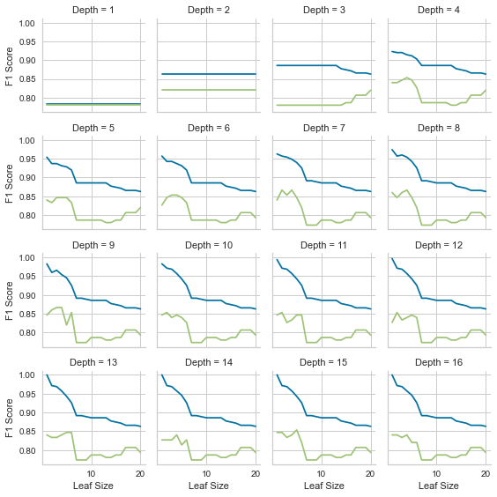

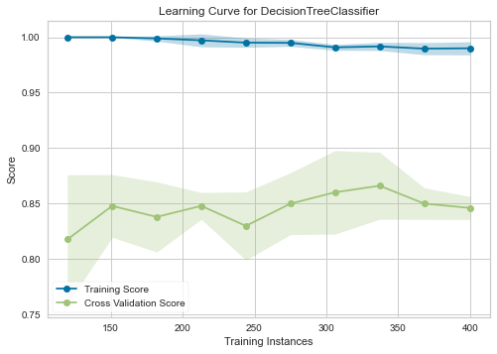

Dataset 2 Results:  
The optimal value of max_depth was 9. The optimal value of min_samples_leaf was 1. Likewise the accuracy of Decision Tree classifier was 0.8828571428571429 when the optimized hyperparameter(s) value(s) were used.



2. Support Vector Machine  
  
2.1 Hyperparameters Exploration  
  
For this project, Support Vector Machine will be hypertuned by adjusting: ['C', 'kernel']. The following charts show how the accuracy is affected when the hyperparamter(s) are changed for both dataset 1 and dataset 2:  
  
  
  
2.2 Hypertuning  
  
GridSearchCV was performed for Support Vector Machine classifier.  
  
Dataset 1 Results:  
The optimal value of C was 0.01. The optimal value of kernel was linear. Likewise the accuracy of Support Vector Machine classifier was 0.8114285714285716 when the optimized hyperparameter(s) value(s) were used.

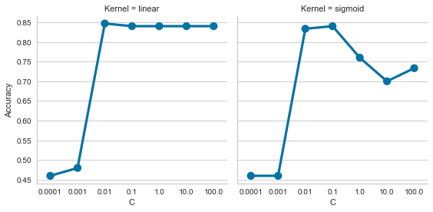

<Figure size 576x396 with 0 Axes>



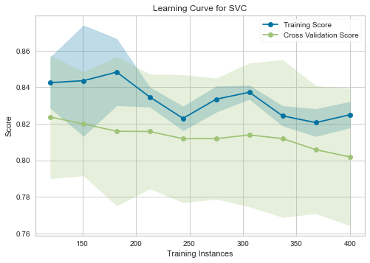

Dataset 2 Results:  
The optimal value of C was 0.01. The optimal value of kernel was linear. Likewise the accuracy of Support Vector Machine classifier was 0.8114285714285716 when the optimized hyperparameter(s) value(s) were used.



3. K-Nearest Neighbors  
  
3.1 Hyperparameters Exploration  
  
For this project, K-Nearest Neighbors will be hypertuned by adjusting: ['n_neighbors']. The following charts show how the accuracy is affected when the hyperparamter(s) are changed for both dataset 1 and dataset 2:  
  
  
  
3.2 Hypertuning  
  
GridSearchCV was performed for K-Nearest Neighbors classifier.  
  
Dataset 1 Results:  
The optimal value of n_neighbors was 3. Likewise the accuracy of K-Nearest Neighbors classifier was 0.9142857142857143 when the optimized hyperparameter(s) value(s) were used.

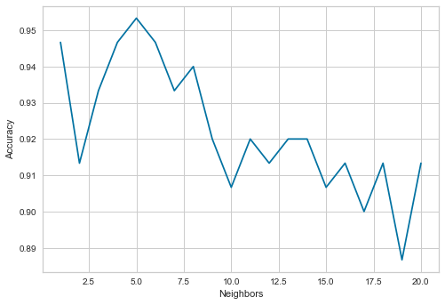



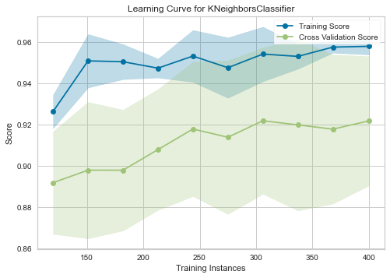

Dataset 2 Results:  
The optimal value of n_neighbors was 3. Likewise the accuracy of K-Nearest Neighbors classifier was 0.9142857142857143 when the optimized hyperparameter(s) value(s) were used.



4. Neural Network  
  
4.1 Hyperparameters Exploration  
  
For this project, Neural Network will be hypertuned by adjusting: ['hidden_layer_sizes', 'learning_rate_init']. The following charts show how the accuracy is affected when the hyperparamter(s) are changed for both dataset 1 and dataset 2:  
  
  
  
4.2 Hypertuning  
  
GridSearchCV was performed for Neural Network classifier.  
  
Dataset 1 Results:  
The optimal value of hidden_layer_sizes was 36. The optimal value of learning_rate_init was 0.01. Likewise the accuracy of Neural Network classifier was 0.9199999999999999 when the optimized hyperparameter(s) value(s) were used.

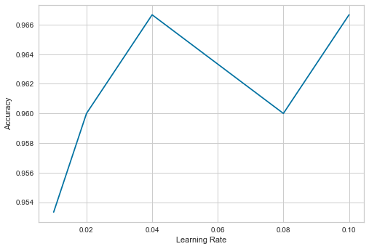

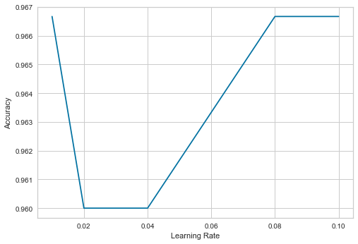

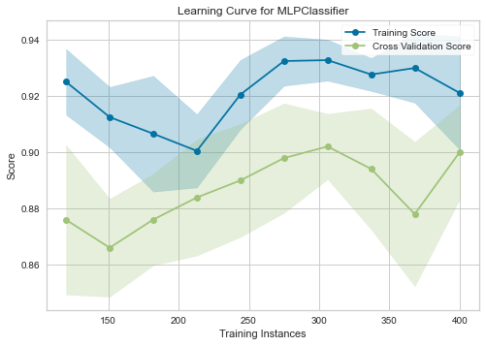

Dataset 2 Results:  
The optimal value of hidden_layer_sizes was 16. The optimal value of learning_rate_init was 0.04. Likewise the accuracy of Neural Network classifier was 0.9400000000000001 when the optimized hyperparameter(s) value(s) were used.

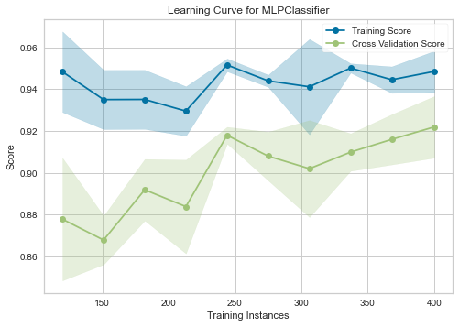

5. Gradient Boosting  
  
5.1 Hyperparameters Exploration  
  
For this project, Gradient Boosting will be hypertuned by adjusting: ['max_depth', 'n_estimators']. The following charts show how the accuracy is affected when the hyperparamter(s) are changed for both dataset 1 and dataset 2:  
  
  
  
5.2 Hypertuning  
  
GridSearchCV was performed for Gradient Boosting classifier.  
  
Dataset 1 Results:  
The optimal value of max_depth was 3. The optimal value of n_estimators was 90. Likewise the accuracy of Gradient Boosting classifier was 0.8742857142857143 when the optimized hyperparameter(s) value(s) were used.

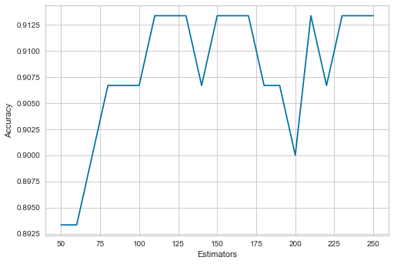



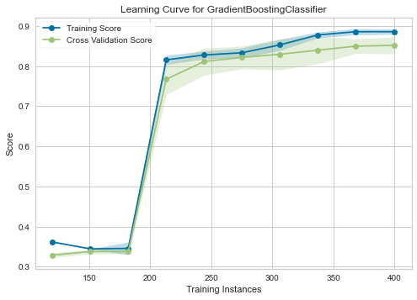

Dataset 2 Results:  
The optimal value of max_depth was 3. The optimal value of n_estimators was 90. Likewise the accuracy of Gradient Boosting classifier was 0.8742857142857143 when the optimized hyperparameter(s) value(s) were used.

