DW: DE-Normalized Logical Model

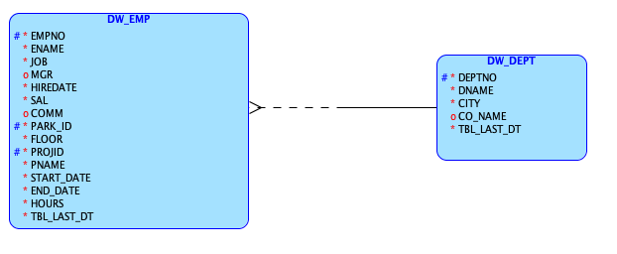

DW: DE-Normalized Relational Model

