Week 6 Lab #6: Play with AI
Anthony Bayate | Kean University | Web Client-Side Programming | Fleet Command: Battleship vs. Admiral Orca

Live game
https://ab-as1-fleet-command-ai.vercel.app
Team: Anthony Bayate (individual submission)

Idea
Fleet Command is Battleship where the opponent is an AI admiral, "Admiral Orca". The player places a fleet of five ships (manually with a rotate preview, or randomly), then trades shots with the AI on 10x10 grids. Extras: a Sonar ping (3 per game) that reports how many enemy ship squares are in a 3x3 area at the cost of a turn, a selectable AI difficulty, a battle log, and a win/loss record per difficulty saved in localStorage.

The AI opponent
The AI lives in ai.js and has three levels:
- Easy: fires at a random unexplored square.
- Medium: hunt/target. Searches on a checkerboard (every ship is at least 2 long, so half the board is enough); after a hit it probes neighbours and prefers extending a line of hits.
- Hard: probability-density search. For every unexplored square it counts how many legal placements of the ships still afloat would cover it and fires at the highest count. Placements that explain unresolved hits get much more weight, and sunk ships are removed from the remaining list so the model updates after every result.
The AI only sees what a human would see (hit, miss, sunk and the length of the sunk ship). It never reads the player's board.

Does the AI get smarter? Measured results
I simulated 300 games per level against random fleets and counted the shots needed to sink all five ships (lower is better):
AI level | Average shots to win
Easy | 95.2
Medium | 52.3
Hard | 44.8
Easy behaves like a random shooter, which needs close to 95 shots to clear the board; Hard needs under half of that.

Screenshot
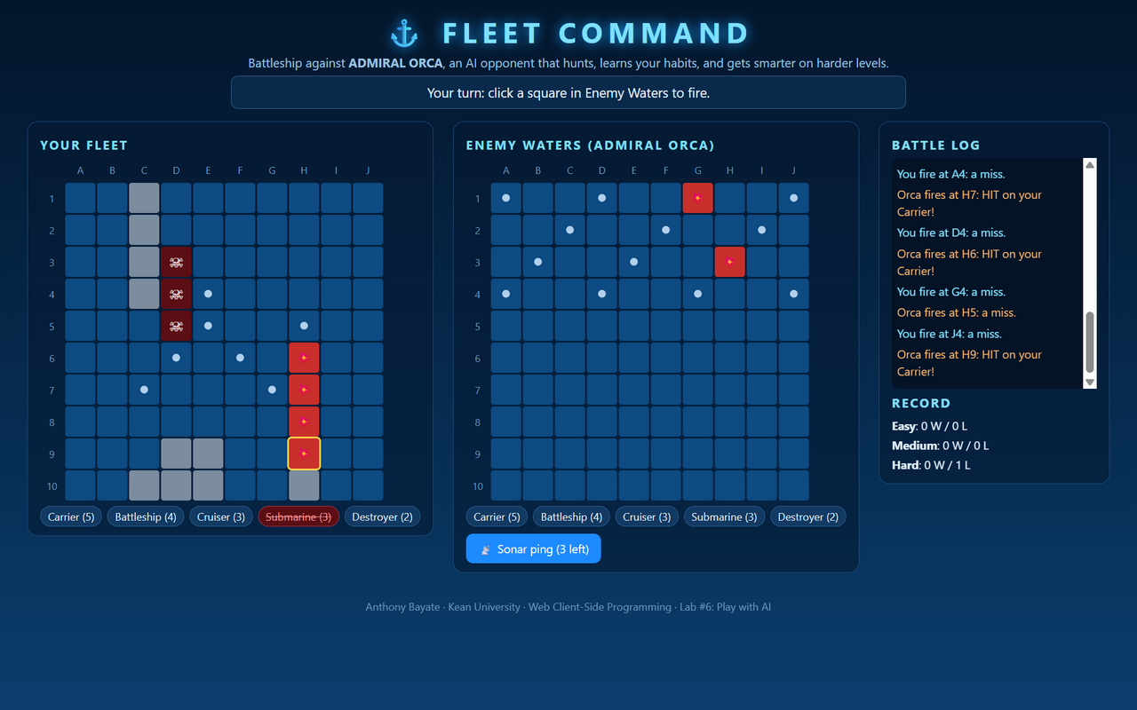

Tech and AI usage
- HTML/CSS/JS only (index.html, style.css, ai.js, game.js). Deployed to Vercel.
- I used an LLM (Claude) to help design the AI levels and write code, then tested it with the shot-count simulation above and a scripted full playthrough in the browser.

Team / testing notes
(Add any teammates and what classmates thought of the AI.)

