

**Client:** *Camp Bow Wow*

Part I- Business Description

Camp Bow Wow was founded in the year 2000 in Colorado. Due to high demand, the small business became a premier dog care franchise. Year to date, 160+ locations exist all over North America. The business itself is based solely on pet care services. The services include daycare, boarding, training, and grooming. A local entrepreneur has recently opened two locations in the Capital area. One location is in Baton Rouge, and the other is in the neighboring city of Prairieville. The owner comes to your team and requests that a database is to be made to highlight its data for the month of January. He explains the following description of the business. One location has many employees that work there. Of all the employees, there is a hierarchy of Store Managers, Assistant Managers, Leads, and Crew Members. Each employee reports directly to the position above. One or more services can be done by an employee. A service can be administered to many dogs. Dogs can be owned by many customers. One or more services can be performed by employees while many customers can request many services for their dogs. Finally, many dogs are housed at one location.

Part II- ER Diagram

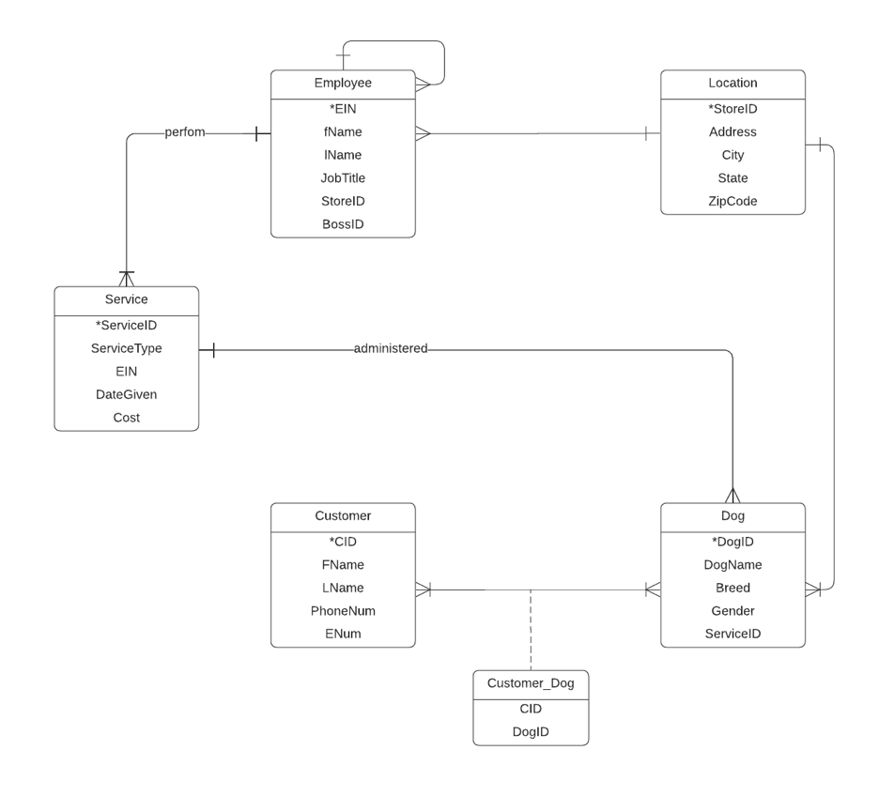

Part III - Relational Data Model

Employee (**EIN**, Fname, Lname, JobTitle, BossID, /*StoreID*/)

Location (**StoreID**, Address, City, State, ZipCode)

StationedAt (/***EIN****/, /****StoreID***/)

Service (**ServiceID**, ServiceType, DateGiven, Cost, /*EIN*/)

Dog (**DogID**, DogName, Breed, Gender, /*ServiceID*/)

DoneTo (*/****ServiceID****/, /****DogID****/)*

Customer (**CustmerID**, Fname, Lname, PhoneNum, EmergencyNum)

Part IV – Data Dictionary

|  |  |  |  |
| --- | --- | --- | --- |
| Name of Attributes | Definition | Data Type | Possible Value (examples) |
| StoreID | Store identification Number | NCHAR (10) | S001,S002 |
| Address | Store Location | NCHAR(20) | ‘123 Puppy Way’, '56 Old Jefferson Way' |
| City | City in which the store is | NCHAR(20) | Baton Rouge, Praireville |
| State | The state in with the store is | NCHAR(20) | LA, TX |
| ZipCode | Area code of the store | NCHAR(20) | 70820, 70769 |
| EIN | Employee identification Number | NCHAR(50) | E001, E002, |
| fName | Employee First Name | NCHAR(50) | Bob, Karen |
| lName | Employee Last Name | NCHAR(50) | Marley, Johnson |
| JobTitle | Employee job position | NCHAR(50) | Assistant manager,  Leads, employees |
| BossID | Boss’ Identification Number | NCHAR(50) | Store manager |
| fname | Individual’s First Name | NCHAR(10) | Alice, Ned |
| lname | Individual’s Last Name | NCHAR(10) | Washington, Doe |
| DogID | Dog Identification Number | NCHAR(10) | D001, D002 |
| DogName | Name of dog | NCHAR(10) | Fluffy, Sky, Alex |
| DogBreed | Breed of dog | NCHAR(20) | Rottweiler, Bulldog |
| Gender | Gender of dog | NCHAR(10) | M, F |
| CID | Customer Identification Number | NCHAR(10) | C001, C002 |
| PhoneNum | Customer phone number | varchar(20) | (225)555-1234, (225)324-5683 |
| EmergencyNum | Customer emergency contact number | Varchar(20) | (123)504-1234, (123)504-6733 |
| ServiceID | Service Identification number | NCHAR(10) | SER001, SER002 |
| ServiceType | Type of service provided | NCHAR(10) | Grooming, boarding, training |
| DateGiven | Date in which service was provided | NCHAR(10) | 01/06/2022 |
| Cost | Total cost of service provided | NCHAR(10) | $45-$70 |

Part V – Query Matrix and SQL Queries

|  |  |  |  |  |  |  |  |  |  |  |
| --- | --- | --- | --- | --- | --- | --- | --- | --- | --- | --- |
| **Query Matrix:** |  |  |  |  |  |  |  |  |  |  |
|  | Q1 | Q2 | Q3 | Q4 | Q5 | Q6 | Q7 | Q8 | Q9 | Q10 |
| 1.Multiple Join |  |  |  |  |  | X |  | X |  |  |
| 2. Subquery |  | x |  |  |  |  |  |  | X |  |
| 3. COUNT and DISTINCT | x |  |  |  |  |  |  |  |  |  |
| 4.GROUP BY with HAVING | x |  |  |  |  |  |  |  | x |  |
| 5. ORDER BY | x |  |  |  |  |  | X |  |  |  |
| 6. Aggregate |  |  | X |  |  |  |  |  |  |  |
| 7. LIKE |  |  |  |  |  | X |  |  |  |  |
| 8. DATE |  |  |  |  |  |  |  |  |  |  |
| 9. IN/NOT IN |  |  |  |  |  |  |  | X |  | x |
| 10. IS NULL | x |  |  |  |  |  |  |  |  |  |

**#1 How many different types of dogs are on the dog table?**

**select count(distinct breed) from dog;**

**#2 Find services that are greater than the average cost**

**SELECT ServiceID, ServiceType**

**FROM Service**

**WHERE cost >(SELECT AVG(cost)**

**FROM service);**

**#3 Count the number of employees at Store #2**

**select count(ein) as 'total employes'**

**from employee e, location l**

**where l.storeid = e.storeid**

**and e.storeid = 'S002';**

**#4 Find the average price of a grooming service.**

**SELECT ServiceType, AVG(cost) as avgcost**

**FROM service**

**WHERE serviceType in ('Grooming');**

**#5 Find out which employees do not have a boss**

**SELECT Fname, lname, jobtitle**

**FROM employee**

**WHERE bossid IS NULL;**

**#6 List the employees at the Baton Rouge Location**

**SELECT e.EIN, e.fName, e.lName, l.city**

**FROM employee e, location l**

**WHERE e.storeID = l.storeID**

**AND l.city = 'Baton Rouge';**

**#7 Find names of employees that start with the letter a.**

**SELECT EIN, Fname, Lname**

**FROM Employee**

**WHERE Fname LIKE 'a%'**

**ORDER BY Fname;**

**#8 Find all the names of the male dogs.**

**SELECT DogName, DogID FROM Dog WHERE Gender IN (SELECT Gender FROM Dog WHERE Gender = 'M') GROUP BY DogID;**

**#10**