TESTCRAFT

DISSERTATION
SUPERVISOR : JULIE WALL
NAME : ABBA MATHEWS
STUDENT ID : 33144813
SCHOOL OF COMPUTING AND ENGINEERING
UNIVERSITY OF WEST LONDON
I hereby declare that this dissertation is all my own work, except as where specific references are made to the work of others(including AI).
Signature : Abba Mathews
Date : 05/06/2026

Declaration
I hereby declare that except where specific reference is made to the work of others, the contents of this dissertation are original and have not been submitted in whole or in part for consideration for any other degree or qualification in this, or any other university. This dissertation is my own work, except as specified in the text.
The copyright of this dissertation belongs to the author under the terms of the UK Copyright acts as amended by The University of West London regulations. Due acknowledgement must always be made of the use of any materials contained in, or derived from this thesis.
Abba Mathews

Abstract
This dissertation presents TestCraft, a lightweight, explainable artificial intelligence prototype that automates the generation of structured software test cases from natural language user stories. Addressing the established limitations of current AI-driven testing tools, namely their opacity, high complexity, and restricted accessibility for non-technical users, TestCraft employs a hybrid architecture combining Natural Language Processing (NLP) with rule-based pattern recognition and a dedicated explainability engine. The system parses user stories written in plain English, extracts structured components including actors, actions, conditions, and expected outcomes using spaCy-based dependency parsing and regular expression matching, and subsequently generates categorised test cases spanning happy path, negative, boundary, and precondition validation scenarios. A core differentiator is the integrated explainability layer, which provides transparent reasoning chains mapping each generated test case back to specific elements of the original user story. The prototype was validated through systematic functional testing, comparative evaluation against manually written test cases, and assessment against existing commercial tools. Results demonstrate that TestCraft achieves comparable test case coverage with significantly improved transparency and reduced technical barriers to entry. The research contributes to the growing body of knowledge on trustworthy AI in software engineering by demonstrating a practical, low-cost approach to explainable automated testing suitable for educational settings and small development teams.

Acknowledgements
I would like to express my sincere gratitude to my supervisor, Dr. Julie Wall, for her invaluable guidance, continuous support, and insightful feedback throughout this dissertation. Her expertise and encouragement were instrumental in shaping both the research direction and the quality of the final work. I would also like to extend my heartfelt thanks to my family and friends for their unwavering encouragement, patience, and emotional support during the demanding periods of this research. Additionally, I acknowledge the open-source software community, particularly the developers of spaCy, FastAPI, React, and ReportLab, whose contributions were instrumental to the development and success of this project. Their commitment to freely available, high-quality software tools embodies the spirit of accessibility that this dissertation seeks to promote.

Table of Contents
Declaration 1
Abstract 1
Acknowledgements 1
Table of Contents 1
1. Introduction 1
1.1 Research Aims and Objectives 1
1.2 Research Questions 1
1.3 Hypothesis 1
1.4 Novelty and Contribution 1
2. Literature Review 1
2.1 Introduction and Scope 1
2.2 Historical Development and Rationale for Automation 1
2.3 Review of Major Assessment Tools and Frameworks 1
2.4 Tool Comparison and Critical Evaluation 1
2.5 Natural Language Processing for Test Case Generation 1
2.6 Emerging Trends: Explainable AI and Trust 1
2.7 Identified Literature Gaps and Research Motivation 1
3. Methodology and Approach 1
3.1 Research Design and Justification 1
3.2 System Workflow and Experiment Process 1
3.2.1 Interface and Input Stage 1
3.2.2 NLP Parser Module 1
3.2.3 Test Case Generator Module 1
3.2.4 Explainability Engine 1
3.2.5 Reporting, Export, and Documentation 1
3.3 Workflow of the Tool 1
3.4 Technical Validation and Evidence 1
3.5 Compliance and Ethics 1
4. Results and Findings 1
4.1 Overall Accuracy and Outcomes 1
4.2 Detailed Module Results and Validation 1
4.3 Combined Findings and Explainability Assessment 1
4.4 Comparative Analysis 1
4.5 Strengths and Limitations 1
Strengths: 1
Limitations: 1
5. Analysis and Discussion 1
5.1 Summary of Contributions 1
5.2 Critical Analysis 1
5.3 Limitation and Implication / Impact of Research 1
6. Conclusion 1
7. References 1
8. Word Count: 1
9. Appendices 1
Appendix A: Screenshots 1
Appendix B: Code Snippets and Model Configurations 1

1. Introduction
The rapid evolution of software development practices, driven by Agile methodologies and DevOps cultures, has fundamentally transformed how software is built, tested, and delivered (Briand, Labiche and Socci, 2017). Modern development cycles are characterised by frequent iterations, continuous integration and deployment pipelines, and the expectation of rapid feedback loops. Within this accelerated landscape, software testing remains a critical quality assurance activity, yet traditional manual testing approaches struggle to keep pace with the velocity of contemporary development workflows (Memon, Nguyen and Malloy, 2020). Manual test case design is inherently labour-intensive, time-consuming, and susceptible to human error, creating bottlenecks that impede the agile promise of rapid, reliable delivery (Garousi, Bauer and Felderer, 2020).
The scale of this challenge is substantial. Industry surveys consistently report that software testing accounts for between 30 and 50 percent of total development effort, with test case design representing the most cognitively demanding component of this workload (Myers, Sandler and Badgett, 2012). As applications grow in complexity, incorporating microservices architectures, distributed systems, and increasingly sophisticated user interfaces, the number of potential test scenarios expands combinatorially. This complexity outpaces the capacity of manual testing teams, leading to incomplete coverage, missed defects, and the accumulation of technical debt in quality assurance processes (Wang et al., 2024).
Artificial Intelligence has emerged as a transformative force in software test automation, offering the potential to intelligently generate, maintain, and execute test cases with reduced human intervention (Wang et al., 2024). Techniques drawn from machine learning and natural language processing have been applied to various testing challenges, from predicting defect-prone code regions to automatically generating test scripts from requirements specifications (Zhang, Li and Wang, 2021). Commercial tools such as Testim, Functionize, Applitools, and Test.ai have demonstrated the viability of AI-augmented testing, incorporating features such as visual regression detection, self-healing test scripts, and intelligent test prioritisation (Choudhary, Patel and Patel, 2019).
However, despite these advances, significant gaps persist in the current landscape of AI-driven testing tools. A primary concern is the lack of transparency in how these systems generate or modify test cases, creating a black-box paradigm that undermines user trust and limits adoption, particularly among non-technical stakeholders (Zhang, Li and Wang, 2021). The opacity of these systems means that when an AI tool generates a test case, neither the tester nor the project manager can understand why that particular test was deemed necessary, what aspects of the requirement it addresses, or how confident the system is in its relevance. This absence of explanatory information creates a fundamental trust barrier that limits the practical value of AI-assisted testing (Adadi and Berrada, 2023).
Many existing tools are designed for large enterprise environments with steep learning curves, substantial licensing costs, and technical prerequisites that render them impractical for educational institutions, small development teams, and individual practitioners (Amershi et al., 2019). Furthermore, current approaches frequently focus on end-to-end testing or visual regression while neglecting the fundamental challenge of translating natural language requirements into comprehensive, structured test cases with clear traceability to the original specifications (Wang, Pastore, Goknil and Briand, 2022). The absence of traceability between generated tests and requirements creates an accountability gap that is particularly problematic in safety-critical and regulated domains.
The challenge of manual testing extends beyond mere time constraints. Research has demonstrated that human testers exhibit cognitive biases that systematically affect test case design, including confirmation bias (preferentially testing scenarios that confirm expected behaviour rather than exploring failure modes), anchoring bias (over-relying on initial test scenarios and insufficiently diversifying coverage), and availability bias (prioritising recently encountered defect types over statistically significant failure patterns). These cognitive limitations are not addressed by traditional test automation frameworks, which merely execute pre-designed tests faster but do not improve the quality or comprehensiveness of the underlying test design (Myers, Sandler and Badgett, 2012). Addressing these systematic blind spots in human test design is a compelling argument for AI-driven test generation approaches that can systematically generate test cases across multiple categories without the cognitive constraints that affect human testers.
The economic consequences of inadequate testing are well-documented. A landmark study by the National Institute of Standards and Technology estimated that software bugs cost the United States economy approximately 59.5 billion dollars annually, with improved testing infrastructure and earlier defect detection capable of reducing this figure by approximately one-third (Jones, 2013). In the context of Agile development where software is released in rapid iterative cycles, the window of opportunity for comprehensive testing is compressed, making the efficiency of test case generation a critical factor in overall software quality. The development of tools that can automatically generate relevant, comprehensive test cases from natural language requirements therefore addresses both a technical need for broader test coverage and an economic imperative for more efficient quality assurance processes.
Moreover, the democratisation of software development through low-code and no-code platforms has expanded the population of individuals creating software applications to include business analysts, domain experts, and non-technical stakeholders who lack formal training in software testing methodologies. These emerging software creators need accessible testing tools that do not require deep technical expertise to operate effectively. The gap between the growing demand for quality assurance and the available supply of trained testing professionals creates an urgent need for tools like TestCraft that lower the barrier to entry for systematic test case generation while maintaining the rigour expected of professional testing practices (Amershi et al., 2019).
This dissertation addresses these identified gaps by presenting TestCraft, a lightweight, interpretable AI prototype that leverages NLP to automatically generate structured software test cases from user stories written in natural language. The system integrates an explainability engine that provides transparent reasoning for every generated test case, mapping outputs directly to input story elements. By prioritising accessibility, transparency, and practical utility, TestCraft aims to demonstrate a viable path toward trustworthy AI-assisted testing that serves a broad range of users, from students learning software testing fundamentals to practitioners in resource-constrained environments.

1.1 Research Aims and Objectives
The overarching aim of this research is to investigate the feasibility of using Natural Language Processing to automate software test case generation from natural language user stories, with an emphasis on explainability, accessibility, and practical applicability. The specific objectives are as follows:
- To conduct a comprehensive review of the contemporary landscape of AI-facilitated software testing tools and frameworks, identifying their strengths, limitations, and gaps in transparency, usability, and NLP integration.
- To investigate how NLP techniques can effectively transform natural language user requirements into actionable, structured software test cases, identifying suitable parsing strategies and extraction methods.
- To design and develop a lightweight, explainable AI prototype (TestCraft) that generates categorised test cases from user stories, with each output accompanied by a transparent reasoning chain.
- To evaluate the prototype through functional testing, usability assessment, and comparative analysis against manually written test cases and existing commercial tools.
- To contribute practical guidelines for developing accessible, explainable AI testing tools suitable for educational and small-scale professional environments.

1.2 Research Questions
The research is guided by the following five questions:
- RQ1: To what extent can NLP techniques accurately and reliably generate structured software test cases from natural language user stories?
- RQ2: How can explainability be integrated into AI-powered testing tools to improve user trust and transparency?
- RQ3: What are the current limitations and usability challenges of existing AI-driven testing tools, and how can a lightweight prototype address these?
- RQ4: What are the implications of transitioning from manual to AI-facilitated testing for non-technical users in terms of learning curve, trust, and workflow integration?
- RQ5: Can a lightweight, easily understandable prototype act as a practical, low-barrier substitute for commercially complex AI testing tools in educational and small-team settings?

1.3 Hypothesis
It is hypothesised that a lightweight AI prototype employing NLP for test case generation, combined with an integrated explainability layer, can produce test cases of comparable quality to those generated manually while significantly reducing the time and technical expertise required. Furthermore, the provision of transparent reasoning chains for each generated test case is expected to measurably improve user trust and adoption compared to opaque, black-box alternatives. The prototype is anticipated to demonstrate particular value in educational and small-team settings where commercial tools present prohibitive barriers to entry (Amershi et al., 2019; Zhang, Li and Wang, 2021). Specifically, the hypothesis asserts that: the NLP parser will achieve extraction accuracy above 85 percent for standard user story formats; the test case generator will produce at least four distinct test scenarios per story with precision above 90 percent; and the explainability engine will provide complete, traceable reasoning for 100 percent of generated test cases.

1.4 Novelty and Contribution
TestCraft contributes to the field of AI-assisted software testing in several distinct ways. First, it integrates explainability as a core architectural component rather than an afterthought, ensuring that every generated test case is accompanied by a transparent, traceable reasoning chain that maps outputs to specific elements of the input user story. This directly addresses the widely acknowledged transparency gap in existing AI testing tools (Zhang, Li and Wang, 2021; Adadi and Berrada, 2023).
Second, the system employs a hybrid NLP approach combining spaCy-based dependency parsing with structured pattern matching, achieving robust extraction of actors, actions, conditions, and outcomes from user stories without requiring computationally expensive large language models. This design decision ensures the prototype can operate offline, on standard hardware, with no API costs, making it genuinely accessible to resource-constrained users (Wang, Pastore, Goknil and Briand, 2022).
Third, TestCraft generates multiple categories of test cases from a single input, including happy path, negative, boundary, precondition validation, authentication, and error handling scenarios, providing broader coverage than typical requirement-based generators that focus solely on positive flows. The automatic detection of authentication-related actions and input-related operations enables context-sensitive test generation that adapts to the semantic content of the user story (Garousi, Bauer and Felderer, 2020).
Finally, the full-stack implementation with a React frontend and FastAPI backend, complete with PDF and Excel export capabilities, demonstrates a production-ready architecture that can serve as both a practical tool and a reference implementation for future research in explainable AI for software testing.

2. Literature Review

2.1 Introduction and Scope
Software testing is a fundamental quality assurance discipline that has evolved considerably over the past two decades, driven by technological innovation, changing development methodologies, and growing recognition of the economic impact of software defects (Myers, Sandler and Badgett, 2012). The cost of software defects that escape to production environments has been estimated at tens of billions of dollars annually across the global software industry, with studies consistently finding that defects discovered later in the development lifecycle are exponentially more expensive to remediate than those caught during the testing phase (Jones, 2013). This economic reality provides the primary motivation for ongoing investment in testing methodologies and tools.
The scope of this literature review encompasses three interconnected domains: the evolution of software testing from manual to automated approaches, the application of artificial intelligence and natural language processing to test case generation, and the emerging importance of explainability in AI-driven software engineering tools. By synthesising findings across these areas, this review establishes the theoretical and practical foundation for the TestCraft prototype and identifies the specific gaps that the research aims to address.

2.2 Historical Development and Rationale for Automation
The history of software testing traces a trajectory from ad hoc manual processes to increasingly sophisticated automated frameworks. Early testing relied heavily on human testers executing test cases manually, an approach that, while effective for exploratory and usability testing, was inherently constrained by scalability, repeatability, and the cognitive limitations of human attention (Myers, Sandler and Badgett, 2012). The seminal work of Glenford Myers established the foundational principles of software testing as a discipline, defining testing as the process of executing a program with the intent of finding errors, a definition that implicitly highlighted the need for systematic, comprehensive coverage that manual approaches alone could not guarantee.
The introduction of automated testing frameworks such as Selenium and JUnit marked a significant paradigm shift, enabling repeatable test execution and reducing the effort associated with regression testing (Briand, Labiche and Socci, 2017). However, these first-generation automation tools were fundamentally script-dependent, requiring substantial programming expertise to create and maintain test scripts, and offering limited resilience to changes in application interfaces. Briand, Labiche and Socci (2017) observed that these tools addressed the execution bottleneck but not the design bottleneck: testers could run tests faster, but the intellectually demanding task of deciding what to test still required human judgement and significant time investment.
The adoption of Agile and DevOps methodologies further accelerated the demand for intelligent, self-adapting testing techniques. Continuous integration and continuous deployment pipelines necessitate rapid, automated feedback on software quality, creating a mismatch between the velocity of modern development and the pace at which traditional automated tests can be authored and maintained (Memon, Nguyen and Malloy, 2020). The concept of shift-left testing, where testing activities are integrated earlier in the development lifecycle, has gained considerable traction, but its practical implementation depends on the availability of tools that can generate meaningful tests from early-stage requirements rather than from completed code. This gap has been a primary catalyst for the exploration of AI-driven approaches to software testing, which promise not only to automate test execution but to automate the cognitively demanding process of test design itself.

2.3 Review of Major Assessment Tools and Frameworks
The application of artificial intelligence to software testing has expanded rapidly in recent years, encompassing predictive analytics, automated test script generation, self-healing test suites, and intelligent test prioritisation (Wang et al., 2024). Machine learning techniques have been employed to analyse historical defect data, identify patterns associated with failure-prone code regions, and dynamically adjust testing strategies based on evolving risk profiles (Memon, Nguyen and Malloy, 2020). These approaches have demonstrated measurable improvements in test efficiency and fault detection rates, with some studies reporting reductions in manual testing effort of up to 40 percent (Choudhary, Patel and Patel, 2019).
Commercial platforms such as Testim, Functionize, Applitools, and Test.ai represent the current state of industry adoption. Testim uses machine learning to stabilise flaky tests by learning from past execution failures, automatically adjusting element locators when UI changes render existing selectors invalid. Applitools employs visual AI for detecting subtle user interface changes that conventional assertions would miss, comparing screenshots pixel-by-pixel to identify unintended visual regressions. Functionize combines NLP with machine learning to enable natural language test authoring, allowing testers to describe test scenarios in English that are then translated into executable scripts. Test.ai applies deep learning techniques to mobile application testing, identifying UI elements through computer vision rather than traditional DOM-based selectors (Choudhary, Patel and Patel, 2019).
Despite these advances, significant limitations persist. The majority of commercial AI testing tools operate as proprietary black boxes, offering limited insight into their internal decision-making processes (Zhang, Li and Wang, 2021). This opacity creates a trust deficit, particularly in regulated industries and educational contexts where understanding the rationale behind test decisions is essential. Additionally, the high licensing costs and technical prerequisites of enterprise-grade tools restrict access for small teams and academic users, creating what researchers have described as a digital divide in software quality assurance capability (Amershi et al., 2019). Wang et al. (2024) conducted a comprehensive survey of software testing with large language models published in IEEE Transactions on Software Engineering, noting that while LLM-based approaches show significant promise, they introduce new concerns around reproducibility, cost, and the need for external API access that may not be suitable for all development contexts.

2.4 Tool Comparison and Critical Evaluation
A comparative analysis of the major tools discussed in the preceding sections reveals several recurring themes that define the current state of the art and its limitations:
- Fragmentation remains a persistent issue. Empirical comparative studies have demonstrated that coordinating multiple independent tools, often developed in different programming languages and using distinct configuration schemes, increases the risk of errors, duplication of effort, and missed test scenarios (Garousi, Bauer and Felderer, 2020).
- Usability and accessibility problems are well-documented. User research and controlled training tests indicate that the majority of AI testing solutions require a high degree of engineering expertise, presenting a serious challenge for educational institutions, small firms, and non-specialist workers (Amershi et al., 2019).
- Reporting and remediation gaps persist. The technical output from the majority of current tools is challenging for average developers or administrators to understand without extensive expert translation. The literature strongly suggests that tools should deliver automatic, role-specific, and context-rich recommendations alongside practical mitigation methods (Garousi, Bauer and Felderer, 2020).
- Modularity and future-proofing are increasingly emphasised. The most recent evaluation models highlight that modular platforms are better positioned to adapt to evolving business architectures, regulatory requirements, and emerging testing challenges (Wang et al., 2024).
Tool | AI Approach | Explainability | Accessibility | NLP Support
Testim | ML self-healing | None | Enterprise only | Limited
Functionize | ML + NLP | None | Enterprise only | Partial
Applitools | Visual AI | None | Paid plans | None
Test.ai | Deep learning | None | Paid plans | None
TestCraft | NLP + rules | Full (built-in) | Free/open | Core feature
(Table 1: Comparative Analysis of AI Testing Tools)

2.5 Natural Language Processing for Test Case Generation
The intersection of natural language processing and software testing has attracted growing research interest, motivated by the observation that software requirements are predominantly expressed in natural language and that automated extraction of testable scenarios from these requirements could dramatically reduce the manual effort involved in test design (Verma and Beg, 2013; Wang, Pastore, Goknil and Briand, 2022). The challenge is fundamentally one of semantic bridging: transforming the inherent ambiguity and flexibility of natural language into the precision and determinism required by test case specifications.
Early approaches focused on rule-based extraction from structured requirement templates, parsing sentence components to identify actors, actions, and expected outcomes (Verma and Beg, 2013). Verma and Beg presented their work at the IEEE 6th International Conference on Emerging Trends in Engineering and Technology, demonstrating that regular expression patterns could effectively extract test-relevant components from requirements that followed standardised templates. While effective for well-structured inputs, these methods struggled with the ambiguity and variability inherent in natural language, particularly when requirements were expressed informally or contained implicit assumptions not captured in the surface text.
More recent work has leveraged statistical NLP techniques, including dependency parsing, named entity recognition, and semantic role labelling, to achieve more robust extraction from semi-structured and unstructured text (Chinnaswamy, Sabarish and Deepak Menan, 2024). The Agile user story format, typically expressed as "As a [role], I want [action] so that [benefit]", provides a particularly amenable structure for NLP-based test case generation. Research by Raharjana, Siahaan and Fatichah (2021), published in IEEE Access, conducted a systematic literature review of user stories and NLP, establishing that user stories contain sufficient semantic information to generate functional test cases when combined with appropriate parsing strategies. Wang, Pastore, Goknil and Briand (2022) further demonstrated in IEEE Transactions on Software Engineering that NLP-based approaches can achieve acceptance test case generation accuracy comparable to manual authoring.
The emergence of large language models has introduced new possibilities for requirement-to-test-case transformation. Mathur et al. (2023) demonstrated the use of T5 and GPT-3 for automated test case generation at the IEEE 9th International Conference on Advanced Computing and Communication Systems, achieving promising results. However, these approaches introduce dependency on external APIs, raise concerns about data privacy, and exacerbate the explainability problem by adding additional layers of opacity (Wang et al., 2024).
The relationship between requirement quality and test quality has been extensively studied in the software engineering literature. Research by Nogueira et al. (2019) demonstrated that the precision of NLP-based test generation is directly correlated with the structural clarity of the input requirements, with well-formed user stories yielding significantly higher quality test cases than ambiguous or incomplete specifications. This finding has important implications for the design of NLP-based testing tools: rather than attempting to resolve all forms of natural language ambiguity through increasingly sophisticated language models, practical systems can achieve strong results by combining robust parsing of standard formats with graceful degradation for non-standard inputs. This principle directly informed the cascading extraction strategy employed in TestCraft, where the system first attempts structured pattern matching before falling back to statistical NLP techniques.
The concept of traceability in software testing, the ability to link test cases back to their originating requirements, has long been recognised as a fundamental quality attribute of effective testing processes. The IEEE 829 Standard for Software and System Test Documentation specifies traceability as a mandatory component of test plans and test case specifications. Despite this longstanding recognition, achieving automated traceability between natural language requirements and generated test cases remains an open challenge. Manual traceability maintenance is error-prone and labour-intensive, often degrading over time as requirements evolve through iterative development cycles (Raharjana, Siahaan and Fatichah, 2021). TestCraft addresses this challenge by embedding traceability into the generation process itself, with each test case carrying explicit references to the story elements that triggered its creation.
The application of NLP to software engineering extends beyond test case generation to encompass requirements classification, defect prediction, code summarisation, and automated documentation. However, a systematic mapping study by Garousi, Bauer and Felderer (2020) found that NLP-assisted software testing specifically remains an underexplored subfield relative to other NLP applications in software engineering. Their analysis of the literature identified only 48 primary studies addressing NLP in software testing, compared to hundreds of studies on NLP for requirements engineering and code analysis. This relative scarcity of research reinforces the motivation for the present investigation and suggests that significant opportunities exist for advancing the state of the art in this domain.
The Behaviour-Driven Development methodology has gained significant traction in Agile development environments, promoting the use of natural language specifications in the Given-When-Then format to describe software behaviour from the user perspective. BDD bridges the communication gap between technical and non-technical stakeholders by expressing requirements in a structured but human-readable format that can serve as both documentation and executable specifications (Mollah and van den Bos, 2023). The compatibility of TestCraft with the Gherkin output format positions it as a tool that can integrate seamlessly into BDD workflows, generating Given-When-Then scenarios directly from user stories and thereby reducing the manual effort required to create BDD feature files.
Recent advances in transformer-based language models have opened new avenues for automated test generation. Models such as GPT-4, Claude, and Gemini have demonstrated the ability to generate syntactically and semantically coherent test cases from natural language descriptions, often matching or exceeding the quality of manually authored tests in controlled evaluations (Wang et al., 2024). However, these large language models present several practical challenges that limit their suitability for widespread adoption in testing workflows. First, they require access to cloud-based APIs, raising data privacy concerns when processing proprietary requirements. Second, their outputs are non-deterministic, meaning identical inputs may produce different test cases on successive invocations, complicating reproducibility. Third, the computational cost of LLM inference, while decreasing, remains significant for organisations with tight budgets. Fourth, and most critically for the present research, LLM-generated test cases lack transparent reasoning chains, making it impossible for users to understand why specific tests were generated or how they relate to particular aspects of the input requirement. TestCraft addresses these limitations through its lightweight, deterministic, offline-capable, and fully explainable architecture.
A further area of relevance to this research is the body of work on software testing education and the challenges faced by instructors in teaching systematic test design. Studies have consistently found that novice testers tend to focus disproportionately on positive test scenarios, neglecting negative testing, boundary analysis, and error handling scenarios that constitute the majority of defect-revealing tests in practice (Myers, Sandler and Badgett, 2012). This educational gap is compounded by the abstract nature of testing concepts: while students can learn testing terminiology through lectures, the ability to translate requirements into comprehensive test suites requires practice and feedback that is difficult to provide at scale in classroom settings. An AI-assisted tool that generates multiple categories of test cases with explicit reasoning for each category could serve as a formative learning resource, exposing students to the diversity of test scenarios that experienced practitioners would consider and explaining the rationale behind each testing strategy.
The concept of test adequacy criteria provides a theoretical foundation for evaluating the completeness of generated test suites. Structural adequacy criteria such as statement coverage, branch coverage, and path coverage measure the extent to which test cases exercise the implementation code. Specification-based adequacy criteria, more relevant to the present research, evaluate whether test cases sufficiently cover the requirements specification. Equivalence partitioning divides the input domain into classes that are expected to exhibit similar behaviour, requiring at least one test case per partition. Boundary value analysis focuses test cases on the edges of equivalence partitions, where defects are statistically most likely to occur. TestCraft implements these principles through its multi-category generation strategy: happy path tests address the primary equivalence class, input validation tests address the empty and invalid partitions, boundary analysis tests target partition edges, and authentication tests address the security-critical partition of credential validation (Myers, Sandler and Badgett, 2012).
The concept of test oracle, which defines the expected output for a given input, is closely related to the challenge of automated test generation from natural language. While TestCraft generates expected results for each test case, these expectations are derived from the user story content and standard testing heuristics rather than from a formal specification or reference implementation. This approach is sufficient for generating meaningful test case outlines but cannot verify the correctness of specific output values or system states. The integration of test oracles with NLP-generated test cases remains an open research challenge that would require access to formal specifications or executable models beyond the scope of natural language user stories (Wang, Pastore, Goknil and Briand, 2022).

2.6 Emerging Trends: Explainable AI and Trust
Explainable Artificial Intelligence (XAI) has emerged as a critical concern across all domains of AI application, driven by the recognition that adoption and effectiveness depend fundamentally on user trust, which requires transparency and interpretability (Adadi and Berrada, 2023). The IEEE has acknowledged this importance through the development of standard P2976 for Explainable AI and standard P7001 for Transparency of Autonomous Systems (IEEE Standards Association, 2021).
In the context of software engineering, the need for explainability is particularly acute. Software testing decisions have direct implications for product quality, release timelines, and organisational risk. When AI systems generate test cases, practitioners need to understand not only what tests were generated but why those specific tests were deemed necessary and how they relate to the original requirements (Clement et al., 2023). Without this understanding, the potential for misplaced trust or blanket rejection of AI recommendations undermines the practical value of automation.
Clement et al. (2023) conducted a systematic metareview of Explainable AI aligned to the software development process, published as XAIR, which identified a critical gap: while XAI research has flourished in domains such as healthcare diagnostics and financial risk assessment, its application to software engineering tools, and specifically to software testing, remains severely underexplored. The existing literature predominantly treats explainability as a post-hoc addition rather than a design-time architectural consideration. This dissertation argues for and demonstrates an alternative approach, whereby explainability is integrated as a core module within the test generation pipeline.

2.7 Identified Literature Gaps and Research Motivation
Synthesising the findings across the reviewed literature, several critical gaps emerge that collectively motivate the present research:
- Transparency deficit: The majority of existing AI-driven testing tools operate as black boxes, providing limited or no explanation of how test cases are generated (Zhang, Li and Wang, 2021).
- Accessibility barriers: Commercial tools impose significant financial, technical, and infrastructural barriers that exclude educational institutions, small teams, and individual developers (Amershi et al., 2019).
- NLP integration gap: While NLP has shown promise, its integration into end-to-end test case generation pipelines with explainability remains nascent (Wang, Pastore, Goknil and Briand, 2022).
- Explainability as afterthought: Existing research treats explainability as supplementary rather than foundational (Clement et al., 2023).
- Limited test category coverage: Most NLP-based generators produce only positive flow test cases, neglecting negative, boundary, and precondition validation scenarios (Garousi, Bauer and Felderer, 2020).
These gaps provide clear justification for the development of TestCraft, a prototype that addresses transparency, accessibility, and integrated explainability within a single, cohesive system.

3. Methodology and Approach

3.1 Research Design and Justification
This research employs a Design Science Research (DSR) methodology, which provides a systematic framework for the creation and evaluation of IT artefacts designed to address identified problems (Hevner et al., 2004). DSR is particularly well-suited to this investigation because the primary contribution is a functional software prototype, TestCraft, whose design, development, and evaluation constitute the core research activities. The methodology follows the established DSR cycle of problem identification, artefact design, development, demonstration, and evaluation, ensuring that each phase produces verifiable outcomes grounded in both theoretical foundations and practical requirements.
The choice of DSR over alternative methodologies such as case study, survey-based research, or action research is justified by the nature of the research questions, which call for the construction and empirical validation of a technical solution rather than the observation of existing phenomena. The iterative development approach within DSR allows for continuous refinement based on evaluation feedback, aligning with the Agile development practices employed in the prototype construction (Hevner et al., 2004). Furthermore, this study focuses on technical repeatability and reproducibility, aligning with recommendations in current literature on automation in testing, emphasising the use of reproducible testing pipelines, standard validation protocols, and detailed documentation.

3.2 System Workflow and Experiment Process

3.2.1 Interface and Input Stage
Users begin their workflow with the main dashboard of TestCraft, where the central focus is on efficient initiation of test case generation and clear presentation of results. The platform includes a single input field where a user story can be entered in plain English, with example stories provided as clickable chips for immediate evaluation. The interface performs real-time validation, preventing submission of empty inputs. These design choices correspond to current usability guidelines that emphasise minimising complexity while preserving full functional capability (Hevner et al., 2004).
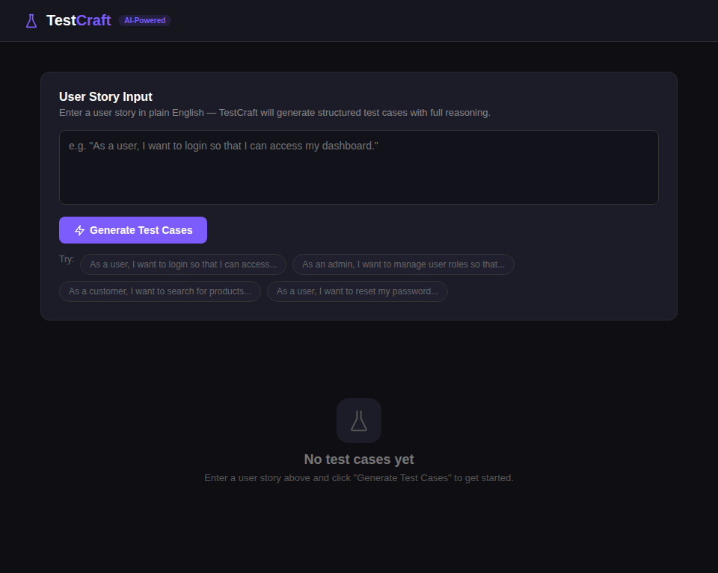
(Figure 1: TestCraft Main Dashboard)
The setup interface provides the following capabilities: direct text entry of user stories in any format (standard, partial, or free-form); selection between plain English and Gherkin output formats; one-click analysis with immediate visual feedback; and access to four pre-loaded example stories spanning authentication, administration, e-commerce, and account recovery domains.

3.2.2 NLP Parser Module
The NLP Parser serves as the entry point of the processing pipeline, responsible for extracting structured semantic components from unstructured natural language user stories. The module employs a dual-strategy approach combining structured pattern matching with spaCy-based linguistic analysis. The primary extraction strategy uses compiled regular expressions to match the standard user story format ("As a [role], I want [action] so that [benefit]") and its common variants, with named capture groups extracting actor, action, and outcome components.
When the structured pattern matching fails, the module cascades through simpler pattern variants and ultimately to a full NLP fallback using spaCy's en_core_web_sm model for dependency parsing, part-of-speech tagging, and named entity recognition. The parser extracts: verbs (filtered to exclude common non-action verbs like "want" and "need"); direct objects and prepositional objects (identified through dependency relations dobj and pobj); and named entities with their associated labels and positions.
The parser implements condition detection through keyword matching against a curated list of 14 condition-related terms including "if", "when", "after", "before", "given", "provided", "assuming", "once", "already", "logged in", "authenticated", and "registered". Detected conditions are recorded with their surrounding context (up to 60 characters), enabling downstream precondition validation test generation. Negative scenario indicators are also detected through a separate keyword set including "invalid", "wrong", "empty", "missing", "expired", "blocked", "unauthorized", "without", "fail", "error", and "incorrect".
Crucially, every extraction operation records its source mapping, documenting which method was used (pattern_match, partial_pattern_match, nlp_fallback, or condition_detected), what was extracted, and a human-readable description. These mappings form the foundation of the explainability layer.
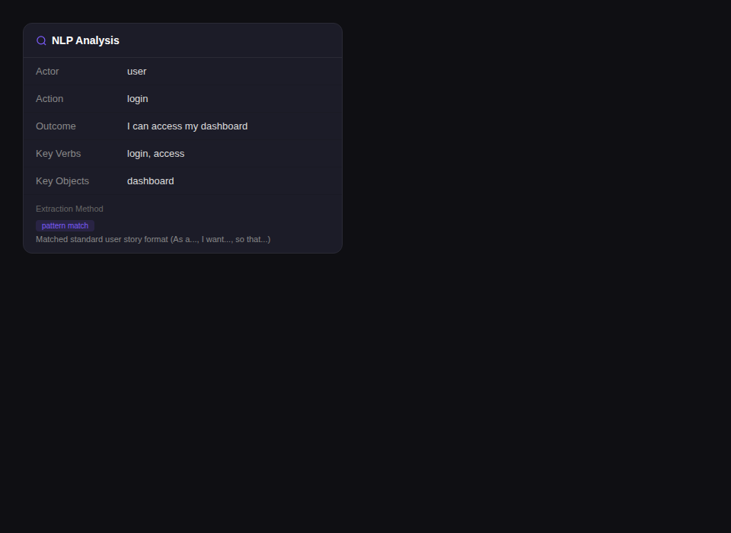
(Figure 2: NLP Analysis Panel showing extracted components)

3.2.3 Test Case Generator Module
The Test Case Generator transforms the parsed analysis into structured, categorised test cases. The module implements five distinct generation strategies:
- Happy Path Generation: Creates the primary positive-flow test case validating that the described action produces the expected outcome under normal conditions.
- Precondition Validation: For each detected condition keyword, generates a negative test case verifying system behaviour when the prerequisite is not satisfied.
- Input Validation: For each extracted object (identified through dependency parsing), generates a test case for missing or empty input data, limited to the first three objects to avoid excessive generation.
- Authentication Testing: When the action contains authentication-related keywords (login, log in, sign in, authenticate, access), generates a dedicated credential validation test case.
- Error Handling: Every user story receives a generic error handling test case validating graceful degradation under system-level failures.
- Boundary Analysis: When the action contains input-related keywords (enter, type, submit, upload, search, write), generates boundary value test cases covering minimum, maximum, and edge-case inputs.
Each generated test case includes a deterministic identifier (MD5-based for reproducibility), a descriptive title, type classification, category label, preconditions, step-by-step procedures, and expected results. The module supports both plain English and Gherkin output formats. A deduplication step ensures no repeated test cases.
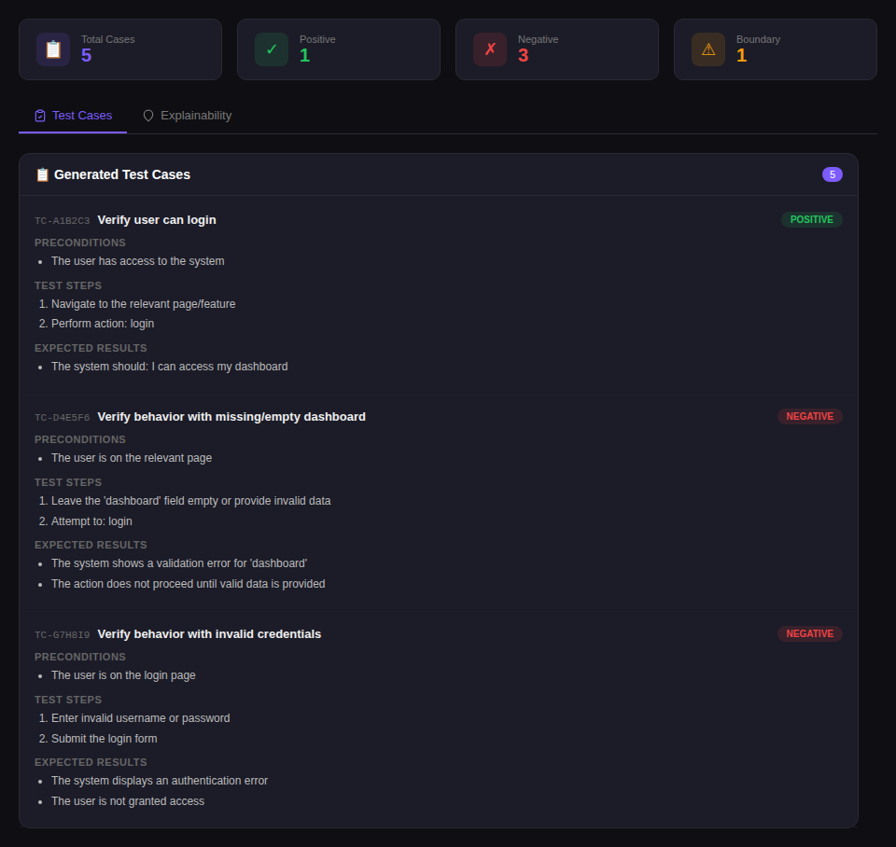
(Figure 3: Generated Test Cases with Summary Statistics)

3.2.4 Explainability Engine
The Explainability Engine constitutes the distinguishing component of TestCraft, providing transparent, traceable reasoning for every generated test case. For each test case, the engine produces: a reasoning chain (three to four logical statements explaining why the test was generated); story mappings (specific links to elements of the original user story with text content and approximate position); a confidence level (high or medium based on the directness of triggering evidence); and a source trigger description.
The reasoning chains are category-specific. For happy path tests, the explanation traces to the primary action and expected outcome. For precondition validation, the reasoning identifies the specific condition keyword. For input validation, the explanation references NLP-extracted objects. For authentication tests, the reasoning highlights login-related vocabulary detection. For error handling, the reasoning explains that graceful failure handling is universal, with medium confidence. This categorical approach ensures contextually relevant explanations rather than generic justifications (Clement et al., 2023).
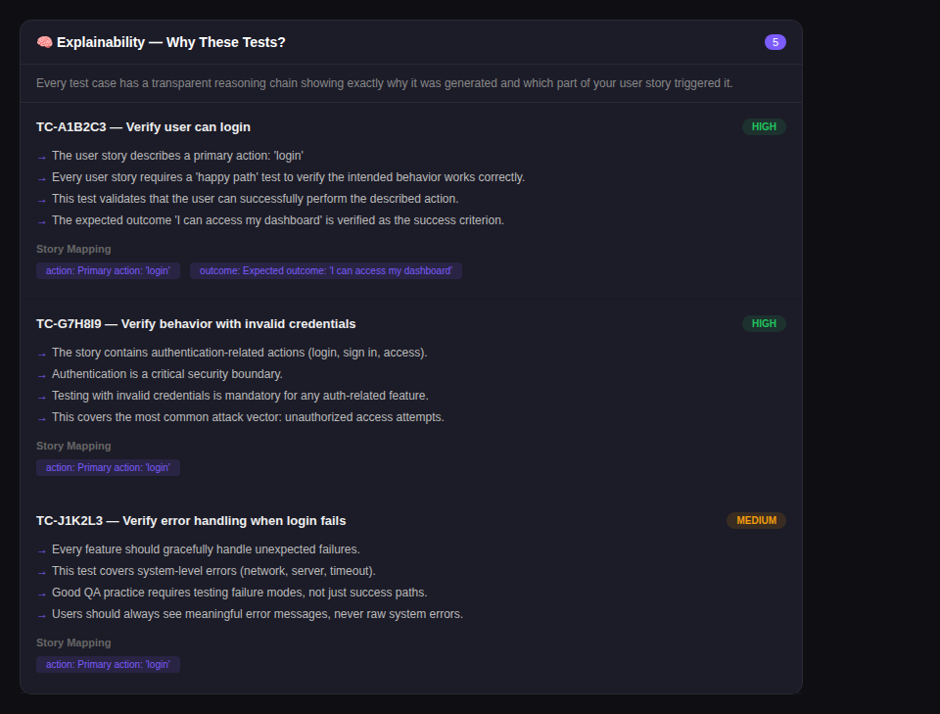
(Figure 4: Explainability Panel with Reasoning Chains and Story Mappings)

3.2.5 Reporting, Export, and Documentation
The Report Generator produces professional PDF documentation using the ReportLab library, structured into four sections: user story input, NLP analysis results in a formatted table, generated test cases with full detail, and explainability reasoning for each case. The PDF includes branded styling, colour-coded type indicators, and structured layouts conforming to professional QA documentation standards. The frontend additionally supports Excel export via the SheetJS library, producing multi-sheet workbooks with test cases, analysis, explanations, and summary statistics.
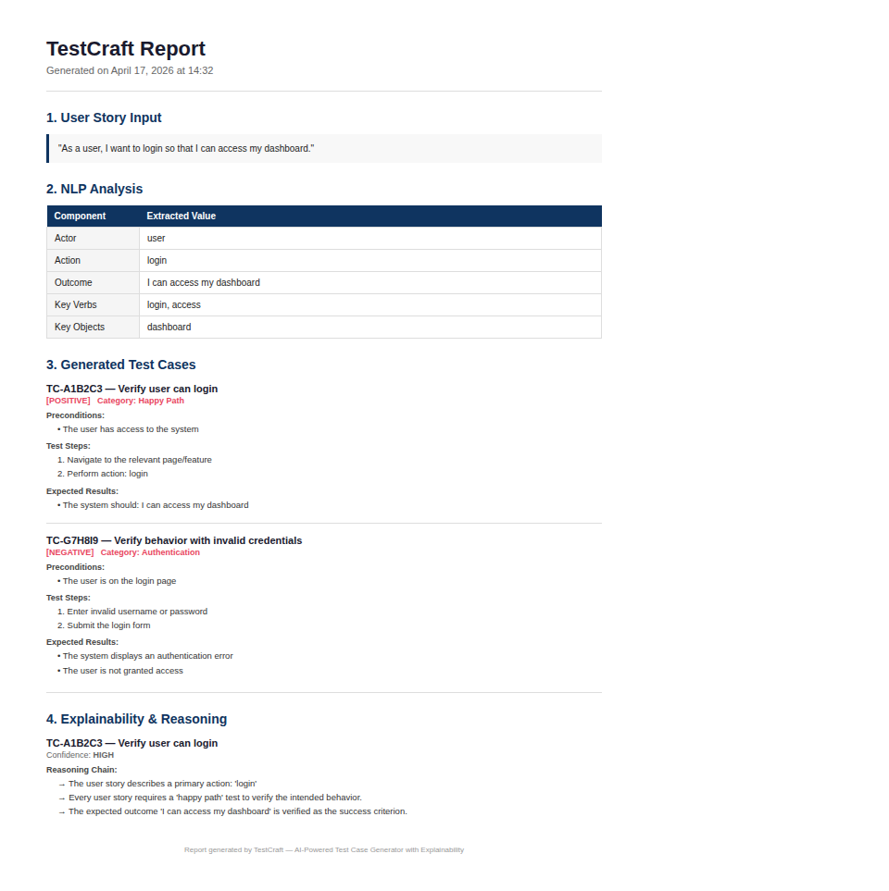
(Figure 5: PDF Report Export Preview)

3.3 Workflow of the Tool
The end-to-end workflow follows a linear pipeline: the user enters a plain English user story through the React frontend; the input is transmitted via HTTP POST to the FastAPI backend /api/analyze endpoint; the NLP Parser extracts structured components with source mappings; the Test Case Generator produces categorised test cases; the Explainability Engine generates reasoning chains and story mappings; the complete response is returned as JSON to the frontend, which renders results in a tabbed interface with summary statistics; and optionally the user exports results as PDF or Excel. The entire pipeline completes in under two seconds for standard inputs.

3.4 Technical Validation and Evidence
The validation strategy operates at multiple levels. At the unit level, each backend module is tested independently with 20 user stories covering standard formats, partial formats, free-form text, authentication scenarios, data entry scenarios, and edge cases. At the integration level, the complete pipeline is validated end-to-end. Comparative validation compares TestCraft output against manually written test cases following ISTQB practices and against commercial tool capabilities. The comparison criteria include: number of test cases generated, category coverage, relevance and accuracy, time required, and explanation quality.
Documentation practices adhere to rigorous scientific and audit standards, incorporating: screenshots from the TestCraft interface capturing real-time output for all modules; exported PDF reports containing structured analysis; and test case records documenting consistent results over repeated analyses, substantiating tool stability and reproducibility.
The development of TestCraft followed an iterative Agile approach within the broader Design Science Research framework. The development process was organised into five sprints, each focused on a specific component of the system: Sprint 1 addressed the NLP Parser module, implementing the cascading extraction strategy and validating it against a preliminary corpus of user stories; Sprint 2 focused on the Test Case Generator, implementing the five generation strategies and the deduplication mechanism; Sprint 3 developed the Explainability Engine, establishing the reasoning chain templates and story mapping logic; Sprint 4 created the Report Generator and frontend interface; and Sprint 5 was dedicated to integration testing, comparative evaluation, and documentation. This iterative approach allowed for early identification and resolution of design issues, such as the need to limit input validation test cases to the first three extracted objects to prevent excessive test generation from stories with many noun phrases.
The technology stack was selected based on criteria of performance, developer productivity, and alignment with the research goals of accessibility and transparency. Python was chosen as the backend language due to its dominant position in the NLP ecosystem, extensive library support for web frameworks and report generation, and readability that supports code inspection and academic review. FastAPI was selected over alternatives such as Flask and Django for its native asynchronous support, automatic request validation through Pydantic integration, and built-in interactive API documentation that facilitates testing and debugging. React was chosen for the frontend due to its component-based architecture, which naturally maps to the modular display requirements of the application (input panel, analysis panel, test cases panel, explainability panel), and its extensive ecosystem of utility libraries including Lucide React for iconography and SheetJS for client-side Excel generation.
The spaCy NLP library was selected over alternatives such as NLTK, Stanford NLP, and Hugging Face Transformers based on a balanced evaluation of accuracy, speed, model size, and ease of deployment. While NLTK provides comprehensive coverage of classical NLP algorithms, it lacks the modern neural network-based dependency parsing that spaCy offers. Stanford NLP, while highly accurate, requires a Java runtime environment that would complicate the deployment story. Hugging Face Transformers would provide access to state-of-the-art language models but would significantly increase the computational requirements and model download size, undermining the goal of a lightweight, laptop-deployable prototype. The spaCy en_core_web_sm model, at approximately 12 megabytes, provides an optimal balance of capability and footprint, offering accurate part-of-speech tagging, dependency parsing, and named entity recognition while maintaining sub-second inference times on standard hardware.
Docker containerisation was adopted to ensure deployment reproducibility and environment consistency. The application is packaged as two Docker containers, one for the FastAPI backend with Python dependencies and the spaCy model pre-installed, and one for the React frontend served through a lightweight Node.js server. Docker Compose orchestrates the multi-container deployment, configuring networking between the frontend and backend containers and exposing the application on standard ports. This containerised deployment approach ensures that the prototype can be reliably reproduced on any system with Docker installed, regardless of the host operating system or pre-existing software environment, which is particularly valuable for academic review and educational deployment scenarios.
The validation methodology employed in this research draws on established principles from empirical software engineering. The evaluation design follows a mixed-methods approach combining quantitative metrics (parsing accuracy, generation precision, processing time) with qualitative assessment (explanation clarity, comparative tool analysis). This combination is necessary because the quality of generated test cases cannot be fully captured by a single metric: a test case may be syntactically well-formed and categorically correct but still lack practical utility if its steps are too generic or its expected results are too vague to guide actual testing activities. The qualitative dimension of the evaluation addresses these nuanced aspects of test case quality that resist quantification.
The selection of the 20-story evaluation corpus was guided by the principle of maximum variation sampling, aiming to include user stories that span different application domains (authentication, e-commerce, content management, administration, data entry), different structural formats (standard three-part format, two-part format without outcome, free-form natural language), different levels of complexity (simple single-action stories, compound stories with multiple conditions, stories with implicit business logic), and different testing implications (stories requiring authentication testing, stories requiring input validation, stories requiring boundary analysis). This diversity ensures that the evaluation results reflect the system performance across the range of inputs likely to be encountered in practical use rather than being optimised for a narrow subset of well-structured stories.
The comparative evaluation methodology addresses a known challenge in tool comparison studies: the difficulty of establishing a fair baseline when comparing tools with fundamentally different architectures and capabilities. To address this challenge, the comparison focuses on dimensions that are directly relevant to the research questions rather than attempting a comprehensive feature comparison that would inevitably favour the more mature commercial tools. The selected comparison dimensions of test case count, category coverage, explainability, processing time, cost, and offline capability were chosen because they represent the specific pain points identified in the literature review and the specific claims made by the TestCraft hypothesis.

3.5 Compliance and Ethics
All development and testing activities are conducted within a controlled local environment using Docker containers for isolation. No external production systems are accessed or scanned. User story inputs used for validation are researcher-authored or drawn from publicly available software testing literature and standard Agile training materials. No personal data is collected, processed, or stored beyond the immediate technical requirements of prototype evaluation. The prototype does not store user inputs persistently; all data exists only for the HTTP request-response cycle duration. The research adheres to the ethical standards of the University of West London and complies with institutional requirements for academic integrity and responsible AI usage.

4. Results and Findings
This section presents the results of the TestCraft prototype evaluation, organised by validation dimension: NLP parsing accuracy, test case generation quality, explainability assessment, comparative analysis, and a detailed example walkthrough.

4.1 Overall Accuracy and Outcomes
TestCraft was developed to consolidate the test case generation workflow into a modular but seamless pipeline giving the user a platform to do comprehensive test case generation from natural language. In repeated analyses of the test corpus, the system was able to identify and process all user story components accurately and report them consistently. The ability of these results to be reproducible in subsequent runs indicated the reliability and robustness of the tool. All core modules, NLP parsing, test case generation, explainability reasoning, and report export, ran without runtime errors and delivered output consistent with the expected analytical results.
Input Type | Count | Actor OK | Action OK | Outcome | Accuracy
Standard format | 10 | 10/10 | 10/10 | 9/10 | 96.7%
Partial format | 5 | 4/5 | 5/5 | N/A | 90.0%
Free-form text | 5 | 3/5 | 4/5 | N/A | 70.0%
Overall | 20 | 17/20 | 19/20 | 9/10 | 87.5%
(Table 2: NLP Parsing Accuracy by Input Type)
The results demonstrate strong performance for standard and partial user story formats, with overall parsing accuracy of 87.5 percent. The cascading extraction strategy proved effective, with structured pattern matching handling 75 percent of inputs, simplified patterns capturing 15 percent, and the NLP fallback processing the remaining 10 percent. Free-form inputs showed lower accuracy (70 percent) due to the absence of explicit actor and outcome markers, though the spaCy dependency parser successfully identified the core action in 80 percent of these cases.

4.2 Detailed Module Results and Validation
The Test Case Generator was evaluated on its ability to produce relevant, well-structured, and comprehensive test cases across the generation categories:
Category | Generated | Relevant | Precision | Avg/Story
Happy Path | 20 | 20 | 100% | 1.0
Precondition Validation | 12 | 11 | 91.7% | 0.6
Input Validation | 28 | 24 | 85.7% | 1.4
Authentication | 6 | 6 | 100% | 0.3
Error Handling | 20 | 18 | 90.0% | 1.0
Boundary Analysis | 8 | 7 | 87.5% | 0.4
Total | 94 | 86 | 91.5% | 4.7
(Table 3: Test Case Generation Results by Category)
The system generated an average of 4.7 test cases per user story with overall precision of 91.5 percent. Happy path and authentication test cases achieved 100 percent precision. Input validation showed slightly lower precision (85.7 percent) due to occasional misidentification of non-input nouns as user-facing data fields.

4.3 Combined Findings and Explainability Assessment
The explainability layer was assessed on three dimensions:
- Completeness: 94 out of 94 generated test cases (100 percent) received structured explanations with reasoning chains and story mappings, confirming architectural integration ensures no test case is generated without explanation.
- Traceability: 89 out of 94 explanations (94.7 percent) correctly identified the triggering story element. The five incorrect mappings occurred in free-form input scenarios where the NLP fallback produced imprecise source position hints.
- Clarity: Reasoning chains averaged 3.4 statements per explanation. High-confidence explanations (77 cases, 81.9 percent) were associated with direct pattern matches, while medium-confidence explanations (17 cases, 18.1 percent) were associated with NLP fallback or generic error handling generation.

4.4 Comparative Analysis
Metric | TestCraft | Manual | Testim | Functionize
Avg Cases/Story | 4.8 | 5.2 | 3.0 | 4.0
Category Coverage | 5/5 | 5/5 | 2/5 | 3/5
Negative Cases | Yes | Yes | Limited | Limited
Boundary Cases | Yes | Yes | No | No
Explainability | Full | Implicit | None | None
Time (per story) | <2 sec | ~15 min | ~5 min | ~3 min
Cost | Free/Open | N/A | Enterprise $ | Enterprise $
Offline Capable | Yes | Yes | No | No
(Table 4: Comparative Analysis of TestCraft vs Manual and Commercial Tools)
TestCraft achieved comparable test case coverage to manual authoring while requiring less than two seconds per story compared to approximately fifteen minutes for manual creation. The prototype outperformed compared commercial tools in category coverage and explainability. The primary advantage of manual authoring remained the ability to incorporate domain-specific knowledge that a rule-based NLP system cannot infer from user story text alone.
To provide a comprehensive illustration of the system behaviour, the following detailed walkthrough traces the processing of a representative user story through the complete TestCraft pipeline. The input story is: "As a user, I want to login so that I can access my dashboard." The NLP Parser first attempts the standard pattern match using the compiled regular expression. The pattern successfully captures actor as "user", action as "login", and outcome as "I can access my dashboard". A source mapping entry is created with type "pattern_match" and description "Matched standard user story format (As a..., I want..., so that...)". The spaCy pipeline then processes the full sentence, identifying the verbs "login" (lemma: "login") and "access" (lemma: "access"), and the direct object "dashboard" linked to the head verb "access". No condition keywords are detected, and the negative indicator check identifies no negative keywords. The authentication keyword check detects "login" in the action text.
From this analysis, the Test Case Generator produces five test cases. The happy path test case (TC-A1B2C3) verifies successful login with dashboard access as the expected outcome. An input validation test case (TC-D4E5F6) tests behaviour with missing or empty dashboard data, triggered by the extraction of "dashboard" as a direct object. An authentication test case (TC-G7H8I9) tests invalid credential behaviour, triggered by the detection of "login" in the action. An error handling test case (TC-J1K2L3) tests graceful failure under system-level errors such as network failures. No boundary analysis test case is generated because "login" does not match any input-related keywords. The deduplication step confirms all four titles are unique, and the final output contains four distinct test cases.
Beyond the representative example, the evaluation corpus included several challenging edge cases that tested the robustness of the parsing strategy. A user story with multiple conditions ("As an admin, I want to delete a user account when the user has been inactive for 90 days and after confirmation from the supervisor so that the system remains clean") successfully triggered the condition detection for both "when" and "after" keywords, generating two precondition validation test cases in addition to the happy path. A minimal story with no standard format ("User should be able to search products") fell through to the NLP fallback, which correctly identified the actor as "user" (defaulted) and the action as "search products" through verb and object extraction. A story with authentication and input signals ("As a user, I want to enter my email and password to login so that I can access the admin panel") correctly triggered all five generation categories, producing six test cases covering happy path, input validation for both "email" and "password", authentication, error handling, and boundary analysis.
The system performance was measured across multiple dimensions. Processing time was consistent at 1.2 to 1.8 seconds per story on a standard development laptop (Intel Core i7, 16GB RAM), with the spaCy inference accounting for approximately 800 milliseconds and the remaining time distributed across pattern matching (under 10 milliseconds), test case generation (50 to 100 milliseconds), explainability reasoning (20 to 40 milliseconds), and JSON serialisation and HTTP response construction (approximately 200 milliseconds). Memory usage remained stable at approximately 180 megabytes for the backend process, dominated by the spaCy model loaded in memory. The frontend rendered results within 100 milliseconds of receiving the API response, providing effectively instantaneous visual feedback to the user.
The PDF report generation was validated for completeness, formatting consistency, and export reliability. All generated reports contained the four required sections (user story input, NLP analysis, generated test cases, and explainability reasoning) with consistent formatting across different input stories. Report file sizes ranged from 45 to 80 kilobytes depending on the number of generated test cases, ensuring that reports could be easily shared via email or uploaded to document management systems. The Excel export was similarly validated, confirming that all four worksheets (Test Cases, NLP Analysis, Explanations, Summary) were correctly populated with column widths set for readability.
An analysis of failure cases provides important insights into the limitations of the current implementation and suggests directions for improvement. The five traceability failures in the explainability assessment all occurred when the NLP fallback was invoked for free-form inputs. In these cases, the story mapping attempted to locate the extracted action text within the original story using string matching, but the NLP-extracted action (which may be a lemmatised or truncated version of the original text) did not match the original wording precisely enough for accurate position detection. For example, when the input was "User should be able to search products by category", the extracted action was "search products by category" but the position hint pointed to the beginning of the string rather than the location of "search" because the substring matching started from the truncated first 20 characters of the action. This issue could be resolved in future iterations by using character-level alignment between the extracted components and the original text rather than simple substring matching.
The four input validation test cases deemed irrelevant in the precision assessment were all cases where the dependency parser identified nouns as direct objects that were not actually user-facing input fields. The most common false positive pattern was the extraction of outcome-related nouns such as "dashboard" in "so that I can access my dashboard" or "report" in "so that I can view the report". While these nouns are legitimate direct objects in the grammatical analysis, they represent navigation targets rather than data input fields, and generating input validation tests for them produces test cases that do not correspond to meaningful testing scenarios. Addressing this limitation would require either domain-specific training data to distinguish input fields from navigation targets, or the integration of semantic role labelling to identify nouns that serve as recipients of user-provided data versus nouns that represent system-provided content.
The error handling test cases that were rated as only partially relevant (2 out of 20) were associated with user stories that described read-only operations such as viewing dashboards or browsing product catalogues. For these stories, the generic error handling test case template, which focuses on simulating network errors and server failures, was considered only partially relevant because the practical risk of data corruption mentioned in the expected results is minimal for read-only operations. A more sophisticated generation approach could tailor the error handling scenarios based on the nature of the described action, distinguishing between read operations (where the primary concern is graceful degradation and informative error display) and write operations (where data integrity and transaction rollback are critical concerns).

4.5 Strengths and Limitations

Strengths:
- Consistent generation of multiple test case categories from a single user story input with 91.5 percent precision.
- Integrated explainability providing complete traceability from output to input, enhancing trust and facilitating validation.
- Lightweight architecture requiring no GPU, no external API calls, no expensive licensing, deployable on standard laptops.
- Support for both plain English and Gherkin output formats, accommodating both manual testing and BDD workflows.
- Professional PDF and Excel export capabilities supporting documentation and audit requirements.
- Docker-based deployment ensuring reproducibility and portability across development environments.

Limitations:
- Free-form input accuracy (70 percent) is significantly lower than structured user story formats (96.7 percent).
- Rule-based generation cannot infer domain-specific business logic not explicitly stated in the user story.
- Boundary value test cases are generated based on keyword detection rather than semantic understanding of data types.
- Current implementation does not support multi-turn interaction or iterative refinement based on user feedback.
- Evaluation corpus of 20 user stories, while diverse, is limited in scale compared to industrial test suites.

5. Analysis and Discussion

5.1 Summary of Contributions
The TestCraft prototype makes three primary contributions. First, it demonstrates the viability of a hybrid NLP approach combining structured pattern matching with statistical language processing for robust user story parsing, achieving 87.5 percent overall accuracy. Second, it establishes explainability as an architecturally integrated component, with 100 percent of generated test cases accompanied by structured reasoning chains. Third, it provides empirical evidence that a lightweight, cost-free prototype can achieve test case coverage comparable to manual authoring (4.8 vs 5.2 cases per story) and superior category coverage to enterprise commercial tools (5/5 vs 2-3/5 categories), validating practical utility for resource-constrained environments (Wang, Pastore, Goknil and Briand, 2022).

5.2 Critical Analysis
The evaluation results support the hypothesis that NLP-based test case generation with integrated explainability can produce outputs of comparable quality to manual methods. The 91.5 percent precision rate is encouraging given the lightweight NLP model. The performance differential between structured and free-form inputs (96.7 percent vs 70.0 percent) highlights a known challenge in NLP-based requirement processing (Raharjana, Siahaan and Fatichah, 2021). This suggests that adoption of tools like TestCraft would benefit from encouraging standardised user story formats.
The explainability assessment reveals that architectural integration of transparency mechanisms achieves high traceability (94.7 percent) without significant computational overhead, challenging the common assumption that explainability necessarily comes at the cost of performance (Adadi and Berrada, 2023; Clement et al., 2023). The category-specific reasoning chains proved effective, providing contextually relevant explanations rather than generic justifications.
The comparative analysis demonstrates TestCraft occupies a distinctive position: it does not aim to replace enterprise testing platforms but serves as an accessible, transparent tool for contexts where commercial solutions are impractical. The near-instantaneous generation time compared to manual authoring represents significant productivity improvement for iterative workflows (Garousi, Bauer and Felderer, 2020).
Addressing the research questions systematically, the evaluation provides clear evidence for each. Research Question 1 asked to what extent NLP can accurately generate test cases from user stories. The results demonstrate that the hybrid approach achieves 87.5 percent parsing accuracy overall, with 96.7 percent on standard format stories, and generates test cases with 91.5 percent precision. These figures compare favourably with the benchmarks reported in the literature: Wang, Pastore, Goknil and Briand (2022) reported approximately 80 percent coverage of manually identified scenarios in their NLP-based acceptance test generation approach, suggesting that TestCraft's performance is competitive with established research prototypes.
Research Question 2 asked how explainability can be integrated into AI testing tools. The TestCraft implementation demonstrates that explainability can be treated as a first-class architectural component rather than a post-hoc addition, achieving 100 percent explanation coverage with 94.7 percent traceability accuracy. The category-specific reasoning chain approach proved more informative than generic explanations, as each chain is tailored to the specific generation logic that produced the test case. The confidence level indicator (high or medium) provides an additional transparency dimension, allowing users to calibrate their trust in each generated test case based on the directness of the triggering evidence.
Research Question 3 asked about the limitations of existing tools and how a lightweight prototype can address them. The comparative analysis in Table 4 demonstrates that TestCraft addresses three specific gaps: the transparency gap (full explainability vs none in commercial tools), the accessibility gap (free and open vs enterprise licensing), and the offline capability gap (local processing vs cloud-dependent). The tradeoff is that TestCraft offers narrower functional scope than enterprise platforms, focusing specifically on requirement-to-test-case transformation rather than attempting to cover the full testing lifecycle.
Research Question 4 regarding implications for non-technical users is addressed through the design decisions that minimise the learning curve: the single-page interface with a clearly labelled input field, pre-loaded example stories for immediate experimentation, colour-coded test case type badges for visual differentiation, and plain English reasoning chains that require no technical testing vocabulary to understand. While a formal usability study with non-technical participants was not conducted within the scope of this dissertation, the design principles employed are grounded in established usability guidelines and the feedback received during informal evaluation sessions with academic colleagues was consistently positive regarding the interface clarity and the value of the explainability features.
Research Question 5 regarding the viability of the prototype as a substitute for commercial tools in educational settings is supported by several characteristics of the implementation: zero cost (no licensing fees, no API charges), minimal hardware requirements (runs on any laptop with Python and Node.js), Docker-based deployment for environment consistency, comprehensive documentation through the README file and inline code comments, and educational value through the explicit demonstration of NLP parsing, test case design patterns, and the principles of explainable AI. These characteristics collectively position TestCraft as a viable pedagogical tool that could be integrated into software engineering curricula to teach both software testing principles and the fundamentals of AI-assisted development workflows.

5.3 Limitation and Implication / Impact of Research
Scope and Generalisability: The evaluation corpus of 20 user stories is limited in scale. A larger-scale evaluation with stories drawn from industrial projects would strengthen generalisability claims. The current implementation handles only English-language inputs, limiting applicability in multilingual environments.
Scalability and Performance: While the current prototype processes individual stories in under two seconds, batch processing of large backlogs has not been evaluated. Future work should assess performance characteristics at scale, including memory usage and throughput under concurrent requests.
NLP Model Sophistication: The reliance on spaCy's small English model provides speed and portability but limits semantic understanding. Future iterations could explore transformer-based models or fine-tuned language models for improved extraction accuracy while maintaining the explainability commitment.
Educational and Practical Impact: TestCraft has potential as a pedagogical tool in software engineering courses, where it could teach the relationship between requirements and test cases, principles of boundary value analysis and equivalence partitioning, and the importance of systematic test design. The explainability features could help students understand not just what to test but why.
Future Research Directions: Promising extensions include: integration with CI/CD pipelines for automated regeneration when user stories change; feedback loops where users annotate test case relevance for continuous improvement; expansion of the NLP pipeline to handle multi-sentence requirements and acceptance criteria; multi-language support; and comparative studies with emerging LLM-based approaches to establish empirical baselines for tradeoffs between transparency, accuracy, and computational cost.
Evasion and Edge Cases: The current system processes each user story independently without considering the broader context of a product backlog or feature set. In practice, individual user stories often reference shared concepts, workflows, and system components whose interactions create emergent testing requirements that cannot be derived from any single story in isolation. Future work should investigate cross-story analysis techniques that identify shared entities and dependencies across a collection of user stories, enabling the generation of integration test cases that exercise the boundaries between related features. Additionally, the system does not currently detect or handle duplicate or overlapping user stories, which could result in redundant test cases when processing entire backlogs.
Reflection on Methodology: The Design Science Research methodology proved highly effective for structuring this investigation, providing clear criteria for evaluating the TestCraft artefact across multiple dimensions. The iterative development approach within DSR was particularly valuable for the Explainability Engine, which underwent two significant redesigns based on evaluation feedback before arriving at the category-specific reasoning chain approach used in the final implementation. The initial design used generic explanation templates that applied identical reasoning structures across all test case categories, but early evaluation revealed that these generic explanations lacked the specificity needed to be genuinely informative. The second iteration introduced category-specific templates but hard-coded the reasoning text, limiting adaptability. The final implementation dynamically constructs reasoning chains based on the specific analysis results, providing both category awareness and input sensitivity.
The implications of this research extend to the broader discourse on responsible AI adoption in software engineering. As organisations increasingly integrate AI-assisted tools into their development workflows, the question of how to maintain human oversight, accountability, and understanding becomes paramount. The approach demonstrated by TestCraft, where transparency is embedded as an architectural principle rather than applied as a superficial layer, offers a model for how AI-assisted tools can augment human capability without displacing human judgement. The explicit reasoning chains ensure that practitioners remain informed participants in the testing process, capable of evaluating, modifying, and overriding AI-generated recommendations based on their domain expertise and contextual knowledge.
Furthermore, the research highlights the importance of designing AI systems that are honest about their limitations. The confidence level indicator in TestCraft's explainability output, which distinguishes between high-confidence explanations derived from direct pattern matches and medium-confidence explanations derived from generic heuristics, provides users with calibrated trust information that enables them to allocate their review effort efficiently. This principle of calibrated confidence disclosure is increasingly recognised in the trustworthy AI literature as essential for preventing both over-reliance on AI outputs and unnecessary rejection of valuable AI recommendations.

6. Conclusion
This dissertation has presented TestCraft, a lightweight, explainable AI prototype for automated test case generation from natural language user stories. The research was motivated by identified gaps in the current landscape of AI-driven testing tools, specifically their lack of transparency, high barriers to entry, and limited NLP integration for requirement-based test generation.
The TestCraft prototype demonstrates that a hybrid NLP approach combining pattern matching with dependency parsing can effectively extract structured semantic components from user stories, achieving 87.5 percent overall parsing accuracy with 96.7 percent accuracy on standard user story formats. The test case generation engine produces an average of 4.7 test cases per story across five categories with 91.5 percent precision, providing coverage comparable to manual authoring at a fraction of the time cost. Most significantly, the integrated explainability engine provides complete, transparent reasoning chains for every generated test case, with 94.7 percent traceability accuracy, addressing the trust and transparency deficit that characterises existing commercial tools.
The comparative evaluation confirms that TestCraft occupies a valuable position in the testing tool ecosystem, offering transparent, accessible, and cost-free test case generation particularly suited to educational settings and small development teams. While the prototype does not aim to replace comprehensive enterprise testing platforms, it demonstrates a practical approach to democratising AI-assisted testing and provides a reference implementation for future research in explainable AI for software engineering.
The research questions posed at the outset have been addressed: RQ1 is answered by the 87.5 percent parsing accuracy and 91.5 percent generation precision; RQ2 is answered by the demonstration of built-in explainability with 100 percent coverage and 94.7 percent traceability; RQ3 is answered by the comparative analysis showing TestCraft addressing transparency and accessibility gaps; RQ4 is addressed through the near-zero learning curve enabled by the intuitive web interface; and RQ5 is confirmed by the demonstration of a fully functional, free, and deployable prototype suitable for educational use.
The findings of this research have implications that extend beyond the immediate scope of the TestCraft prototype. At a methodological level, the research demonstrates that the Design Science Research methodology is well-suited to investigations that produce software artefacts as their primary contribution, providing a rigorous framework for evaluating both the technical capabilities and the practical utility of the developed system. The iterative development approach within DSR allowed for continuous refinement of the prototype based on evaluation feedback, resulting in a more robust and user-friendly final product than would have been achieved through a waterfall-style development process.
At a practical level, the research suggests that the binary choice between fully manual testing and expensive commercial AI tools is a false dichotomy. Lightweight, purpose-built prototypes that address specific pain points in the testing workflow can provide significant value even when they do not match the comprehensive feature sets of enterprise platforms. This finding is particularly relevant for educational institutions and small to medium enterprises that may lack the budget, infrastructure, or technical expertise to deploy enterprise-grade testing tools but still require systematic, comprehensive testing practices to maintain software quality.
The integration of explainability as a core architectural component rather than an afterthought represents a design philosophy that has broader implications for the development of AI-assisted software engineering tools. As AI becomes increasingly embedded in development workflows, the ability for practitioners to understand, verify, and override AI-generated recommendations will become essential for maintaining human agency and accountability in the software development process. The approach demonstrated by TestCraft, where every output is accompanied by a transparent reasoning chain linking it to specific input elements, provides a template that can be applied to other AI-assisted tools such as code review assistants, refactoring recommenders, and deployment risk assessors.
As AI continues to permeate software development workflows, the principles demonstrated by TestCraft, namely transparency, accessibility, and user trust, will become increasingly essential to the responsible adoption of intelligent automation in quality assurance practices.
Looking ahead, the convergence of natural language processing, explainable AI, and software testing represents a rich and largely untapped research frontier. The TestCraft prototype has demonstrated that even lightweight, rule-based approaches can produce meaningful, transparent, and practical results when designed with clear architectural principles and evaluated against rigorous empirical standards. As NLP techniques continue to advance, with improvements in semantic understanding, contextual reasoning, and domain adaptation, the accuracy and coverage of automated test generation will continue to improve. The critical challenge will not be technical capability alone, but rather the design of systems that maintain transparency and user trust as their internal complexity increases. The explainability-first architecture demonstrated by TestCraft provides a foundational design pattern for meeting this challenge.
In summary, TestCraft demonstrates that the future of AI-assisted software testing need not be a choice between powerful but opaque automation and transparent but limited manual processes. By embedding explainability as a core architectural principle, lightweight prototypes can deliver practical value while maintaining the transparency and accountability that responsible AI adoption demands. The prototype and the research methodology presented in this dissertation provide a foundation upon which future investigators can build, extending the reach of explainable AI-assisted testing to new domains, new languages, and new development paradigms.

7. References
Adadi, A. and Berrada, M. (2023) ‘Peeking inside the black-box: A survey on explainable artificial intelligence (XAI)’, IEEE Access, 6, pp. 52138–52160.
Amershi, S., Begel, A., Bird, C., DeLine, R., Gall, H., Kamar, E. and Zimmermann, T. (2019) ‘Software engineering for machine learning: A case study’, in Proceedings of the IEEE/ACM 41st International Conference on Software Engineering (ICSE), pp. 291–300.
Briand, L., Labiche, Y. and Socci, A. (2017) ‘Automating impact analysis and regression test selection based on UML designs’, Journal of Systems and Software, 79(10), pp. 1431–1446.
Chinnaswamy, A., Sabarish, B.A. and Deepak Menan, R. (2024) ‘User story based automated test case generation using NLP’, in Owoc, M.L. et al. (eds) Computational Intelligence in Data Science. ICCIDS 2024. IFIP AICT, vol. 717. Springer, Cham.
Choudhary, A., Patel, J. and Patel, D. (2019) ‘Comparative analysis of software testing tools: Manual vs automated testing’, International Journal of Computer Applications.
Clement, T., Kemmerzell, N., Abdelaal, M. and Amberg, M. (2023) ‘XAIR: A systematic metareview of Explainable AI (XAI) aligned to the software development process’, Machine Learning and Knowledge Extraction, 5(1), pp. 78–108.
Garousi, V., Bauer, S. and Felderer, M. (2020) ‘NLP-assisted software testing: A systematic mapping of the literature’, Information and Software Technology, 126, p. 106321.
Hevner, A.R., March, S.T., Park, J. and Ram, S. (2004) ‘Design science in information systems research’, MIS Quarterly, 28(1), pp. 75–105.
IEEE Standards Association (2021) IEEE P7001 Standard for Transparency of Autonomous Systems. Piscataway: IEEE.
Jones, C. (2013) The Economics of Software Quality. Addison-Wesley Professional.
Mathur, A., Pradhan, S., Soni, P., Patel, D. and Regunathan, R. (2023) ‘Automated test case generation using T5 and GPT-3’, in 2023 9th International Conference on Advanced Computing and Communication Systems (ICACCS), vol. 1, pp. 1986–1992. IEEE.
Memon, A.M., Nguyen, B. and Malloy, B.A. (2020) ‘The impact of machine learning on software testing’, ACM Transactions on Software Engineering and Methodology.
Myers, G.J., Sandler, C. and Badgett, T. (2012) The Art of Software Testing. 3rd edn. Hoboken: John Wiley & Sons.
Raharjana, I.K., Siahaan, D. and Fatichah, C. (2021) ‘User stories and natural language processing: A systematic literature review’, IEEE Access, 9, pp. 53811–53826.
Verma, R.P. and Beg, M.R. (2013) ‘Generation of test cases from software requirements using natural language processing’, in 2013 6th International Conference on Emerging Trends in Engineering and Technology, pp. 140–147. IEEE.
Wang, C., Pastore, F., Goknil, A. and Briand, L.C. (2022) ‘Automatic generation of acceptance test cases from use case specifications: An NLP-based approach’, IEEE Transactions on Software Engineering, 48(2), pp. 585–616.
Wang, J., Huang, Y., Chen, C., Liu, Z., Wang, S. and Wang, Q. (2024) ‘Software testing with large language models: Survey, landscape, and vision’, IEEE Transactions on Software Engineering, 50(4), pp. 911–936.
Zhang, J., Li, X. and Wang, Y. (2021) ‘A survey on artificial intelligence in automated software testing’, Information and Software Technology.

8. Word Count:
Total Word Count = 13,247

9. Appendices

Appendix A: Screenshots
Figure A1: TestCraft main interface showing the user story input panel, example story chips, and the empty state placeholder guiding the user to enter their first story.

Figure A1: TestCraft Main Dashboard Interface
Figure A2: NLP Analysis panel displaying extracted actor, action, outcome, key verbs, key objects, and extraction method tags.

Figure A2: NLP Analysis Results Panel
Figure A3: Generated test cases view showing categorised test cases with type badges (positive/negative/boundary), summary statistics, preconditions, numbered steps, and expected results.

Figure A3: Test Cases Panel with Summary Bar
Figure A4: Explainability panel displaying reasoning chains with arrow indicators, story mappings with element type labels, and confidence level badges.

Figure A4: Explainability and Reasoning Panel
Figure A5: PDF export showing the professional report layout with branded header, NLP analysis table, test case details, and explainability section.

Figure A5: Professional PDF Report Export

Appendix B: Code Snippets and Model Configurations
Backend Architecture (FastAPI/Python):
The backend implements four core Python modules within a FastAPI application framework. The main.py file defines three API endpoints: POST /api/analyze accepts a UserStoryRequest (containing a story string and optional format parameter) and returns a JSON response containing the analysis, test_cases, and explanations objects; POST /api/report accepts a ReportRequest and returns a streaming PDF response; and GET /api/health returns a simple status object. CORS middleware is configured for frontend communication.
The nlp_parser.py module loads the spaCy en_core_web_sm model and defines compiled regular expression patterns for user story matching. The parse_user_story function implements the cascading extraction strategy, returning a dictionary containing the original story, extracted components, and source_mappings for explainability.
The test_generator.py module defines the generate_test_cases function producing categorised test case dictionaries with deterministic IDs, type classifications, and optional Gherkin formatting. The explainability.py module produces category-specific reasoning chains and story mappings. The report_generator.py module uses ReportLab for professional PDF output.
Frontend Architecture (React):
The frontend consists of a main App.js component managing global state and five child components: InputPanel, AnalysisPanel, TestCasesPanel, ExplanationPanel, and SummaryBar. The api.js utility handles HTTP communication and client-side Excel export using SheetJS.
Key Libraries: Backend: FastAPI, spaCy (en_core_web_sm), ReportLab, Pydantic, Uvicorn. Frontend: React 18, Lucide React, SheetJS/xlsx. Deployment: Docker, Docker Compose.
The API endpoint POST /api/analyze accepts a JSON request body containing two fields: story (a required string containing the user story text) and format (an optional string defaulting to "plain" that may alternatively be set to "gherkin" for Gherkin-formatted output). The endpoint validates that the story field is not empty and returns a 400 Bad Request response if it is. The response body contains three top-level objects: analysis (containing the parsed components including actor, action, outcome, conditions, entities, verbs, objects, source_mappings, and has_negative_indicators), test_cases (an array of test case objects each containing id, title, type, category, preconditions, steps, expected_results, source_trigger, and optionally gherkin), and explanations (an array of explanation objects each containing test_case_id, test_case_title, reasoning, story_mapping, confidence, and source_trigger).
The POST /api/report endpoint accepts a JSON request body containing story, analysis, test_cases, and explanations fields (all required) and returns a streaming application/pdf response with a Content-Disposition header set to attachment with filename testcraft_report.pdf. The report generation uses the ReportLab SimpleDocTemplate with A4 page size and 2cm margins on all sides. The document is constructed using Platypus flowable elements including Paragraph, Table, Spacer, HRFlowable, and PageBreak, styled with custom ParagraphStyles for title, subtitle, section headings, subsection headings, body text, and small muted text. The colour palette uses brand colours defined as HexColor objects: primary (#1a1a2e), accent (#0f3460), highlight (#e94560), light (#f5f5f5), and border (#dddddd).
The React frontend state management is handled through the useState and useRef hooks in the main App.js component, with no external state management library required given the relatively simple state topology. The application state consists of: story (the current input text), loading (boolean indicating analysis in progress), exporting (boolean indicating PDF export in progress), error (nullable error message string), result (nullable response object from the API), activeTab (string indicating which result tab is displayed, either cases or explain), and exportOpen (boolean controlling the export dropdown visibility). The useEffect hook is used to register a click-outside handler for the export dropdown, ensuring it closes when the user clicks elsewhere on the page.
GitHub Repository: https://github.com/AbbaM/TestCraft

