# BACKGROUND

This chapter provides background information about OWL technology ,

OWL API, traditional retrieving information method,

To be written…..

## OWL:

The definition of OWL according to [1], it is a semantic web language that represents knowledge about the world, group of things, and the relations between them. It has the ability to represent explicit and implicit things. So, what is knowledge representation (KR)? [2] Describe it in five roles that played by it. These roles are: KR as surrogates, KR as a set of ontological commitments, KR as a fragmentary theory of intelligent reasoning, KR as a medium for efficient computation, and KR a medium of human expression. All that can be described by one sentence: it is a representation of the world and our knowledge of it and is it accessible to programs and can be user.

[1, 3] State that the intention behind creating OWL is to be used not only by human but also by applications. OWL can be access from machines because it is based on computational logic so that the machine using some software can reason over them. The information on the web is scattered as described by OWL working group. This information could mean something for humans but not for machines. So, the semantic web gives explicit meaning for this information. As a result, integrating and processing the information would be easier for machines.

According to [1, 4], there are two versions of OWL: OWL and OWL 2. OWL is a W3C recommendation since 2004, and then OWL 2 was published in 2009, followed with a second edition in 2012. OWL 2 is just an extension and revision of the original OWL publish in 2004. OWL has several defined syntaxes including Functional Syntax, RDF/XML, OWL/XML and the Manchester OWL Syntax. In 2012, OWL 2 has been introduced by OWL working group [5]. It is not different than OWL, it could be seen as an extension of OWL with some additional features. OWL 2 have several syntaxes and semantics, usually a developer needs only one syntax and one semantic. Figure 1 shows the structure of OWL 2.

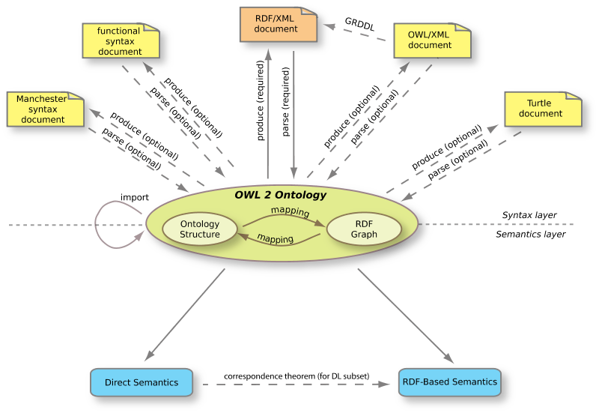

**Figure 1: The structure of OWL 2 [5]**

OWL files or documents are called ontologies, as described in [1]. The purpose of these ontologies is to make it easier of machine to access information in the web and preform reasoning on them. These ontologies can be put into the web or into a local computer depending on the need. One of the advantages of ontologies in the web is that they can be referenced from or reference to other ontologies. Ontologies can be placed in a local computer to be used locally.

Ontology as described by [6] is “a formal explicit description of concepts in a domain of discourse (**classes** (sometimes called **concepts**)), properties of each concept describing various features and attributes of the concept (**slots** (sometimes called **roles** or **properties**)), and restrictions on slots (**facets** (sometimes called **role restrictions**)). An ontology together with a set of individual **instances** of classes constitutes a **knowledge base**. In reality, there is a fine line where the ontology ends and the knowledge base begins.”

## OWL API:

In Wikipedia [7], Application Programming Interface (API) is described as a set of protocols that make sure the software components interact with each other in the right way, and it could take many forms in different areas. It is used in the web as a set of Hypertext Transfer Protocol (HTTP). Also, it has heavy use as libraries of programming language. API is used in different forms such as libraries of programming languages. For example, Java APIs. In object-oriented languages like java, the API is a set of classes and methods to be accessed and used. Basic examples would be like using the inputting and outputting classes e.g. (BufferedReader and BufferedWriter classes in java). Since this project will be built using java-programming language, the API used is a java API which is called OWL API. OWL API is a set of classes and methods that facilitate the access to Web Ontology Language (OWL) ontologies. It creates objects that represent ontologies objects and manages the interactivity between them and any other program.

OWL API is described in [4] as an Application Programming Interface for the purpose of specifying how to interact with OWL Ontologies. OWL ontologies can be created, manipulated, and reasoned over using OWL API. It has been available since almost the same time of OWL. OWL API went through several revisions following the development of OWL. OWL API has the ability to parse and serialize OWL ontologies to different syntaxes such as Functional Syntax, RDF/XML, OWL/XML and the Manchester OWL Syntax.

OWL API takes out the burden of parsing and serializing OWL ontologies from the developer back, since it has been taken care of in the implementation of it [4]. It has been implanted using java. OWL API comes also with some capabilities such as loading and saving ontologies.

OWL ontologies being accessed using OWL API only through OntologyManager interface [4]. OntologyManager interface manage all changes in ontology as seen in Figure 2 below shows UML diagram of how ontologies would be managed using OWL API.

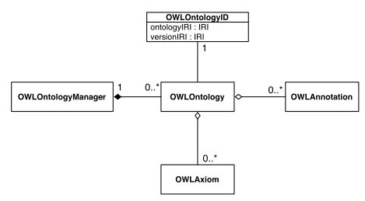

Figure : UML diagram showing the management of ontologies using OWL API [4]

Inference is applied on the OWL ontologies using OWLReasoner interface [4]. This interface provides some useful check like consistency, checking computation of class and axiom entailments. Since the reasoning functionality is separate, developers either can use the available or can provide their own implementation. There are some already exist implementations of reasoners such as FaCT++, HermiT, and Pellet.

As for query using OWL API, it does not offer much as a query mechanism [4]. Since, it provides some sort of basic querying which is based on entailment checking functionality.

1. Group, W.C.O.W. *Web Ontology Language (OWL)*. 2012 [cited 2014 April 19, 2014]; Available from: <http://www.w3.org/2001/sw/wiki/OWL>.

2. Davis, R., H. Shrobe, and P. Szolovits, *What is a Knowledge Representation?*, in *AI Magazine*. 1993. p. 17-33.

3. Group, O.W. *OWL Web Ontology Language Overview*. 2004 [cited 2014 May 13, 2014]; Available from: <http://www.w3.org/TR/owl-features>.

4. M, H. and B. S, *The OWL API: A Java API for OWL ontologies.* Semantic Web, 2011. **2**(Number 1 / 2011): p. 11-21.

5. Group, O.W. *OWL 2 Web Ontology Language Document Overview*. 2012 [cited 2014 May 13, 2014]; Available from: <http://www.w3.org/TR/owl2-overview/>.

6. Noy, N.F. and D.L. McGuinness, *Ontology development 101: A guide to creating your first ontology*. 2001, Stanford knowledge systems laboratory technical report KSL-01-05 and Stanford medical informatics technical report SMI-2001-0880.

7. Wikipedia. *Application programming interface*. [cited 2014 April 21, 2014]; Available from: <http://en.wikipedia.org/wiki/Application_programming_interface>.