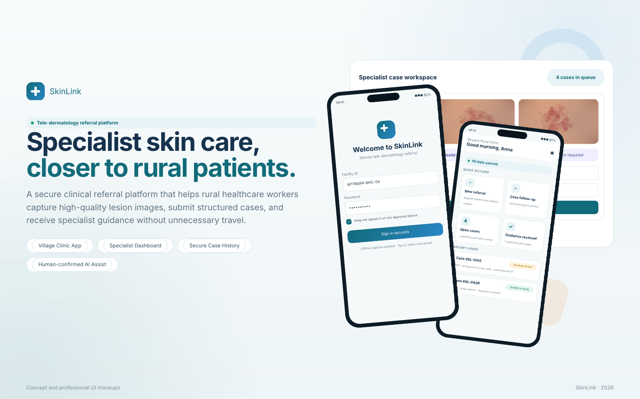

EXECUTIVE CONCEPT
1. Platform concept and clinical purpose
SkinLink is designed as a Tele-Dermatology Referral Platform that connects rural health facilities with dermatology specialists. It enables healthcare workers to register a patient, capture clinical-quality skin lesion images, submit structured clinical information, and receive specialist diagnostic guidance and treatment recommendations.
Primary purpose
Bring specialist-supported dermatology care closer to rural patients while improving referral quality, response time and continuity of care.

2. Core problem the system addresses
Rural patients often experience delayed or avoidable referral because dermatology expertise is concentrated in larger hospitals. The platform is intended to reduce four recurring barriers:
Limited specialist access  Few dermatologists are available at district level, leaving rural providers with limited specialist support. | Long travel distances  Patients may travel far to referral hospitals even when a case could be managed locally with specialist guidance.
Delayed diagnosis  Referral delays can prolong symptoms and postpone appropriate treatment or escalation. | Risk of misdiagnosis  Non-specialists may lack dermatology-specific experience, especially where image and history documentation are incomplete.

Design response
A structured digital referral pathway combines consent, images, clinical notes, triage, specialist review, treatment guidance and follow-up in one traceable case history.

CLINICAL WORKFLOW
3. End-to-end referral journey
The proposed workflow begins at the village clinic and continues through specialist review, guidance and outcome follow-up. Each stage produces a documented case event so that responsibility and clinical reasoning remain clear.
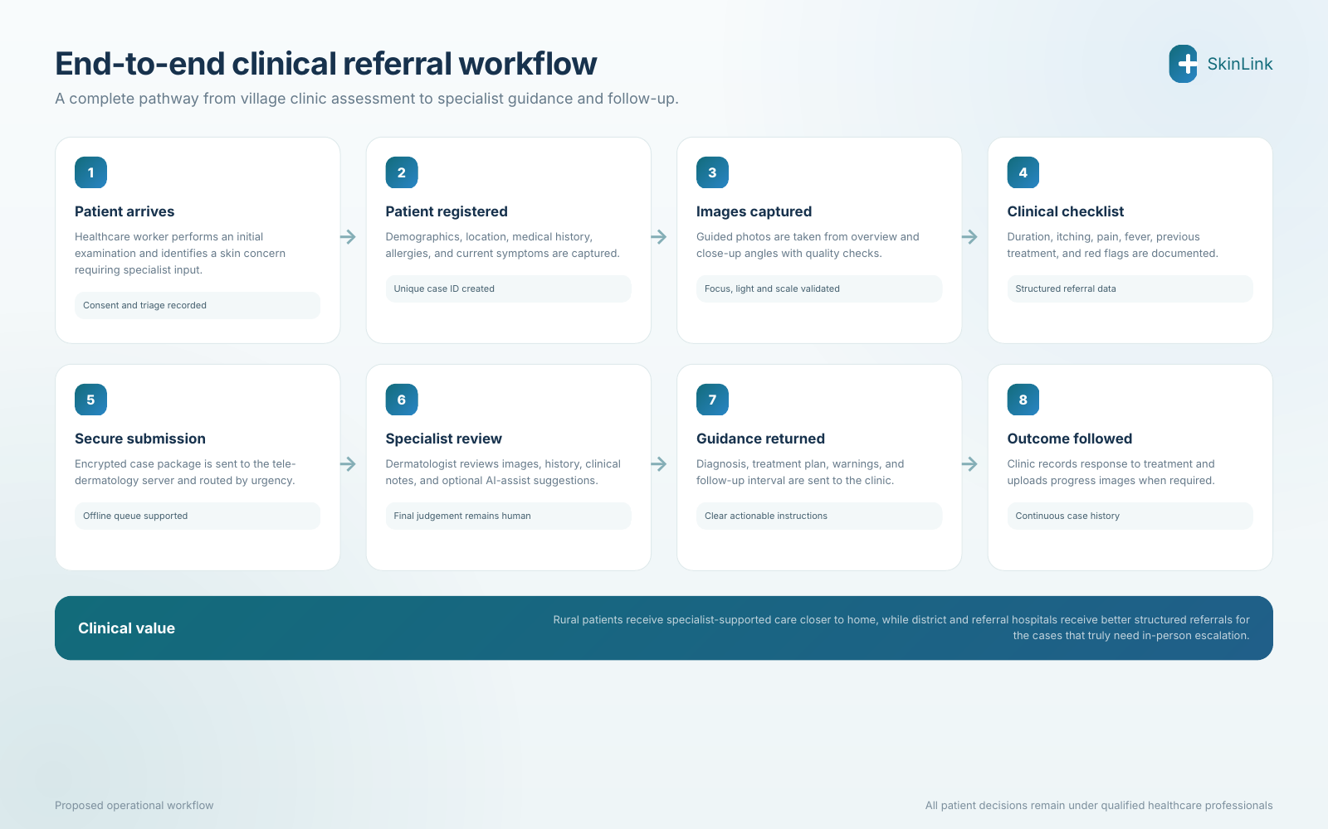
Figure 1. Proposed end-to-end clinical referral workflow.
- Urgent clinical red flags should trigger immediate escalation rather than waiting for routine remote review.
- Offline drafts and resilient synchronisation support facilities with unstable connectivity.
- The same case record should preserve the original images, specialist response, treatment and follow-up outcome.

VILLAGE CLINIC APP
4. Access, dashboard and patient registration
The mobile experience is intentionally simple: healthcare workers can sign in securely, see synchronisation status, start a referral, and review existing cases without navigating complex menus.
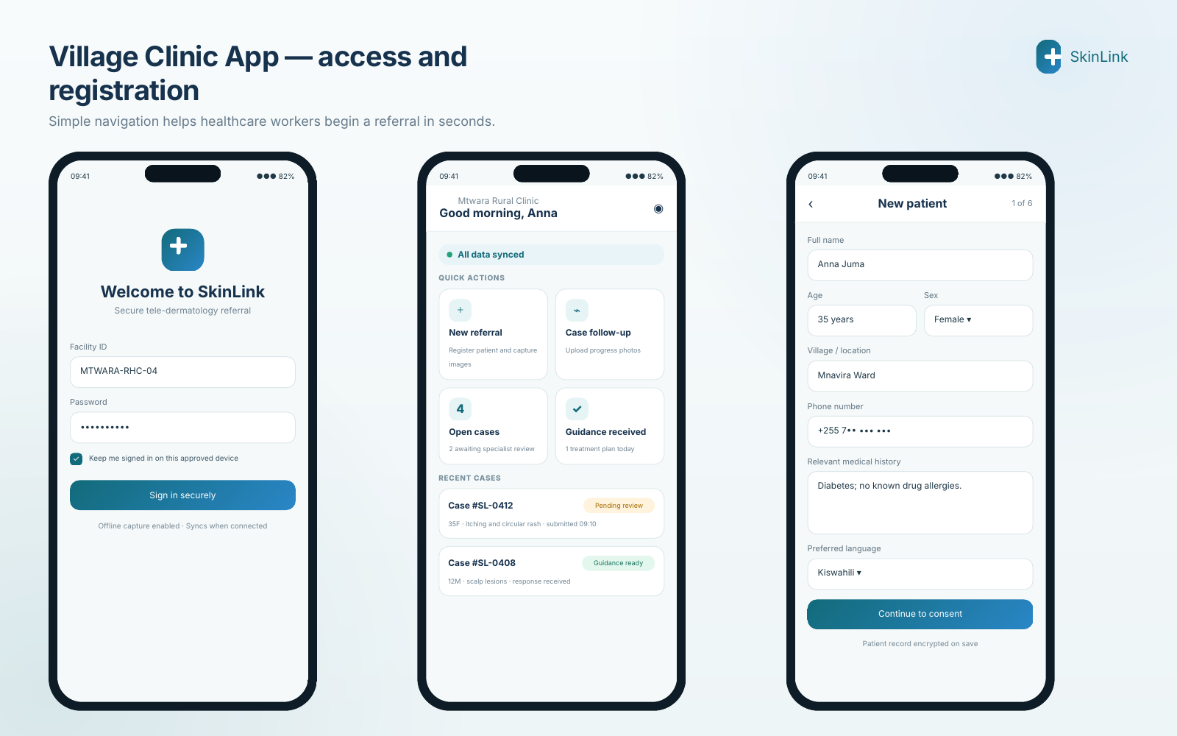
Figure 2. Secure access, clinical home dashboard and patient registration.
Approved-device access  Facility credentials, secure sign-in and optional offline use on approved devices. | Action-led dashboard  New referral, follow-up, open cases and guidance-ready cases are visible immediately.
Structured patient record  Demographics, location, contact, medical history, allergies and preferred language. | Data-quality prompts  Required fields and clear validation reduce incomplete referrals before image capture begins.

VILLAGE CLINIC APP
5. Consent and guided clinical image capture
Image quality and patient consent are central to safe tele-dermatology. The app guides staff through permission, photography and quality review before clinical assessment.
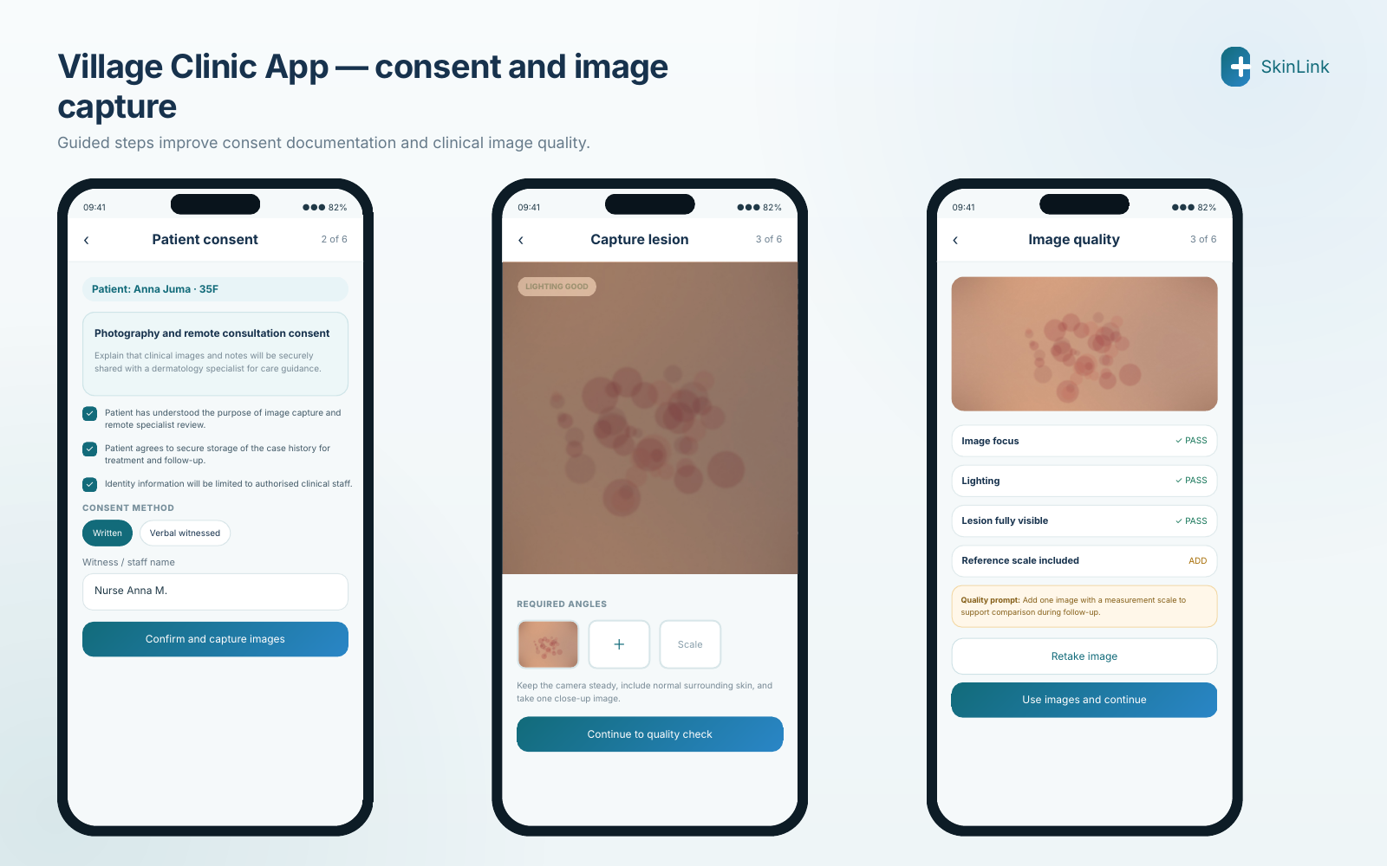
Figure 3. Consent documentation, guided lesion photography and image-quality checks.
- Consent wording explains photography, remote review, secure storage and authorised access.
- Capture guidance supports overview, close-up and scale-reference images.
- Automatic prompts check focus, lighting, lesion visibility and required angles before submission.
Clinical photography standard
Workers should be trained to include surrounding normal skin, avoid identifiable body features where unnecessary, and repeat images when focus or lighting is inadequate.

VILLAGE CLINIC APP
6. Clinical assessment, case review and submission
A structured assessment reduces ambiguity for the specialist. The worker records symptoms, duration, body site, previous treatment, associated conditions and red flags, then reviews the complete referral before secure submission.
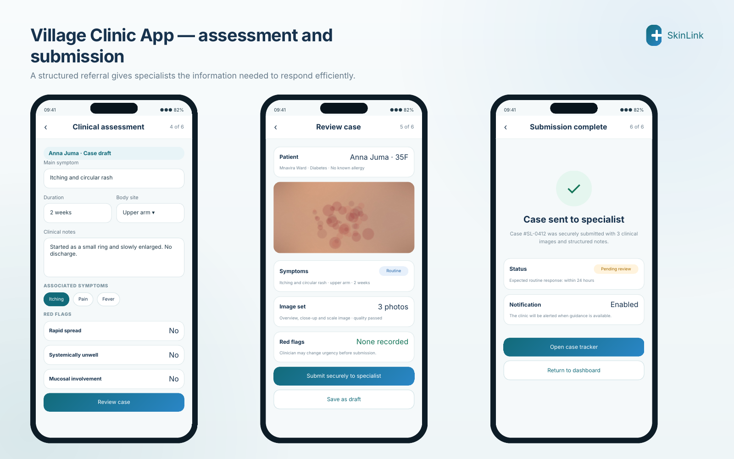
Figure 4. Clinical checklist, case summary and secure submission confirmation.
Structured clinical checklist  Symptoms, duration, site, severity indicators and previous treatment are recorded consistently. | Urgency classification  Routine or urgent status is based on clinical information and can be adjusted before submission.
Pre-submission review  The worker confirms patient details, image count, quality results and red-flag status. | Traceable confirmation  A unique case number, submission time, status and expected response window are displayed.

VILLAGE CLINIC APP
7. Case tracking, specialist guidance and follow-up
The clinic should always know what is happening to a referral. Status milestones show whether the case is synchronised, assigned, under review or complete, while the guidance screen converts the specialist response into clear clinical actions.
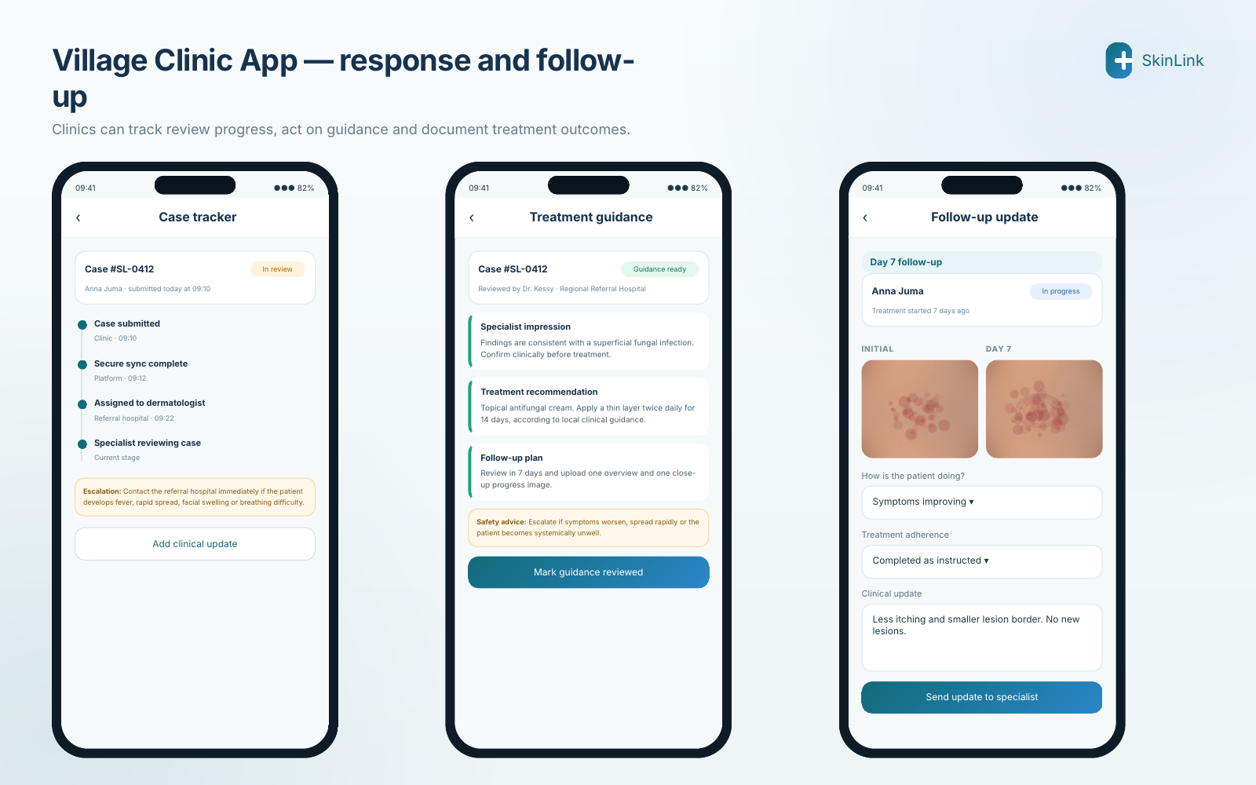
Figure 5. Case status, treatment guidance and 7-day follow-up workflow.
- Guidance includes specialist impression, treatment plan, safety-net advice and follow-up interval.
- Follow-up compares progress images and records adherence, symptom change and new concerns.
- Cases can be reopened or escalated when the patient worsens or fails to improve.
Illustrative clinical content
Treatment wording shown in the mockups is only an interface example. Live guidance must follow approved local clinical protocols and the responsible specialist’s judgement.

SPECIALIST EXPERIENCE
8. Specialist case queue and review dashboard
Dermatologists require a high-density but calm workspace that prioritises urgent cases, presents image and history evidence together, and supports rapid completion without losing clinical context.
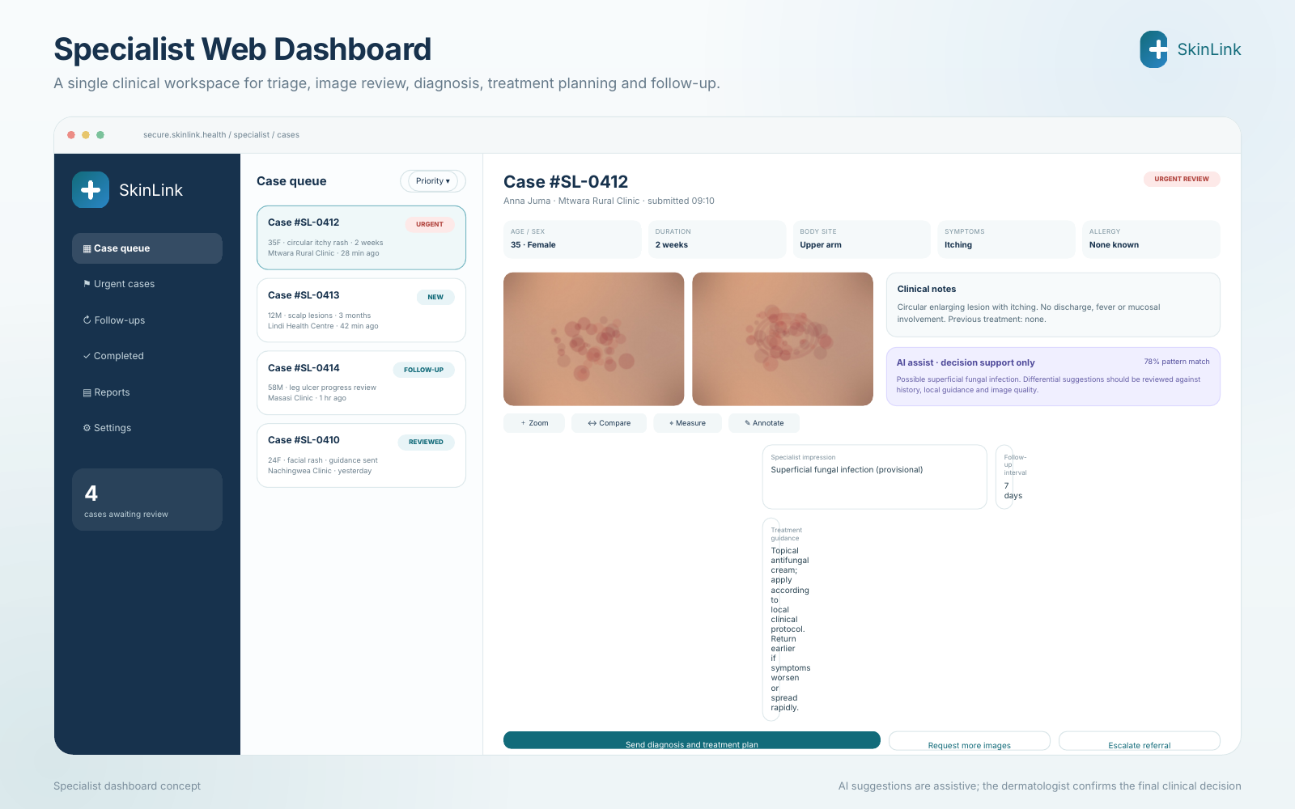
Figure 6. Specialist dashboard with triage queue, image review, AI-assist panel and treatment form.
Priority queue  Cases can be filtered by urgency, waiting time, facility, new submission or follow-up status. | Unified clinical view  Patient summary, symptoms, images, notes, red flags and prior communication appear in one case workspace.
Decision support  Optional AI suggestions are clearly separated from the specialist’s final assessment. | Clinical actions  Send guidance, request more images, clarify information, escalate in-person referral or schedule follow-up.

SPECIALIST EXPERIENCE
9. Image analysis, clarification and audit trail
Remote review becomes safer when the specialist can inspect image detail, compare views, request missing evidence and see every interaction in chronological order.
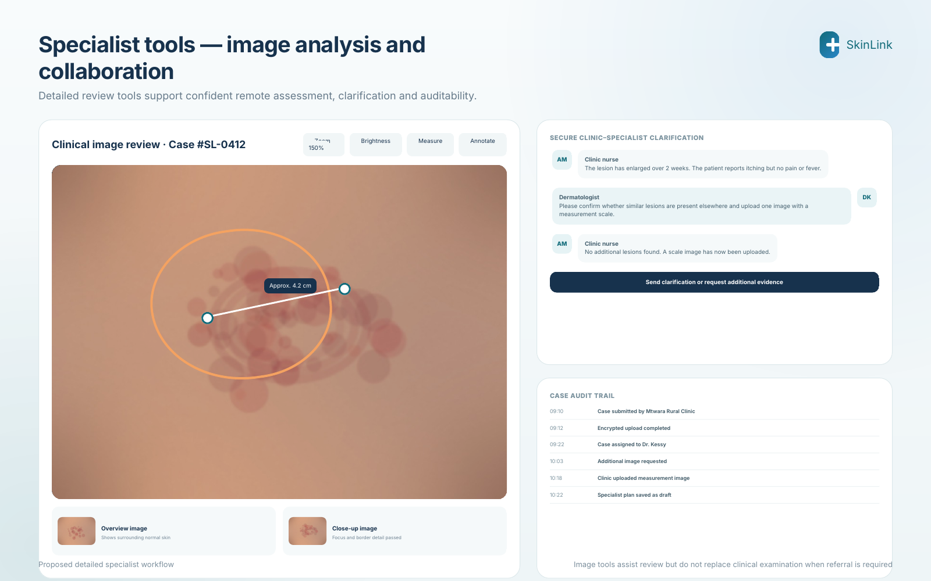
Figure 7. Image measurement and annotation, secure clarification and complete case audit history.
- Image tools may include zoom, brightness adjustment, side-by-side comparison, measurement and annotation.
- Secure messaging keeps questions and answers attached to the correct clinical case.
- The audit trail records submission, assignment, access, requests, uploads, decisions and later edits.

PLATFORM SCOPE
10. Key actors and functional modules
The platform connects four principal actors—patient, rural healthcare provider, dermatologist and health facility—through a set of modules covering the full referral lifecycle.
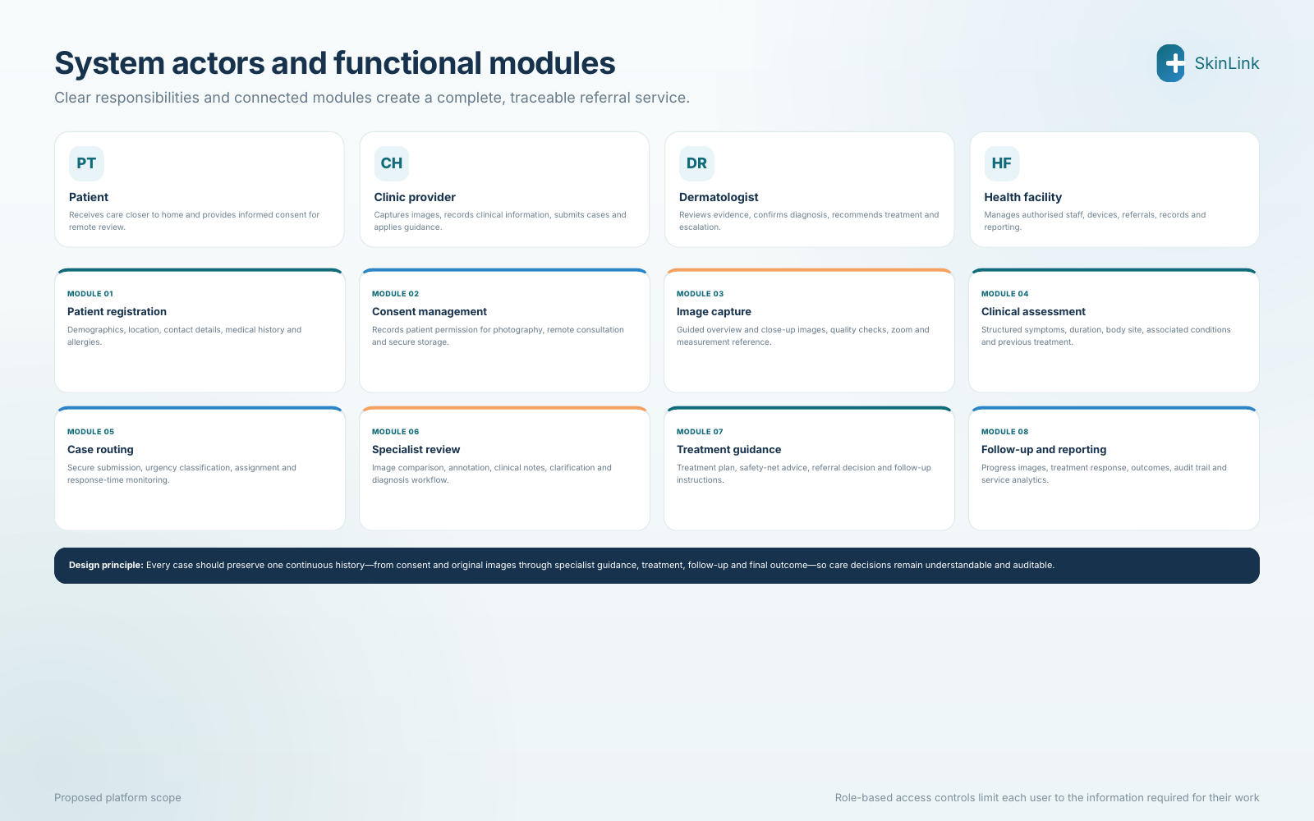
Figure 8. System actors and proposed functional modules.
Single continuous case history
Consent, clinical data, images, specialist reasoning, guidance, treatment, follow-up and outcome should remain linked under one case identity.

TECHNOLOGY DESIGN
11. Technology architecture and data flow
The architecture separates user interfaces, application services, secure data storage and infrastructure. This supports independent scaling, strong access control and later integration with broader health information systems.
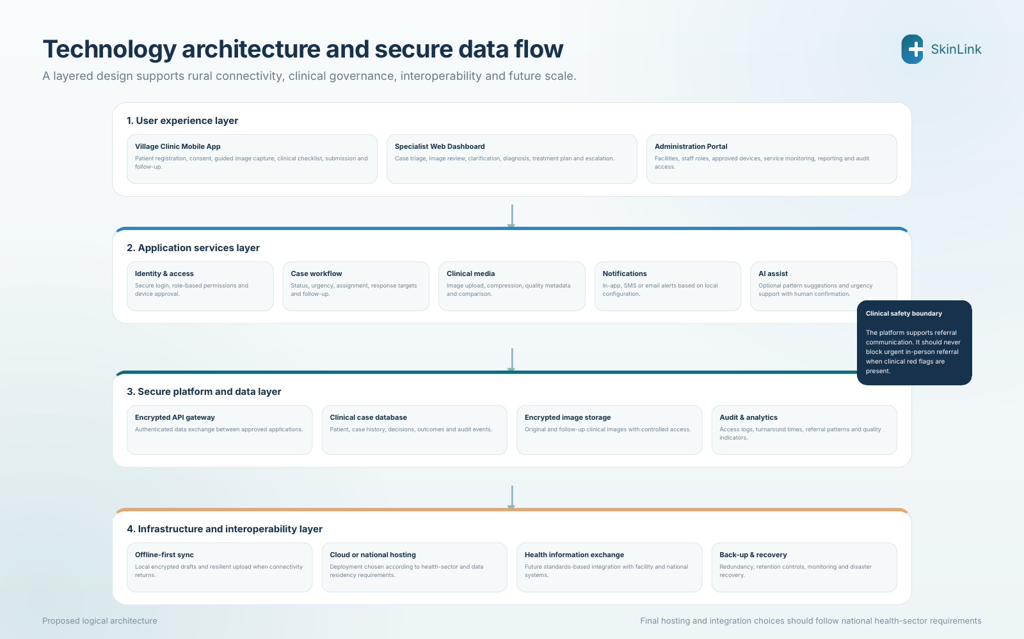
Figure 9. Proposed logical technology architecture for SkinLink.
- The Village Clinic App should support encrypted local drafts and reliable synchronisation after connectivity returns.
- The central platform stores patient data, images, case history, decisions and audit events under role-based access.
- Future interoperability should use approved health-information standards and national integration requirements.

GOVERNANCE AND SAFETY
12. Data security, ethics and responsible AI
Because the platform handles sensitive health information and clinical images, privacy and clinical governance must be designed into every workflow rather than added later.
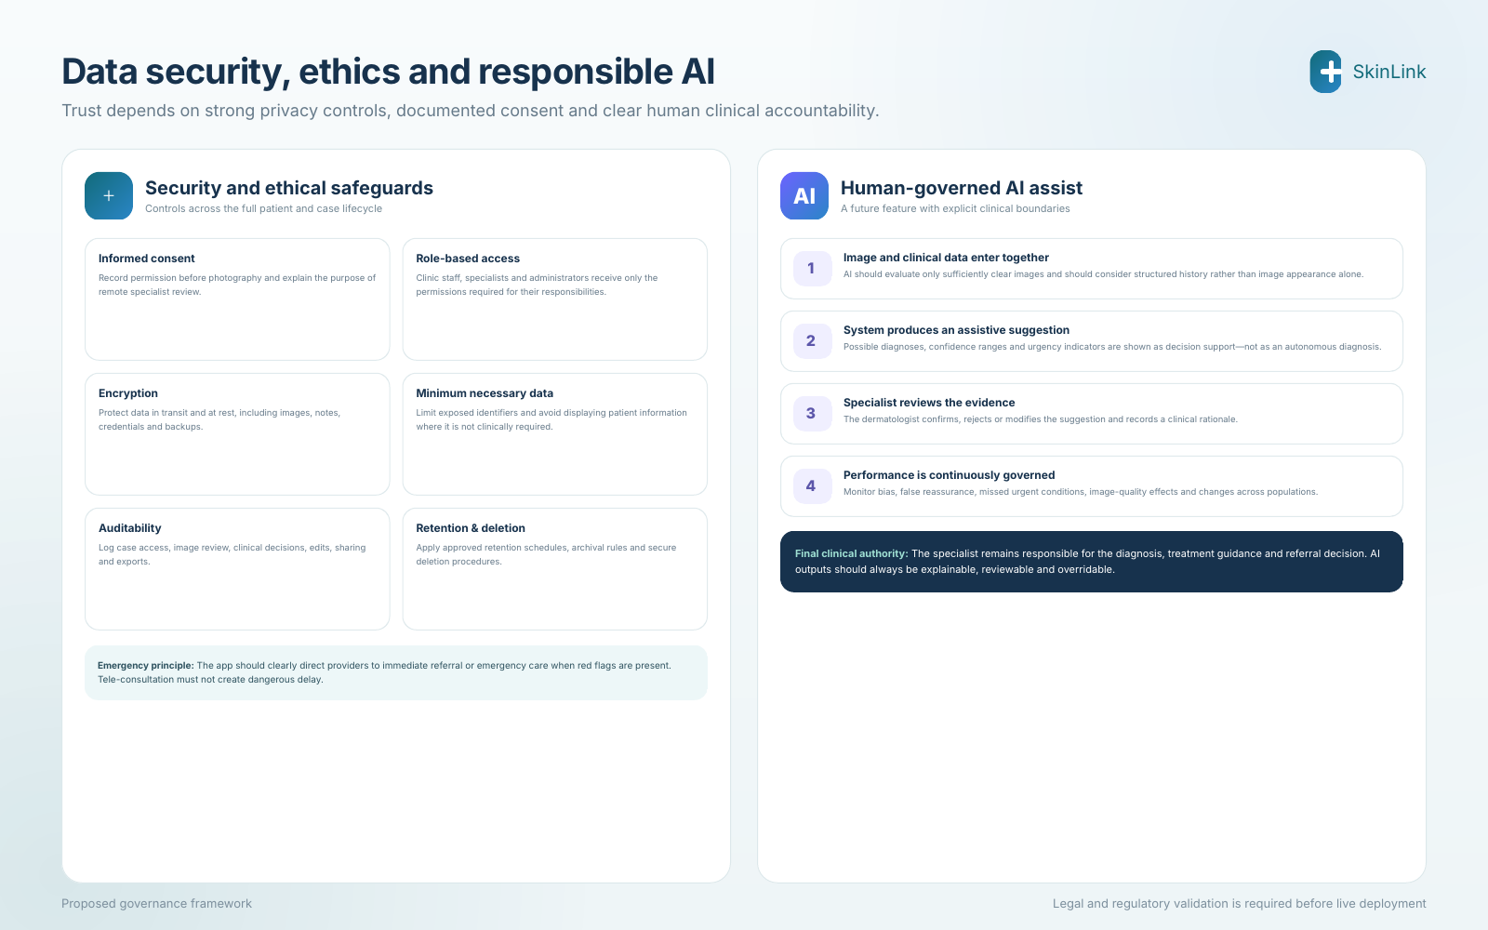
Figure 10. Proposed security controls and human-governed AI-assist workflow.
Security controls  Encrypted transfer and storage, secure login, approved devices, role permissions, backups and monitoring. | Patient ethics  Consent before photography, minimum necessary identifiers, confidentiality and appropriate retention.
AI boundary  AI may suggest patterns or urgency, but the specialist confirms or rejects the result. | Clinical safety  The system must never delay emergency referral when serious red flags or rapid deterioration are present.

IMPLEMENTATION
13. Healthcare worker training and phased rollout
The quality of the service depends heavily on the people using it. Short practical training should combine clinical photography, structured documentation, confidentiality, red-flag recognition and follow-up technique.
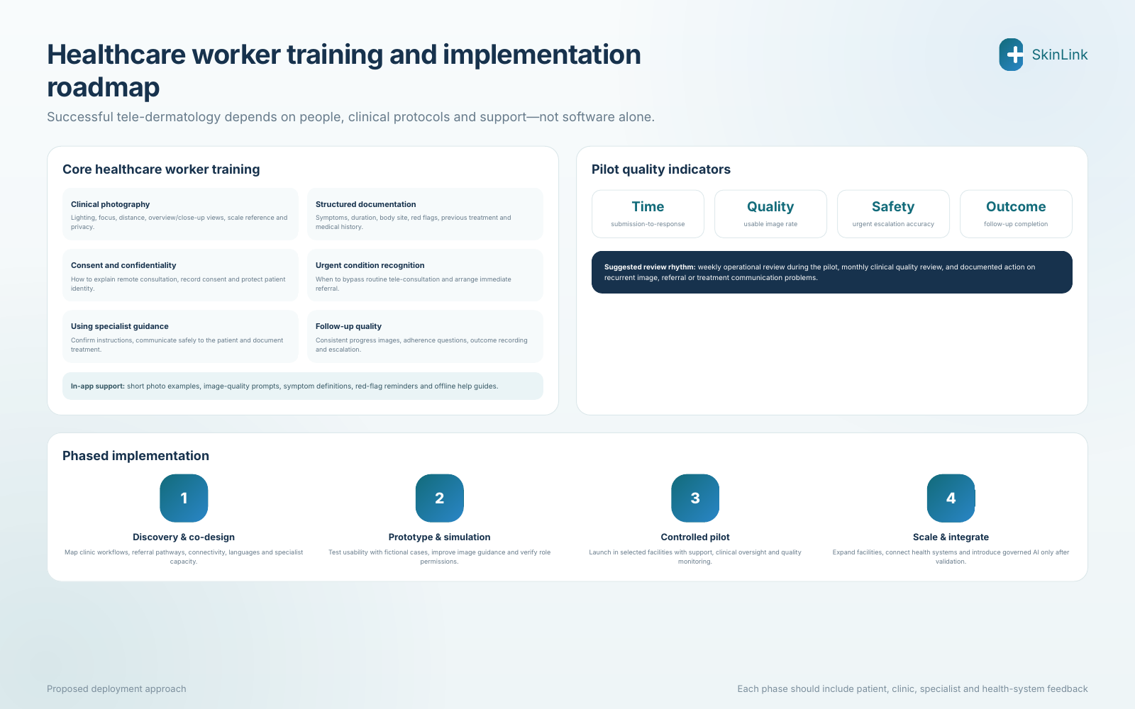
Figure 11. Training topics, pilot quality indicators and phased implementation roadmap.
Recommended implementation principle
Start with co-design and controlled simulation, then pilot in selected facilities with active specialist oversight before expanding coverage or introducing AI.

EVALUATION
14. Expected impact and potential research outputs
The intervention is expected to improve access to specialist-supported dermatology care while generating evidence about feasibility, quality, outcomes and cost in rural Tanzania.
Faster clinical guidance  Reduce the time between initial clinic assessment and specialist-supported treatment or referral. | Fewer avoidable journeys  Manage suitable cases locally and reserve referral travel for patients who require in-person specialist care.
Improved rural treatment  Give healthcare workers clear guidance, follow-up instructions and continuing learning from specialist feedback. | Better surveillance data  Create structured information on skin conditions, referral patterns, treatment response and geographical demand.

14.1 Suggested evaluation domains
Domain | Example measures | Research question
Feasibility | Adoption, case completion, connectivity failures, staff usability | Can rural facilities reliably use the workflow in routine care?
Diagnostic quality | Agreement between remote and in-person assessment; image adequacy | How accurate and clinically useful is remote dermatology review?
Referral impact | Referral rate, avoided travel, urgent escalations, time to treatment | Does the platform improve referral targeting and speed?
Cost-effectiveness | Patient travel cost, provider time, platform cost, cost per completed case | Is the service economically justified at pilot and scale?
Equity and safety | Access by geography and demographic group; adverse events; missed urgent cases | Does the intervention improve access without creating new safety or equity risks?
The original concept identifies four priority research outputs: feasibility of tele-dermatology in rural Tanzania, accuracy of remote dermatology diagnosis, impact on referral rates, and cost-effectiveness analysis.
Clinical and regulatory note
Before deployment, the concept requires formal clinical validation, legal and ethical review, approved data-governance procedures, and alignment with national health-sector regulations.

