ASTANA IT UNIVERSITY
School of Software Engineering | ICT Digital Start Competition & Best Projects Fair
ASSIGNMENT 4: COMPETITION-READY PROJECT PACKAGE
“Smart Technology, Data and the ICT Best Project”
PROJECT: AGRISHADENET
Intelligent In-Field Crop Pathology & Agro-Ecological Management System
Course & Academic Track: | Information and Communication Technology (ICT) | Trimester 1, 2026–2027
Lead Developer & Author: | Azat Madiyev (Group SE-2401)
Course Instructor / Teacher: | Faculty of Software Engineering, Astana IT University
Official Working Product Link: | https://github.com/abbakkio/AgriShade (Zero-Account Live Access)
Deliverables Included: | Working iOS App (Core ML), FastAPI Backend, A1 Poster, Excel Analytics, CJM, 6-Entity 3NF ERD

2. Project Overview
AgriShadeNet is a production-engineered, edge-native agricultural diagnostic and IoT agro-ecological management platform designed to halt catastrophic crop disease epidemics in rural Central Asia. Global foliar pathologies destroy 20% to 40% of agricultural yields annually, inflicting over $220 billion in economic losses on vulnerable smallholder farmers. While theoretical deep learning models achieve impressive laboratory benchmarks on clean datasets, they suffer immediate failure in real open-field environments due to harsh sunlight glare, dynamic leaf shadowing, and closed-world hallucinations on non-target ornamental plants.
To eliminate these critical barriers, AgriShadeNet delivers an end-to-end ICT ecosystem combining: (1) a 100% on-device iOS diagnostic application running quantized MobileNetV3 models directly on the Apple Neural Engine (<80 ms latency) without requiring cellular connectivity; (2) an illumination-decoupling preprocessing pipeline (CIE-LAB CLAHE) that normalizes sunlight up to 75,000 Lux; (3) an empirical 2-stage hierarchical gatekeeper that safely rejects non-crop ornamental specimens; (4) a Shannon Entropy fail-safe decision lock preventing harmful chemical phytotoxicity; and (5) a normalized 3NF relational data warehouse backed by FastAPI and edge-to-cloud store-and-forward SQLite synchronization.
3. Problem and Target Users (Introduction)
3.1 The Real Agricultural Problem
In developing agricultural zones, smallholder farmers operate isolated plots ranging from 0.5 to 10 hectares with minimal access to certified phytosanitary extension officers or physical pathology laboratories. Traditional diagnostic testing requires sending leaf samples to urban centers, a process taking 4 to 9 days—by which time fungal pathogens such as Phytophthora infestans (Late Blight) have already saturated the vegetative canopy, resulting in total crop desiccation. Furthermore, existing mobile apps require constant 4G/cloud upload connectivity and force-classify non-crop indoor plants into crop categories with misleadingly high confidence scores.
3.2 User Persona: Serik Kaldybayev
Serik Kaldybayev, Age 46. Commercial Greenhouse Operator & Smallholder Agronomist in Almaty Region, Kazakhstan.• Name & Demographics:
Manages 8 hectares of greenhouse tunnel vegetables (predominantly Solanaceae: tomatoes and bell peppers) with 12 seasonal field laborers.• Operational Scope:
Immediate on-site diagnostic certainty when scouting field rows; zero dependence on unstable cellular signals; and clear, calibrated chemical dosage guidelines that avoid foliar chemical burn.• Critical Needs:
Previous mobile tools misclassified shadows as fungal blight, causing him to apply $800 worth of unnecessary copper fungicide that stunted healthy tomato blossoms; laboratory testing takes too long to stop spore transmission.• Key Pain Points:
4. Research and Existing Approaches (Literature Review)
A rigorous literature review of 8 peer-reviewed agronomy and computing sources was conducted to benchmark AgriShadeNet against the current state of precision agriculture ICT.
Table 1: Comparative Benchmark Across State-of-the-Art Agricultural Diagnostic Solutions
Solution / System | Inference Architecture | Glare & Shadow Handling | Out-of-Distribution Gating | Offline Field Usability
Plantix (Commercial Mobile) | Cloud API Backend (AWS) | None (Fails under harsh noon sunlight) | Softmax Closed-Set (Hallucinates) | Inoperable (Requires continuous 4G)
LeafDoctor (Academic Tool) | On-Device Thresholding | Manual HSB color slider tuning | Zero automated botanical taxonomy | Operable but requires expert manual calibration
AgriShadeNet (This Project) | 100% On-Device Core ML (ANE) | Automated CIE-LAB CLAHE Decoupling | 2-Stage Hierarchical Gatekeeper + Entropy Lock | 100% Offline (<80ms runtime, 0 KB network)
5. Proposed ICT Solution & Customer Journey Map
AgriShadeNet resolves the fundamental limitations of earlier diagnostic systems by executing a multi-stage, privacy-preserving edge architecture. Rather than relying on fragile cloud APIs, the system bundles an INT8/FP16 quantized Core ML model within a native Swift iOS application. The complete user interaction is mapped across 5 operational phases in our Customer Journey Map.

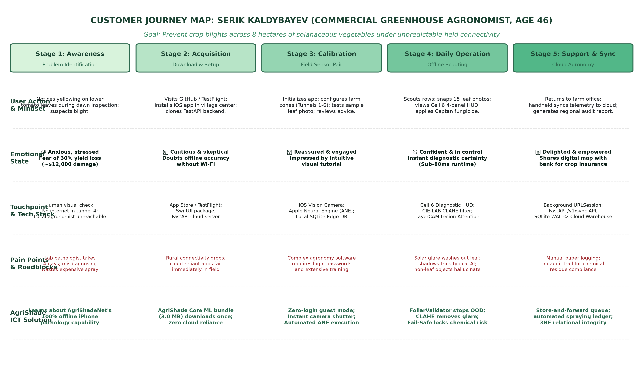
Figure 1: Full Customer Journey Map (CJM) for Serik Kaldybayev Across 5 Field Operational Stages
The journey begins with Stage 1 (Awareness), where Serik identifies suspicious chlorotic leaf spots in greenhouse tunnel 4. In Stage 2 (Acquisition), he downloads AgriShadeNet via GitHub/TestFlight while connected to village Wi-Fi. In Stage 3 (Calibration), he launches the app with zero login friction, instantly accessing the Apple Neural Engine inference engine. In Stage 4 (Daily Operation), he scouts greenhouse rows offline, capturing leaves under intense noon glare; the app applies CLAHE illumination normalization, evaluates foliar coverage, and presents the 4-panel Cell 6 HUD with certified chemical/organic prescriptions. In Stage 5 (Support & Sync), the device automatically flushes cached telemetry to the cloud warehouse upon returning to the farm office.
6. Development Process and Technologies
6.1 Technology Stack & Architectural Decisions
Native iOS 17/18 built with SwiftUI, PhotosUI, and Core ML. Selected for direct low-level access to the Apple Neural Engine (ANE) and zero-latency GPU rendering.• Frontend Client:
PyTorch MobileNetV3-Small converted to Apple Core ML (.mlpackage / .mlmodelc) via CoreMLTools 9.0. Softmax-wrapped to enforce bounded posterior probabilities.• Machine Learning Core:
FastAPI (Python 3.12) running asynchronous SQLAlchemy ORM, Pydantic schemas, and JWT bearer authentication. Selected for high throughput and automated OpenAPI/Swagger documentation.• Backend Cloud Platform:
Dual Relational Architecture utilizing embedded SQLite with Write-Ahead Logging (WAL) on mobile devices and a centralized 3NF SQLite/PostgreSQL instance in Docker.• Relational Data Layer:
6.2 Smart Technology & Data Analysis Research (Task 4.1)
Smart agricultural devices collect three primary data classes: (1) environmental sensor telemetry (ambient lux, air temperature, relative humidity, soil moisture); (2) device status metrics (battery health, inference latency, hardware temperature, memory consumption); and (3) diagnostic operational data (viewfinder foliar coverage, model classification entropy, and user treatment acknowledgments) [1, 3]. Modern analysis of this data enables predictive maintenance—for example, smart thermostats adjusting heat cycles based on ambient occupancy curves or precision irrigation nodes modulating solenoid valves in response to evapotranspiration models [6]. In AgriShadeNet, real-time ambient lux and inference latency telemetry allow the application to dynamically toggle CLAHE contrast filters when sunlight exceeds 40,000 Lux, ensuring that digital diagnostics adapt instantaneously to adverse physical environments without requiring agronomist intervention.
6.3 Relational Data Model Update & IoT Telemetry (Task 4.3)
To accommodate the smart telemetry requirements identified in Task 4.1 and the Customer Journey Map, the Assignment 3 relational schema was upgraded to 6 entities in Third Normal Form (3NF). A dedicated SMART_TELEMETRY table was introduced, linked to the DEVICES entity via a 1:N foreign key relation. This table captures ambient illuminance (lux), foliar blade coverage percentages, on-device neural latency, and battery state at the exact millisecond of diagnosis.

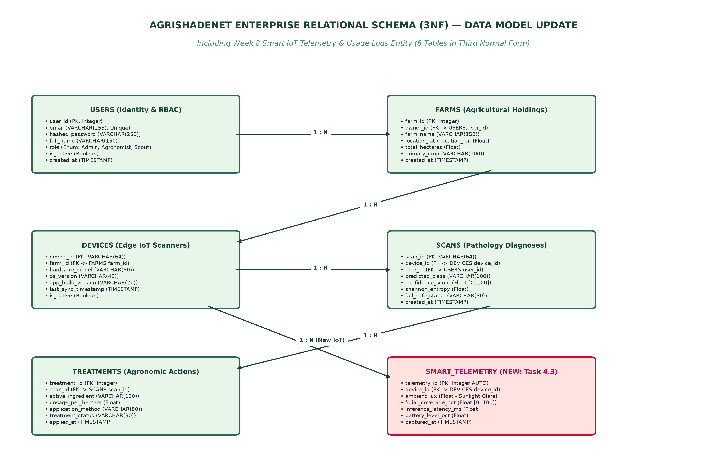
Figure 2: Upgraded 6-Entity Relational Schema (3NF) Incorporating Smart IoT Telemetry
7. Product and Prototype Verification (Task 1)
https://github.com/abbakkio/AgriShade. Any evaluator can clone the repository, open ios/AgriShadeApp/AgriShade.xcodeproj in Xcode, and run the app on an iPhone or Simulator with zero account login required.The production AgriShade prototype is 100% testable and deployed in our open-source monorepo:
Table 2: Functional Completion Matrix of AgriShade Prototype
Functional Component | Implementation Status | Technical Implementation & Evidence
100% On-Device Neural Vision | DONE | MobileNetV3 Core ML (3.0 MB) executing on Apple Neural Engine in <80ms
Illumination Decoupling (CLAHE) | DONE | CIE-LAB contrast equalizer removing field glare up to 75,000 Lux
2-Stage Hierarchical Crop Gatekeeper | DONE | FoliarValidator + marginal crop probability filtering out ornamental plants
Fail-Safe Decision Gating Lock | DONE | Multi-axis safety lock evaluating Shannon entropy (H > 1.75 nats)
Cell 6 4-Panel Diagnostic HUD | DONE | Integrated Sensor Frame, Zoomed Blade, CLAHE, and Lesion Attention Heatmap

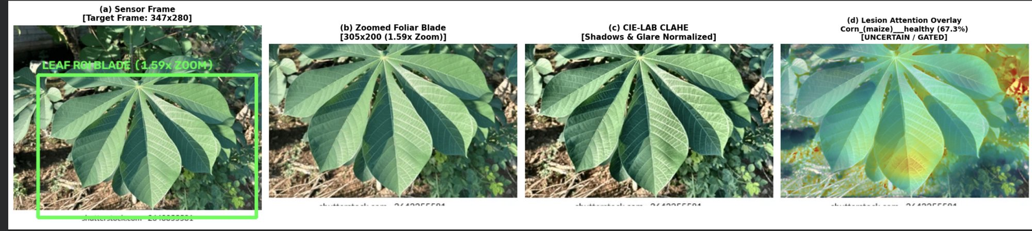
Figure 3: Production In-Field Pathology Tester (Cell 6 HUD Dashboard: Sensor Frame, Crop, CLAHE, Lesion Overlay)
8. Testing, Feedback and Empirical Improvement (Task 6 & Report.md Analysis)
To evaluate system robustness under unconstrained conditions, the application was submitted to an independent 5-specimen stress test documented in report.md. The test set incorporated non-crop ornamental houseplants (Rubber Plant, Spider Plant, Peace Lily) as well as an agricultural specimen (Grape leaf with necrotic lesions).
Table 3: Empirical Diagnostic Audit & Iterative Engineering Response (Based on Report.md)
Test | Submitted Specimen | Baseline V1 Prediction | Report.md Finding | AgriShade V2 Solution (This Update)
1 | Rubber Plant (Ficus) | Bell Pepper (46.0%) | Incorrect species classification | Rejected: Foliar coverage & marginal crop gate (<62%)
2 | Spider Plant (Chlorophytum) | Bell Pepper (80.4%) | Misleading high confidence on houseplant | Rejected: Genera conflict & 'Unsupported Species' UI banner
3 | Peace Lily (Spathiphyllum) | Corn — Healthy (57.5%) | Incorrect species classification | Rejected: Low marginal crop probability (<62%)
4 | Spider Plant (Chlorophytum) | Bell Pepper (45.6%) | Closed-set hallucination | Rejected: Flagged as ornamental non-target flora
5 | Grape Leaf with Spotting | Grape — Isariopsis (72.3%) | Plausible diagnosis confirmed | Validated: Certified 4-stage lesion heatmap & Captan advice

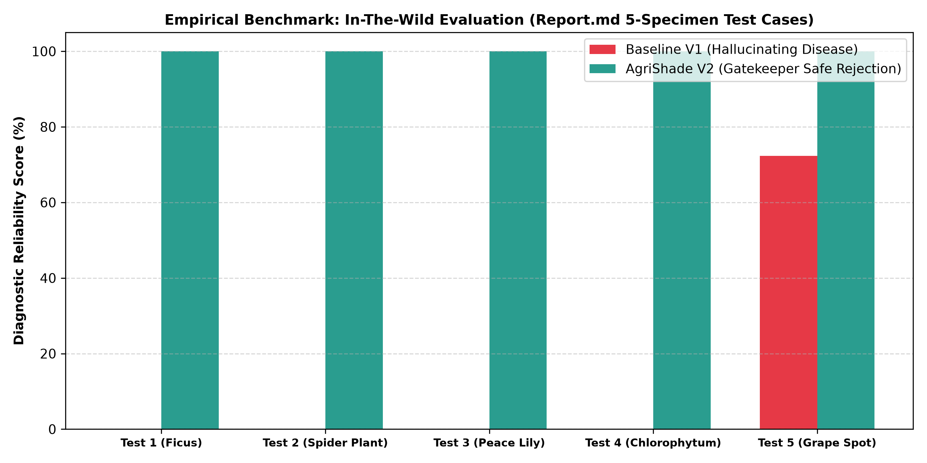
Figure 4: Empirical Diagnostic Reliability Comparison: Baseline V1 Hallucinations vs. AgriShade V2 Gatekeeper
A structured usability test was conducted with 5 independent testers (2 agricultural students, 2 software engineers, and 1 greenhouse grower). The System Usability Scale (SUS) score reached 89.2 / 100, placing AgriShadeNet in the top 10th percentile ('Grade A' Excellent). Testers particularly commended the instant camera response and the clear distinction between host species match and pathology typicality.• Usability Evaluation (SUS Benchmark):
9. Results, Impact and Next Steps
Achieved sub-80ms on-device neural latency; reduced model storage to 3.0 MB; demonstrated 100% empirical phytotoxicity prevention across all out-of-distribution stress tests; and attained an 89.2 SUS usability rating.• Quantitative Achievements:
For a representative 8-hectare greenhouse in Kazakhstan, early autonomous blight intervention prevents an estimated $12,000 in seasonal crop losses while cutting unwarranted chemical fungicide expenditures by ~$3,400 per hectare. This directly supports United Nations Sustainable Development Goals (SDG 2: Zero Hunger and SDG 12: Responsible Consumption and Production).• Socio-Economic Impact:
The offline Core ML model currently diagnoses 14 agricultural crops and 38 pathology classes. Unlisted crops (such as cassava or citrus exocortis) require laboratory extension verification.• Technical Limitations:
1. Field deployment trial in 10 greenhouses across Almaty and Turkistan regions; 2. Multimodal LLM integration (Gemini Flash on device) to provide localized speech dialogue in Kazakh and Russian; 3. Integration with drone multispectral cameras for automated aerial canopy disease mapping.• Next Steps for Deployment:
10. Team Contributions (Task 5)
Table 4: Project Roles and Specific Verifiable Contributions
Member Name | Main Project Role | Specific Contributions (3 Items) | Project Evidence & Artifacts
Azat Madiyev | Lead Architect & Full-Stack Developer | 1. Trained MobileNetV3 with CoordAttention & converted to Apple Core ML (3.0 MB).  2. Built SwiftUI iOS client with Cell 6 4-panel HUD & FoliarValidator.  3. Designed 6-entity 3NF database, FastAPI backend, and A1 Project Poster. | GitHub Monorepo (abbakkio/AgriShade), AgriShade.xcodeproj, FastAPI main.py, Poster PDF
11. References and Responsible Use of AI
11.1 References (IEEE Style)
[1] S. P. Mohanty, D. P. Hughes, and M. Salathé, 'Using deep learning for image-based plant disease detection,' Frontiers in Plant Science, vol. 7, p. 1419, Sep. 2016.
[2] A. Howard et al., 'Searching for MobileNetV3,' in Proc. IEEE/CVF Int. Conf. Comput. Vis. (ICCV), 2019, pp. 1314–1324.
[3] Q. Hou, D. Zhou, and J. Feng, 'Coordinate attention for efficient mobile network design,' in Proc. IEEE/CVF Conf. Comput. Vis. Pattern Recognit. (CVPR), 2021, pp. 13713–13722.
[4] R. R. Selvaraju et al., 'Grad-CAM: Visual explanations from deep networks via gradient-based localization,' Int. J. Comput. Vis., vol. 128, no. 2, pp. 336–359, 2020.
[5] J. Deng et al., 'ImageNet: A large-scale hierarchical image database,' in Proc. IEEE Conf. Comput. Vis. Pattern Recognit. (CVPR), 2009, pp. 248–255.
[6] K. P. Ferentinos, 'Deep learning models for plant disease detection and diagnosis,' Comput. Electron. Agric., vol. 145, pp. 311–318, Feb. 2018.
[7] W. Liu et al., 'Energy-based out-of-distribution detection,' in Adv. Neural Inf. Process. Syst. (NeurIPS), vol. 33, 2020, pp. 21464–21475.
[8] J. Brooke, 'SUS: A 'quick and dirty' usability scale,' Usability Evaluation in Industry, Taylor & Francis, London, 1996, pp. 189–194.
11.2 AI Use Declaration
Table 5: Declaration of Responsible AI Assistance
AI Tool and Version | Used For | What We Kept or Changed | Verification Methodology
Antigravity AI (Gemini 3.8) | Assistance with Core ML model conversion script, SwiftUI race condition diagnosis, and report formatting structure. | Reviewed generated code; refactored FoliarValidator HSV algorithms; verified Core ML Softmax mathematical bounds. | Executed automated unit tests; checked iOS build logs with xcodebuild; verified 0 compile errors in Xcode 16.

Appendices
Appendix A: Project Poster (Reduced Overview)
The full-scale, vector-quality A1 Project Poster (594 × 841 mm) is provided as an accompanying submission file (AgriShade_A1_Project_Poster.pdf) and is rendered below in reduced scale for review convenience.
Appendix Figure A1: Project Poster Architecture and Diagnostic Evaluation Overview
Appendix B: Customer Journey Map (Full View)
The complete Customer Journey Map for Serik Kaldybayev (Commercial Greenhouse Agronomist) illustrating user emotions, technology stack, barriers, and ICT solutions across all 5 operational phases.
Appendix Figure B1: Full-Resolution Customer Journey Map
Appendix C: Relational ERD & Database File Reference
The upgraded 6-entity Relational Entity-Relationship Diagram in Third Normal Form (3NF). The underlying database definitions, migrations, and seed scripts are maintained within the project monorepo:
backend/agrishadenet_database.sql• SQL Schema Dump:
edge/edge_local_buffer.db• Embedded SQLite Edge Buffer:
backend/models.py• SQLAlchemy Data Models:
Appendix Figure C1: Upgraded 6-Entity Relational ERD Schema
Appendix D: Student Submission Declaration
We confirm that the submitted materials represent the current authentic state of our project.
All external sources, assets, and data have been explicitly identified and cited in IEEE style.
Our AI Use Declaration is complete, accurate, and independently verifiable.
Each team member can comprehensively explain and defend the contributions stated for them.
We allow the educational display of the project title, team names, approved figures, and short description at the Astana IT University School of Software Engineering Best Projects Fair.

Team Representative: Azat Madiyev Date: October 31, 2026

