**Edhi Welfare Trust Project**

By

Aurang Zeb Khan (CS120162008, [abbangash333@gmail.com](mailto:abbangash333@gmail.com))

Ibrahim (CS120162017, Kkibrahim008@gmail.com)

Muhammad Ibrahim (CS120162031, [mibrahimk52@gmail.com](mailto:mibrahimk52@gmail.com))

**Supervisor**

Dr. Muhammad Muneer

Institute of Computing

KUST, Kohat

___________

Signature



**Institute of Computing**

**Kohat University of Science and Technology, Kohat-26000**

**Khyber Pakhtunkhwa, Pakistan**

**Edhi Welfare Trust Project**

By

Aurang Zeb Khan (CS120162008, [abbangash333@gmail.com](mailto:abbangash333@gmail.com))

Ibrahim (CS120162017, Kkibrahim008@gmail.com)

Muhammad Ibrahim (CS120162031, [mibrahimk52@gmail.com](mailto:mibrahimk52@gmail.com))

A thesis submitted in partial fulfillment of the requirements for the degree of

BSCS.

Thesis Supervisor:

Dr. Muhammad Muneer

Thesis Supervisor’s Signature: ____________________________________

FYP Coordinator’s Signature: ____________________________________

Director’s Signature: ____________________________________

Institute of Computing

Kohat University of Science and Technology, Kohat-26000

Khyber Pakhtunkhwa, Pakistan

(October), (2020)

Contents

Declaration 4

Plagiarism Certificate (Turnitin Report) 4

Copyright Statement 5

Dedication 6

AKNOWLEDGEMENT 7

Abstract 8

Chapter 1: INTRODUCTION 9

1.1 INTRODUCTION 9

1.2 PROJECT DEFINITION 9

1.3 EXISTING FLOW 10

1.4 PROBLEM STATEMENT 10

1.5 PROPOSED SOLUTION 10

1.6 OBJECTIVES 11

1.7 MOTIVATION 11

1.8 PROJECT OVERVIEW 11

1.9 DETAILS/SCOPE OF THE PROJECT 12

Chapter 2: LITERATURE REVIEW 14

2.1 EDHI WELFARE TRUST 14

2.2 SIMILAR SOFTWARE APPLICATIONS 14

2.3 SOFTWARE DEVELOPMENT LIFE CYCLE(SDLC) 15

2.3.1 Software Development Life Cycle Process Model: 16

2.3.2 Waterfall Model: 16

2.3.3 Consecutive Phases in the Waterfall Model 17

2.3.4 Advantages of Waterfall model 18

2.3.5 Disadvantages of Waterfall model: 18

2.3.6 When to use the Waterfall model: 19

2.4 WHY ARE WE USING WATERFALL MODEL? 19

2.5 SDLC FOR OUR PROPOSED PROJECT 19

2.5.1 Analysis Requirement and Literature Review 20

2.5.2 Initial Designing: 20

2.5.3 Coding: 20

2.5.4 Evaluation: 20

Chapter 3: REQUIREMENTS AND PROPOSED SYSTEM 21

3.1 Requirements: 21

3.1.1 Functional Requirements: 21

3.1.2 Non-Functional Requirements: 21

3.1.3 Software and Hardware requirements 21

3.2 Proposed System 22

3.2.1 Admin: 22

3.2.2 Users: 22

3.2.3 Ambulance Users: 22

3.2.4 Missing Person 23

3.2.5 Blood Donation 23

3.2.6 Donation 23

3.3 Features of the Proposed System 23

3.3.1 Display of various Information 23

3.3.2 Customization of app 23

3.3.3 Reports 24

3.3.4 Login Options 24

3.3.5 GPS based ambulance tracking 24

Chapter 4: Analysis and Design 25

4.2 Designing during production: 25

4.3 Objectives of design: 26

4.4 Our project design components: 26

4.5 Activities used for better design development: 27

4.6 Modeling the Project: 27

4.7 Use case diagram: 28

4.8 Activity Diagram: 36

4.9 Sequence diagram: 46

Chapter 5: Implementation 49

5.1 Selection of Language: 49

5.2 Tools and technologies: 49

Chapter 6: Testing 50

6.1 Black-box testing 50

6.2 White-box testing 50

6.3 Unit Testing: 51

6.4 Test cases For Unit Testing 51

Test case 1: Enter Valid and active number and OTP: 51

Test case 3: Enter Inactive number: 51

Test case 4: Enter right OTP: 52

Successful login. 52

Test case 5: Front page content: 52

6.5 Integration Testing: 52

Incremental Testing: 52

Test Cases for Integration Testing: 53

Test case 1: Link Between Login and front Page: 53

Chapter 7: Conclusion and future work 54

1. Missing person access through posts. 54

2. Blood donation or request 54

3. Ambulance service through GPS 54

4. Donation of item and money 54

7.1 Future work: 54

# Declaration

I certify that this project titled “*title”* is my own work. The work has not been presented elsewhere for assessment. The material that has been used from other sources has been properly acknowledged / referred.

Signature of Students

# Plagiarism Certificate (Turnitin Report)

This thesis has been checked for Plagiarism. Turnitin report endorsed by Supervisor is attached at the end of thesis.

______________________________________

Signature of Students

______________________________________

Signature of Supervisor

# Copyright Statement

* Copyright in text of this thesis rests with the student author. Copies (by any process) either in full, or of extracts, may be made only in accordance with instructions given by the author and lodged in the Library of KUST. Details may be obtained by the Librarian. This page must form part of any such copies made. Further copies (by any process) may not be made without the permission (in writing) of the author.
* The ownership of any intellectual property rights which may be described in this thesis is vested in Institute of Computing, KUST, subject to any prior agreement to the contrary, and may not be made available for use by third parties without the written permission of the institute, which will prescribe the terms and conditions of any such agreement.
* Further information on the conditions under which disclosures and exploitation may take place is available from the Library of KUST, Kohat.

# Dedication

I dedicated my final year project to my beloved parents, teachers and my friends for giving all the possible support, love and encouragement throughout my studies and to my respectable supervisor Dr. Muhammad Munir who guide me in a befitting manner.

# AKNOWLEDGEMENT

ALMIGHTY ALLAH is great and by the grace of ALMIGHTY ALLAH, after a dedicated and devoted attitude I am able to finish this thesis with the goal to have a bright future ahead. I am very much thankful to my supervisor Dr. Muhammad Munir for their nice and professional attitude that is granted in such a way which brings a fruit in shape of my complete project work efficiently and effectively. I am also thankful to all my colleagues who encouraged me to keep my efforts intact throughout the project completion process

# Abstract

An android based application Edhi Trust has been proposed. This application will assist its users in many ways associated with different activities and services of Edhi Welfare Trust. The users will be facilitated and provided different ways to reach the Edhi Homes which are located at different places in the country specially in KPK. People will be able to post various type of posts for the whole community of users. The posts may include but not limited to report missing people, information, accidents reporting, and requests for blood donations, etc. Moreover, this application will help people to locate nearby ambulances application will keep detailed information about different centers along with their requests for donations and their services for the community. This application will give state-of-the-art interface for user, where they will be able to modify their usage in many ways. The posts can be filtered, ordered, and prioritized with different queries of the database. The application will have support for helping different specialized services like missing person, blood donation, ambulance services and donation of items.

# Chapter 1: INTRODUCTION

## 1.1 INTRODUCTION

Edhi Home is a welfare organization that is giving services to the people of the world on the bases of human rights. Edhi has a special role in the field of missing persons and providing shelter to homeless persons especially in Pakistan. Edhi ambulance service is one of the prominent services in Pakistan which is available free of cost throughout the country. There are different other services which are provided by the Edhi Centers like hospitals, graveyards for unknown dead bodies, orphanage home, Refugee services, etc. Besides this, there is a donation system for needy people too.

The main work at Edhi centers is done manually on papers. There is no such computer-based application available for this organization to manage its work efficiently. There is only a website of Edh ([www.Edhi.org](http://www.Edhi.org)) where a donation can be collected. There is no other software for this organization like other International Organizations particularly operated by some known bodies like the United Nations. There is a need of Android and iOS applications to help Edhi Centers run their operations in a better and more managed way.

The main purpose of the proposed project is to develop an Android and iOS-based application for Edhi Welfare Trust. With the help of this application, users will be able to perform various tasks. These tasks can be posting about missing people and items, tracking nearby ambulances, donations of money and other commodities. Moreover, the Edhi Trust will also be able to keep an appropriate record of its operations by using the proposed application.

## 1.2 PROJECT DEFINITION

The name of the proposed project is the Edhi Trust Organization. It will be an Android as well as an iOS-based application to facilitate a large number of mobile phone users. The proposed application will be able to provide detailed information about the Edhi centers and their services. The users of the proposed application will be able to search out the different centers along with the list of their offered services. The centers can be searched in two different ways. The first method is to check and read different information which will be provided through this application and contact their nearest center for help. The second method which is fast and easy to use is to search nearest centers or other places through Google map search, which will also be provided in this application.

Moreover, many online sophisticated and advanced features will also be available for users to easily avail the services of this organization. With the help of this application, the shortcoming of the current system would be covered up. It would provide the services of Edhi Trust in an easy way to the users and saves time in providing and getting these services.

## 1.3 EXISTING FLOW

There is no such application available for the Edhi Trust Welfare organization to provide its services online. Moreover, the available other similar applications are either irrelevant to us or do not provide all the proposed features in a single package. For online tracking of the ambulances, an application is implemented in Delhi, India. However, that application only covers a single service for hiring ambulances.

The targeted organization, Edhi Welfare Trust, mainly operates all its operations manually. It does not have any appropriate application for users to avail its services. Moreover, the available website of Edhi Trust is just an informative page that has very basic information about it. Currently, the Edhi ambulance service can be hired by dialing 115, only, without knowing the availability of any nearby ambulance.

## 1.4 PROBLEM STATEMENT

In our daily life, we may face various issues which could not be reported immediately without skipping the legal formalities. For example, for reporting a missing person one must visit the police station located in the territory of that missed person. Logging first information report (FIR) is essential for everyone, however, it is a time taking process. Also, the whole process needs time to search for more people who are lost.

Emergency situations such as accidents require immediate medical attention and patients need to be transported from the accident site to the hospital. In this case, the emergency system is critical for saving precious lives. The importance of taking a patient to a hospital can be judged by the fact that if the arrival of the ambulance is delayed due to any problems, the patient's medical condition may be deteriorated or even result in death. The delay may be due to finding the nearby located ambulance service or requesting an ambulance which is far away from for the place where has been requested. Moreover, the sharing of appropriate location with the ambulance driver is also very essential to handle an emergency situation.

Edhi Trust offers various services which many people don’t know. Most of the people don’t know about the location of centers, their services and requested donations from the community. There is an acute need for designing a platform to address all such issues associated with Edhi Trust. Moreover, many services provided by this organization can be computerized. Such services are reporting missing people, announcements for donations, information about centers, etc.

## 1.5 PROPOSED SOLUTION

To overcome the various issues in the manual system associated with Edhi Trust services can be formally and efficiently computerized. The services like reporting missing persons or items, requests for monetary donations, blood donations and ambulances can be shared among the users by using internet-enabled mobile phones. The main objective is to facilitate the community by sharing and managing relevant information in a short period of time.

We are proposing to develop an android based application which will have the following modules:

* Display information about missing persons.
* Management of the added posts by the administrators
* Allowing users searches in various ways.
* Identification of users through their mobile numbers
* Allowing the user to adapt any from various options for login. The login options can be smart login by using an SMS in the background, OTP, Pin and typical username and password methods
* Providing location and contact information about ambulances
* During the occurrence of an accident, the victim presses the “Help” button in the Smartphone application which generates and sends location along with the victim’s identity to the database server or can directly search nearest ambulance centers and can call through the calling button.

## 1.6 OBJECTIVES

The main objectives of the proposed project are as following:

* To facilitate people, avail the services of Edhi Trust Welfare Organization
* To let the users, understand the facts and service provided by this organization
* To facilitate the user easily donate to the Edhi Trust
* To provide a platform for users easily post about the missing people and items
* To help people easily search out the nearby Edhi ambulances in case of any emergency
* To help Edhi Service manage its operations in a sophisticated way

## 1.7 MOTIVATION

Edhi Organization is an international organization and it is providing services within the country and outside the country in various areas. In spite of all hardships, this organization performs well throughout the world, especially in Pakistan. Basic reasons for creating this application are:

* There is no specific software application for this organization.
* People also feel it harder to find their loved ones who are once lost.
* There is no GPS based tracking and contacting the ambulance services which brings very ease to the public.
* There is no online data available about this organization.
* With the help of this project, most of the shortcomings of the current system would be resolved.

## 1.8 PROJECT OVERVIEW

The project name is “Edhi Trust Organization app” and it is specifically proposed for the Edhi organization. The proposed application will be developed for Android-based as well as iOS mobile phones.

Initially, we shall take a few centers and services and implement an app on them and shall further exceed. There will be a friendly and usable layout for users and administrators. Moreover, it is always desired to have an application flexible in all aspects. A list of the salient features of this app can be summarized as:

* Users will have own interfaces, services, and logins system. Where they can upload information about missing persons and also can request for blood donations. Users can donate money and other items through an easy interface.
* Users can request for ambulance service in an easy way whenever they need, especially in case of emergency. They will be provided with the location of the ambulance and the contact number of the driver.
* Google maps will be used for various purposes because it is one of the best tools to track someone’s location.
* Admin users can delete, modify, and can change the posts.
* Detailed information can be added for offline information in case of the unavailability of internet connection.
* The developed application will have a user-friendly interface.

## 1.9 DETAILS/SCOPE OF THE PROJECT

The Project will cover all salient features and specified modules from small scale to large one. This application will assist its users in many ways associated with different activities and services of Edhi Welfare Trust. The users will be facilitated and provided different ways to reach the Edhi Homes which are located at different places in the country. People will be able to post various types of posts for the whole community of users. The posts may include but not limited to reporting missing people, information about lost or found items, accident reporting, and requests for blood donations, etc. Moreover, this application will help people to locate nearby ambulances searching. The application will keep detailed information about different centers along with their requests for donations and their services for the community. A brief description of the users can be seen in figure 1.1.



Figure 1.1- User App view

The key features of the entire system can be seen in figure 1.2.

F

E

A

T

U

R

E

S

**DONATIONS**

Donation collection and record keeping for the organization

**POSTING**

Posting for missing people, blood donations, general queries etc.

**AMBULANCE TRACKING**

Easily find and contact the nearby available ambulances

**DONATIONS**

Donation collection and record keeping for the organization

**Center information**

Easily find center information

Figure 1.2-Key features of the system

# Chapter 2: LITERATURE REVIEW

## 2.1 EDHI WELFARE TRUST

Edhi Trust is a multifold organization and non-profit social welfare program which serves various welfare task in the society and do request for donations from the people. He was born on February 28, 1928. At Time of Partition, they migrated from Gujrat to Pakistan (Karachi). At the very beginning in 1951 Abdul Sattar Edhi bought a shop in Matador (Karachi) and opened a free dispensary on small scale. scaling from that small beginning Edhi has built up the Edhi Foundation (International welfare trust organization). Edhi established his first center in 1957 and then the Edhi Trust.

What started as one man operating from a single room in Karachi is now the Edhi Foundation that’s his great struggle. The foundation has over 300 centers across the country, in big cities, small towns, and remote rural areas, providing medical aid, family planning and emergency assistance. They own air ambulances, providing quick access to far-flung areas and many more services that work from larger services to small services.

Edhi Home is a welfare organization that is giving services to the people of the world on the bases of human rights. Edhi has a special role in the field of missing persons and providing shelter to homeless persons especially in Pakistan. Edhi ambulance service is one of the prominent services in Pakistan which is available free of cost throughout the country. There are different other services that are provided by the Edhi Centers like hospitals, graveyards for unknown dead bodies, orphanage homes, and refugee services, etc.

Edhi centers and offices operate in most of the cities throughout the country providing various facilities. Some internationals offices are also operating in the USA, Australia, Japan, Bangladesh, Afghanistan, and the UK.

## 2.2 SIMILAR SOFTWARE APPLICATIONS

Since our proposed application covers various features associated with Edhi Welfare Trust, therefore, one cannot find an application having all the features defined in our proposed application. However, there are many applications that cover some of the functionalities of the proposed system. Most of the applications are designed collection of donations only. Some are designed to provide people an access to getting blood on time or report missing people.

An application that is mainly developed and being used for tracking ambulances is available for the residents of Delhi, India. This application as referred to as the Uber of ambulances. People can easily track the nearest ambulances by using google maps in case of any emergency. This application is named as Medulance and easily available in the Google Play store. It has the same mechanism used the Uber and Careem Taxi service. The application is well designed and considered very useful by the users.

For the collection of donations, an application “Share the Food” is launched by the World Food Organization. This is a lightweight application and can be used very easily. Users can just Tap their phones to donate 50 cents a day. This application also provides statistical data about the donations.

Social media is considered very useful for the collection of donations and reporting of missing people. However, these facilities are also misused by many people. Most of the group or page admins use such types of posts for getting more shares and likes. Moreover, the existing social sites are mainly developed for generic purposes and cannot be particularly or merely used for the collection of donations or reporting missing people.

A website FindU was proposed to be developed for finding and reporting missing people. It was proposed to be built for keeping the records of all the missing people. Moreover, it was also sought to have an access to other resources like social media to get information about the missing people. However, due to some integration issues, this project failed to be completed till now.

In table 2.1 a list of similar applications has been provided. The applications are covering some of the features of our proposed application. The purpose of mentioning these apps is to get motivation and ideas for the development project.

## 2.3 SOFTWARE DEVELOPMENT LIFE CYCLE(SDLC)

It works like a framework that defines the steps involved in software development. The detailed plans for building, deploying, and maintaining software are covered by the Software development life cycle. By following the proper SDLC process model we are getting high-quality software. So, it is necessary to follow the proper model to get high-quality software.

It involves all the steps necessary for developing good software. For planning different steps in software development, we are using different models. Some SDLC models include waterfall models, spiral models, incremental model, RAD model, and agile models.

SDLC involves several different phases, the names of different phases are given below:

• Requirement gathering and analysis

• Design

• Implementation or coding

• Testing

• Deployment

• Maintenance

Diagram of the software development lifecycle model:

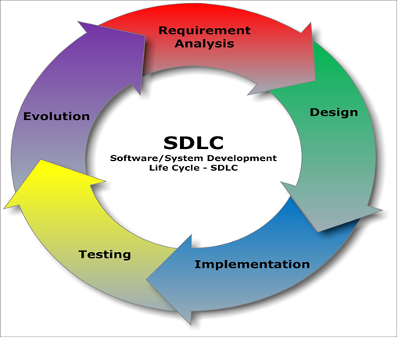

Figure 2.1**–** Software Development Life Cycle

### 2.3.1 Software Development Life Cycle Process Model:

Different people use various models for the development of software. Without using any specific model, we may face different problems like insufficient space for design and testing. Additionally, the assortment of procedure models significantly affects the productivity of the established application. For our planned project, we pick the Waterfall model owing to its bulging features like testing amenities during various iterations.

### 2.3.2 Waterfall Model:

The waterfall model is familiarized as the first development model. In the Waterfall model, each individual phase must be accomplished before the subsequent phase or stage begins and there is no overlapping. In the "Waterfall Model" the complete process of software development is separated into discrete phases. The productivity of one phase is used as the input of the succeeding phase sequentially means that the next phase in the development process starts after the completion of the preceding phase. The waterfall model is a progressive design process in which we are moving downwards through the subsequent phases like initiation, Requirement analysis, Design Construction, Testing, Implementation, and maintenance.

Requirement Analysis

System Design

Implementation

System Deployment

System Testing

System Maintenance

Figure 2.2– Waterfall Model

### 2.3.3 Consecutive Phases in the Waterfall Model

* *Requirement:*

The initial stage comprises understanding what requirements to be designed, its function, and its purpose. This phase also contains the specification of input or output final product.

* *Design:*

The requirements and specifications of the first phase are studied in this phase of the cycle, and the system design is prepared. The overall architecture of the system is defined through the design phase. It also specifies the hardware and software requirements.

* *Implementation:*

By means of the input of system design, initially, we will develop the system in a minor program called a unit, which is unified in the next stage. Each part is established and functionally verified and referenced as a unit or part test.

* *Integration and testing:*

After performing unit tests, we will combine all units into a separate system, to check it for error.

* *System deployment:*

After performing a unit test and integration test we will install or deploy the software into the android compatible environment where users can download. We will try to find errors if found.

* *Maintenance:*

We will use this step after completing and releasing the final product. This phase will be used to improve software performance. This feature appears due to a modification request made by a customer or a fault found through real-time use of the system.

We are moving slowly downward to the different phases of the waterfall model. We can’t move forward if the previous phase of the project has not been completed.

### 2.3.4 Advantages of Waterfall model

* It allows dividing the project into small unit control.
* It is simple and easy to understand and use.
* We can easily manage due to the strictness of the model – each phase has a specific review process.
* Consecutive phases are completed one at a time.
* It performs better in small projects especially when the requirements are clearly understood.
* A schedule can be set with deadlines for each stage of development and a product can advance through the development process like a car in a car-wash, and theoretically, be delivered on time.

### 2.3.5 Disadvantages of Waterfall model:

* It does not allow for much revision.
* Once an application is in the testing stage, it is very difficult to go back and change something that was not well-thought-out in the concept stage.
* No working software is produced until late during the life cycle.

### 2.3.6 When to use the Waterfall model:

* Requirements are very well known, clear and fixed.
* The product definition is stable.
* Technology is understood.
* There are no ambiguous requirements
* Much resources with required expertise are available freely

## 2.4 WHY ARE WE USING WATERFALL MODEL?

We are using this model because:

* Our final year project evaluation is done through phases of wise completion of the project. So, it is best to follow this model.
* It is very easy to understand.
* It is very simple.
* There is a review system for each phase which reduces error propagation into the next stage.
* Scheduling and planning are also set for each phase in this model. So, we will complete each phase on time.

## 2.5 SDLC FOR OUR PROPOSED PROJECT

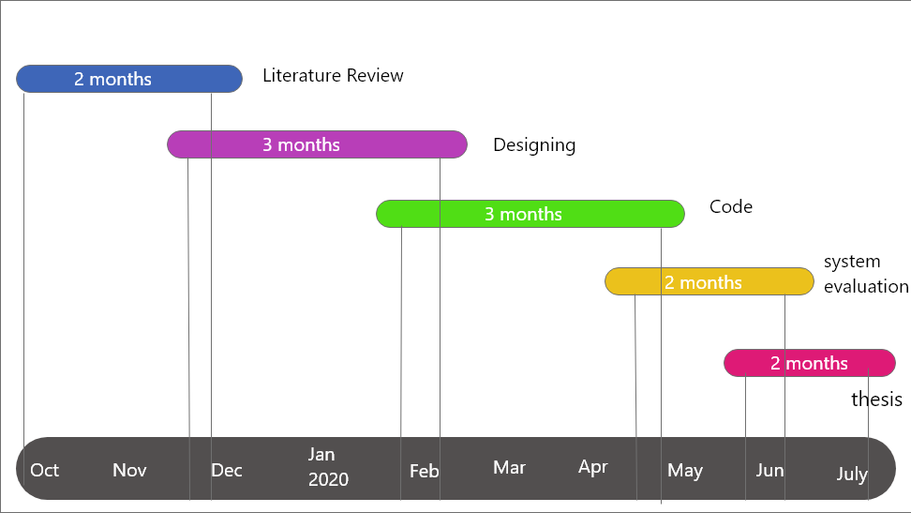

Figure 2.3– SDLC for our proposed project

### 2.5.1 Analysis Requirement and Literature Review

We have successfully completed the analysis requirement and literature review in approximately two months of time. We collect different information about the organization and also list out the requirements which are necessary for the implementation of the project. This phase will be the input for the next designing phase.

### 2.5.2 Initial Designing:

The requirement we collected will work as a base for designing. We have planned to complete the designing phase of our project in the next 3 months.

### 2.5.3 Coding:

After the completion of the designing phase, we will complete the coding phase in 3 months of period.

### 2.5.4 Evaluation:

After completing the designing and coding phase we will evaluate our system by performing different tests in 1 month. It will help us to remove errors from our project.

# Chapter 3: REQUIREMENTS AND PROPOSED SYSTEM



## 3.1 Requirements:

Identifying requirements are important for converting an idea into some real-world application. Because we can’t go directory to the development without knowing the proper requirements which are necessary to develop the proper application. Basically, all projects are developed by identifying the following requirements for their project. We are also identifying these requirements for our projects.

* Functional requirements
* Non-Function requirements
* Software and Hardware requirements

### 3.1.1 Functional Requirements:

* User will register itself with application
* User can update their profile
* User can donate, request and can track ambulance nearest to them
* User can post for missing person recovery
* Admin can delete, update and can modify different user information
* Admin can register drivers for their center.
* Users can search for details, centers, and ambulance driver details.

### 3.1.2 Non-Functional Requirements:

* Role-based control will be implemented. Admin, Users, and driver will only use those features of the application which are allocated to them.
* The application will be available 24 hours a day.
* The centers' admin and registered drivers will respond quickly.
* This application can be installed in already used phones.

### 3.1.3 Software and Hardware requirements

Development tools are given below:

*Hardware:*

MacBook for iOS and any other laptop on which android studio can be run.

*Software:*

* Eclipse or Android Studio
* Swift
* Google Maps
* Firebase

## 3.2 Proposed System

To overcome the various issues in the manual system associated with Edhi Trust services can be formally and efficiently computerized. The services like reporting missing persons or requests for monetary donations, blood donations and ambulances can be shared among the users by using internet-enabled mobile phones. The main objective is to facilitate the community by sharing and managing relevant information in a short period of time.

We are proposing to develop an android as well as an iOS-based application which will have the following modules:

### 3.2.1 Admin:

There will be many admin accounts; one admin for each centre. The admins will be responsible for the overall management of the system and their centres. The admins will upload information about their centre’s data. There will be a filter for search by the centre where the user would be able to see all contained information about every centre. All admins would be able to see one another's centre information. Admin would be able to modify and delete the user post. Admin would also influence the user account creation and deletion.

### 3.2.2 Users:

Users are authenticated through a one-time password (OTP) method. Biometric authentical is also used by many applications. Usually, figure prints are used for this purpose. The applications after login, give an informative dashboard providing some important data relevant to the users. Different users may get different information on their home layout pages depending on their requirements.

The user interface would be friendly and usable. They will be able to see the uploaded Post by scrolling up or down. Along with that, there will be various filters for searching i.e. age, name, city(location). There will be a usable option for uploading data for a founded or missed person. The user will be asked to put the name, location and age and picture (if possible) before uploading the post. there will be an option for donation.

### 3.2.3 Ambulance Users:

The ambulance user will be operated by the ambulance drivers. Using these accounts other users will be able to track them. Each ambulance user will be bounded with his/her mobile number which will be shared with the users when they require to contact them. The ambulance user can set their status as free or hired depending upon their situation.

### 3.2.4 Missing Person

There will information about missing persons. Every post will have on identification based on name, picture, location and time. This app will be launched on the basis of SIM data so there will be the availability of contact to person. This all can be uploaded to the database through this application.

### 3.2.5 Blood Donation

Users can request for blood. A blood request will be sent to the admin for validation. Users can check the details of blood like total packs of blood in a centre and how many groups of blood there are in a centre available.

### 3.2.6 Donation

Users will be able to donate items they want by just entering their detail to the application.

## 3.3 Features of the Proposed System

The proposed project will have numerous features for users and administrators. The main objective is to make the application more user-friendly and flexible covering all the aspects of the targeted domain. Some features of our project are given below:

### 3.3.1 Display of various Information

With the help of the app, one can be able to see various posts. The information may include the missing person, information about donations, news feed. it would be a specific app for Edhi and every individual would be benefited by using this app within specified credentials.

### 3.3.2 Customization of app

The app would be usable and functional in all aspects. Moreover, the user would be able to search a distinct category of a post by using different filters i.e.:

* Search by center
* Search by category

1. Missing person
2. Blood donation
3. Ambulance

The dashboards and interfaces would be automatically changed by going in various searches.

### 3.3.3 Reports

The user would be able to poke the post that is fake, unethical or unwanted and admin would take action against the post. He might delete it totally or resolve the problem. Admin can have access to every user because the app would launch by number. And through a number one can access his CNIC number and take action against any unwanted act.

### 3.3.4 Login Options

Various options of login would be implemented. These may be:

* Auto login
* Smart login
* OTP
* Pin
* The typical method of login by name and password

### 3.3.5 GPS based ambulance tracking

There almost 1800 working ambulances of Edhi organization. They are not GPS based. There is one emergency number 115 through which they regulate the service. Its main office is in Karachi.

We shall make such an app in which the ambulances can be tracked by GPS. It would reduce the time of service delivery and would increase more efficiency in emergency cases.

During the occurrence of an accident, the victim presses the “Help” button in the Smartphone application which would generate and sends location along with the victim’s identity to the database server or can directly search nearest ambulance enters and can call through calling button.

# Chapter 4: Analysis and Design

**4.1 Introduction:**

Design is the second phase of the software development life cycle. In designing we are making plans for the implementation of our software. Plans should be made clear so, that the error generations in designing phase is less or has no errors in all. If we made plans that are erroneous then our software after development will either be failed or its costs will be much higher then we expect. So, designing is the plan to convert your idea into some real interface. It is actually a plan for the construction of the software in best way. The designing actually refers to the following

* How different activity of the designing work.
* The design process which shows that how that activity of the design is planned
* What will be the result of the activity and process in design?

Different stages are involved in designing. Before jumping into the production of real interface we go through the following sequential stages which are necessary for constructing and developing application. These stages are called pre- production design stages. These stages are given below.

* **Design brief**:

In design brief we prepared an early statement for our design. In this statement we analyze all modules which are included in our design and how they interact with each other.

* **Analysis of our design goals:**

In this stage we analyze different goals of our software. In our software we analyze all modules and how they will work when the user uses this application in daily life.

* **Researched:**

We researched similar design interfaces so that we can develop better user interfaces.

* **Specification different modules of design:**

We have specified different modules of our design for our software. We also specified different design solutions for each of these modules.

### 4.2 Designing during production:

During design we worked separately on each design phase of our software. Tried to improve and brings some new features in design.

### 4.3 Objectives of design:

Design provide an easy interface to the user which are helping them to solve their real-life problems. Our design will provide an easy interface to the user through which user can upload the data of missing persons to the application which will be seen by other users. We will provide and easy interface through which user can donate and request for blood and can also find nearest ambulances in case of emergency.

* To provide user friendly interface.
* Design will give an efficient way of finding information’s
* The design will be easy to learn

### 4.4 Our project design components:

Our project consists of three different applications which are given below:

* **User application**
* **Driver application**
* **Admin application**

**4.4.1 User application:**

User application has the following features

* Design phase for uploading missing person data into application
* Design module for searching the different request about missing person and blood requests uploaded by different users
* Design module for searching different centers
* Design module for searching addresses of different centers in KPK.
* Design module for updating users’ profiles

**4.4.2 Driver application:**

Driver application has the following features

* Design module for getting user notifications and providing information that whether driver is available or not
* Getting the location of the user who need the service

**4.4.3 Admin application:**

Admin application has the following features

* Design module for getting user notification.
* Design module for deleting data uploaded to an application
* Design module to upload data about centers
* Design module to add new ambulance driver

### 4.5 Activities used for better design development:

Analysis and design help in the transformation of requirement specifications into implementation, which are helping in developing users’ friendly interface of our software.

Software analysis and design is the middle phase, which helps human-readable requirements to be changed into genuine code.

The list given below is used by the designer for effective, user friendly and efficient interface.

* **DFD**
* **Use case diagram**
* **Sequence diagram**
* **Activity diagram**
* **Class diagram**
* **Components diagram**
* **State Diagram**
* **Package Diagram**
* **Component Diagram**
* **ERD diagram**

We will construct sequence diagram, use case diagram, activity diagram and entity relationship diagram for our project.

### 4.6 Modeling the Project:

Modeling the system is the process of extracting and forming important structures that how the system will look like. Modeling is done before coding. UML tools is used in modeling the system.

* **UML**

UML is the object-oriented system notation that is used to specify the software system in terms of objects. We will use the following diagram for better designing of our project

* **Use case diagram**
* **Sequence diagram**
* **Activity diagram**
* **ERD diagram**

### 4.7 Use case diagram:

Use case diagram in our project will summarize different details of the software users which are associated with our project. The system users are also known as actors of the system. In this diagram we will show that how our software interacts with different user of the software. We will use different connectors for making association of different users with system. Use case diagram will help us in making.

**Objectives of use case diagram:**

* It will help us to make scenario in which the software interacts with the people
* Goals of our system that helps the users
* The scope of our designed system
* It will help us to make the basic flow of events in our system
* It will help us to know the requirements for our system

**4.7.1 Use case diagram notations:**

Different notations are used for construction use case diagram. The short description of these components is given below

* **System:**

It shows the particular actions between the system and actors. It is also called as scenario. Diagrammatic representation is given below

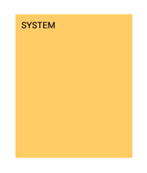

Figure 4. 1-System

It is horizontal oval shaped structure diagram which show the different uses of the users. Diagrammatic representation is given below

* **Actors:**

Actor can be an entity which is interacting with the system. The entity can be a person, an organization or an outside the system which can interact with the system.

* **Associations:**

It is a line between use case and an actor which shows that how an actor is related with use case. Associations are of two types

* **Extend**
* **Include**

Diagrammatic representation of the associations is given below

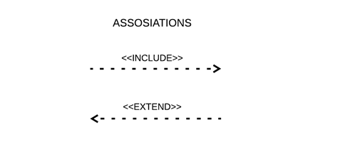

**4.7.2 Use case diagrams for our projects:**

As we are going to develop three different applications so, we have constructed three use case diagrams for each application. The detail of each use case diagram is given below

* **Use case diagram for user**
* **Use case diagram for driver**
* **Use case diagram for admin**

**4.7.3 Use case diagrams for users:**

The user use case diagram and its description are given below.

Figure 4. 2 User Case Diagram for User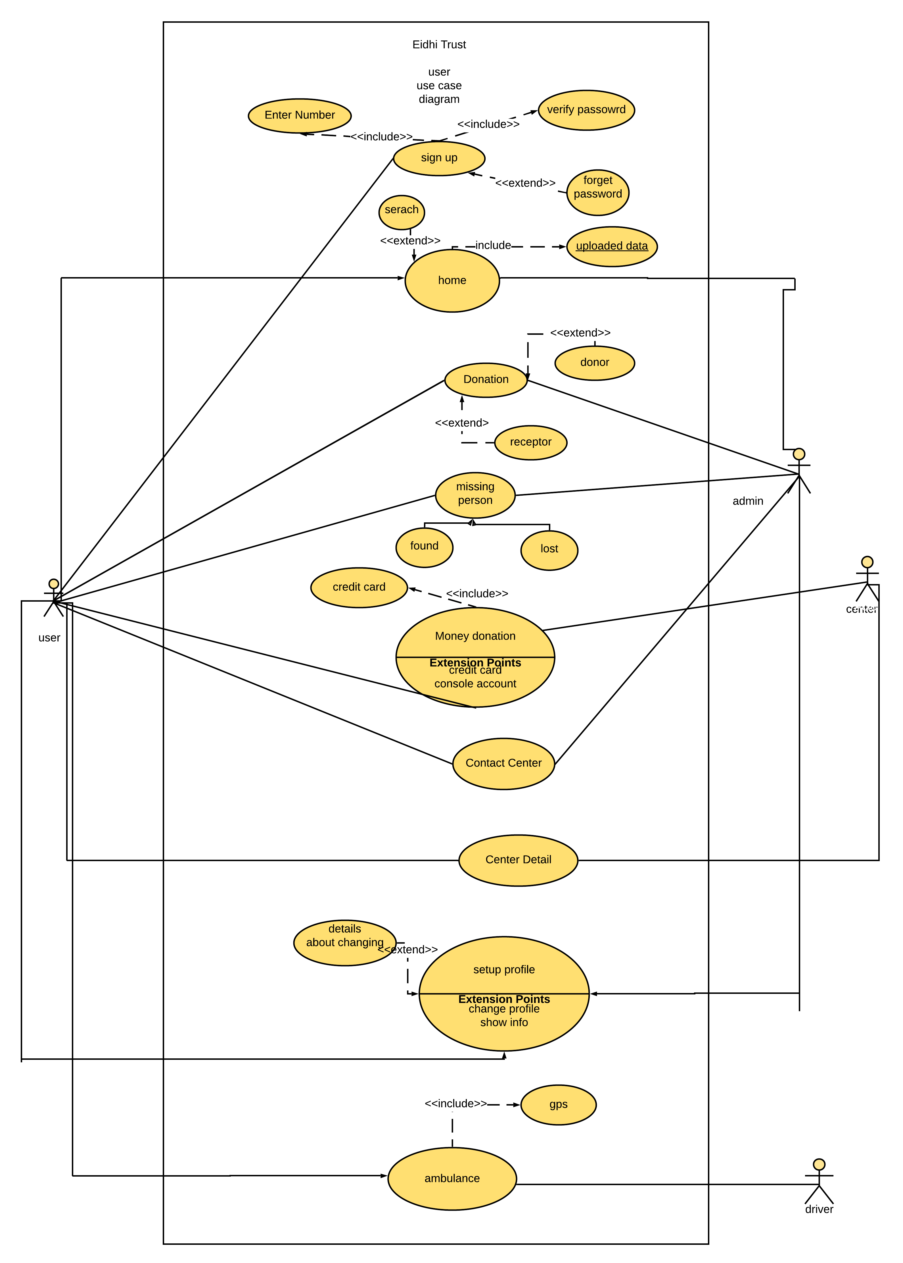

**Illustration about user use case:**

The description of the user use case diagram is given below:

* **LOG IN:**

First of all, there is a log in use case that is related with the user only.

* **HOME:**

It’s the second use case. it contains all the uploaded data .data may contain post about missing person or blood donation. User and admin can see it. there is option for search. a search through many filters can be done.

* **BLOOD DONATION:**

The third use case is of blood donation. A person can donate the blood or can request for a blood. the post can also be viewed by the admin. it means the user posts will be added to newsfeed and can be viewed by filters or suggestion.

* **MISSING PERSON POST:**

The fourth use case is for missing person / found person details updating. A user can upload the post about this scenario with some information attached with the very particular post. This use case also related with admin actor because every user post will be on home page in app. and any other user or admin can access that post.

* **MONEY DONATION:**

The fifth use case is for money donation. He would be able to donate money by his account number. this is related with the center actor.

* **CONTACT CENTER:**

This use case would be used to have the direct access to center for specific purpose.

* **CENTER DETAIL:**

This is the seventh use case. it would contain all stored information about the centers. This use case is related with two actors one is user and the second center.

* **CHANGE IN PROFILE:**

The eighth use case is related to modification in profile. which simply means the changes with cell number or address may be updated for better services. There would be many blanks with updating button at end which simply apply modification in data base.

* **AMBULANCE BOOKING:**

The ninth use case is for ambulance. The user(actor) is related with driver of ambulance (actor). This relation would require the use of GPS for offering and getting the service.

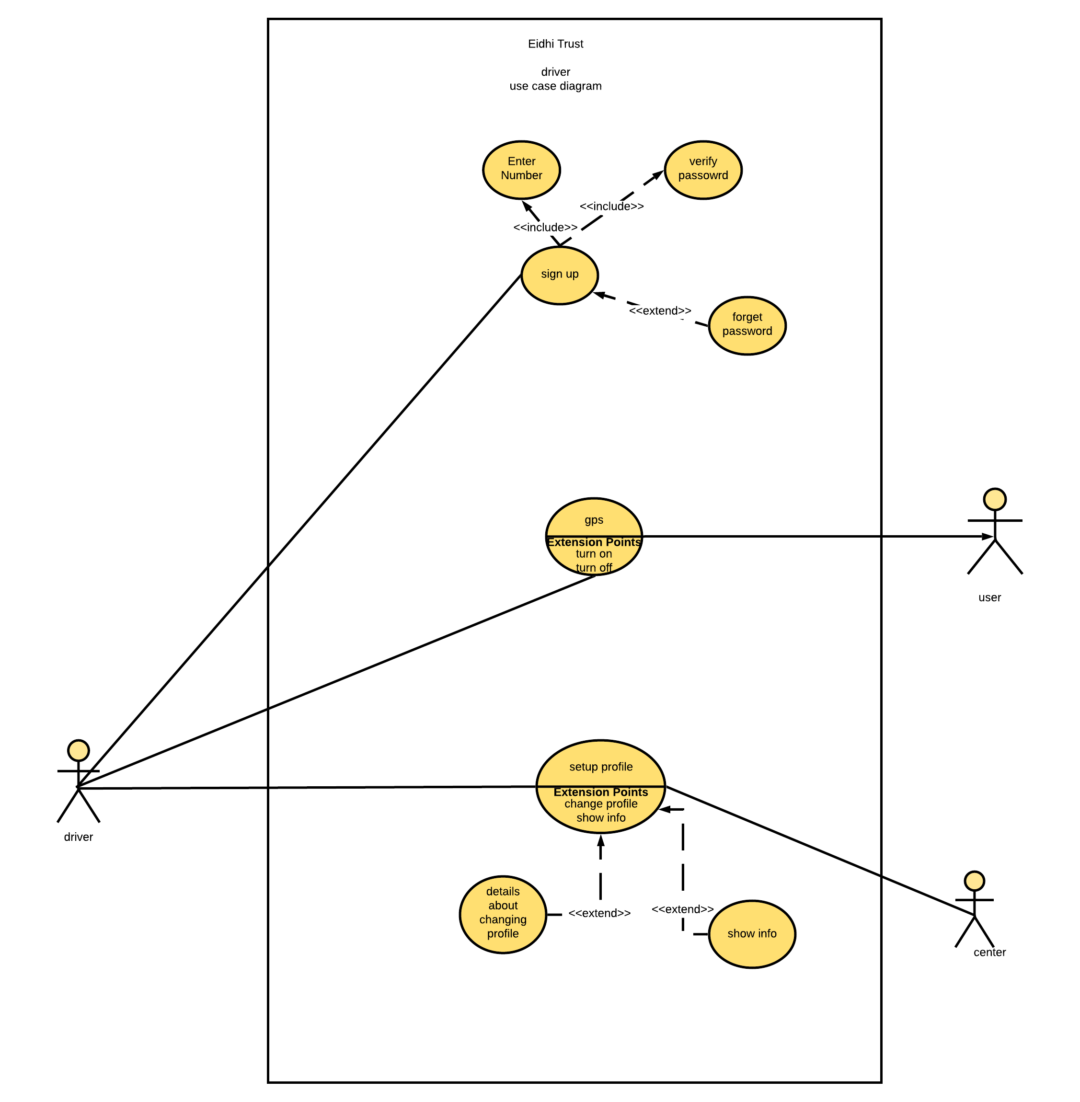**4.7.4 Use case diagram for driver:**

**Illustration about driver use case:**

* **LOG IN:**

First of all, the driver would get logged in through number. This use case is only related to driver(actor).

* **BOOKING:**

The second use case is for providing ambulance service. there are two actors for this use case. The booking of the ambulance can only be availed when the driver’s and the user’s GPS is ON.

.

* **CHANGE IN PROFILE:**

Third use case is for changing or updating profile.

**4.7.5 Use case diagram for admin:**

The use case diagram of the admin is given below. We have attached description with this diagram so, that it can be understand in best way.

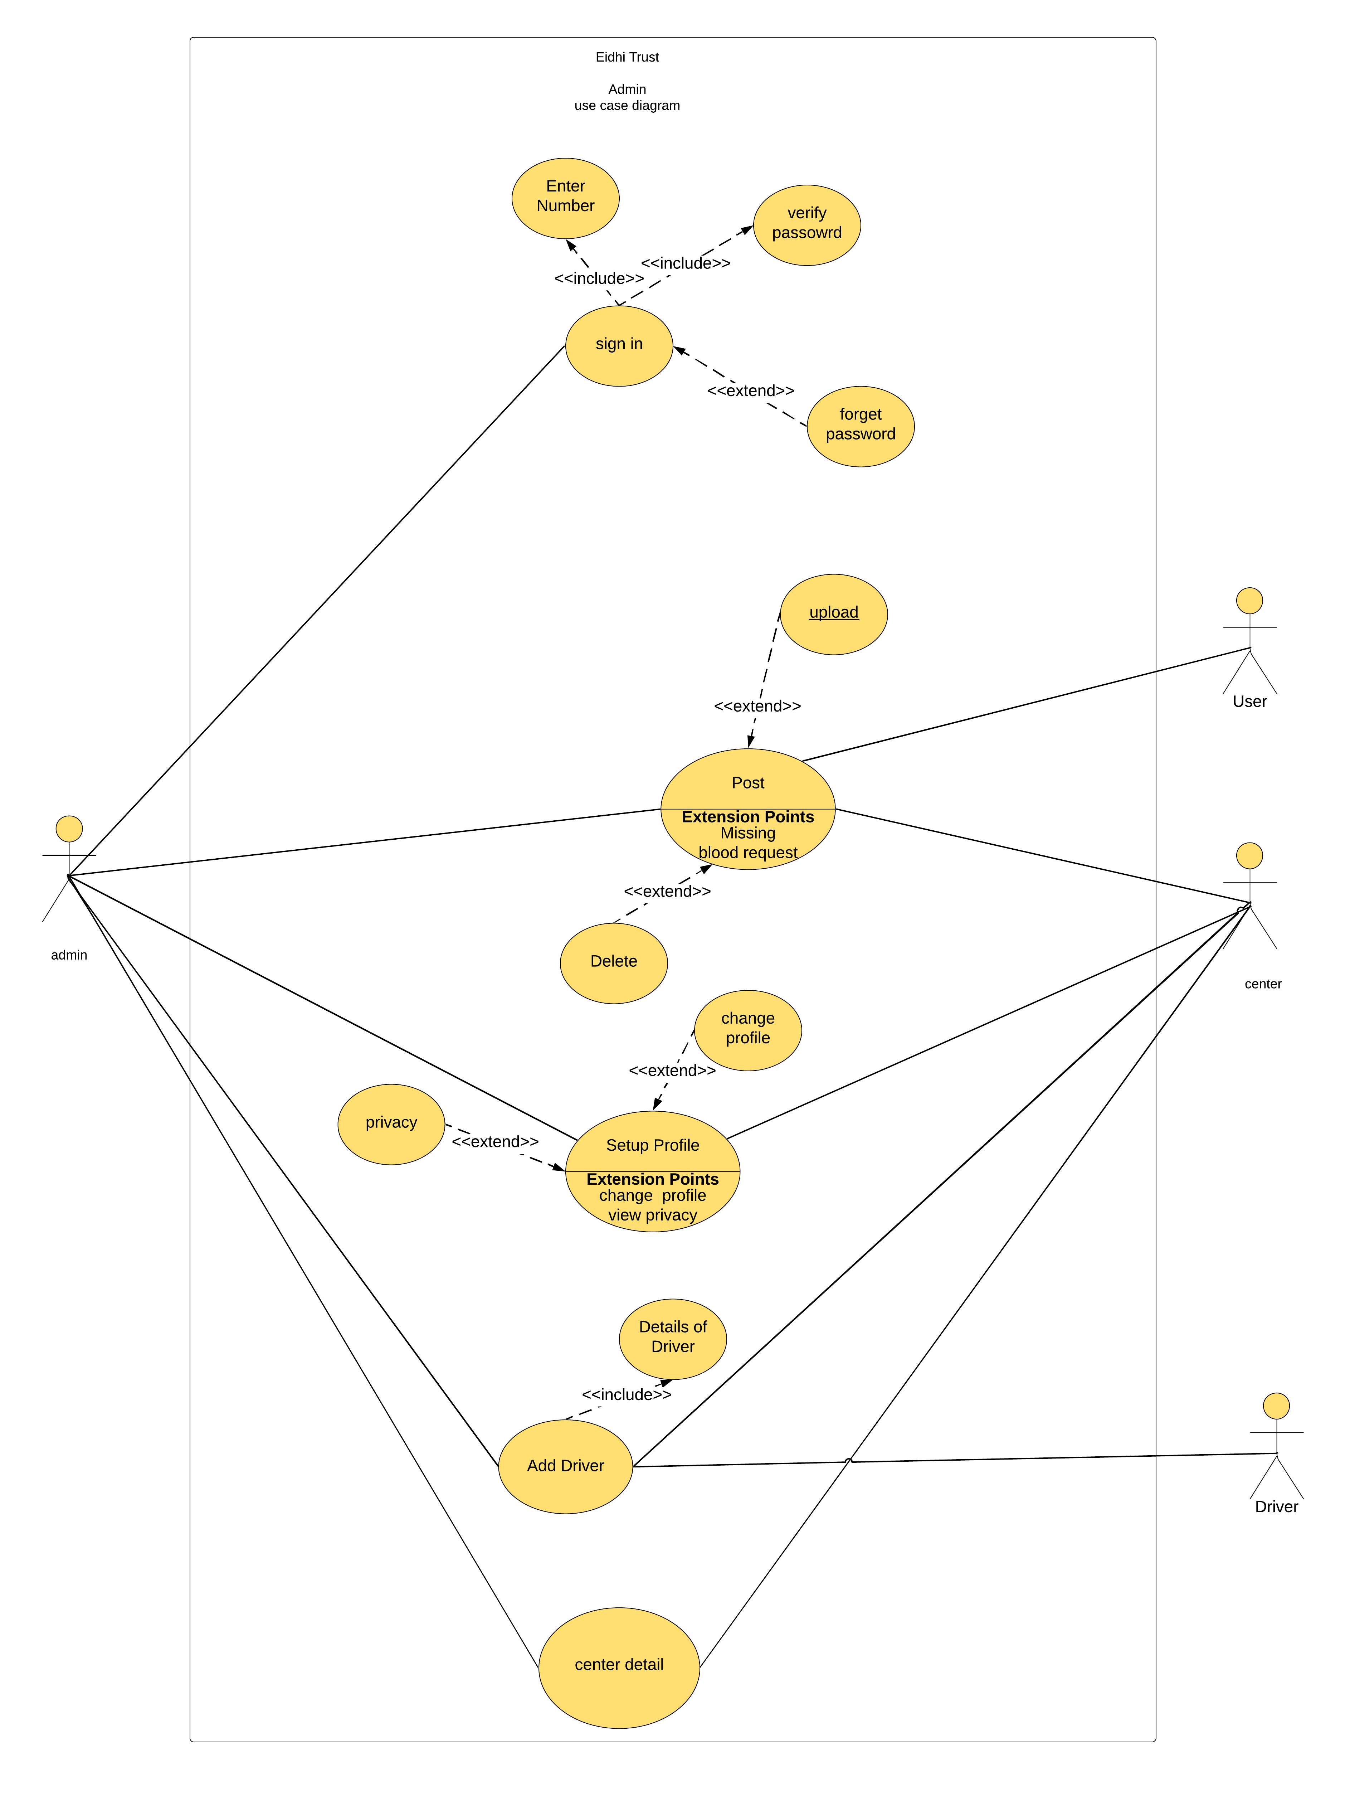

**Illustration about Admin Use case:**

There is closed system (Boundaries) that are defined for the use cases and actors.

There are 4 actors.

1. Admin
2. Center /database.
3. User
4. Driver

The use case in admin are given below:

* **LOG IN:**

First use case is sign up /login. the admin will be signed up or logged in with in the system for further process. However, there is no need of log in for center.

* **POST:**

The second use case is for post. like user an admin can also do posting. while in posting there will be further two options for missing person post and for blood post. this use case is related through arrows with 3 actors. admin user and center. it means that whatever admin posts that will be visible to user also and will be updated to center.

* **CHANGE IN PROFILE:**

The third use case if of change in profile that may be either for an admin or for center information. Because an admin can have different number or can upload different pictures. and same will be the case with another actor that is center. the center can be shifted from one place to another and can have other variables.

* **ADDING DRIVER:**

The fourth use case is for adding a new driving with in specified rules and regulations for a particular center. this use case is also related with both the actors for the sake of safe and easiness in working.

* **CENTER DETAIL:**

The last use case is center details. the details about center can be visible to user and can only be managed by the admin. so admin and center would have combined relation from this perspective.

### 4.8 Activity Diagram:

It is the behavioral diagram of the system which describe different aspects of the system. It shows the flow one activity to another activity.

* **Notations used in activity diagram:**

Different notations are us in activity diagram. The detail of each notation is mentioned below.

1. **Initial state:**

It is a small circle which is followed by the arrow which shows the initial action state. The arrows from the circle also shows the start point for any activity.

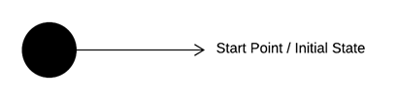

1. **Activity or action state:**

It is used to represent the set of actions in diagram. The notation used for activity is given below.

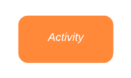

1. **Control flow:**

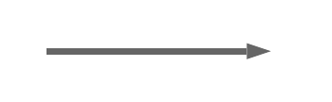It shows the flow of control in diagram. It is represented by an arrow.

1. **Object flow:**

It shows the flow of an object from one activity to another activity.

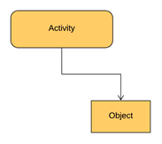

1. **Decision and branching:**

It shows that the control flow and object flow go down one path.

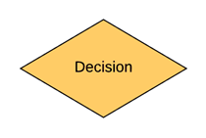

1. **Guard:**

Guard is a statement that is written next to the decision notation. This must be true before going to the next activity.

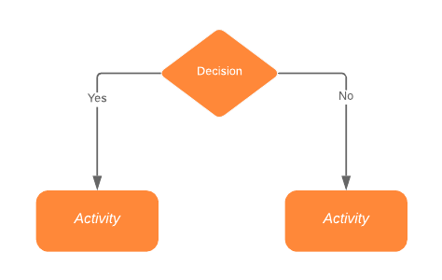

1. **Synchronization:**

Two nodes are used in synchronization one node is called fork node and another node is called join node. Fork node is import for splitting of incoming flow into two or more concurrent. Join node joins two multiple flow into a single flow.

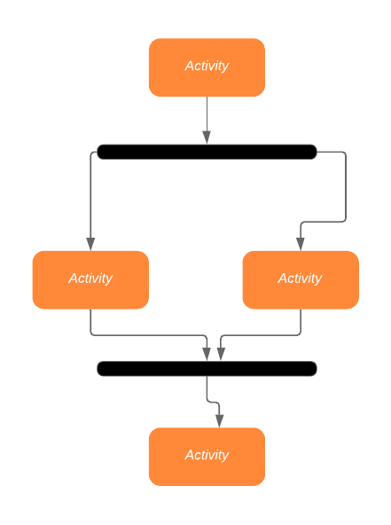

1. **Time Event:**

It stops flow for some time. Diagrammatic representation of the time event is given below

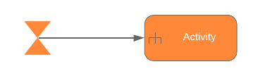

1. **Object:**

Object is connected to a set of object flows. Diagrammatic representation of the time event is given below

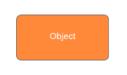

**4.8.1 Activity diagrams for our projects:**

As we are going to develop three different applications so, we have constructed three use activity diagrams for each application. The detail of each use activity diagram is given below

* **Activity diagram for user**
* **Activity diagram for driver**
* **Activity diagram for admin**

**4.8.2 Activity diagram for user:**

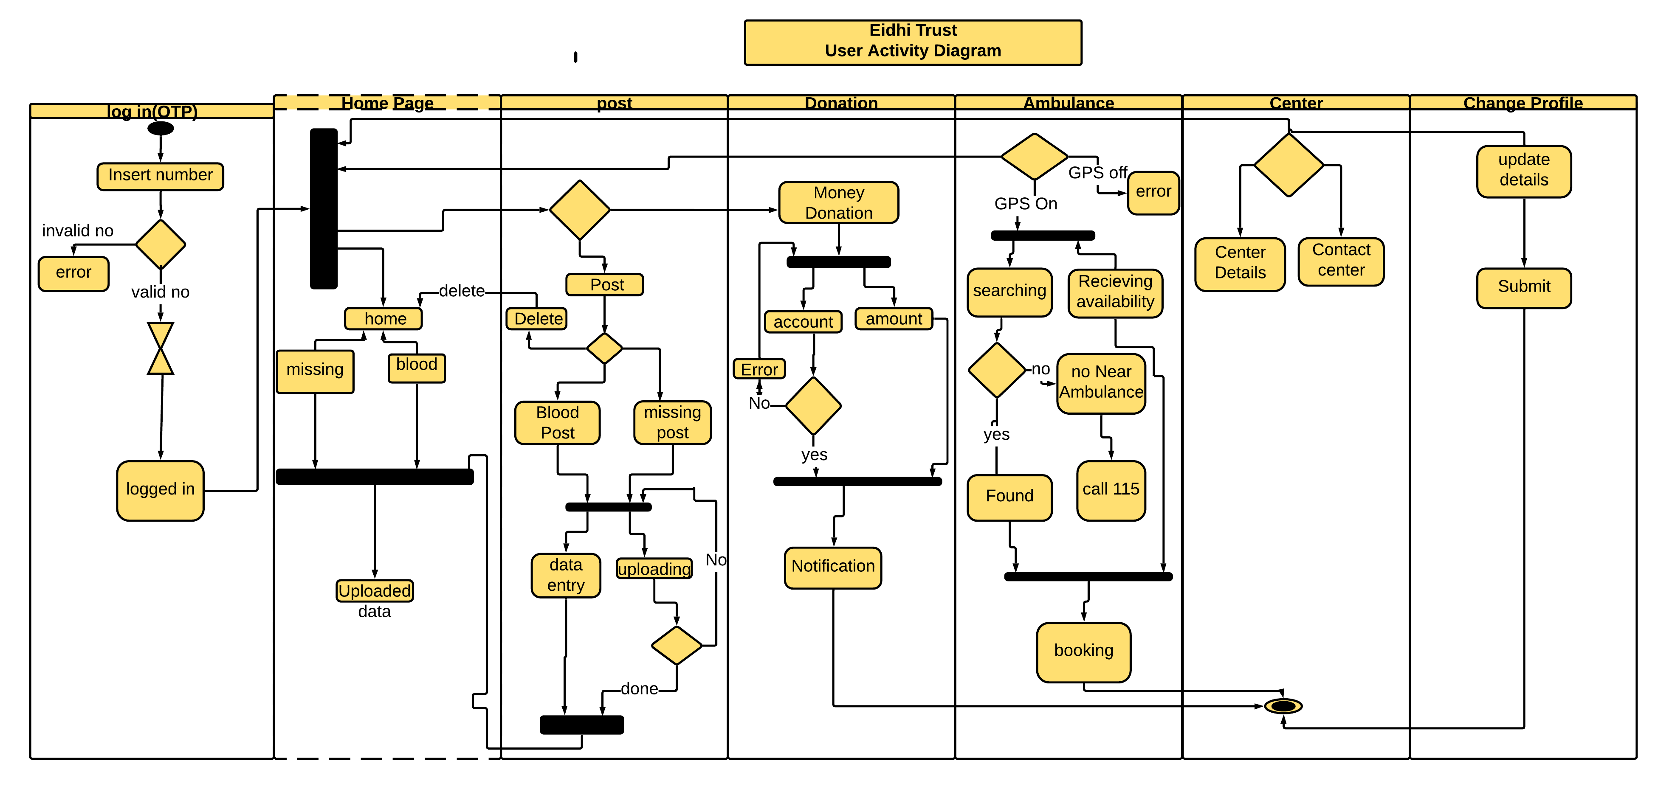

* **ILLUSTRATION ABOUT USER ACTIVITY DIAGRAM:**
* **LOGIN:**

The log in activity start from launching an application. The user will enter his number and will get a pin. the actions flow from log in activity to decision taking activity. if the number is incorrect there will be an error shown on screen. if the number is correct then it will take some time and user will get a code and will be able to switch to home page.

* **Home dashboard:**

In home page there is fork node which means that the admin will be able to do many things which will be available on home dashboard.

* **Home:**

In home activity there will be uploaded data. It means all the post that would be related to missing/ found person and blood related posts. These posts may be either uploaded by the user or by the admin. These data collectively will make home activity.

* **Post:**

In post activity a and admin will have the options for posting the various posts. i-e for blood or missing person. Admin will give a new layout for data entry. the data entry and uploading process will be in simultaneous way. they are combined by the use of fork node. If the required information’s are fulfilled the post would be uploaded and can be viewed in home. If the post is not uploaded due to some errors then the admin will still need some corrections and would be shifted back.

* **AMBULANCE:**

This activity is use for getting the ambulance service through the use of GPS.

* **CENTER:**

This activity is for the connection between the user and the centers. A user can check the contact details as well as the center details.

* **CHANGE PROFILE:**

In this activity user will be able to change his location, number and other values if he wants. There will be a button at the bottom which will send the new information to the data base.

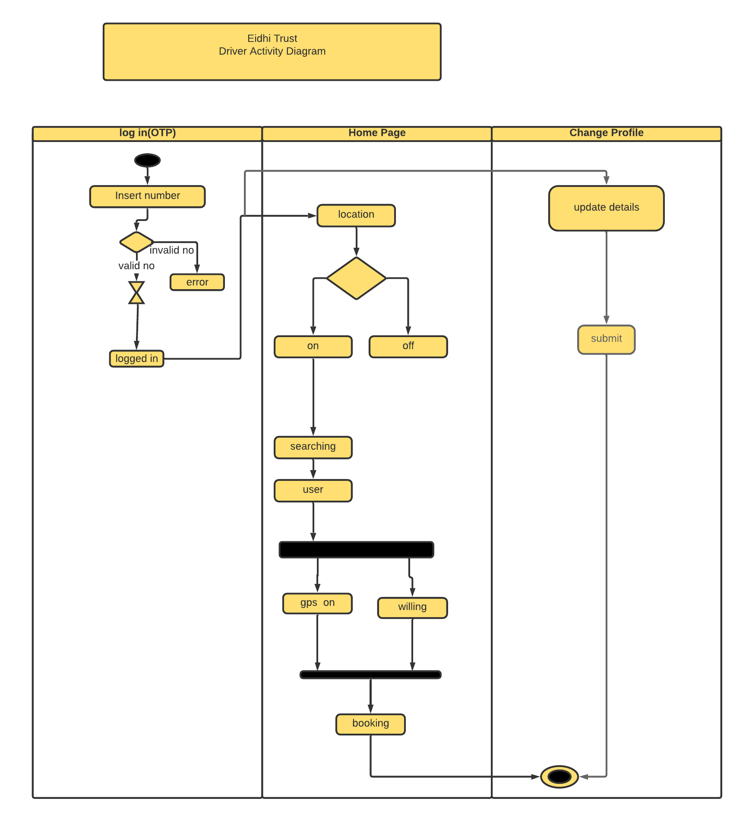**4.8.3 Activity diagram for driver:**

* **ILLUSTRATION ABOUT THE DRIVER ACTIVITY DIAGRAM:**
* **LOGIN:**

The log in activity start from launching an application. The driver would enter his number and would get a pin /pass for safe. The actions flow from log in activity to decision taking activity. if the number is incorrect there would be an error shown on screen. if the number is correct then it will take some time and user would get a code and would be able to switch to home page.

* **HOME PAGE:**

There would be a number of various variables. like location, name, and the distance. By keeping ON the GPS he would be able to search for the users, otherwise not. these are illustrated by the decision-making figure.

* **CHANGE PROFILE:**

In this activity driver would be able to change his location, number and other values if he wants. Which would send the new information to the data base.

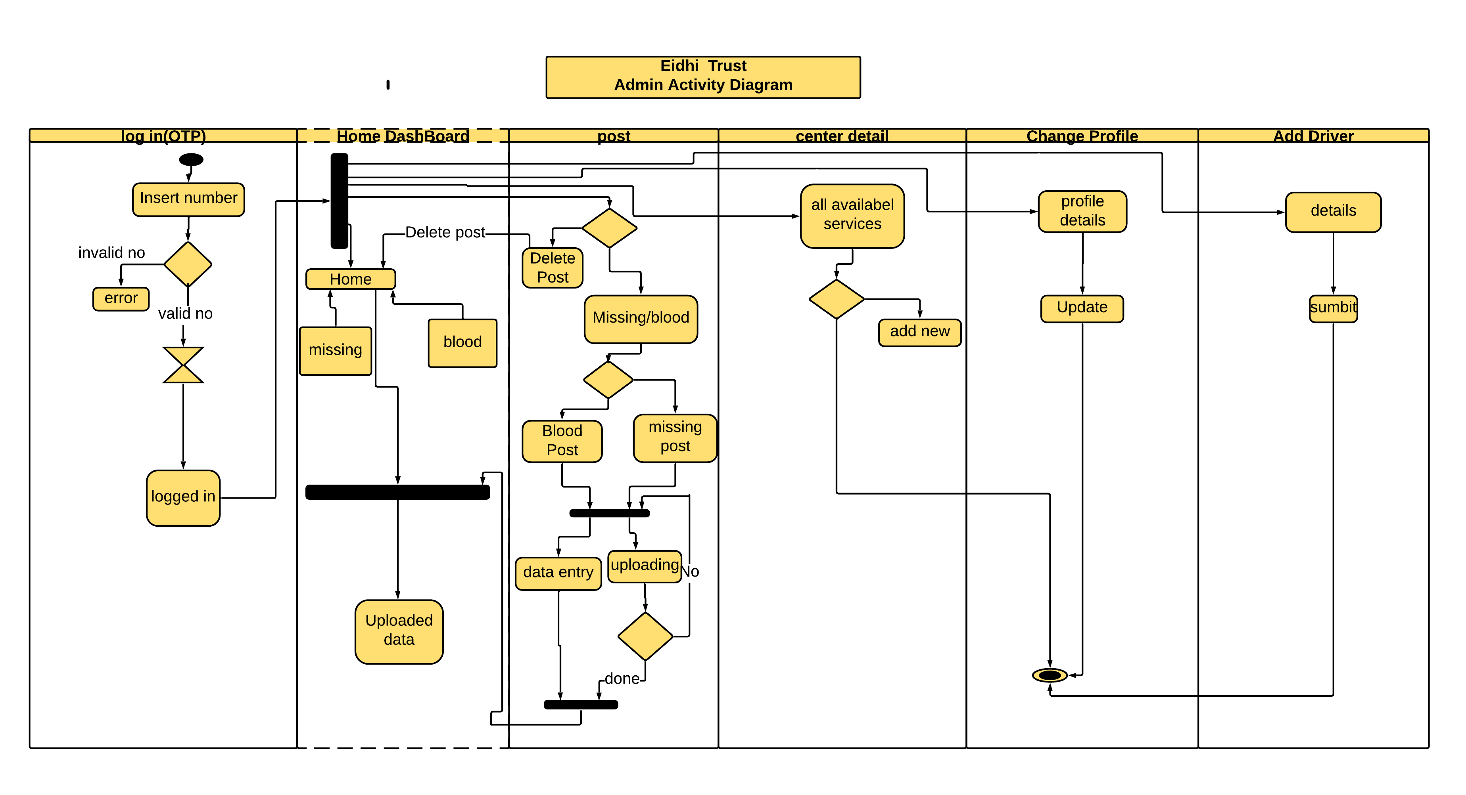**4.8.4 Activity diagram for admin:**

**Illustration about Admin activity diagram:**

* **Start:**

The log in activity start from launching an application. the admin would enter his number and would get a pin /pass for safe the actions flow from log in activity to decision taking activity. if the number is incorrect there would be an error shown on screen. if the number is correct the admin would be able to switch to home page.

* **Home dashboard:**

In home page there is fork node which means that the admin would be able to do many things which would be available on home dashboard.

* **Home:**

In home activity there would be uploaded data. It means all the post that would be related to missing/ found person and blood related posts. These posts may be either uploaded by the user or by the admin. These data collectively will make home activity.

* **Post:**

In post activity a and admin would have the options for posting the various posts. i-e for blood or missing person. Admin would give a new layout for data entry. the data entry and uploading process would be in spontaneous way. They are combined by the use of fork node. If the required information’s are fulfilled the post would be uploaded and can be viewed in home. If the post is not uploaded due to some errors then the admin would still need some corrections and would be shifted back.

* **CENTER DETAILS:**

This activity would have all the contained information of very center. The information would be of available services only. for example, a center has 3 orphans, 4 widows and 5 old people, and some stuff about blood. that would be in center details. Along with it there would be a method of incrementing any variable. this all data would be stored in database.

* **CHANGE PROFILE:**

In this activity and admin would be able to change his location, number and other values if he wants. There would be a button at the bottom which would send the new information to the data base.

* **ADD DRIVER:**

This activity is for hiring the driver to the center.

### 4.9 Sequence diagram:

* It describes the high-level interaction of users with system
* It also describes the high-level interaction of system with other system
* It also describes the high-level interaction between subsystems and for this reason this is sometime called as system diagram.

**Objective of sequence diagram:**

* It shows the high-level interaction among objects in system.
* It shows the interaction between object instances within a collaboration that realizes a use case
* It shows the interaction between objects within a collaboration that realizes an operation

**4.11 Sequence Diagram for our projects:**

As we are going to develop three different applications so, we have constructed three Sequence diagrams for each application. The detail of each use activity diagram is given below

* **Sequence diagram for user**
* **Sequence diagram for driver**
* **Sequence diagram for admin**

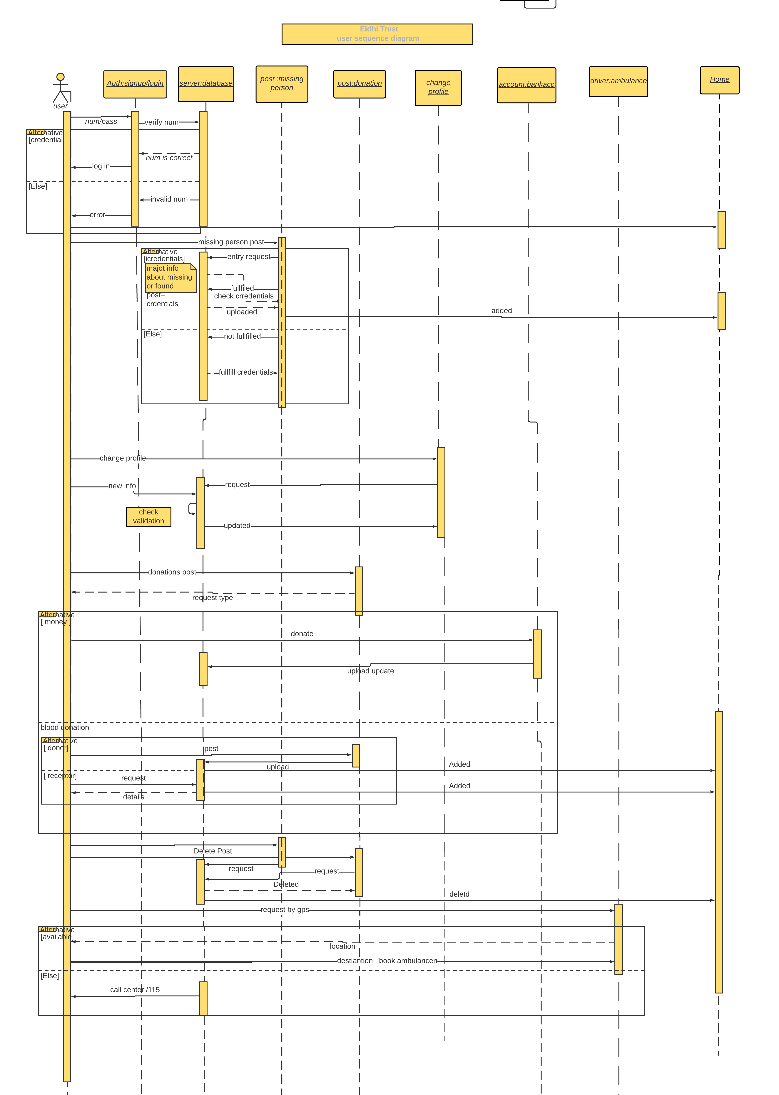**4.11.1 Sequence diagram for user:**

**4.11.2 Sequence diagram for driver:**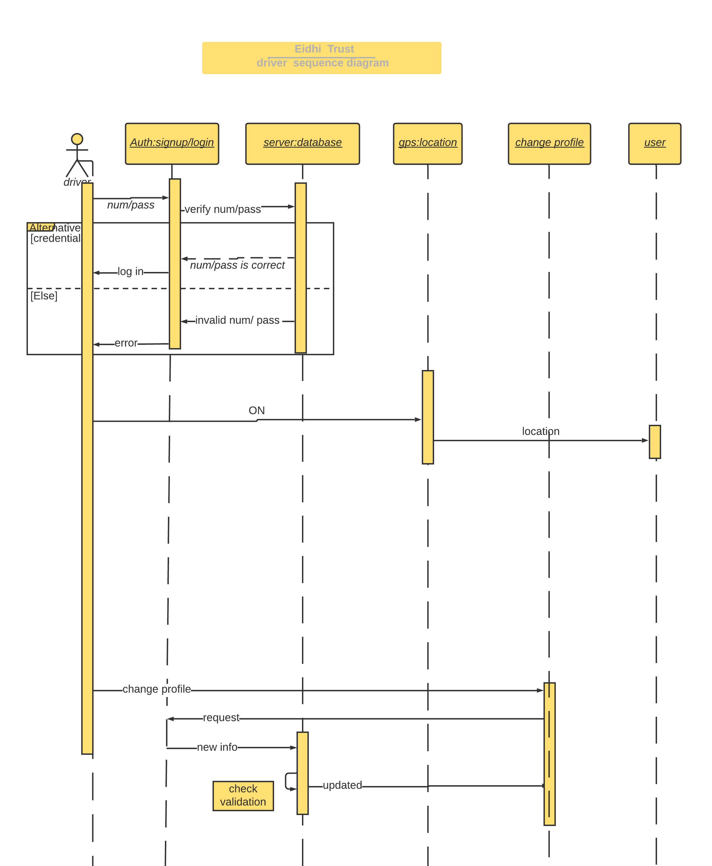

# Chapter 5: Implementation

Framework execution is where dreams and plans become reality. The goal of usage stage is to move framework configuration in to PC executable programming. Framework usage characterizes the development, establishment, testing and conveyance of the proposed framework. After detail investigation and plan of the framework, the framework execution incorporates all other improvement stages to create a useful framework. In the usage stage, programming dialects, equipment and related instruments for the advancement of the undertaking are chosen by the nature and prerequisite of the venture.

## 5.1 Selection of Language:

As our application is in android studio and Android applications can be developed in Java, Kotlin, C++, C# and many other languages. As we have both Android Application and web-based application, so for Android application we used java for programming the backend of the Edhi application and and XML for the system design.

## 5.2 Tools and technologies:

The tools and technologies used for automatic timetable generator are:

* core I 3, core i5 and mac book 2013 has been used to build the software.
* XML and Adobe Xd has been used for design
* Java is used for back end coding
* swift is used for iOS development
* Firebase is used as a database.
* Waterfall model has been used as development model.

# Chapter 6: Testing

Programming testing is an examination directed to give partners data about the nature of the product item or administration under test. Software testing can likewise give a target, free perspective on the product to permit the business to acknowledge and comprehend the dangers of programming execution. Test methods incorporate the way toward executing a program or application with the goal of discovering programming bugs (mistakes or different imperfections), and confirming that the product item is good for use.

Programming testing includes the execution of a product segment or framework part to assess at least one properties of intrigue. As a rule, these properties demonstrate the degree to which the segment or framework under test:

* meets the necessities that guided its plan and advancement,
* reacts effectively to a wide range of sources of info,
* plays out its capacities inside a worthy time,
* is adequately usable,

## 6.1 Black-box testing

Black box testing is a technique for programming testing that inspects the usefulness of an application without peering into its inward structures or operations. This strategy for test can be applied for all intents and purposes to each degree of programming testing: unit, reconciliation, framework and acknowledgment. It is now and then alluded to as determination-based testing.

## 6.2 White-box testing

White-box testing (otherwise called clear box testing, glass box testing, straightforward box testing, and auxiliary testing) is a strategy for programming testing that tests inner structures or operations of an application, instead of its usefulness (for example discovery testing). In white-box testing an inward point of view of the framework, just as programming abilities, are utilized to configuration experiments. The analyzer picks contributions to practice ways through the code and decide the normal yields. This is similar to testing hubs in a circuit, for example in-circuit testing (ICT). White-box testing can be applied at the unit, incorporation and framework levels of the product testing measure. Albeit customary analyzers would in general consider white-box testing as being done at the unit level, it is utilized for incorporation and framework testing all the more oftentimes today.

## 6.3 Unit Testing:

**UNIT TESTING is a sort of programming testing where singular units or segments of a product are tried. The reason for existing is to approve that every unit of the product code proceeds true to form. Unit Testing is finished during the turn of events (coding period) of an application by the engineers. Unit Tests disconnect a segment of code and check its rightness. A unit might be an individual capacity, technique, method, module, or item.**

In SDLC, STLC, V Model, Unit testing is first level of testing done before integration testing. Unit testing is a Whitebox testing technique that is usually performed by the developer. Though, in a practical world due to time crunch or reluctance of developers to tests, QA engineers also do unit testing.

## 6.4 Test cases For Unit Testing

A set of test inputs, execution condition, and expected results developed for a particular objective, such as to exercise a particular program path or to verify compliance with a specific requirement.

A test case is a set of condition or variables under which a tester will determine whether an application or software system is working correctly or not.

A series of test are performed again and again in the order to find that system is working correctly out.

### Test case 1: **Enter Valid and active number and OTP**:

|  |  |
| --- | --- |
| Test case name | Login checking. |
| Precondition | User must give valid and active sim number and OTP. |
| Purpose | To see the response of the app after inserting valid data. |
| Input | Number and a OTP for login. |
| Expected Output | User should be added |
| Actual Output | User is added |
| Result of Test | No errors are found |
|  |  |

### Test case 3: Enter Inactive number:

|  |  |
| --- | --- |
| Test case name | Inactive credentials and the response. |
| Precondition | To enter inactive sim number . |
| Purpose | To check the response of the Log in module after entering invalid information |
| Input | Firstly, a number that is inactive. |
| Expected Output | OTP should be sent to the number. |
| Actual Output | Login failed for no OTP access. |
| Result of Test | Its user error and the user will have to active the very number for successful login. |

### Test case 4: Enter right OTP:

|  |  |
| --- | --- |
| Test case name | Enter right OTP and the response |
| Precondition | To get the OTP of varying digits. |
| Purpose | To check the response of the Log in module after entering valid OTP. |
| Input | The user can manually write the OTP or can auto fill the message. |
| Expected Output | Successful login. |
| Actual Output | Login successful. |
| Result of Test | User is logged in and switched to the front page of app. |

### Test case 5: Front page content:

|  |  |
| --- | --- |
| Test case name | Content check in front page. |
| Precondition | User must be logged in and have internet connection. |
| Purpose | To see all the options in one page with 2 horizontally scrollable recycler view for recent posts about blood donation and missing person are working or not |
| Input | Logging is must only once. |
| Expected Output | Post should have to be seen along with other modules. |
| Actual Output | Recent posts are seen along with some options provided the internet connection is good. |
| Result of Test | User become able to use the app in smoother way. |

## 6.5 Integration Testing:

NTEGRATION TESTING is defined as a type of testing where software modules are integrated logically and tested as a group. A typical software project consists of multiple software modules, coded by different programmers. The purpose of this level of testing is to expose defects in the interaction between these software modules when they are integrated

### Incremental Testing:

In the Incremental Testing approach, testing is done by integrating two or more modules that are logically related to each other and then tested for proper functioning of the application. Then the other related modules are integrated incrementally and the process continues until all the logically related modules are integrated and tested successfully.

### Test Cases for Integration Testing:

### Test case 1: Link Between Login and front Page:

|  |  |
| --- | --- |
| Test case name | Link between login and front page |
| Precondition | Valid and active number and right OTP. |
| Purpose | When user enters the credential for login it should be directed to the front page |
| Input | A number and OTP |
| Expected Output | Logged into front or first page |
| Actual Output | Logged in successfully |
| Result of Test | No errors are found |

# Chapter 7: Conclusion and future work

Our Edhi application is successfully made in order to facilitate the public to have a secure and easy application for the various services of Edhi foundation. This has been done after one year of efforts derived from three individuals. It has now 4 utmost services

## Missing person access through posts.

## Blood donation or request

## Ambulance service through GPS

## Donation of item and money

It works very well in this area and faces no problems in fulfillment of the need. There was no such a platform for the Edhi foundation. it will be very much helpful to digitalize the system and bring it to the way of good and easy access.

## 7.1 Future work:

As mentioned above the 4 major functions of the Edhi foundation has been digitalized. it is there by stated that the future work on this project will be the amendment of the new services. Edhi foundation has now a days more than 10 services that is provided to the public in different areas. LikeHospital Services, Childcare Services should be the most prior features to be added.

## ORIGINALITY REPORT

14% 10% 2% 12%

SIMILARITY INDEX INTERNET SOURCES PUBLICATIONS STUDENT PAPERS

|  |  |
| --- | --- |
| PRIMARY SOURCES |  |
| Submitted to Higher Education Commission  1  Pakistan  Student Paper | 5% |
| Submitted to American University of Kuwait  2  Student Paper | 1% |
| Submitted to New Horizon College of  3  Engineering  Student Paper | 1% |
| Submitted to University of Hertfordshire  4  Student Paper | 1% |
| www.slideshare.net 5  Internet Source | 1% |