1-Overview of project: Explain the purpose of this analysis

Steve wants to expand the date set to include the entire stock market over the past several years. Although the code works well for a dozen actions, it may not work as well for thousands of actions. And if so, the execution may take a long time.

The job is to refactor the code to be more efficient and easier to read and then determine if the code refactoring was successful in speeding up the execution of the VBA script.

Finally, a written analysis explaining the findings.

2- Comparison stock performance between 2017 and 2018 using images and codes



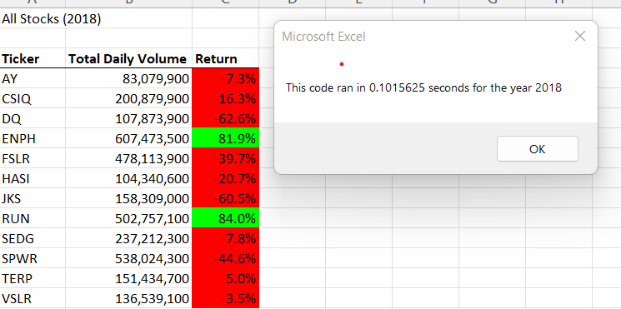

3- After refactoring, code is fresher, easier to understand or read, less complex, and easier to maintain. Cons of code refactoring: Takes time, you may have no idea how long it will take to complete the process. It can also put you in a situation where you don’t know where to go.

Potential benefit of refactoring may include improved code readability and reduced complexity, these can simpler, cleaner, or more expressive internal architecture or object to improve extensibility.

The main benefit of refactoring: Refactoring improves software design, makes software easier to understand helps us to find bugs and also helps to realize the program faster.

Refactoring has an additional benefit. It changes the way a developer thinks about implementation when not refactored.

Disadvantages: It’s risky when

-Developers do not understand what’s all about.

-The existing code doesn’t have proper test cases.

-The application is big.