An Easy How To On Hard Money

Easily Learn How Investors Use Hard Money Successfully

Have you ever wanted to invest in a real estate property but just didn’t have the money to do it right that minute? It’s frustrating when that property is gone just as quickly as it appeared. In fact, most good deals, the investment opportunity is gone very quickly. The truth is that investment properties come and go on a daily basis. You need cash to buy them and invest in them quickly, but bank loans take forever and you just don’t have it right now. It true, it really is hard to invest in the real estate market for beginners, particularly when one does not cash on hand. When you’re just starting out, it is crucial to find a way to break into the market and a loan by a hard money lender can be just the way.

Did you know there’s an easier way to go about it? Most people don’t and that is ultimately their downfall. They rely on bank loans that aren’t quite enough or take too long to get. They lose opportunities and chances to make good money. Worse, they might just not have enough to get the job done. Maybe they have the cash to purchase an investment property but don’t actually have enough to flip it for a profit. That is where Hard Money Loans should come for Real Estate Investing.

The problem is that a lot of investors either don’t trust hard money loans, don’t know how to get them, or don’t even know what they are. Today, you’re going to learn all about them. We’ll go over what you can do with them, how you can get them, what kind to get and so much more!

**Table of Contents**

* **What Is Hard Money**
* **How Is Hard Money Used**
* **How To Get A Hard Money Loan**
* **What To Look Out For**
* **How To Use Hard Money**
* **Summary**

# What Is “Hard Money”?

Originally, hard money referred to metal money, which differs from the paper currency in being made from hard materials. A colloquial English expression derived from this is "cold, hard cash."

Metallic coins have intrinsic economic value independent of their monetary status, which makes them both "hard" metal coins and "soft" paper money. While paper fiat currency only represents a promise to pay bearers in physical currency, when redeemed, it does not represent any promise to pay.

When metallic monies aren't present, hard money refers to other types of monetary instruments that behave somewhat like metal on domestic and international markets. Bitcoin and gold bullion are examples of hard money.



### What Is Hard Money In Real Estate?

See that is the real question here, but the answer is derived from the definition above. Hard Money Loans require something of collateral, which we’ll get into later, but this means that it actually has something physical to back it up. Remember, all U.S Currency is supposed to be backed by the “hard money” of gold and other precious metals. This is the same general concept. It is also important to note that a Hard Money Loan is a “Non Conforming” Loan, which is not the same as a Conforming Loan like a Mortgage. This means the loans approval is not based on credit, income, but rather equity.

A hard money loan consists of currency that is backed up by something the lender will take possession of if the borrower cannot pay the loan amount back.

Hint: that’s one of the catches to Hard Money right there.

Aside from the obvious downside there, there’s a tremendous upside as well, which we’ll also get into shortly. Essentially, the term “Hard Money” in real estate just means a faster and more easily secured loan with a higher interest rate and physical collateral in the event the borrower fails to make monthly mortgage payments.

### Let’s Talk Interest Rates, Down Payments, & Collateral

If you weren’t already aware, Hard Money Loans come with a higher interest rate than your typical mortgage loan. It’s closer to getting a car at a Buy Here Pay Here car lot. The idea is to pay the loan off faster in order to pay less interest. Interest rates could be as high as 15%.When making a property purchase, a down payment is required, usually 20%.

The property as explained above will be used as collateral to ensure the lenders investment should the borrower default on the mortgage. This is the collateral that is used to secure the mortgage. Equity plays a large part in this. Equity is the difference between the loan amount and the property value. The more of the property that is owned without financing, the more Equity you have in it, the better the loan terms will likely be. If you own the property outright, meaning you owe no money on it, then you have 100% of that property’s equity. This means you can use up to 80% of that to get a hard money loan.

Why only 80%? Well, the lender has to make a profit somehow. If you, the borrower, cannot pay them back and they have to take possession of the collateral, they will turn around and sell it to get their money back and then some in most cases. If they don’t make a profit, then why are they lending Hard Money? Lenders are in the business of making money and lend hard money loans to make interest and if that interest is not paid they use the euity in the property to pay themselves off in a foreclosure sale.

The idea is for everyone involved in the transaction to gain instead of incurring losses. However, in the event that the borrower suffers a loss… Well, it’ll be a bad loss because the investor will not lose and they will make sure of that prior to funding a loan by ensuring the property has atleast 20% equity.



# How Is Hard Money Used?

A hard money loan is used by investors, primarily in real estate, to get the money they need fast. Therefore, it is used to acquire investments fast, usually investment properties. From there they do what they need to do to turn a profit. This means paying back the loan and having some leftovers. Making a profit is the primary goal of investing, obviously. To do this, they need to get the loan, purchase the property, update it or remodel it as needed, and then sell it again.

Using hard money loans to purchase rental property investments is not recommended as the interest rate on hard money loans makes this very unprofitable. It’s not impossible, but unless the borrower is purchasing vacation rentals in Southern California or vacation rentals in The Florida Keys… They probably won’t be making enough per month to even break even, much less turn a profit from their rental property investments. It’s not impossible, just inadvisable.

So, an investor will find a hard money lender and present them with their plan and property choice. The hard money lender either approves the loan or denies it. We’ll get into how that works later. If the loan is approved then the borrower/investor takes the money and gets the job done, with success if they do it right.

The hard money loan is not only used to purchase the property but can also be used to pay for renovations and remodeling of the property. Essentially, the borrower needs the money to buy the property and make it worth more. If they are particularly good strategists, then they’ll have the property for a month or three during this time period and will have known that the market value of the property was likely to increase during that time as well.



### Why Is Hard Money Used?

The honest answer is that it is easier and quicker to get approved for a hard money loan than it is any other type of loan, excluding borrowing money from family or friends, obviously. If you need a large sum of cash and need it quickly, then hard money is typically the way to go. The following are some other reasons why Hard Money Loans are preferred by investors:

* Easy Application Processes
* Flexible Underwriting of Loan Details
* No Complex Contracts
* Good For Bad Credit Borrowers
* No Large Upfront Fees

Those reasons alone make hard money loans very attractive, but there are some drawbacks to hard money loans. Such as the following:

* Higher Interest Rates
* Risk to Your Collateral Property
* Lenders Tend To More Conservatively Value Properties

That last one tends to be the most important because your estimation of what a property will be worth and the hard money lender’s estimation might be a bit different. There’s also the matter of finding a hard money lender, which can be tricky, but we know a few tricks that we’re going to let you in on.



# How To Get A Hard Money Loan

If you’re seriously looking at fix n’ flip investments and need money fast, then you’ve likely decided that one of your best bets is a Hard Money Loan. So, how do you go about getting one? You can of course google it and you might find a few good options, but that doesn’t seem like an overly good option. Even reading the reviews can only give you a vague idea of whether or not they are serious lenders or good lenders.

Hard Money Go is a good option if you’re in the State of California. Hard Money Go is a reputable lender in that area. You can follow the link attached to the name for more information on them. The truth is that finding a hard money lender who is honest and respects the underwriting process is very important. One of the best ways to find a Hard Money Lender is to use word of mouth. Finding someone else who uses Hard Money is one of your best bets.

A close second is putting feelers out on Social Media Platforms in groups that invest in real estate similarly to how you intend to do so. Another great Hard Money Lender is RCN Capital which operates in 44 states. While not as quick and efficient as Hard Money Go, they are still a reputable Hard Money Lender that operates in a large portion of the nation.

Remember that these aren’t actual financial institutions in most cases. They are Private Lenders who offer Non-Conforming Loans. So, it isn’t as easy as just looking up numbers in a Phonebook, online, or paper.

### What To Look Out For

For some people, the term “loan sharks” comes to mind when they think of Hard Money Lenders. There’s a good reason for this. There are some loan sharks out there masquerading around as Hard Money Lenders. They are fairly easy to spot if you know what to look for. The following are some of the basic clues:

* Poor or non-existent underwriting process.
* Extremely high-interest rates.
* Require 100% of your collateral for only a 25% or less loan of that amount.

And those are just a few of the things you should look out for. There are also scammers who will never give you a dime and just want your personal information. You should always be careful who you give out your personal information to. It would be wise to get their information and verify that they are who they say they are before trying to do business with them. You might even go as far as to do a criminal background check if your suspicion is aroused for some reason.

**Find Reviews!**

It is without question that any reputable hard money lender will have reviews, even if they’re brand new to the business and the reviews are fake. (Yes, that is a thing.) Even then, they might be putting in the effort to lure you in, but at least they’re showing effort. The best way to tell that the reviews aren’t fake is to look and see if they’re all Five Star Reviews or not. If they are… Well, they’re probably not real. Even a couple of bad reviews are fine because no business and no individual is going to please everyone.

**Do Your Research**

It pretty much boils down to doing your research from trusted sources. That’s Real Estate Investing in a nutshell but it’s especially true when it comes to funding of any kind, especially Hard Money. There is not a part of Real Estate Investing that cannot be tricky in some fashion and Hard Money is no different. The more you know about who you’re investing with and borrowing from, the better off you’ll be.

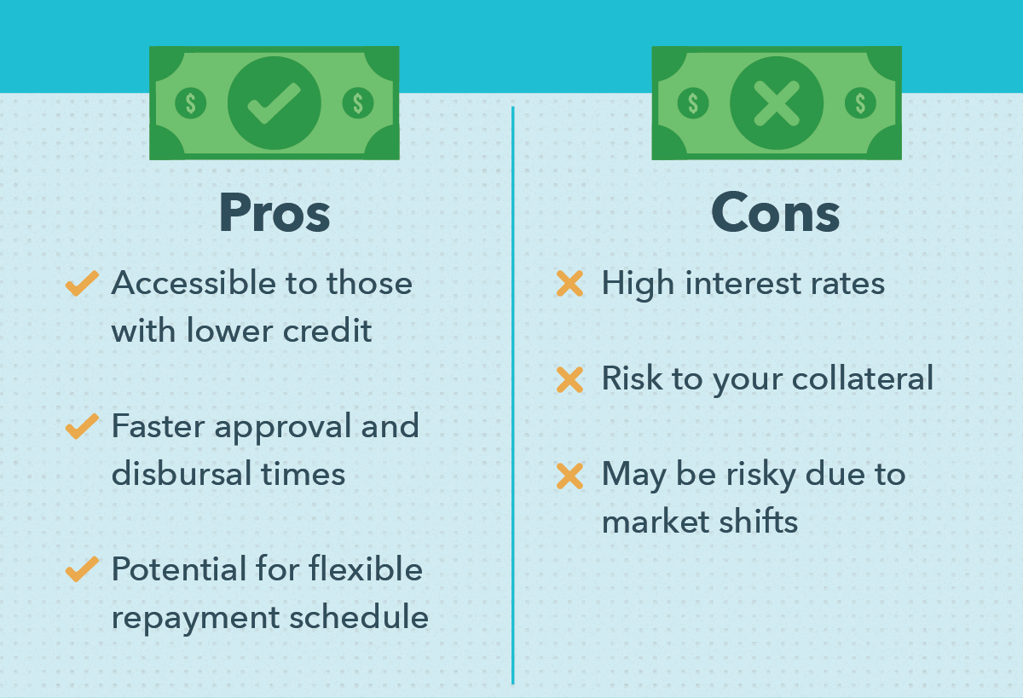

# 

# How To Use Hard Money

We have covered a lot of this already but now we’re going to go over some of the finer points and how to make a plan. Real Estate Investing, in general, requires a fairly well-thought-out plan because things can and will go wrong. Having contingencies protects the investor from disaster. It also protects the lender, whether it be a hard money lender or a financial institution. This means that either type of lender will want to know what your plan for their money is from the start.

The first thing you’ll want to do is find a hard money lender that will work with you and that you can trust. We’ve gone over how to go about that and mentioned a few options like Hard Money Go. Second, you’ll want to start looking at investment properties. Once you find one, you can come up with the details for that property and how much you’ll need to borrow. You then present that to your lender and see if they will approve the loan with your collateral and assorted fees paid.

Though it is short, there is an underwriting process, so you won’t want to pick a property that’s likely to be sold in the next 24 to 48 hours. It is also important to make the seller aware of your intent to buy said property. It’s very important to note that your calculated costs have to be accurate. This means doing your research on what you’ll need to flip the property for a profit. This includes having a contractor on standby, essentially. If you are a contractor that is so much better.

Once you have the cash in hand, you’ll purchase the property and begin implementing your plan. It’s important that it doesn’t take more than a month or a few months to flip the property or you might not break even with the interest rates. Remember, any interest rate under 10% is good and an interest rate under 8% is amazing.

Part of planning is making sure you have everything in order. This includes having all your upfront fees taken care of. You still can go into this expecting to spend no money upfront. You’re going too so you’ll need to have some saved up for that. As far as the actual properties go, you’re definitely not going to be purchasing a $300,000 property to flip for a 30% gain on the first go. So, think cheap but with a good profit margin because the cost of borrowing a hard money loan will eat away at your profit, however at least you have broken into the real estate market and can use this to fuel your future profits.

# 

# How To Use Hard Money: A Summary

This might not have been *everything* you’ll need to know but it was most of it. Most other questions can be answered simply by asking a hard money lender. If you contact a company like Hard Money Go, they’ll probably be very happy to answer your questions and possibly pick you up as a client.

**Hard Money Facts:**

* Hard Money is a type of loan you use for investments, primarily real estate.
* It has a higher interest rate than most conforming loans and is a non-conforming loan.
* Interest rates are typically between 10% and 20%.
* There are upfront fees for most hard money loans, including a down payment.
* To acquire a hard money loan you will need Collateral Property.
* Acquiring a hard money loan requires that you have a plan in place to use the money you borrow from the lender, just like any other loan.
* There is *still* an underwriting process and contracts that need to be signed.
* Hard money loans are faster than more typical loan types.
* Hard money loans do pose a higher risk to the borrower.
* Hard money lenders work with poor credit scores.

That is hard money in a nutshell and that is the basic “how-to” on Hard Money and Hard Money Loans.