**Be One’s Eye**

**Software Requirements Specification**

Software Engineering Project



**Group Id:** Self choose project

**Group Members:** 2018-CS-80

2018-CS-84

2018-CS-85

**Supervisor Name:**  Miss Taliah Tajammal

Department of Computer Science

University of Engineering and Technology Lahore

**Table of Contents**

1 Introduction 3

1.1 Scope 3

1.2 Glossary 3

1.3 Technologies to be used 3

*2.* General Description 4

3.1 User Characteristics 4

3.2 General Constraints 4

3.3 Assumptions & Dependencies 4

2 Specific Requirements 5

3.1 External Interface Requirements: 5

3.1.1 User Interfaces 5

3.2 Functional Requirements 10

3.2.1 User: 10

3.2.2 System: 10

3.3 Use Cases: 10

3.4 Non Functional Requirements: 13

# Introduction

A software requirements specification (SRS) is a document that describes what the software will do and how it will be expected to perform. It also gives us the complete overview of scope, glossary and technologies to be used. The main aim of this document is to identify and analyze the complete understanding and perception of **Be one’s Eye** in detail. It also briefs the functionality the product needs to fulfill, the project targeted audience, system’s user interface and nonfunctional requirements.

## Scope

Primarily, the SRS is concerned with all the functions to make a person to see the outside world by using the Be one’s eye. This project is being developed for the purpose that it is helpful for a person to see things in his daily life. Form text recognition to object recognition, this project provide a complete well-ordered solutions to all the problem that a person might face to see things in his daily life. This SRS is not only related to a specific module or tool of this project but it identifies the complete project (Be one’s Eye).

## Glossary

|  |  |
| --- | --- |
| Term | Definition |
| System | Operating device |
| User | A person who will use this App. |

## Technologies to be used

|  |  |
| --- | --- |
| Technology | Description |
| Visual Studio code | Visual Studio Code is a free [source-code editor](https://en.wikipedia.org/wiki/Source-code_editor) made by [Microsoft](https://en.wikipedia.org/wiki/Microsoft) for [Windows](https://en.wikipedia.org/wiki/Windows), [Linux](https://en.wikipedia.org/wiki/Linux) and [macOS](https://en.wikipedia.org/wiki/MacOS). Features include support for [debugging](https://en.wikipedia.org/wiki/Debugging), [syntax highlighting](https://en.wikipedia.org/wiki/Syntax_highlighting), [intelligent code completion](https://en.wikipedia.org/wiki/Intelligent_code_completion),  [code refactoring](https://en.wikipedia.org/wiki/Code_refactoring), and embedded [Git](https://en.wikipedia.org/wiki/Git). Users can install [extensions](https://en.wikipedia.org/wiki/Plug-in_(computing)) that add additional functionality. |
| Android Emulator | The Android Emulator simulates Android devices on your computer so that you can test your application on a variety of devices and Android API levels without needing to have each physical device. |
| Microsoft Project Professional | Microsoft Project is a [project management software](http://en.wikipedia.org/wiki/Project_management_software) program, developed and sold by [Microsoft](http://en.wikipedia.org/wiki/Microsoft), which is designed to assist a [project manager](http://en.wikipedia.org/wiki/Project_manager) in developing a [plan](http://en.wikipedia.org/wiki/Plan), assigning [resources](http://en.wikipedia.org/wiki/Resource_(project_management)) to tasks, tracking progress, managing the [budget](http://en.wikipedia.org/wiki/Budget), and analyzing workloads. |
| Android Studio | Android Studio is the official integrated development environment (IDE) for Android application development. It is based on the IntelliJ IDEA, a Java integrated development environment for software, and incorporates its code editing and developer tools. |
| Figma | Figma is a browser-based UI and UX design application, with excellent design, prototyping, and code-generation tools. It's currently the leading interface design tool, with robust features which support teams working on every phase of the design process. |
| Firebase Real-time Database | The Firebase Real-time Database is a cloud-hosted database. Data is stored as JSON and synchronized in real time to every connected client. When you build cross-platform apps with our iOS, Android, and JavaScript SDKs, all of your clients share one Real-time Database instance and automatically receive updates with the newest data. |

# General Description

## User Characteristics

The classes of this project are as follows:

* User
* System

The user must have a basic knowledge of computers and intermediate skills of internet surfing along with English language basics. The separate characteristics of each class are given bellow:

**User:**

The user can login to use this app or may skip the login part. She/he may take the picture either from camera or gallery or may crop the picture. The user also see his history and profile and also able to delete his history. The user can listen to the extracted text of image and object, give the feedback and may logout from the app.

**System:**

The system takes the image and text as an input and then convert it to speech. The system can also able to store the process performed by the user in his history.

## General Constraints

This project mainly focus on the text extraction from images, object detection from images and place recognition from images but it has no functionality to detect any text from PDF and documents.

## Assumptions & Dependencies

These are many factors that affects the requirements specified in the SRS. These include:

1. Every user of this app should have the internet.
2. This app has to deal with the numbers of users at a time, so it should be able to work smoothly.
3. The operating device must have the latest Android version
4. The text extracted and the images should be saved into the database of the logged in user.
5. The feedback given from the user should be saved in the database to the user profile.

# Specific Requirements

## External Interface Requirements:

### User Interfaces

**Page 1:**

**Splash Screen**



**Page 2:**

**Login Page**

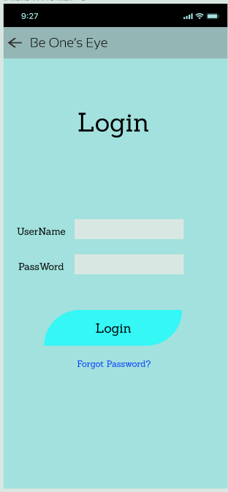

**Page 3:**

**Sign Up Page**

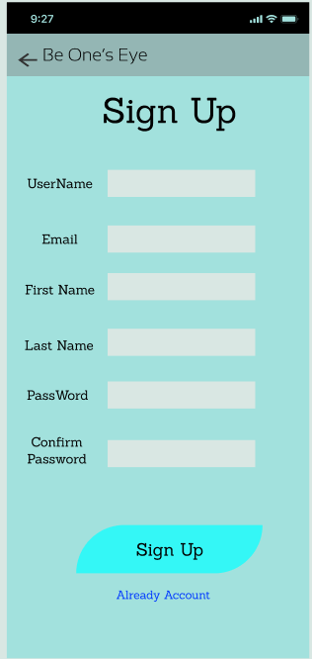

**Page 4:**

**Home Page**

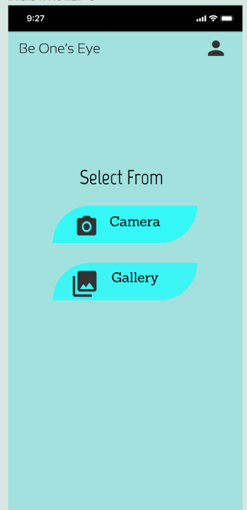

**Page 5:**

**Camera Page**

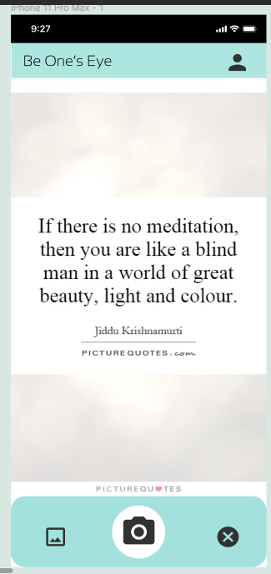

**Page 4:**

**Gallery Page**

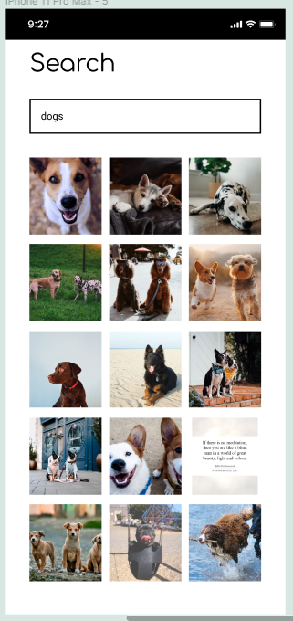

**Page 6:**

**Text Detected and Speak Page**

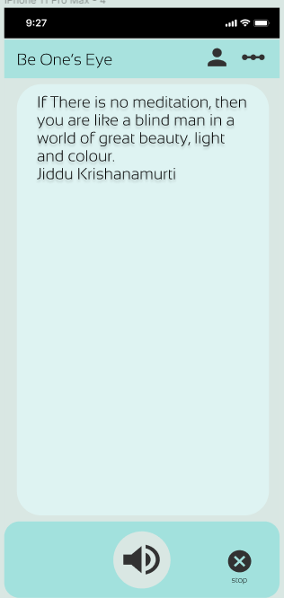

**Page 7:**

**Feedback Page**

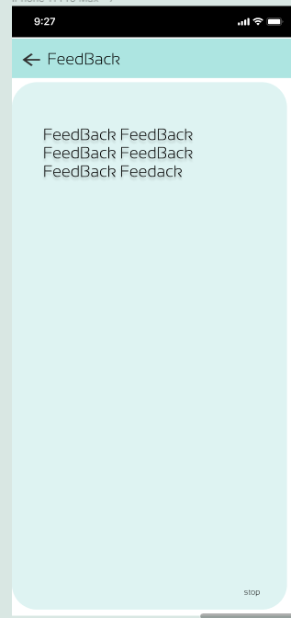

**Page 8:**

**My Account Page**

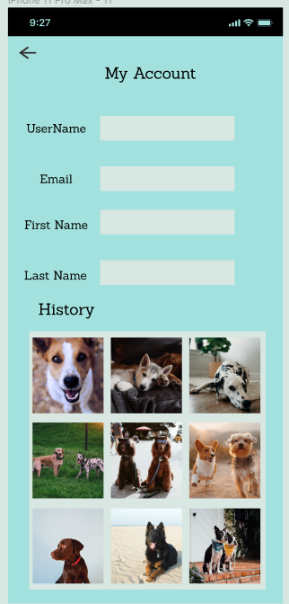

## Functional Requirements

### 3.2.1 User:

1. User shall be able to login.
2. User may skip the login and use the app.
3. User shall take picture from gallery.
4. User shall take picture from camera also.
5. User shall be able to crop image if he wants.
6. User shall be able to see the Extracted text.
7. User shall listen to Extracted Text of Image, Object or place.
8. User shall be able to see his profile.
9. User shall be able to view his history.
10. User should be able delete history or some content in history.
11. User should be able to leave a feedback.
12. User shall be able to see his feedback.
13. User shall be able to give feedback to every Extraction process that he/she perform.
14. User shall be able to logout if he wants.

### System:

1. System should be able to take a picture as Input.
2. System shall be able to detect Image.
3. System should be able to extract Text from Image.
4. System should be able to convert the Text to Speech.
5. System shall be able to store that process performed by user as history in his profile.

## Use Cases:

|  |  |
| --- | --- |
| **Use Case Title** | **User Login** |
| **Use Case Id** | 1 |
| **Requirement Id** | 1 |
| **Description:** This Use Case is about that How the User Get Access to the app and see His Account and his History | |
| **Pre-Conditions:**   * 1. Login Screen Must Be Loaded.   2. Database should be available in online mode. | |
| **Normal Flow** | |
| 1. User Sees the Login Screen | |
| 1. User Will Enter Email and Password. | |
| 1. User Will can choose the Remember Me checkbox, | |
| 1. User Will Hit Login Button | |
| 1. User Will be Directed to see his Profile and History | |
| **Alternative Flow** | |
| a. There is a problem in the data provided; some data needs to be corrected.   * + System will check this Issue and will inform the User.   b. User Will Try once Again | |
| **Post Conditions:**   * + A User is Successfully Logged In. | |
| **Open issues:** | |
| **Authority:** User | |

|  |  |
| --- | --- |
| **Use Case Title** | **User Sign Up** |
| **Use Case Id** | 1 |
| **Requirement Id** | 2 |
| **Description:** This Use Case is about that how the User Sign Up and make a new Account and get Access to the app and see His Account and his History | |
| **Pre-Conditions:**   * 1. Sign Up Screen Must Be Loaded.   2. Database should be available in online mode. | |
| **Normal Flow** | |
| 1. User goes the Sign Up Screen | |
| 1. User Will Enter His Information asked There | |
| 1. User Will can choose the Remember Me checkbox, | |
| 1. User Will Hit Sign Up Button | |
| 1. User Will be Directed to see his Profile and History | |
| **Alternative Flow** | |
| a. There is a problem in the data provided; some data needs to be corrected.   * + System will check this Issue and will inform the User.   b. User Will Try once Again | |
| **Post Conditions:**   * + A New account of User Successfully Created.   + User is Logged In. | |
| **Open issues:** | |
| **Authority:** User | |

|  |  |
| --- | --- |
| **Use Case Title** | **Extraction of Text** |
| **Use Case Id** | 1 |
| **Requirement Id** | 7 |
| **Description:** This Use Case is about that How the User will Extract Text from Image and See and Listen the Text. | |
| **Pre-Conditions:**   * 1. User May or may not be Logged In.   2. Application must have Access to Camera and Files   3. Database must be on Online Mode.   4. Camera Gallery Option Screen must be Loaded | |
| **Normal Flow** | |
| 1. User will see the Take Picture from Camera or Gallery Option | |
| 1. User Will Either Click on Camera or Gallery | |
| 1. User will be Directed to Camera If clicks Camera | |
| 1. User will be Directed to Gallery if he Clicks Gallery | |
| 1. User Will select or Take Picture | |
| 1. The picture will be Directed to system | |
| 1. User Will see and Listen to the Text Extracted from the Image | |
| 1. This will be added to Database if the User is Logged In. | |
| **Alternative Flow** | |
| a. There is Problem with Image that needs to be corrected.   * + System will check this Issue and will inform the User...   b. There is a library problem   * + System will check this Issue and will inform the User.   c. User will Try it again | |
| **Post Conditions:**   * + User will get the Text Extracted.   + User can listen to the audio of that Text. | |
| **Open issues:** | |
| **Authority:** User | |

|  |  |
| --- | --- |
| **Use Case Title** | **Give a Feedback** |
| **Use Case Id** | 1 |
| **Requirement Id** | 12 |
| **Description:** This Use Case is about that How the User will Give feedback about the Extraction Actions that He performs. | |
| **Pre-Conditions:**   * 1. User must be Logged In.   2. Application must have Access to Camera and Files   3. Database must be on Online Mode.   4. User Must have Performed the Extraction Action   5. Camera Gallery Option Screen must be Loaded | |
| **Normal Flow** | |
| 1. User will See Feedback | |
| 1. User Will Type his feedback. | |
| 1. User Will press Publish to publish the Feedback | |
| 1. The Feedback will be added to the Database in user profile. | |
| 1. User will exit this Screen | |
| **Alternative Flow** | |
| a. There is Problem with Publishing the Feedback due to Internet Connectivity.   * + System will check this Issue and will inform the User.   c. User will Try it again | |
| **Post Conditions:**   * + User Will be able to now see his feedback | |
| **Open issues:** | |
| **Authority:** User | |

|  |  |
| --- | --- |
| **Use Case Title** | **Extraction of Text By System** |
| **Use Case Id** | 2 |
| **Requirement Id** | 3 |
| **Description:** This Use Case is about that How the System Will Extract the Text and present it to the User. | |
| **Pre-Conditions:**   * 1. User May or may not be Logged In.   2. Application must have Access to Camera and Files   3. Database must be on Online Mode.   4. System must have access to OCR and Text Extraction Libraries.   5. Application must be Loaded Successfully. | |
| **Normal Flow** | |
| 1. User will see the Take Picture from Camera or Gallery Option | |
| 1. System will get this Image. | |
| 1. System will process it with help of libraries. | |
| 1. System will extract the Text from Image. | |
| 1. System will Detect if Object in Image. | |
| 1. System will present this Text to User. | |
| 1. System will play the Audio of the Text. | |
| 1. The System will add this action to User profile if he is Logged In. | |
| **Alternative Flow** | |
| a. There is Problem with Image that needs to be corrected.   * + System will check this Issue and will inform the User.   b. There is a library problem   * + System will check this Issue and will inform the User.   c. System will ask user to Retry | |
| **Post Conditions:**   * + User will get the Text Extracted.   + User can listen to the audio of that Text. | |
| **Open issues:** | |
| **Authority:** System | |

## Non Functional Requirements:

1. The Operating Device must be compatible with Latest Version of Android
2. The Operating Device must have a camera with high Pixels to Take Clear Pictures.
3. Operating Device must have clear Audio and High Definition Speakers, So that the User must listen it without any disturbance.
4. **Project Work Pl****an**

