**SimLock ApI**

Method Post

<http://3.20.74.120:8080/SimLockCheckFast>

**Body Parameters**

**Key Value**

IMEI

SERIAL

APIKEY $$$SIM_LOCK_Internal$$$

IMEI2 (if available)

**Response**

**{"Status":"ok","Imei":"355352089910703","Serial":"FYQZ407YHFYF","Simlock":"True","Carrier":""}**

Simlock **“True”** means sim is locked and if sim is unlocked then it comes as Simlock **“False”**

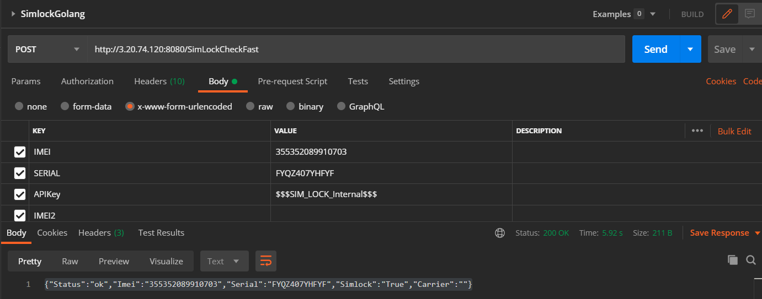

**T-Mobile API**

Method Post

<http://3.137.41.94:8080/TmobFinanceCheck>

**Body Parameters**

**KEY VALUE**

IMEI

APIKEY $$$SIM_LOCK_Internal$$$

**Response**

Blacklisted IMEI

If the Device is Blacklisted the response is **Blacklisted IMEI** and If the Device is Clean the Response will be **Clean**.

