Student name | Ayesha Abbas
Registration number | FA24B1-SE-009
GitHub username | abbasayesha004

Assingment NO:01

Task 1: Gitea on the Ubuntu Server

Step 1.1: Gitea running
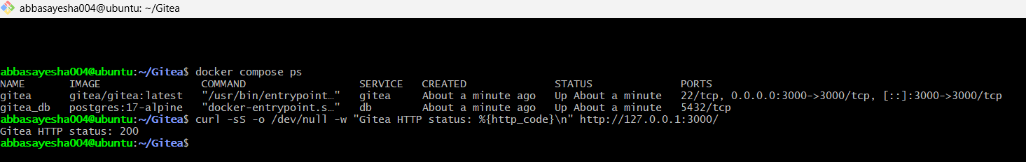
task1_gitea_running.png

Step 1.2: Push to Gitea
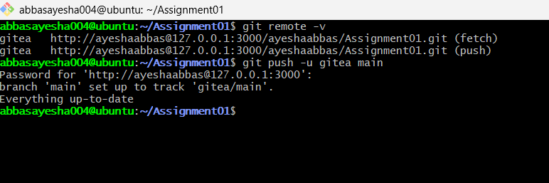
task1_gitea_push.png

Step 1.3: Gitea repository

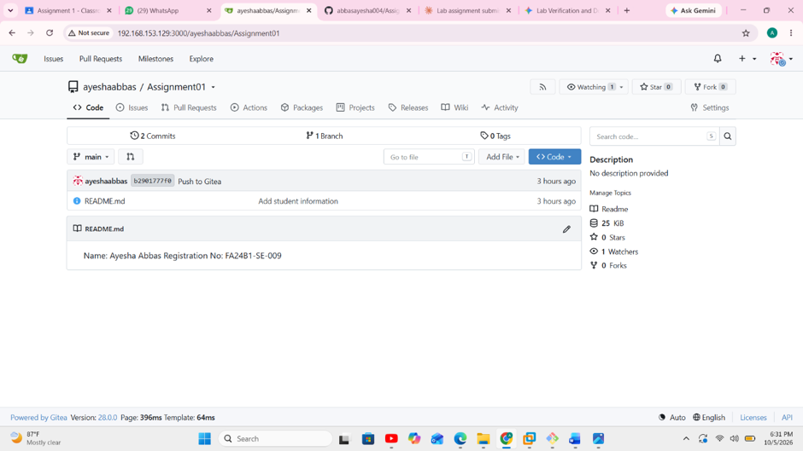
task1_gitea_repository.png

Task 2: Push to GitHub

Step 2.1: Gitea and GitHub remotes
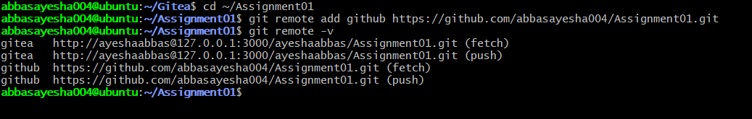
task2_remotes.png

Step 2.2: Push to GitHub
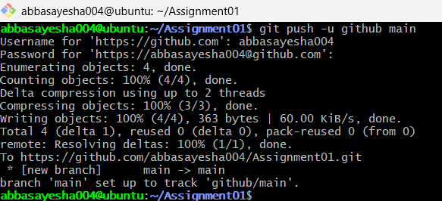
task2_github_push.png

Step 2.3: GitHub repository
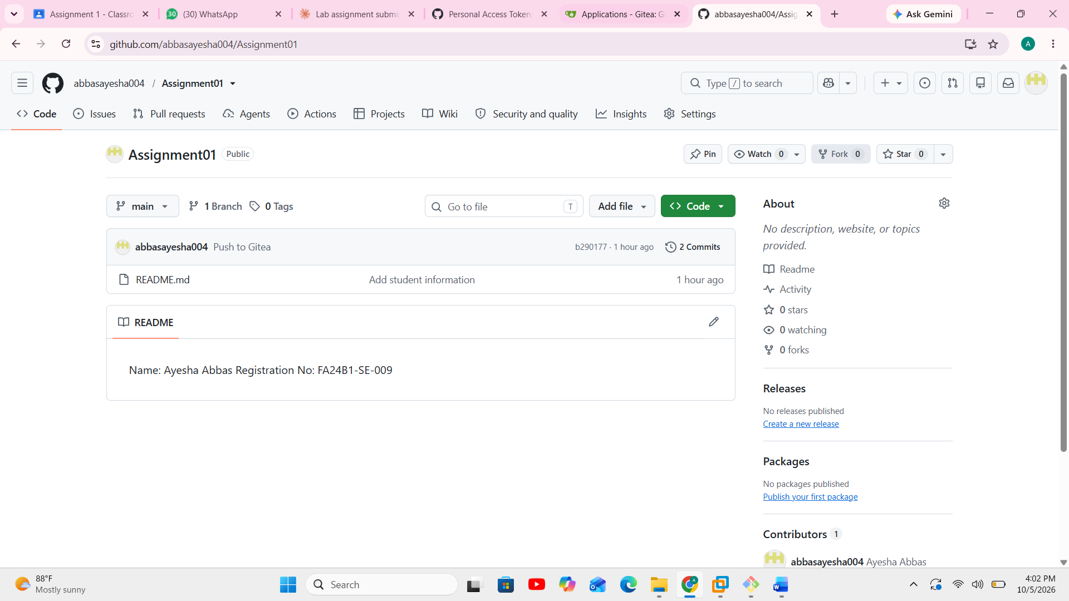
task2_github_repository.png

Task 3: Git LFS

Step 3.1: Git LFS setup
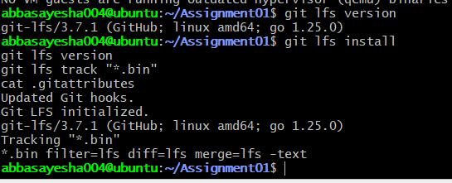
task3_lfs_setup.png

Step 3.2: Three large LFS files
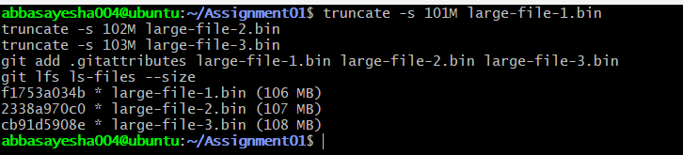
task3_lfs_files.png

Step 3.3: LFS push
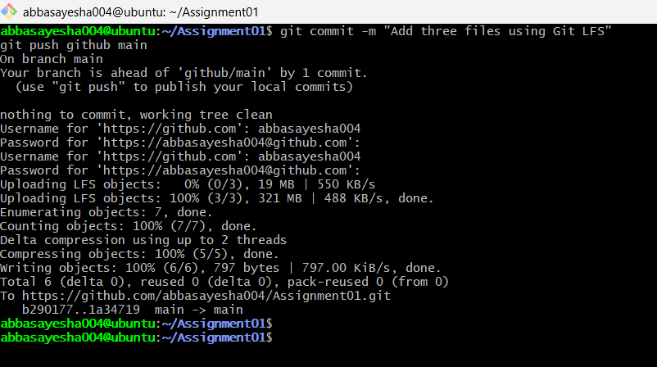
task3_lfs_push.png

Task 4: GitHub Pages Portfolio

Step 4.1: Portfolio repository
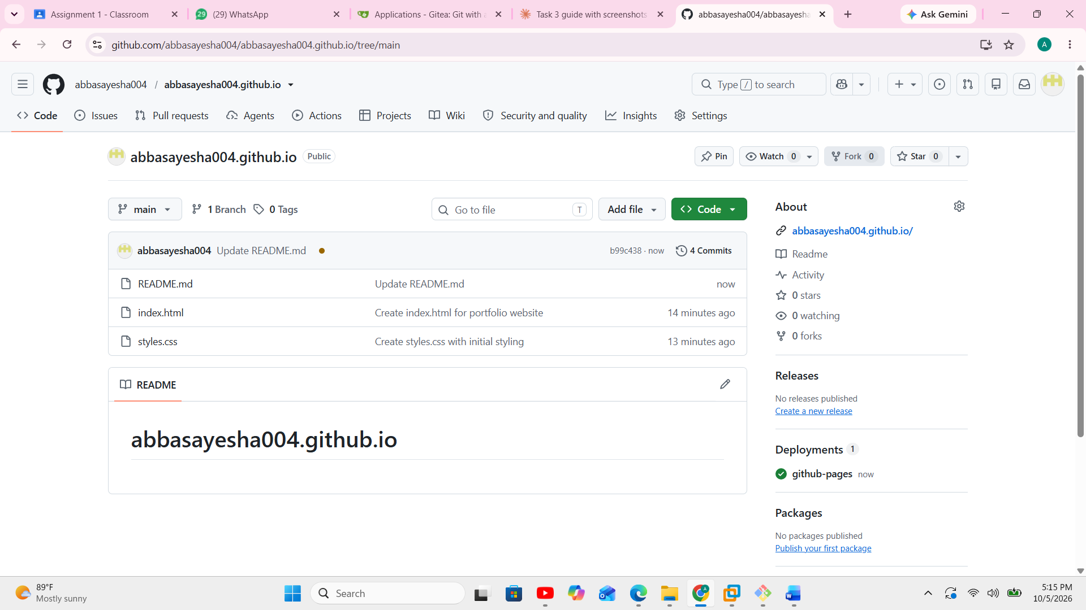
task4_pages_repository.png

Step 4.2: GitHub Pages deployment
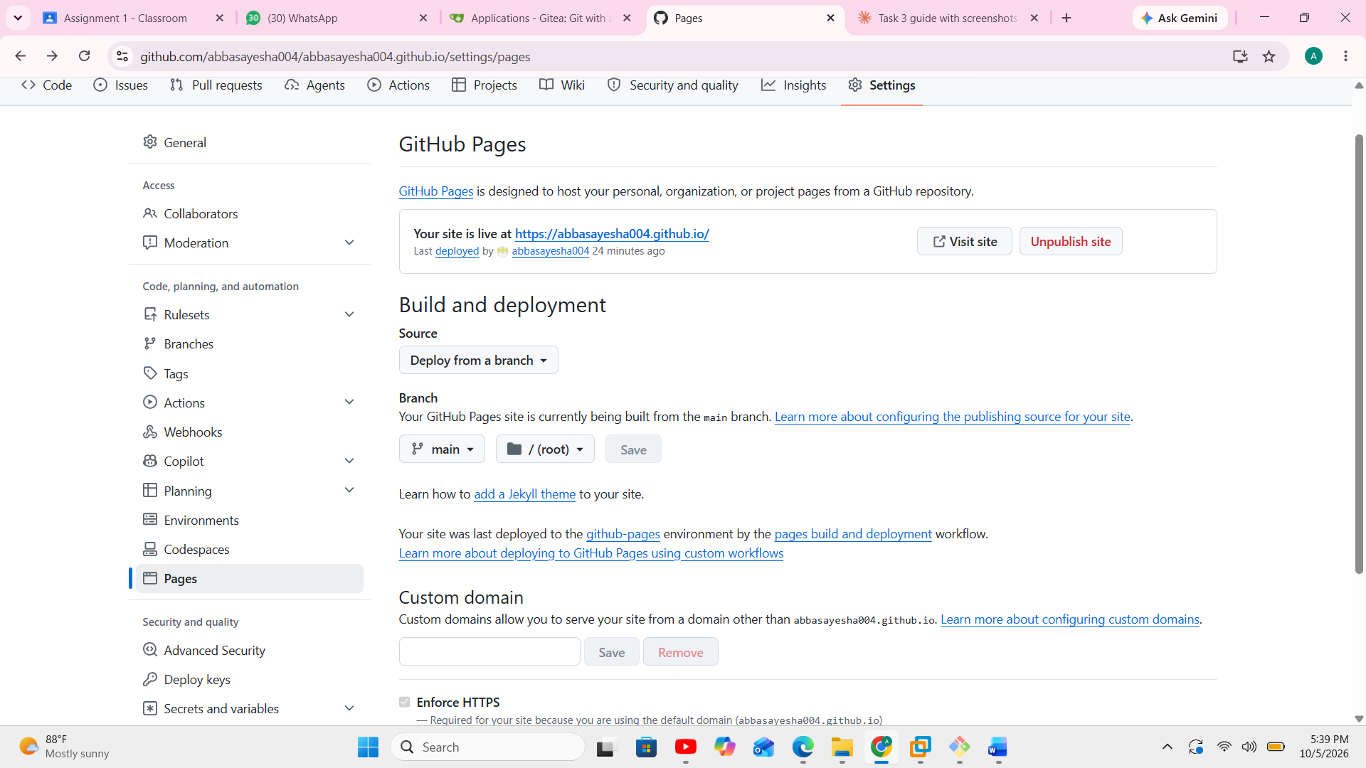
task4_pages_deployment.png

Step 4.3: Live portfolio
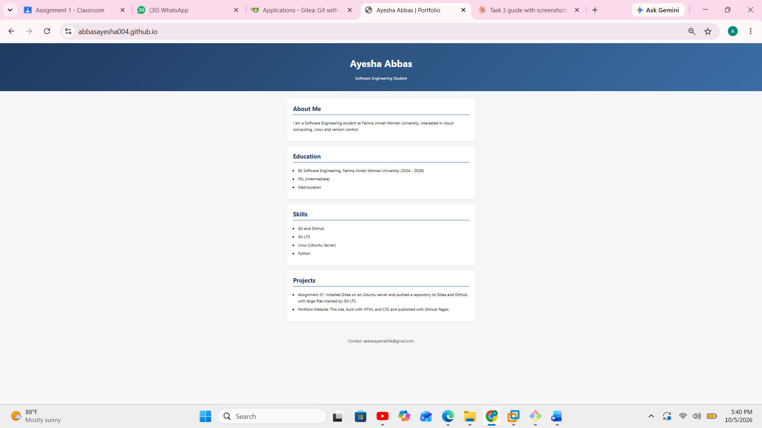
task4_portfolio_live.png

