Oyez lstm

Oyez cnn_lstm

Oyez cnn_lstm_dilation

BERT

BERT LEGAL

Oyex blind data

Oyex generalization on plaintiff data

Network performance on plaintiff data

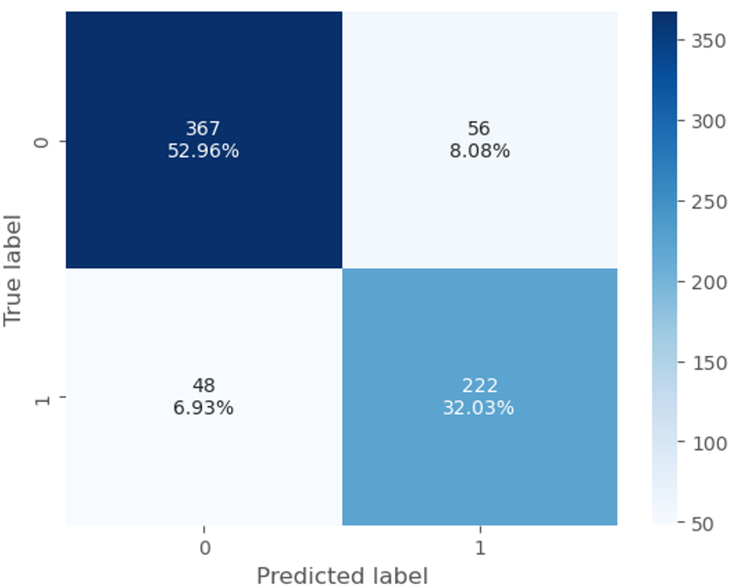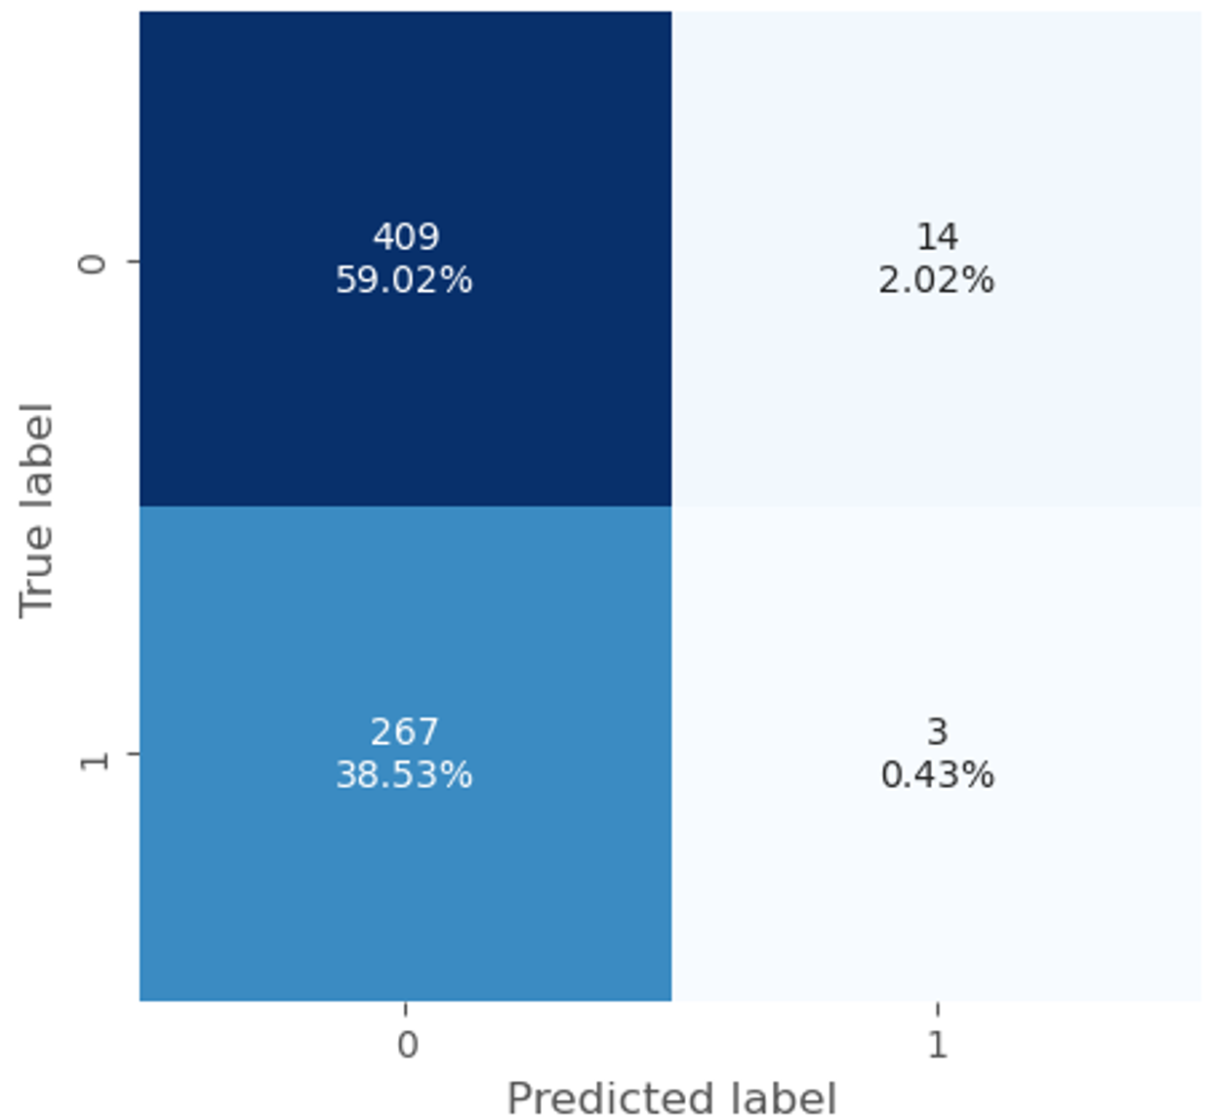

Oyez bert and our netowrk

Oyer newrok gernalixation to petitioner data

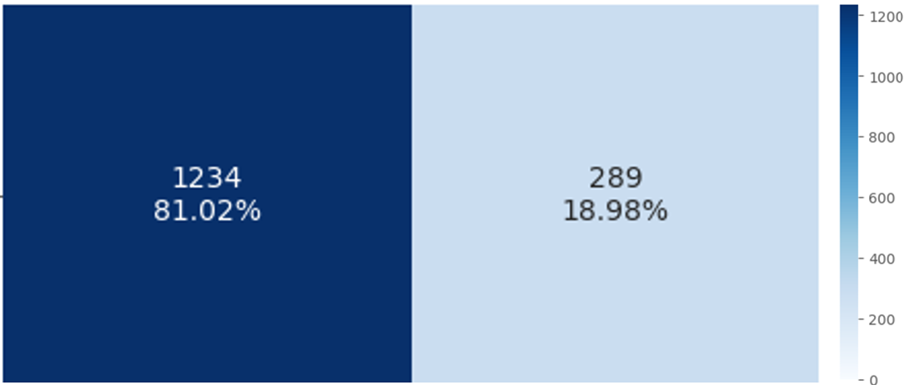

Network plaintiff blind data