Name : Faizan Shoukat Abbasi

Arid No : 17-Arid-1708

Class : BSSE-7

Code link : <https://github.com/abbasifaizan70/SSAC_Assigment_01>

Code output:

ON Web

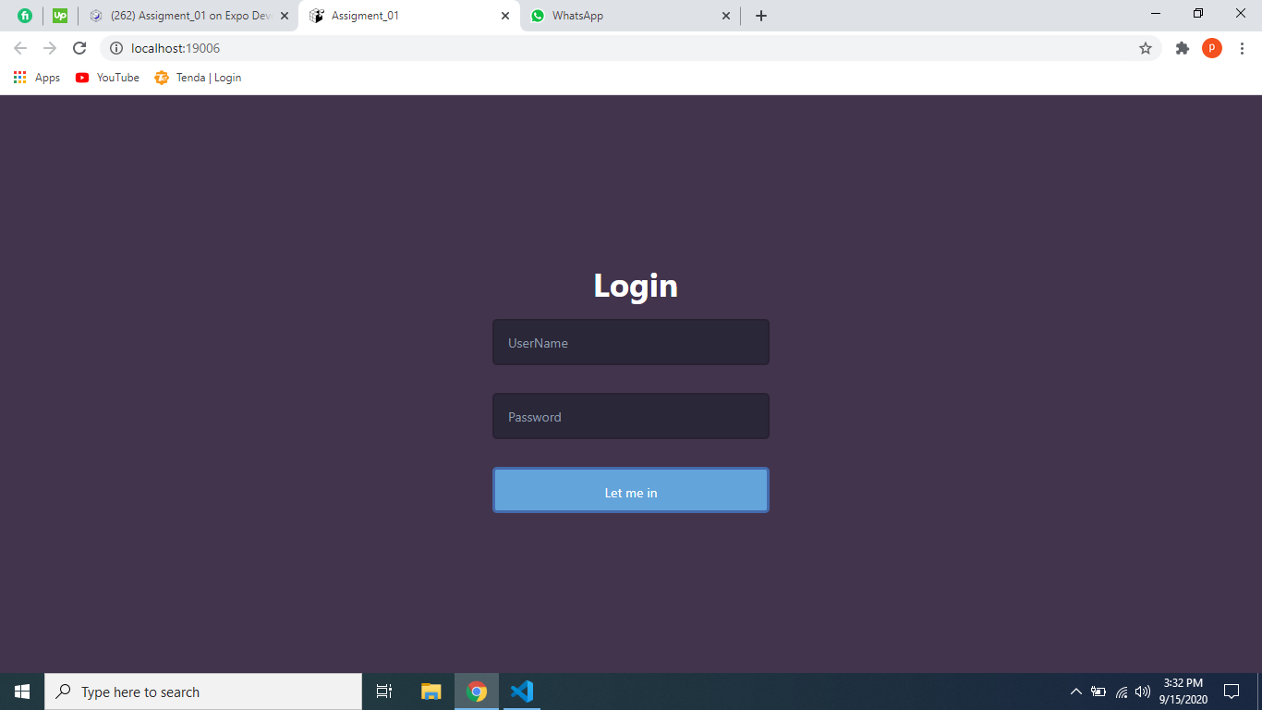

On mobile:

