HEALTHCARE PREDICTIVE ANALYTICS

30-Day Hospital
Readmission Prediction Model
A comparative machine-learning analysis using Random Forest and XGBoost

Project details | Information
Prepared by | Umar Abbasi
Programme / Institution | M Pharm Pharmacology DIPSAR
Organisation / Internship | Workora
Project period | 1 month
Submission date | 12th November, 2026

Technical Report

Abstract
This project developed and compared two supervised machine-learning classifiers—Random Forest and XGBoost—to estimate the likelihood of 30-day hospital readmission using a supplied dataset of 800 synthetic patient records. The target variable was Readmitted30Days. The workflow included data inspection, exploratory data analysis, a stratified train–test split, categorical-aware oversampling of the training data using SMOTENC, one-hot encoding, model training, and evaluation on an untouched test set of 160 records. Random Forest achieved accuracy 0.638, precision 0.360, recall 0.409, F1-score 0.383, and ROC-AUC 0.568. XGBoost achieved 0.619, 0.319, 0.341, 0.330, and 0.562, respectively. Random Forest performed slightly better on all reported metrics; however, both models showed weak discrimination and limited detection of readmissions. As the dataset is synthetic and the results are modest, these models should be regarded as an educational prototype rather than clinically deployable decision-support tools.

1. Introduction
Unplanned hospital readmission within 30 days of discharge is an important healthcare quality and resource-planning concern. Predictive analytics can help identify patterns associated with readmission and support further investigation of discharge planning and follow-up processes. Machine-learning models can analyse multiple patient and care-related variables simultaneously, but their usefulness depends on data quality, representative samples, appropriate validation, and careful interpretation.
This project uses a supplied synthetic dataset to demonstrate an end-to-end predictive modelling workflow. It does not establish clinical risk estimates or validate a tool for patient care.

2. Aim and Objectives
Aim: To develop and evaluate machine-learning models for classifying whether a patient is readmitted within 30 days of hospital discharge.
- Inspect and prepare the supplied dataset for supervised learning.
- Explore the distribution of the target and relationships among selected variables.
- Address class imbalance in the training data using SMOTENC.
- Train Random Forest and XGBoost classifiers using a consistent feature set.
- Compare performance using accuracy, precision, recall, F1-score, and ROC-AUC.
- Examine model feature-importance outputs and document limitations.

3. Dataset Description
The supplied file, healthcare_readmission_model_v2.csv, contained 800 records and 11 columns. The outcome variable was Readmitted30Days, encoded as 0 for No and 1 for Yes. PatientID was retained for record identification and excluded from model predictors.
Dataset characteristic | Observed value
Number of records | 800
Number of columns | 11
Not readmitted (No) | 580 (72.5%)
Readmitted within 30 days (Yes) | 220 (27.5%)
Training / test split | 640 / 160 (80% / 20%)
Training class counts before oversampling | 464 No / 176 Yes
Training class counts after SMOTENC | 464 No / 464 Yes (928 total)
Test class counts (not oversampled) | 116 No / 44 Yes

Predictors included Age, Gender, Diagnosis, PrimaryMedication, ComorbidityCount, PriorAdmissions12M, LengthOfStayDays, DischargeDisposition, and FollowUpBooked. The dataset was treated as synthetic; its values should not be interpreted as real patient observations.

4. Methodology

4.1 Data preparation and split
PatientID and the target column were removed from the predictor matrix. Target labels were mapped to binary values (No = 0; Yes = 1). The data were split into training and test subsets using an 80:20 stratified split with random_state = 42. Stratification preserved the class proportions across the subsets.

4.2 Class-imbalance handling
SMOTENC was applied only to the training subset, with categorical features identified explicitly. It increased the minority-class training examples until both classes contained 464 records. The test subset was not oversampled, preserving an evaluation set with the original class distribution.

4.3 Categorical encoding
Categorical predictors were one-hot encoded using pandas.get_dummies. The encoded test matrix was reindexed to match the training feature columns; categories absent from the test subset were filled with zero. This ensured that both models received the same predictor columns.

4.4 Model development
Model | Configuration used
Random Forest | 200 trees; max_depth = 8; min_samples_split = 5; random_state = 42
XGBoost | 200 estimators; max_depth = 4; learning_rate = 0.05; subsample = 0.8; colsample_bytree = 0.8; eval_metric = logloss; random_state = 42

Both models were fitted on the same SMOTENC-balanced, one-hot-encoded training data. Predictions and positive-class probabilities were generated for the untouched test subset.

4.5 Evaluation measures
Accuracy is the proportion of all test predictions that were correct. Precision is the proportion of predicted readmissions that were actual readmissions. Recall is the proportion of actual readmissions detected. F1-score is the harmonic mean of precision and recall. ROC-AUC measures the model’s ability to rank positive cases above negative cases across classification thresholds.

5. Exploratory Data Analysis
The target distribution showed class imbalance: 72.5% of records were labelled No and 27.5% Yes. The exploratory plots suggested that the readmitted group had a higher median number of prior admissions in the preceding 12 months (approximately 3 versus 2 in the non-readmitted group). Comorbidity-count distributions appeared broadly similar between the two groups. Pairwise correlations among numerical variables were weak in the inspected correlation matrix (approximately −0.09 to +0.04). These are descriptive observations only; they do not establish statistical significance or causation.
Insert the five exploratory plots in this section. Give each plot a numbered caption and a short description. Do not call a pattern statistically significant unless a suitable statistical test has been conducted.

6. Model Performance and Results
Metric | Random Forest | XGBoost
Accuracy | 0.638 | 0.619
Precision | 0.360 | 0.319
Recall | 0.409 | 0.341
F1-score | 0.383 | 0.330
ROC-AUC | 0.568 | 0.562

Random Forest achieved slightly higher values than XGBoost for all five reported metrics. Its recall of 0.409 means it identified approximately 40.9% of actual readmission cases in the test set at the default classification threshold. XGBoost recall was 0.341. Both ROC-AUC values were relatively close to 0.5, indicating weak separation between the outcome classes. The results do not support describing either model as a strong readmission predictor.
Insert both confusion matrices and the ROC curve comparison here. Confusion matrices show true negatives, false positives, false negatives, and true positives at the default threshold. The ROC curve compares sensitivity and false-positive rate across thresholds.

7. Feature-Importance Analysis
Top-10 feature-importance plots were generated separately for Random Forest and XGBoost. Insert both plots in this section and list the features in the order shown by the actual plots. Tree-based feature importance indicates how the fitted model used features; it does not demonstrate that a feature causes readmission.
A dataset-specific consideration is that Diagnosis and PrimaryMedication were reported to have a one-to-one mapping in this dataset. Their encoded columns may therefore contain overlapping information, which can affect how importance is distributed between them. Interpret their rankings cautiously.

8. Prediction Output
A prediction-results file was exported for the 160 held-out test records. It contains the patient identifier, actual outcome, predicted outcome from each model, and each model’s estimated probability for the positive class. This file documents test-set model outputs; it is not a list of validated clinical risk assessments.

9. Discussion
The workflow completed data preparation, training-only oversampling, categorical encoding, model fitting, evaluation, feature-importance plotting, and test-set prediction export. Random Forest was the better-performing model in this comparison, but the difference was modest. The low recall values mean that many actual readmission cases were not identified at the default threshold. In a real clinical setting, missed cases may be consequential, so model selection would require a clearly defined objective and careful assessment of the trade-off between sensitivity and false-positive alerts.
Accuracy alone is insufficient for an imbalanced classification task. Precision, recall, F1-score, ROC-AUC, confusion matrices, and potentially precision–recall curves should be considered together. Further work could include threshold tuning on validation data, probability calibration, cross-validation, and evaluation on an independent dataset.

10. Limitations and Ethical Considerations
- The dataset is synthetic; performance on real hospital populations is unknown.
- The sample contains only 800 records, limiting the strength and generalisability of conclusions.
- Metrics are based on one stratified train–test split and may vary with a different split.
- SMOTENC creates synthetic training examples; these may not represent clinically plausible combinations in every case.
- Diagnosis and PrimaryMedication have a one-to-one mapping in the supplied data, creating potential redundancy.
- Feature importance is model-dependent and must not be interpreted as causal evidence.
- No external validation, prospective evaluation, calibration assessment, or clinical utility analysis was performed.
- The model must not be used to make patient-care decisions or replace professional clinical judgement.

11. Conclusion
This project demonstrated an end-to-end machine-learning workflow for a synthetic 30-day hospital readmission dataset and compared Random Forest with XGBoost. Random Forest produced the higher scores across the evaluated metrics (accuracy 0.638, precision 0.360, recall 0.409, F1-score 0.383, and ROC-AUC 0.568). Nevertheless, both models showed limited predictive performance. The work is best regarded as an educational prototype. Clinical application would require appropriately governed real-world data, rigorous external validation, calibration, fairness assessment, and evaluation with clinical stakeholders.

12. Project Deliverables
- Python source script: readmission_model.py
- Model comparison output: model_comparison.csv (or .xlsx)
- Test-set prediction output: patient_readmission_predictions.csv (or .xlsx)
- Exploratory data-analysis plots
- Confusion matrices, ROC curve, and top-10 feature-importance plots
- This final technical report

References
- scikit-learn developers. scikit-learn documentation. https://scikit-learn.org/stable/
- imbalanced-learn developers. SMOTENC documentation. https://imbalanced-learn.org/stable/references/generated/imblearn.over_sampling.SMOTENC.html
- XGBoost developers. XGBoost documentation. https://xgboost.readthedocs.io/
- pandas development team. pandas documentation. https://pandas.pydata.org/docs/

Appendix: Figure Placement Checklist
- Figure 1. Distribution of 30-day readmission outcome.
- Figure 2. Age distribution of the dataset.
- Figure 3. Comorbidity count by readmission outcome.
- Figure 4. Prior admissions in the previous 12 months by readmission outcome.
- Figure 5. Correlation heatmap of numerical variables.
- Figure 6. Random Forest confusion matrix.
- Figure 7. XGBoost confusion matrix.
- Figure 8. ROC curve comparison.
- Figure 9. Top 10 Random Forest feature importances.
- Figure 10. Top 10 XGBoost feature importances.
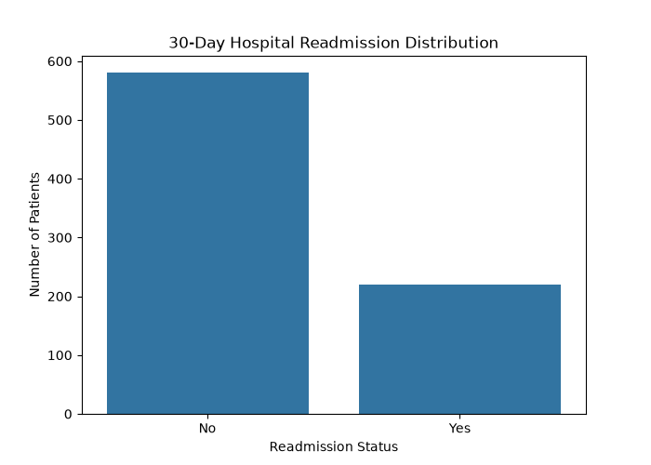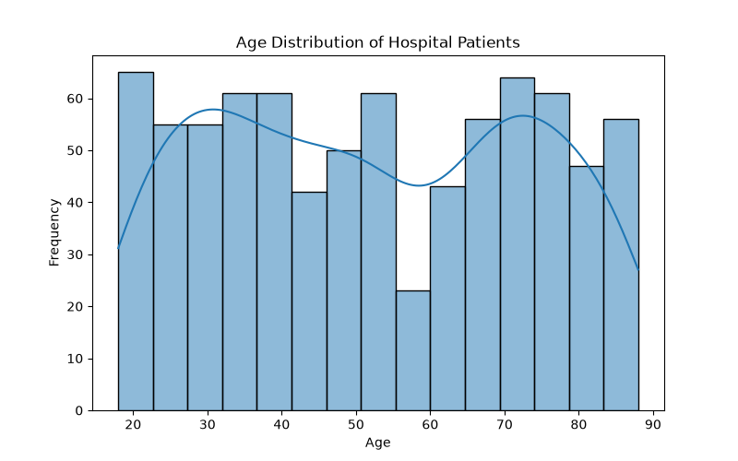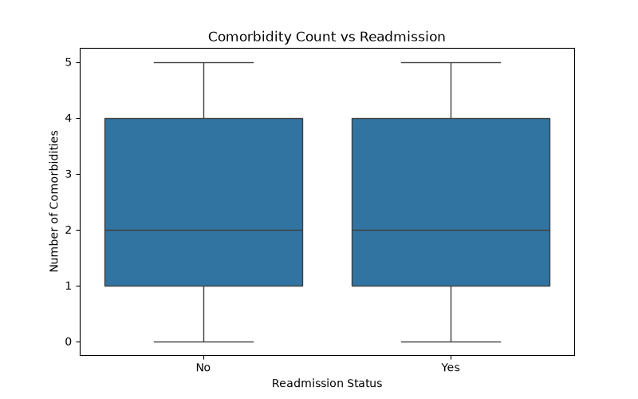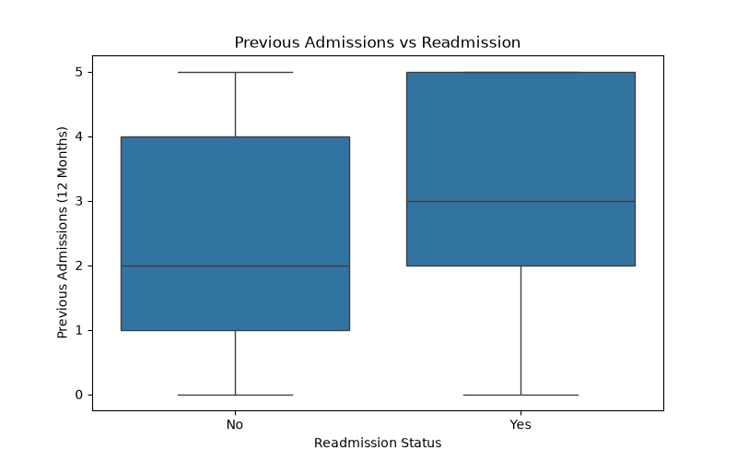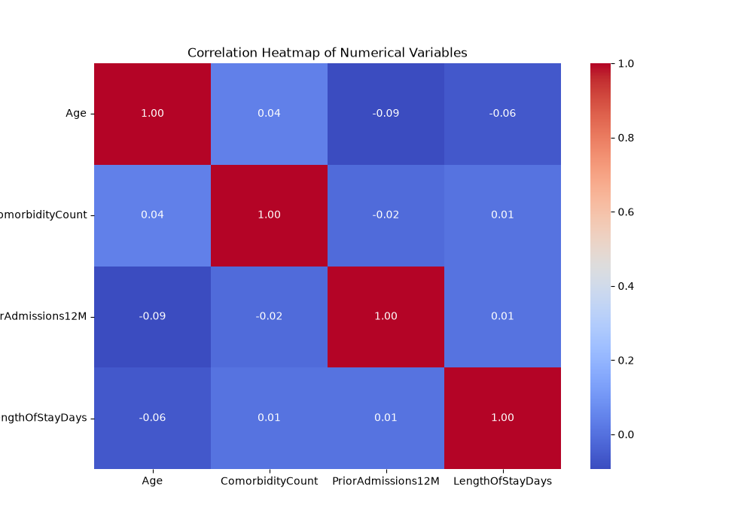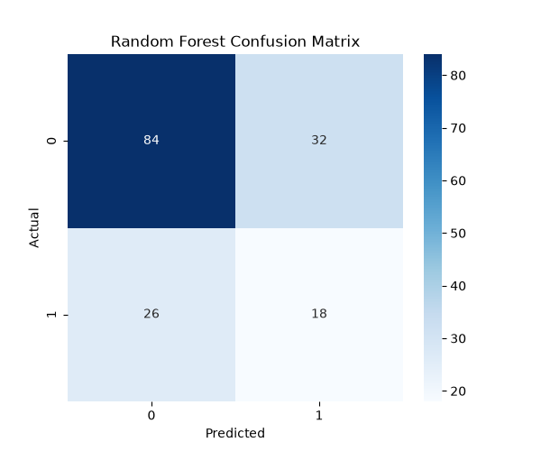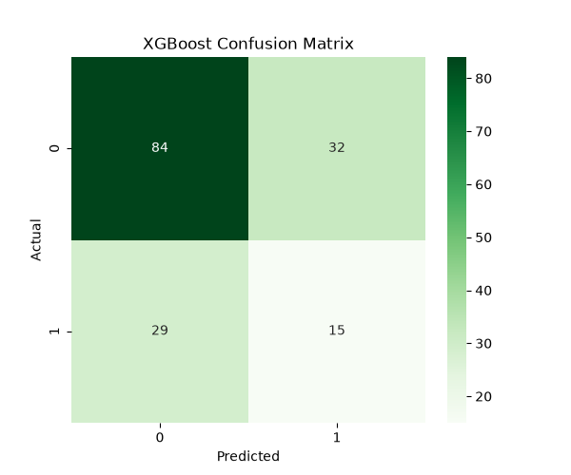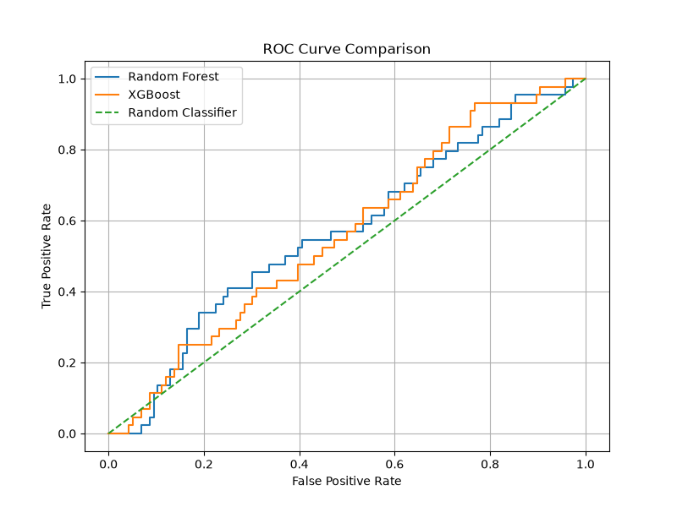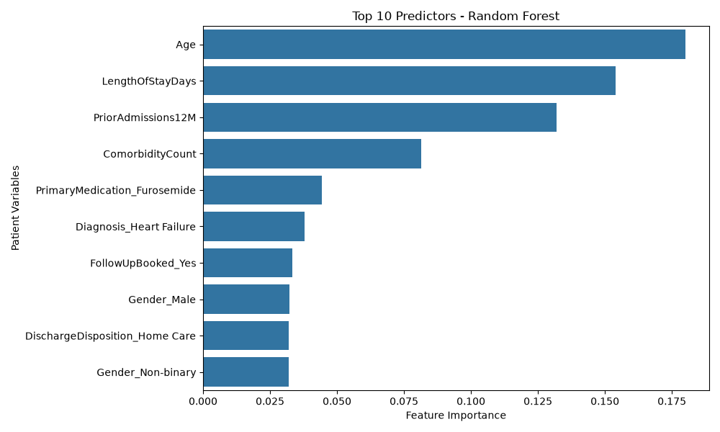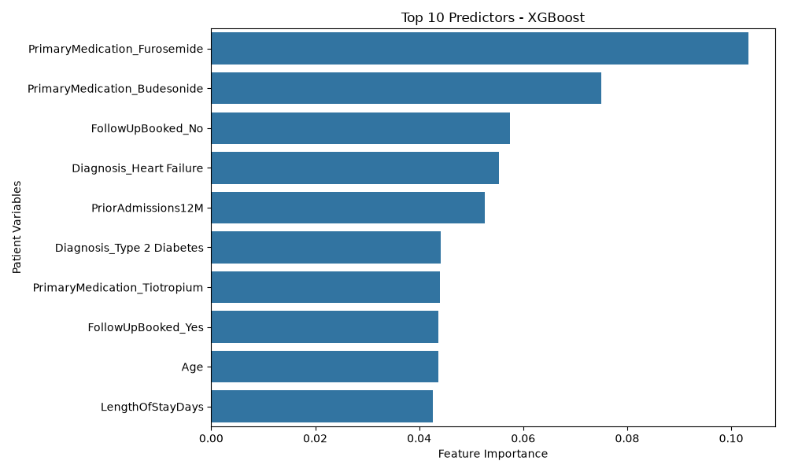

Python Codes

- from sklearn.model_selection import train_test_split
- from sklearn.ensemble import RandomForestClassifier
- from xgboost import XGBClassifier
- from imblearn.over_sampling import SMOTENC

- # ==========================================
- # PROJECT: HEALTHCARE READMISSION PREDICTION
- # TASK 1: DATASET LOADING AND INSPECTION
- # ==========================================

- # Import required libraries

- import pandas as pd
- import numpy as np

- # Task 3: Model Evaluation Libraries

- from sklearn.metrics import (
- accuracy_score,
- precision_score,
- recall_score,
- f1_score,
- confusion_matrix,
- classification_report,
- roc_auc_score,
- roc_curve
- )

- import matplotlib.pyplot as plt
- import seaborn as sns

- print("Libraries imported successfully!")
- # Load healthcare dataset

- df = pd.read_csv("healthcare_readmission_model_v2.csv")

- print("\nDataset loaded successfully!")
- # Check number of rows and columns

- print("\nDataset Dimensions:")
- print(df.shape)

- print("Total Records:", df.shape[0])
- print("Total Columns:", df.shape[1])
- # Display first five records

- print("\nFirst Five Records:")
- print(df.head())
- # Examine dataset information

- print("\nDataset Information:")
- df.info()
- # Check missing values

- print("\nMissing Values:")
- print(df.isnull().sum())
- # Target variable distribution

- print("\nReadmission Distribution:")
- print(df['Readmitted30Days'].value_counts())

- print("\nReadmission Percentage:")
- print(
- df['Readmitted30Days']
- .value_counts(normalize=True) * 100
- )
- import matplotlib.pyplot as plt
- import seaborn as sns

- # TASK 2: EXPLORATORY DATA ANALYSIS

- # 1. Readmission Distribution

- # plt.figure(figsize=(7, 5))

- # sns.countplot(
- # data=df,
- # x='Readmitted30Days'
- # )

- # plt.title('30-Day Hospital Readmission Distribution')
- # plt.xlabel('Readmission Status')
- # plt.ylabel('Number of Patients')

- # plt.show()

- # # 2. Age Distribution

- # plt.figure(figsize=(8, 5))

- # sns.histplot(
- # data=df,
- # x='Age',
- # bins=15,
- # kde=True
- # )

- # plt.title('Age Distribution of Hospital Patients')
- # plt.xlabel('Age')
- # plt.ylabel('Frequency')

- # plt.show()

- # # 3. Comorbidity Count vs Readmission

- # plt.figure(figsize=(8, 5))

- # sns.boxplot(
- # data=df,
- # x='Readmitted30Days',
- # y='ComorbidityCount'
- # )

- # plt.title('Comorbidity Count vs Readmission')
- # plt.xlabel('Readmission Status')
- # plt.ylabel('Number of Comorbidities')

- # plt.show()

- # # 4. Previous Admissions vs Readmission

- # plt.figure(figsize=(8, 5))

- # sns.boxplot(
- # data=df,
- # x='Readmitted30Days',
- # y='PriorAdmissions12M'
- # )

- # plt.title('Previous Admissions vs Readmission')
- # plt.xlabel('Readmission Status')
- # plt.ylabel('Previous Admissions (12 Months)')

- # plt.show()

- # # 5. Correlation Heatmap

- # numerical_data = df.select_dtypes(
- # include=['int64', 'float64']
- # )

- # plt.figure(figsize=(10, 7))

- # sns.heatmap(
- # numerical_data.corr(),
- # annot=True,
- # cmap='coolwarm',
- # fmt='.2f'
- # )

- # plt.title('Correlation Heatmap of Numerical Variables')

- # plt.show()

- # ==========================================
- # TASK 2: DATA PREPROCESSING
- # ==========================================

- # Separate independent and dependent variables

- X = df.drop(
- columns=['PatientID', 'Readmitted30Days']
- )

- y = df['Readmitted30Days'].map({
- 'No': 0,
- 'Yes': 1
- })

- print("\nIndependent Variables:")
- print(X.head())

- print("\nTarget Variable:")
- print(y.head())

- # Identify numerical columns

- numeric_cols = [
- 'Age',
- 'ComorbidityCount',
- 'PriorAdmissions12M',
- 'LengthOfStayDays'
- ]

- # Identify categorical columns

- categorical_cols = [
- 'Gender',
- 'Diagnosis',
- 'PrimaryMedication',
- 'DischargeDisposition',
- 'FollowUpBooked'
- ]

- print("\nNumerical Variables:", numeric_cols)
- print("\nCategorical Variables:", categorical_cols)

- # Split dataset into training and testing sets

- X_train, X_test, y_train, y_test = train_test_split(
- X,
- y,
- test_size=0.20,
- random_state=42,
- stratify=y
- )

- print("\nTraining Data:", X_train.shape)
- print("Testing Data:", X_test.shape)

- print("\nTraining Target Distribution:")
- print(y_train.value_counts())

- print("\nTesting Target Distribution:")
- print(y_test.value_counts())

- # ==========================================
- # CLASS IMBALANCE HANDLING
- # ==========================================

- print("\nBefore SMOTENC:")
- print(y_train.value_counts())

- # Apply SMOTENC only to training data

- smote = SMOTENC(
- categorical_features=categorical_cols,
- random_state=42
- )

- X_train_res, y_train_res = smote.fit_resample(
- X_train,
- y_train
- )

- print("\nAfter SMOTENC:")
- print(y_train_res.value_counts())

- print("\nResampled Training Dataset Shape:")
- print(X_train_res.shape)

- # ==========================================
- # CATEGORICAL ENCODING
- # ==========================================

- # Encode training data

- X_train_encoded = pd.get_dummies(
- X_train_res,
- columns=categorical_cols,
- dtype=int
- )

- # Encode testing data

- X_test_encoded = pd.get_dummies(
- X_test,
- columns=categorical_cols,
- dtype=int
- )

- # Ensure identical columns in both datasets

- X_test_encoded = X_test_encoded.reindex(
- columns=X_train_encoded.columns,
- fill_value=0
- )

- print("\nEncoded Training Shape:")
- print(X_train_encoded.shape)

- print("\nEncoded Testing Shape:")
- print(X_test_encoded.shape)

- # ==========================================
- # RANDOM FOREST CLASSIFIER
- # ==========================================

- rf_model = RandomForestClassifier(
- n_estimators=200,
- max_depth=8,
- min_samples_split=5,
- random_state=42
- )

- # Train the model

- rf_model.fit(
- X_train_encoded,
- y_train_res
- )

- print("\nRandom Forest Model Trained Successfully!")

- # ==========================================
- # XGBOOST CLASSIFIER
- # ==========================================

- xgb_model = XGBClassifier(
- n_estimators=200,
- max_depth=4,
- learning_rate=0.05,
- subsample=0.8,
- colsample_bytree=0.8,
- eval_metric='logloss',
- random_state=42
- )

- # Train the model

- xgb_model.fit(
- X_train_encoded,
- y_train_res
- )

- print("\nXGBoost Model Trained Successfully!")

- # ==========================================
- # TASK 3: MODEL EVALUATION
- # ==========================================

- # Generate predictions using both models

- rf_predictions = rf_model.predict(X_test_encoded)

- xgb_predictions = xgb_model.predict(X_test_encoded)

- # Generate prediction probabilities

- rf_probabilities = rf_model.predict_proba(X_test_encoded)[:, 1]

- xgb_probabilities = xgb_model.predict_proba(X_test_encoded)[:, 1]

- print("\nPredictions Generated Successfully!")

- print("\nPredictions Generated Successfully!")

- # ==========================================
- # STEP 2: PERFORMANCE METRICS
- # ==========================================

- def evaluate_model(name, actual, predicted, probabilities):

- print("\n==============================")
- print(name)
- print("==============================")

- print("Accuracy:", accuracy_score(actual, predicted))

- print("Precision:", precision_score(actual, predicted))

- print("Recall:", recall_score(actual, predicted))

- print("F1 Score:", f1_score(actual, predicted))

- print("ROC-AUC:", roc_auc_score(actual, probabilities))

- print("\nClassification Report:")

- print(classification_report(actual, predicted))

- # Evaluate Random Forest

- evaluate_model(
- "RANDOM FOREST",
- y_test,
- rf_predictions,
- rf_probabilities
- )

- # Evaluate XGBoost

- evaluate_model(
- "XGBOOST",
- y_test,
- xgb_predictions,
- xgb_probabilities
- )

- # ==========================================
- # STEP 3: CONFUSION MATRICES
- # ==========================================

- # Random Forest Confusion Matrix

- plt.figure(figsize=(6, 5))

- sns.heatmap(
- confusion_matrix(y_test, rf_predictions),
- annot=True,
- fmt='d',
- cmap='Blues'
- )

- plt.title('Random Forest Confusion Matrix')
- plt.xlabel('Predicted')
- plt.ylabel('Actual')

- plt.show()

- # XGBoost Confusion Matrix

- plt.figure(figsize=(6, 5))

- sns.heatmap(
- confusion_matrix(y_test, xgb_predictions),
- annot=True,
- fmt='d',
- cmap='Greens'
- )

- plt.title('XGBoost Confusion Matrix')
- plt.xlabel('Predicted')
- plt.ylabel('Actual')

- plt.show()

- # ==========================================
- # STEP 4: ROC CURVE COMPARISON
- # ==========================================

- # Calculate ROC values for Random Forest

- rf_fpr, rf_tpr, _ = roc_curve(
- y_test,
- rf_probabilities
- )

- # Calculate ROC values for XGBoost

- xgb_fpr, xgb_tpr, _ = roc_curve(
- y_test,
- xgb_probabilities
- )

- # Plot ROC curves

- plt.figure(figsize=(8, 6))

- plt.plot(
- rf_fpr,
- rf_tpr,
- label='Random Forest'
- )

- plt.plot(
- xgb_fpr,
- xgb_tpr,
- label='XGBoost'
- )

- plt.plot(
- [0, 1],
- [0, 1],
- linestyle='--',
- label='Random Classifier'
- )

- plt.title('ROC Curve Comparison')

- plt.xlabel('False Positive Rate')

- plt.ylabel('True Positive Rate')

- plt.legend()

- plt.grid()

- plt.show()

- # ==========================================
- # TASK 4: FEATURE IMPORTANCE ANALYSIS
- # ==========================================

- # Random Forest Feature Importance

- rf_importance = pd.DataFrame({
- 'Feature': X_train_encoded.columns,
- 'Importance': rf_model.feature_importances_
- })

- # Sort features by importance

- rf_importance = rf_importance.sort_values(
- by='Importance',
- ascending=False
- )

- print("\nTOP 10 RANDOM FOREST FEATURES:")

- print(rf_importance.head(10))

- # Visualize top 10 features

- plt.figure(figsize=(10, 6))

- sns.barplot(
- data=rf_importance.head(10),
- x='Importance',
- y='Feature'
- )

- plt.title('Top 10 Predictors - Random Forest')
- plt.xlabel('Feature Importance')
- plt.ylabel('Patient Variables')

- plt.tight_layout()

- plt.show()

- # XGBoost Feature Importance

- xgb_importance = pd.DataFrame({
- 'Feature': X_train_encoded.columns,
- 'Importance': xgb_model.feature_importances_
- })

- xgb_importance = xgb_importance.sort_values(
- by='Importance',
- ascending=False
- )

- print("\nTOP 10 XGBOOST FEATURES:")

- print(xgb_importance.head(10))

- plt.figure(figsize=(10, 6))

- sns.barplot(
- data=xgb_importance.head(10),
- x='Importance',
- y='Feature'
- )

- plt.title('Top 10 Predictors - XGBoost')
- plt.xlabel('Feature Importance')
- plt.ylabel('Patient Variables')

- plt.tight_layout()

- plt.show()

- # TASK 5: FINAL MODEL COMPARISON

- model_comparison = pd.DataFrame({
- 'Model': ['Random Forest', 'XGBoost'],

- 'Accuracy': [
- accuracy_score(y_test, rf_predictions),
- accuracy_score(y_test, xgb_predictions)
- ],

- 'Precision': [
- precision_score(y_test, rf_predictions, zero_division=0),
- precision_score(y_test, xgb_predictions, zero_division=0)
- ],

- 'Recall': [
- recall_score(y_test, rf_predictions, zero_division=0),
- recall_score(y_test, xgb_predictions, zero_division=0)
- ],

- 'F1 Score': [
- f1_score(y_test, rf_predictions, zero_division=0),
- f1_score(y_test, xgb_predictions, zero_division=0)
- ],

- 'ROC-AUC': [
- roc_auc_score(y_test, rf_probabilities),
- roc_auc_score(y_test, xgb_probabilities)
- ]
- })

- print("\nFINAL MODEL COMPARISON")
- print(model_comparison.round(3))

- # Save comparison table
- model_comparison.to_csv('model_comparison.csv', index=False)

- # FINAL PATIENT READMISSION PREDICTIONS

- prediction_results = pd.DataFrame({
- 'PatientID': df.loc[X_test.index, 'PatientID'].values,

- 'Actual_Readmission': y_test.map({
- 0: 'No',
- 1: 'Yes'
- }).values,

- 'RandomForest_Prediction': pd.Series(
- rf_predictions, index=X_test.index
- ).map({0: 'No', 1: 'Yes'}).values,

- 'RandomForest_Probability': rf_probabilities,

- 'XGBoost_Prediction': pd.Series(
- xgb_predictions, index=X_test.index
- ).map({0: 'No', 1: 'Yes'}).values,

- 'XGBoost_Probability': xgb_probabilities
- })

- print("\nFINAL PATIENT PREDICTIONS")
- print(prediction_results.head(10))

- # Export predictions
- prediction_results.to_csv(
- 'patient_readmission_predictions.csv',
- index=False
- )

- print("\nPrediction file saved successfully!")

