A] Learning how to generate synthetic data

1. sinusoidal wave image from the internet

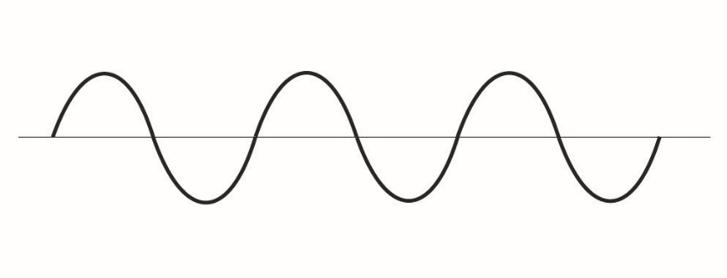

1. Converted the image to time series

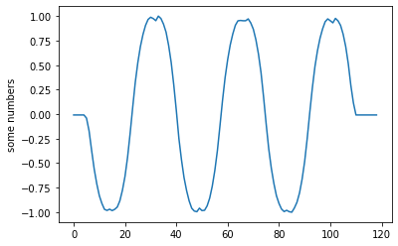

1. Applied noise and fit an ARMA model 100 times on the data above to create 100 time series similar to the one below

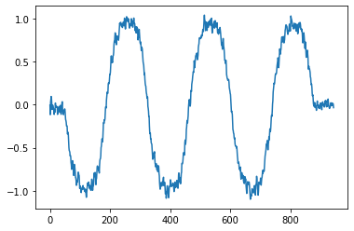

B] Creating own synthetic data

Not yet started

Drawings of classes (frown and smile).

Using couple (4-5) hand drawn samples from each class. Apply ARMA to increase sample size and then applying tsne and dynamic tsne. to see if the classes can be differentiated.

These patterns will then be advanced slowly to see if the t-snes are able to catch patterns.

I am trying to look for a way to scale/resize/shift the time series without changing the amplitude(Y axis) like we do with images when running CNN.

Frown class(jpgs)

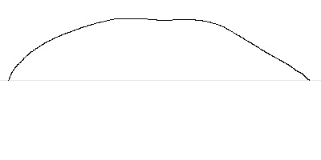 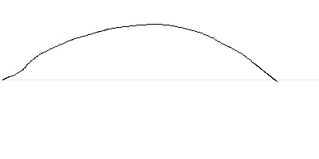

Smile class

