Transforming Salvage into Sustainable Mobility

Abbas Mustafa

Hamza Jadoon

**Background**:

Pakistan has long faced the challenge of high automobile prices due to various factors, including import tariffs, taxes, and limited competition in the domestic market. As a result, many consumers find it increasingly difficult to afford brand new cars. Simultaneously, a large number of accidented or scrapped vehicles are discarded every year, posing environmental concerns.

**Problem Statement:**

The problem at hand is the exorbitant cost of automobiles in Pakistan, which poses a significant barrier to vehicle ownership for the majority of citizens. This issue stems from a combination of factors, including import tariffs, taxes, and limited competition in the domestic automotive market. As a result, the average Pakistani household finds it increasingly challenging to afford new cars, hindering mobility and economic progress. Furthermore, this situation contributes to the abandonment of a substantial number of accidented or scrapped vehicles each year, exacerbating environmental concerns. In light of these challenges, there is an urgent need to develop a cost-effective and sustainable solution that not only reduces the financial burden on consumers but also addresses environmental sustainability by recycling and reusing discarded vehicle components.

**Proposal Overview:**

**Car Recycling Centers:** We propose the establishment of car recycling centers across the country, where accidented or scrapped vehicles can be collected, inspected, and evaluated for reusable parts. These centers would serve as the cornerstone of our initiative.

**Component Salvage and Reuse**: Salvageable components such as engines, transmissions, and electronics would be carefully extracted from the scrapped vehicles. These components would undergo rigorous quality checks and refurbishment processes to ensure they meet safety and performance standards.

**Eco-Friendly Manufacturing:** We would use these salvaged components to build affordable, eco-friendly, and reliable vehicles. By reducing the need for new manufacturing processes and materials, our approach would have a significantly lower carbon footprint compared to traditional car production.

**Affordable Pricing:** The cars produced through this method would be sold at considerably lower prices than brand new vehicles, making them more accessible to a wider range of consumers. This approach would also create a thriving market for budget-friendly cars.

**Benefits:**

**Affordable Cars:** This initiative would make owning a car more affordable for the average Pakistani citizen, thus increasing vehicle ownership rates and mobility.

**Environmental Impact:** Recycling and reusing car components would contribute to reduced waste and greenhouse gas emissions associated with car manufacturing.

**Economic Growth**: The establishment of recycling centers and the entire supply chain around car recycling would generate employment opportunities and stimulate economic growth.

**Government Revenue:** The government can benefit from increased revenue through taxation on the sale of recycled cars and the establishment of recycling centres.

**Innovation and Technology Transfer:** This initiative can foster innovation and technological advancements in the automotive industry in Pakistan.

|  |  |  |  |  |
| --- | --- | --- | --- | --- |
| **Expense Reports** | | | | |
| **S#** | **Expense** | **Cost** | **Duration** | **Total** |
| 1 | Business Registration | 15000 | One Time | Rs15,000.00 |
| 2 | Domain Registration | 3500 | Yearly | Rs3,500.00 |
| 3 | Website Development | 200000 | One Time | Rs200,000.00 |
| 4 | Website Maintenance | 15000 | Yearly | Rs15,000.00 |
| 5 | Warehouse | 50000 | Monthly | Rs600,000.00 |
| 6 | Server Hosting | 5500 | Monthly | Rs66,000.00 |
| 7 | Machinery | 1000000 | One Time | Rs1,000,000.00 |
| 8 | Maintenance | 500000 | Yearly | Rs500,000.00 |
| 9 | Inspection | 200000 | Monthly | Rs2,400,000.00 |
| 10 | Team | 100000 | Monthly | Rs1,200,000.00 |
| 11 | Part purchase | 500000 | Monthly | Rs6,000,000.00 |
|  | **Total** | | | Rs11,999,500.00 |

|  |  |  |  |  |
| --- | --- | --- | --- | --- |
| **Income Statements** | | | | |
| **S#** | **Income (Expected)** | **Value** | **Duration** | **Total** |
| 1 | Car Sales | 5000000 | Monthly | Rs60,000,000.00 |
| 2 | Repair | 200000 | Monthly | Rs2,400,000.00 |
|  | **Total** | | | Rs62,400,000.00 |

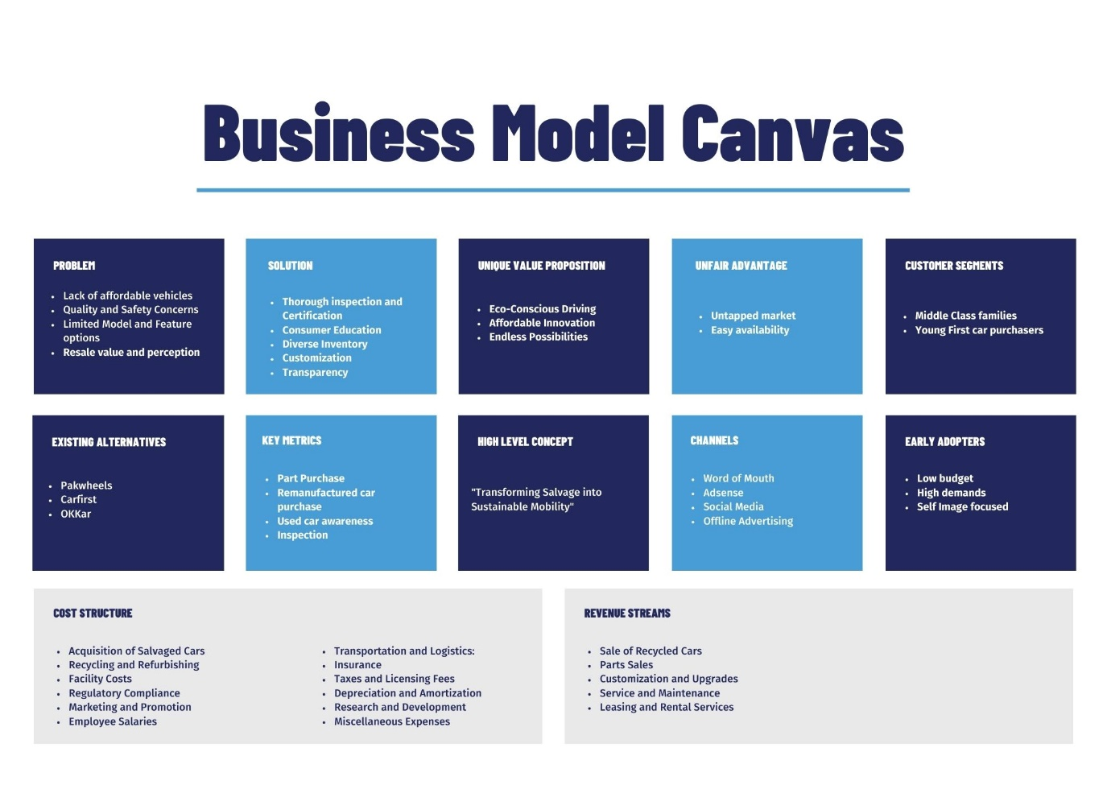

**Conclusion:**

Addressing the issue of expensive cars in Pakistan through car recycling and manufacturing is not only an economically viable solution but also a sustainable one. It aligns with global trends towards environmental responsibility while offering tangible benefits to the local economy and the Pakistani people.

We are eager to engage in further discussions to explore the feasibility and implementation of this proposal. By working together, we can bring affordable, eco-friendly vehicles to the people of Pakistan, driving progress and prosperity for the nation.

Thank you for considering our proposal, and we look forward to the opportunity to collaborate on this transformative initiative.