A simple rmarkdown example

Wolfgang Viechtbauer

01 May, 2020

# Introduction

This is an example of a R markdown document. With some basic formating codes you can make text *italic* and **bold**.

## Subheading

You can also easily make lists:

* item 1
* item 2
* item 3

Or numbered lists:

1. item 1
2. item 2
3. item 3

### Subsubheading

This is a “subsubheading”.

## Equations

If you know some basic latex syntax, you can easily add equations to your document. Equations can appear as part of the regular text (e.g., if $x=2$, then $x+4=6$). Or you can have equations appear in their own line:

$$\frac{1}{2}+\frac{3}{4}=\frac{5}{4}.$$

When you compile the document, the equations should be nicely rendered.

## Links

Links can be created by simply pasting the URL into the document: <https://rmarkdown.rstudio.com/>. Or, you can make a string of text become a link. For example, [R markdown](https://rmarkdown.rstudio.com/).

## Embedding R Code

Where it gets really cool is when you start embedding R code in your document. For example:

set.seed(1234)  
x <- runif(100, min=0, max=30)  
y <- 10 + .5*x + .3*x^2 + rnorm(100, mean=0, sd=25)  
res1 <- lm(y ~ x)  
res2 <- lm(y ~ x + I(x^2))  
summary(res1)

##   
## Call:  
## lm(formula = y ~ x)  
##   
## Residuals:  
## Min 1Q Median 3Q Max   
## -64.856 -22.728 -1.134 19.088 84.584   
##   
## Coefficients:  
## Estimate Std. Error t value Pr(>|t|)   
## (Intercept) -26.7914 5.9636 -4.493 1.93e-05 ***  
## x 8.9745 0.3838 23.385 < 2e-16 ***  
## ---  
## Signif. codes: 0 '***' 0.001 '**' 0.01 '*' 0.05 '.' 0.1 ' ' 1  
##   
## Residual standard error: 31.93 on 98 degrees of freedom  
## Multiple R-squared: 0.848, Adjusted R-squared: 0.8465   
## F-statistic: 546.9 on 1 and 98 DF, p-value: < 2.2e-16

## Dynamically Generated Plots

Using regular R code, you can create graphs, which then get automatically embedded in the document.

plot(x, y, pch=19, xlab="Time in R Course",  
 ylab="Your R Skills", main="R Skills as a Function of Time in Course")  
abline(res1, lty="dotted")  
lines(predict(res2, newdata=data.frame(x=seq(0,30,1))))

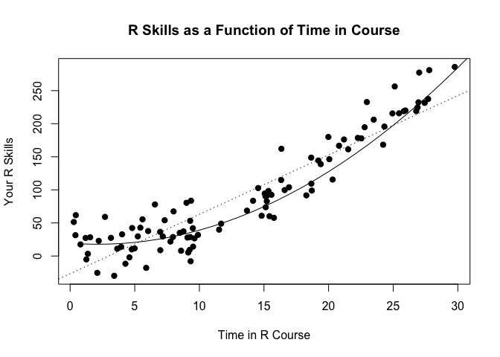

You can also include the results from analyses in your text. For example, for the quadratic model, we find $R^{2}=$ 0.92. I think we should send this article to Science or Nature!

## Tables

You can also create tables from model objects (the pander package is very useful for that).

Results from Quadratic Model

|  |  |  |  |  |
| --- | --- | --- | --- | --- |
|  | Estimate | Std. Error | t value | Pr(>|t|) |
| **(Intercept)** | 18.2 | 6.752 | 2.695 | 0.008289 |
| **x** | -0.7768 | 1.137 | -0.6835 | 0.4959 |
| **I(x^2)** | 0.3437 | 0.03876 | 8.867 | 3.749e-14 |

The kable() function from the knitr package can do something similar.

Results from Quadratic Model

|  |  |  |  |  |
| --- | --- | --- | --- | --- |
|  | Estimate | Std. Error | t value | Pr(>|t|) |
| (Intercept) | 18.200 | 6.752 | 2.695 | 0.008 |
| x | -0.777 | 1.137 | -0.683 | 0.496 |
| I(x^2) | 0.344 | 0.039 | 8.867 | 0.000 |

These are just some of the basics. I hope you can see the potential here!

## References

You can also include references. You need a bibliography file for this (see the references.bib file). For example, the first paper about the R language was written by Ihaka and Gentleman (1996). Blah blah blah. We used R for the analyses (R Core Team 2020).

## More Info

To learn more about R Markdown, you should check out these websites:

* [rmarkdown](https://rmarkdown.rstudio.com/)
* [markdown](https://daringfireball.net/projects/markdown/)
* [pandoc](https://pandoc.org/)

These are some useful packages that can be useful when creating such documents.

* [pander package](https://rapporter.github.io/pander/)
* [xtable package](https://cran.r-project.org/package=xtable)
* [texreg package](https://cran.r-project.org/package=texreg)

# References

Ihaka, R., and R. Gentleman. 1996. “R: A Language for Data Analysis and Graphics.” *Journal of Computational and Graphical Statistics* 5 (3): 299–314.

R Core Team. 2020. *R: A Language and Environment for Statistical Computing*. Vienna, Austria: R Foundation for Statistical Computing. <https://www.R-project.org/>.