AWS-BLOOD BANK-Project
Create a Vpc BANK-VPC
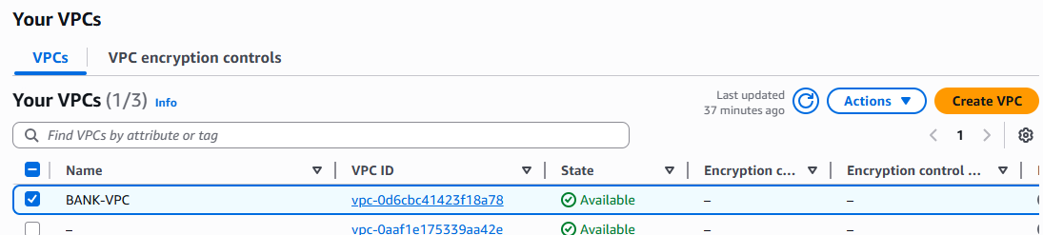
Enable DNS hostnames for the BNK-VPC
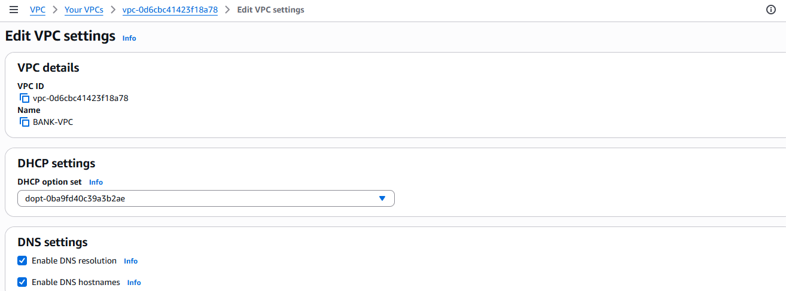
Create 2 Public and 3 Private subnets in different availability zones
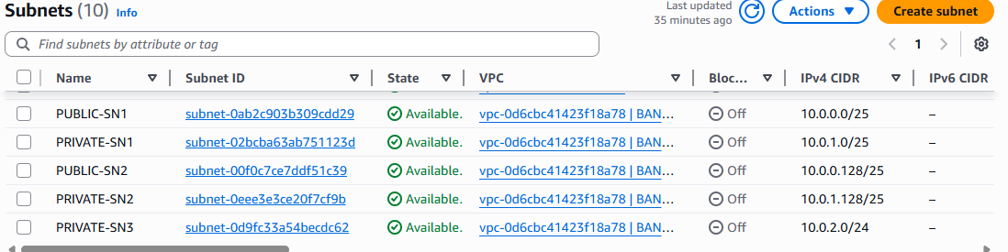
For Public subnets Enable auto assign Public-IP
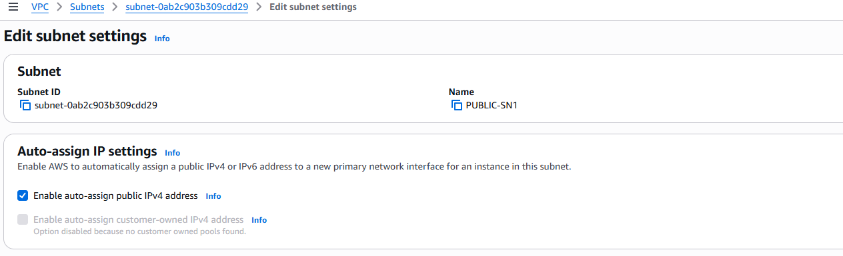
Create Private and Public Route tables
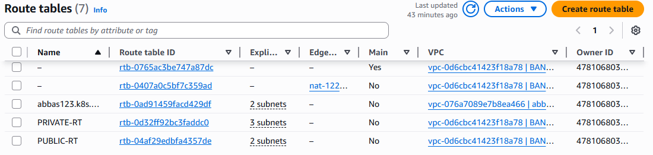

Create Internet Gateway BANK-IGW
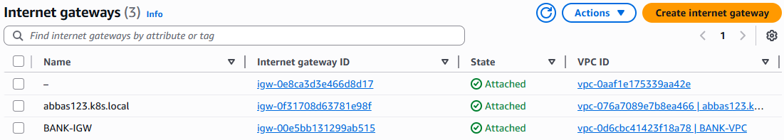
Create a NAT-Gateway BANK-NAT
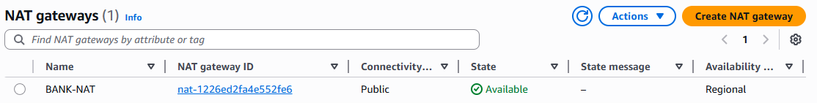
Create a Security Group BANK-SG
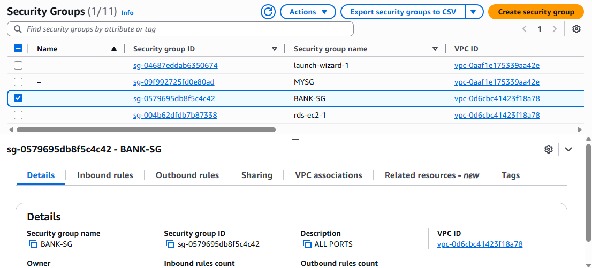
For Public Route table Edit the subnet associations and add the public subnets to it.
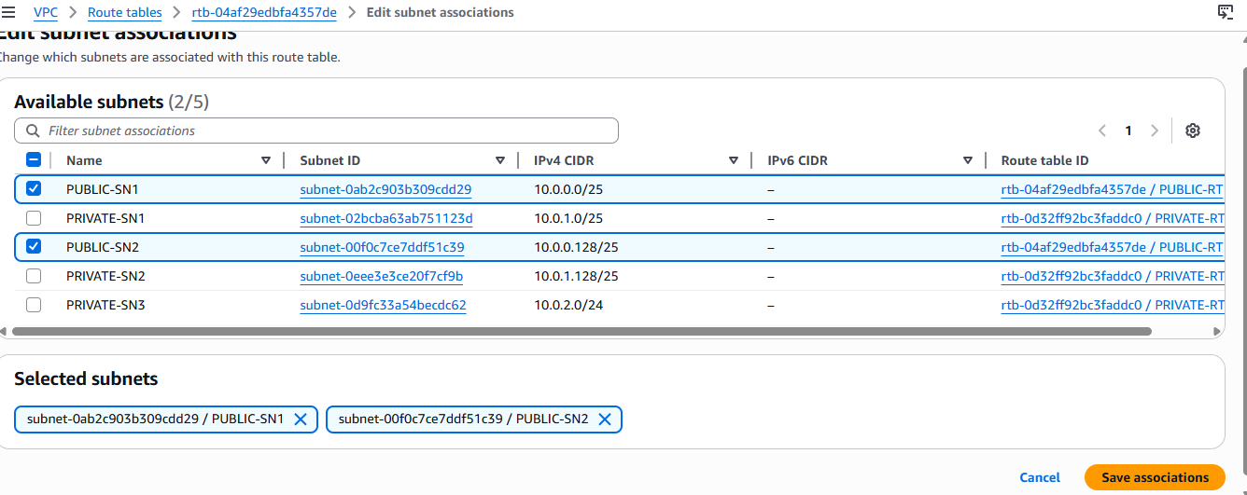
For Private Route table Edit the subnet associations and add the 3 private subnets to it.
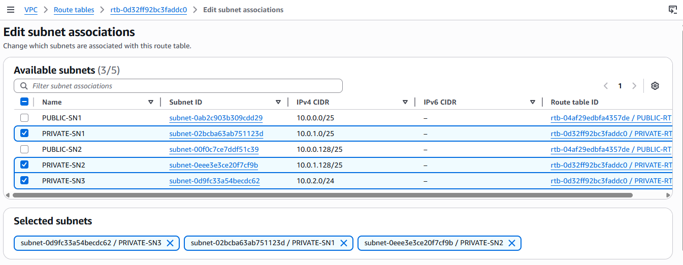
For Public RT- Add the route via BANK-IGW
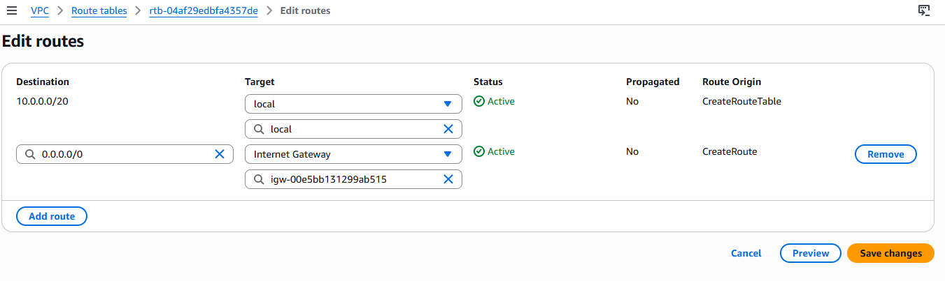
For Private RT- Add the route via NAT-Gateway
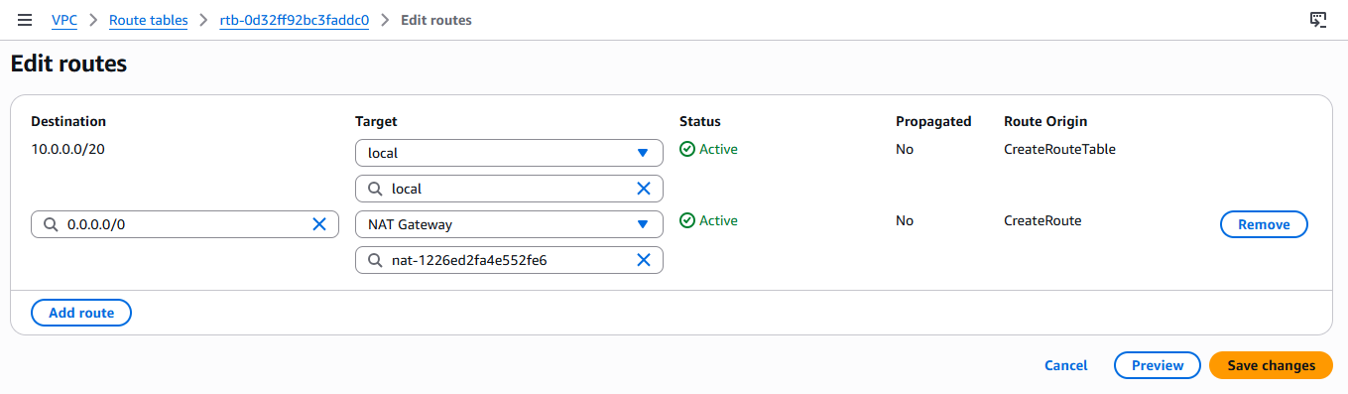
Create a mysql database
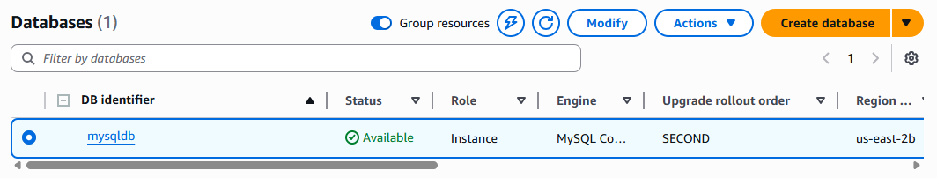
Create a target group for load balancer
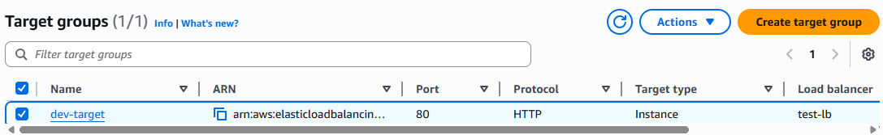
Create a load balancer
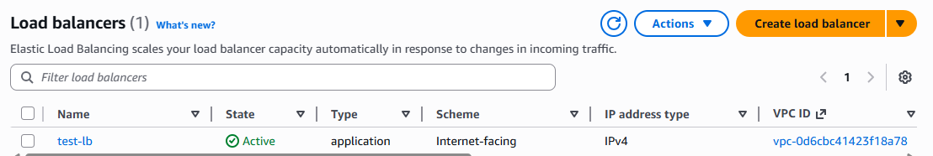
Launch 2 instances. One within Private subnet
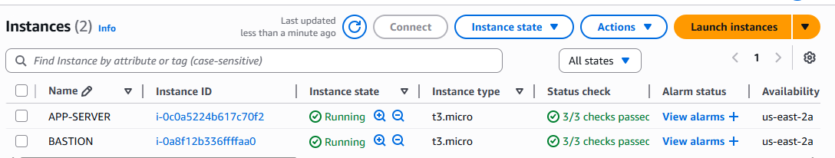
Connect the Private Instance with the help of the Bastion server
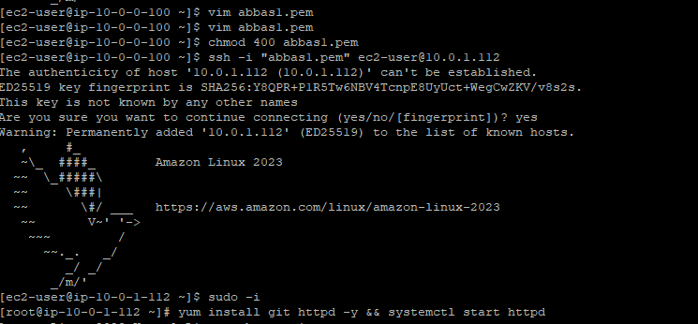
Install git, httpd on the server
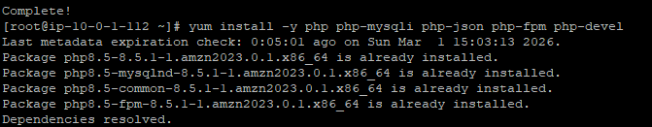
Install database on the server
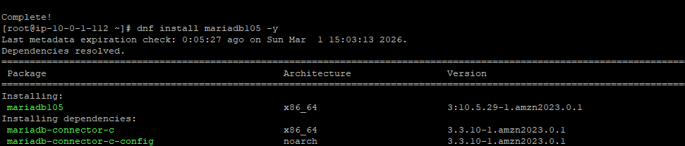
Clone the repository
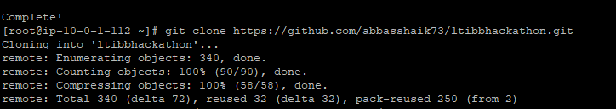
Configure the files
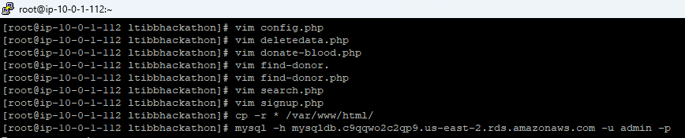
Create databases and tables.
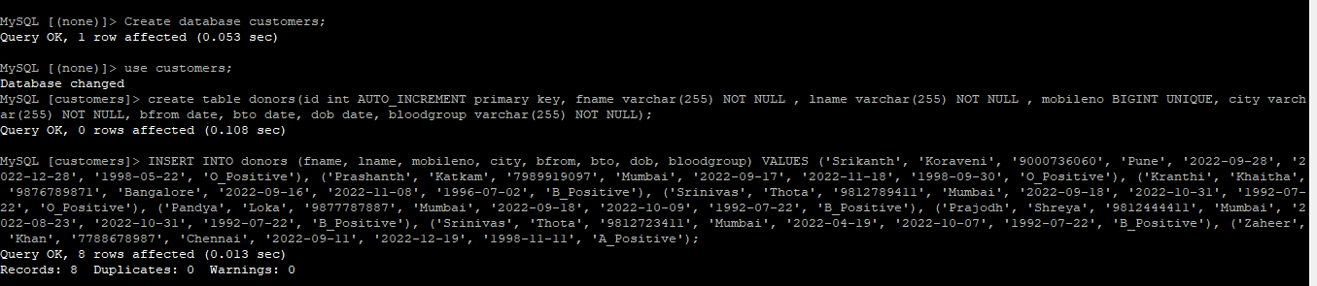

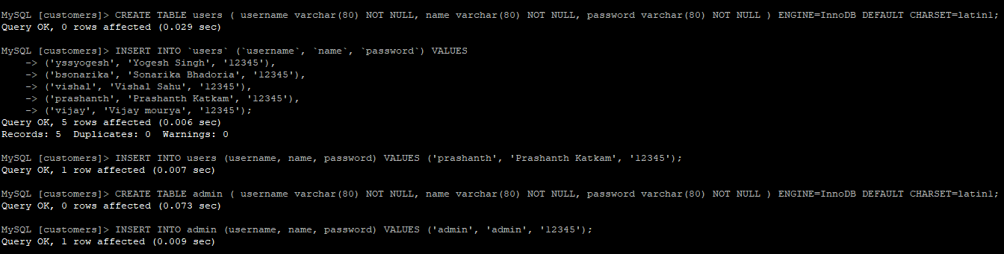
Restart httpd
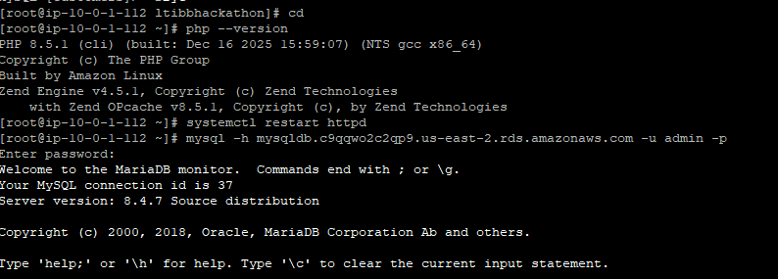
Access the application via loadbalancer DNS
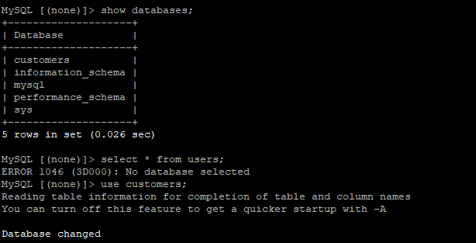
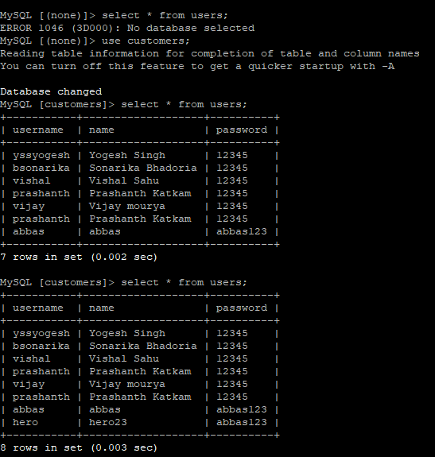
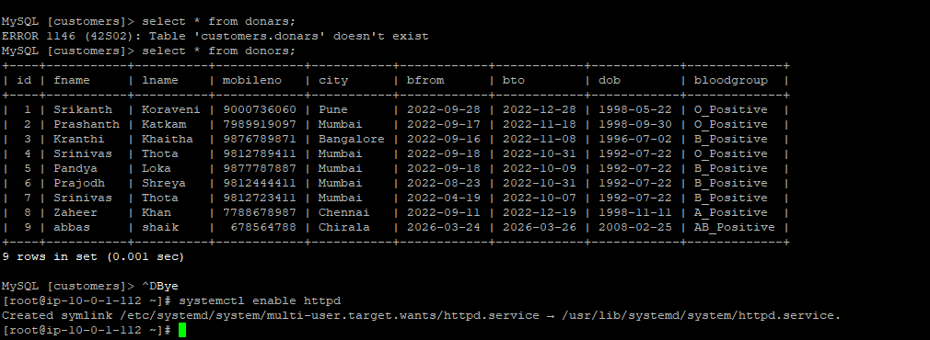
You can check that added details will be shown in the db server.
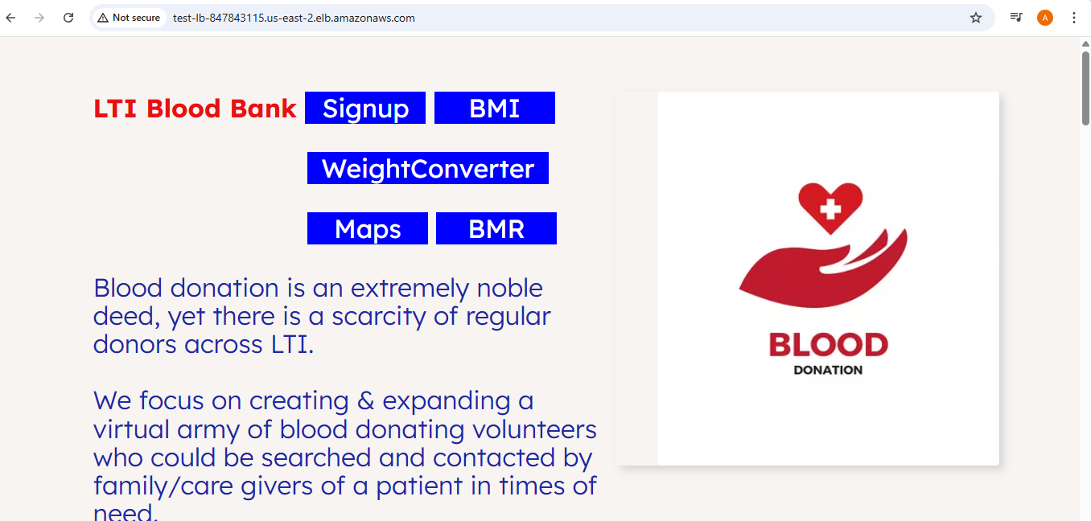
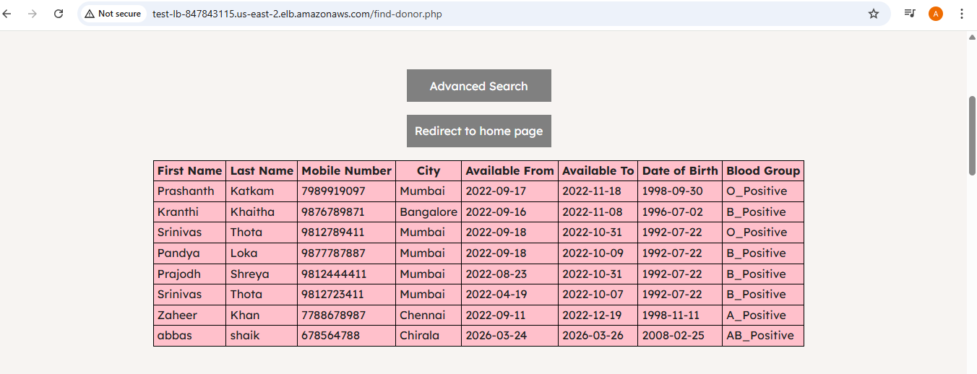
Create a Image from the App-server instance
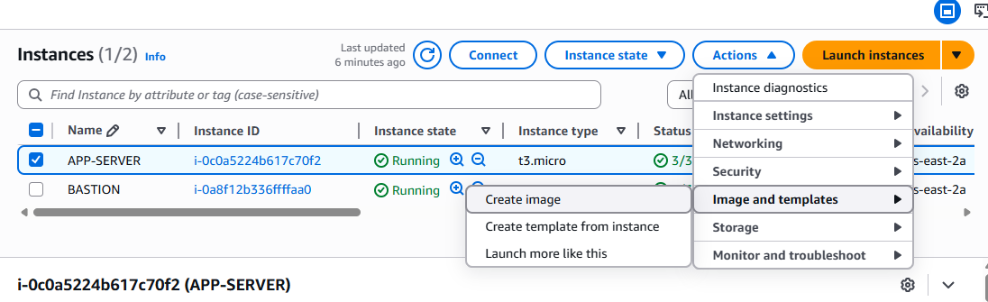
Check the AMI.
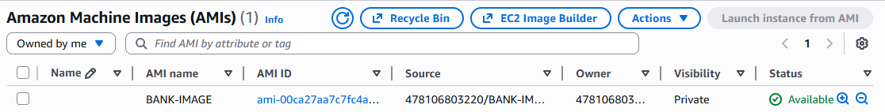
Create an launch template using that image created.
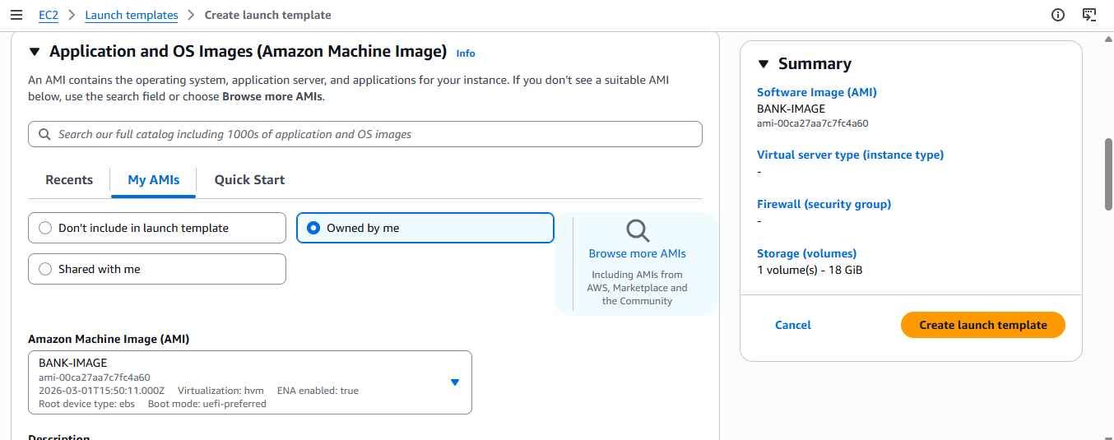
Create the template.
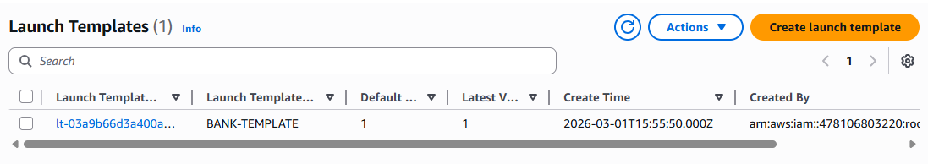
Create an Auto Scaling Group from the template
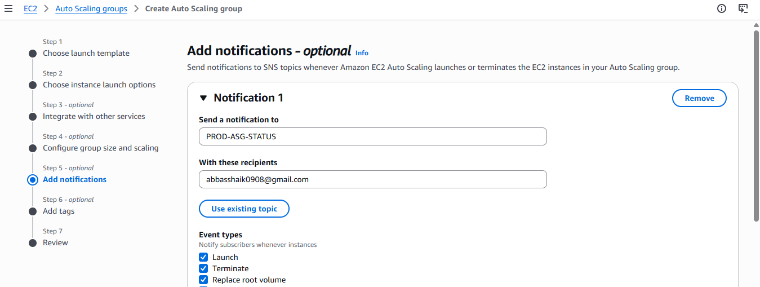
Enable SNS feature
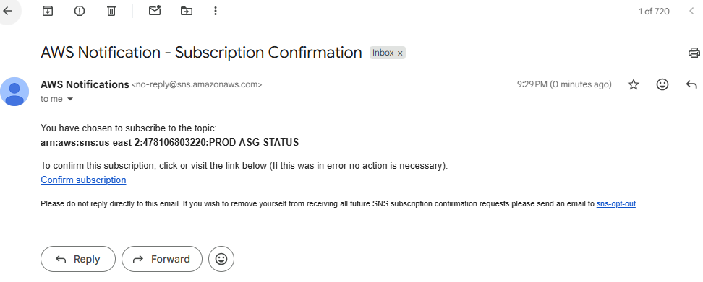
Confirm the subscription
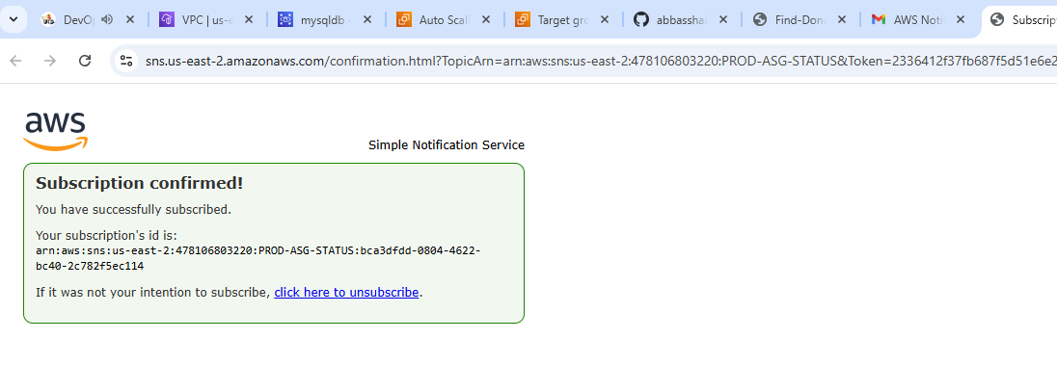
Check the ASG created
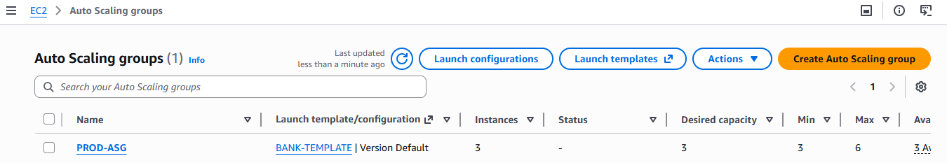
We can see new instances being created using the ASG
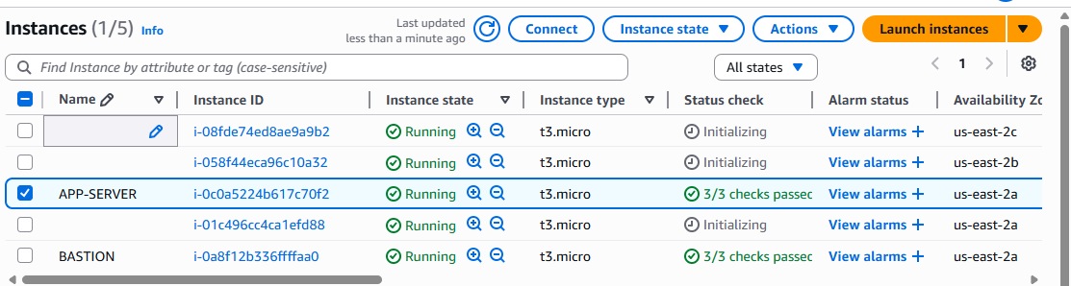
Remove the app-server form the target group so that we can see how the traffic goes through the ASG-servers
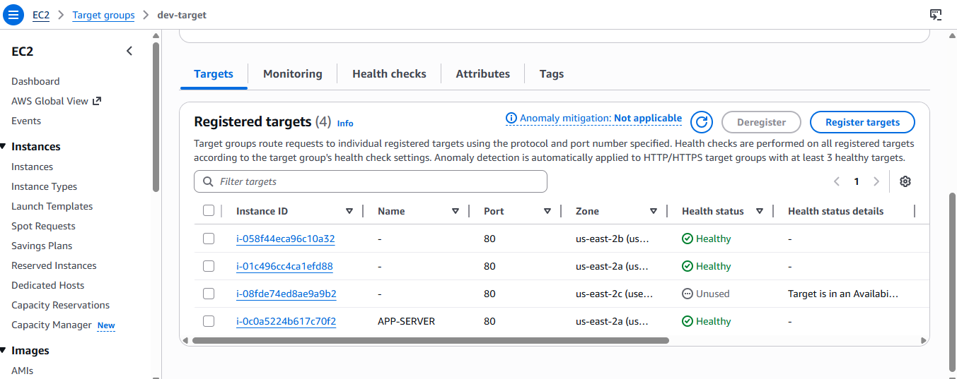
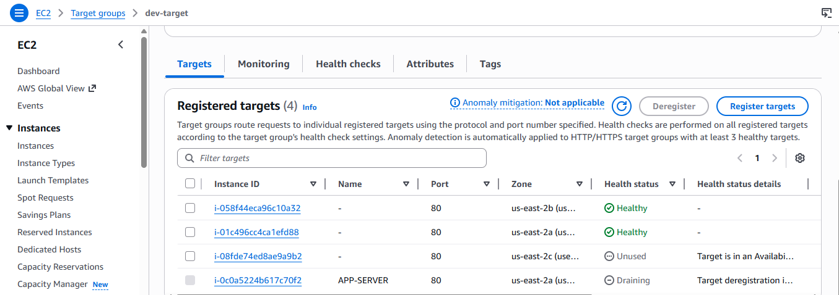
Still we can Access the application
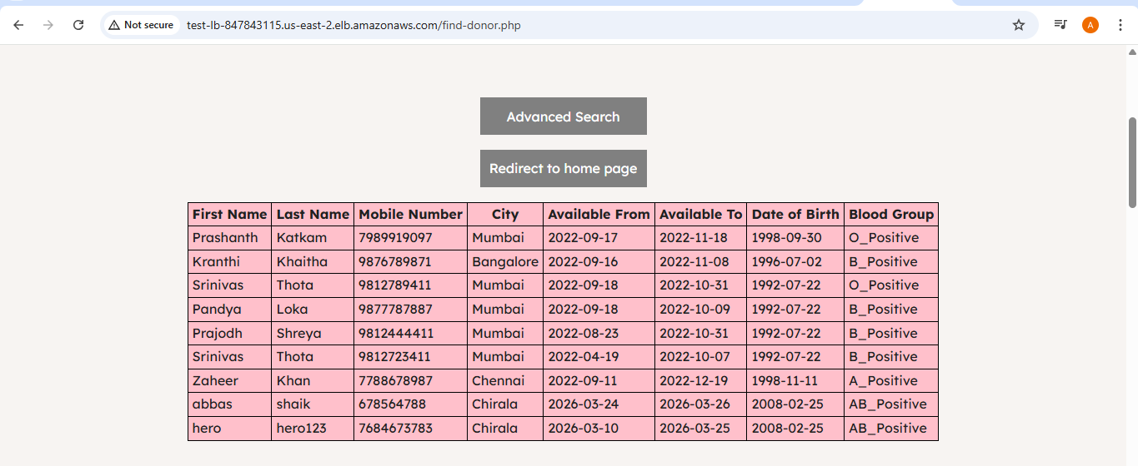
AWF- Amazon Web-access Firewall is used to protect the web applications. Here we can allow/deny any ip from being accessible to the application.
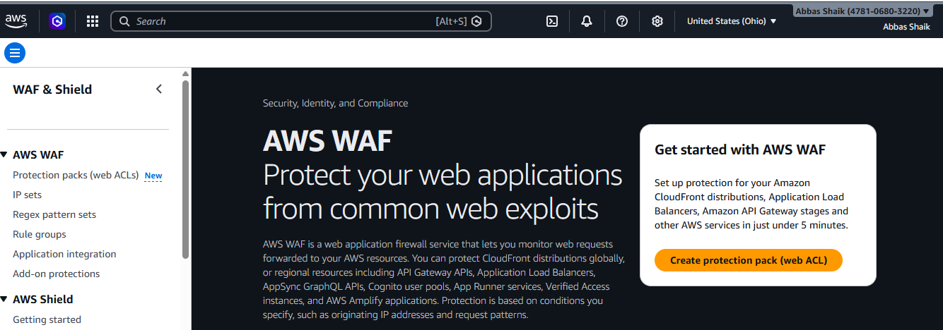
For this we need to create the WAF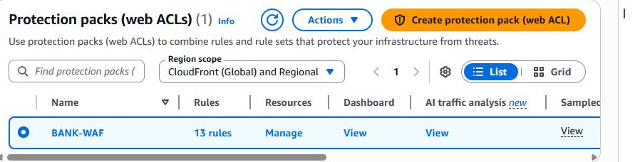
Add a new rule that it should block your ip from accessing the application. Once added you cannot access the particular application.
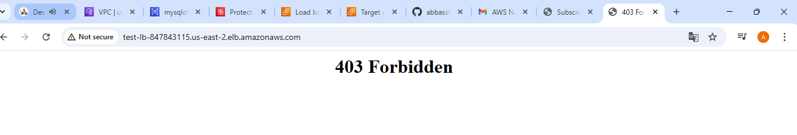
Remove/Delete the rule so that you can access the application.
