Lab 5 – Postman and APIs
Abbas Naim
Software Tools Lab
15 October 2026

Flask user app
This application manages users in a SQLite database through five Flask endpoints. Each user has an automatically generated ID, name, email, phone, address and country. The database code is in database.py and the routes are in app.py. SQLite is included with Python, so only Flask and Flask-Cors are needed to run the application.
Method | Endpoint | Purpose
GET | /api/users | List users
GET | /api/users/<user_id> | Read one user
POST | /api/users/add | Add user
PUT | /api/users/update | Update user
DELETE | /api/users/delete/<user_id> | Delete user

Postman collection and environment
The submitted collection is named Flask user app. Its eight requests cover the five endpoints, a second read after updating, a missing-user check after deletion and a final list. Every request includes a saved example captured from a real HTTP response. The Flask local environment stores base_url as http://127.0.0.1:5001. Request URLs use {{base_url}}, and the add request stores the returned ID in user_id for later requests.
The screenshots show requests sent through the installed Postman lightweight client. This mode does not require sign-in, but it does not support importing collections or environments. Those are supplied as standard Postman JSON files and were tested together using Newman. The full Postman workspace can import both files directly.

Results
All seven Python tests passed. Newman completed 8 requests and 27 assertions with 0 failures. The tests checked CRUD operations, persistence, input validation, missing IDs and JSON error responses. The example sequence changed Omar Saleh’s address to Achrafieh, Beirut and then deleted only that test record. Maya Haddad remains as fictional sample data.

Git and GitHub
Repository: https://github.com/abbassthe/Lab5-AbbasNaim
The SQLite layer was committed and pushed first. The feature/rest-api branch was created from main and pulled the database code from origin/main. The API was tested on that branch and merged back into main. The final repository includes the collection, environment, screenshots and test evidence.
To run: install requirements.txt, run python seed.py, then python app.py. Open http://127.0.0.1:5001/api/users in a browser. Full instructions are in README.md.

Create and list users
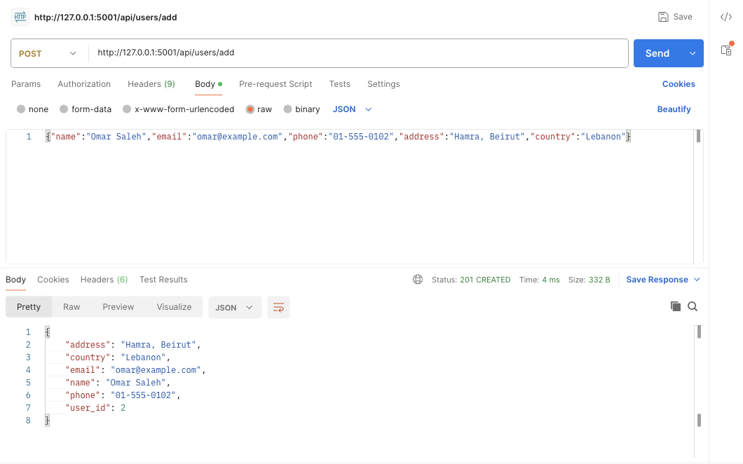
POST creates a user and returns 201 Created.
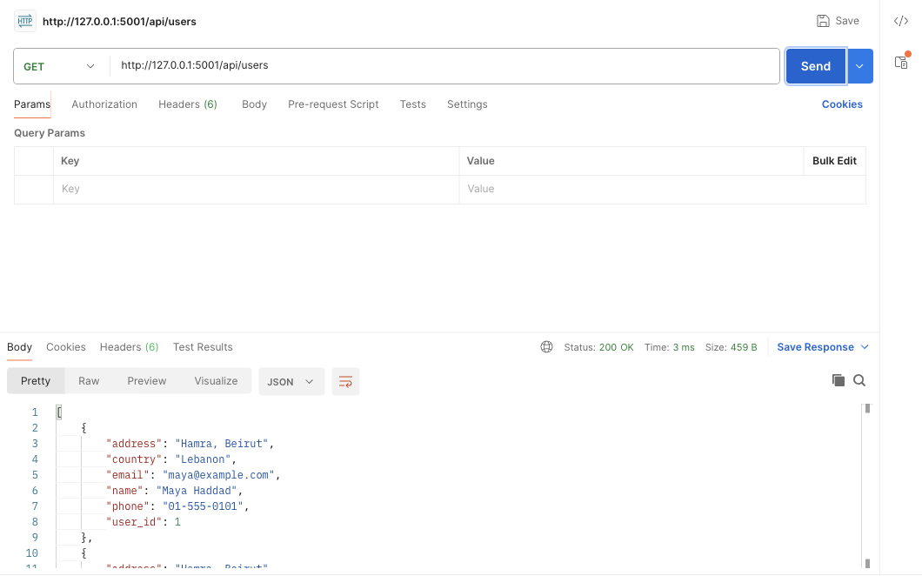
GET returns the users stored in SQLite.

Read and update a user
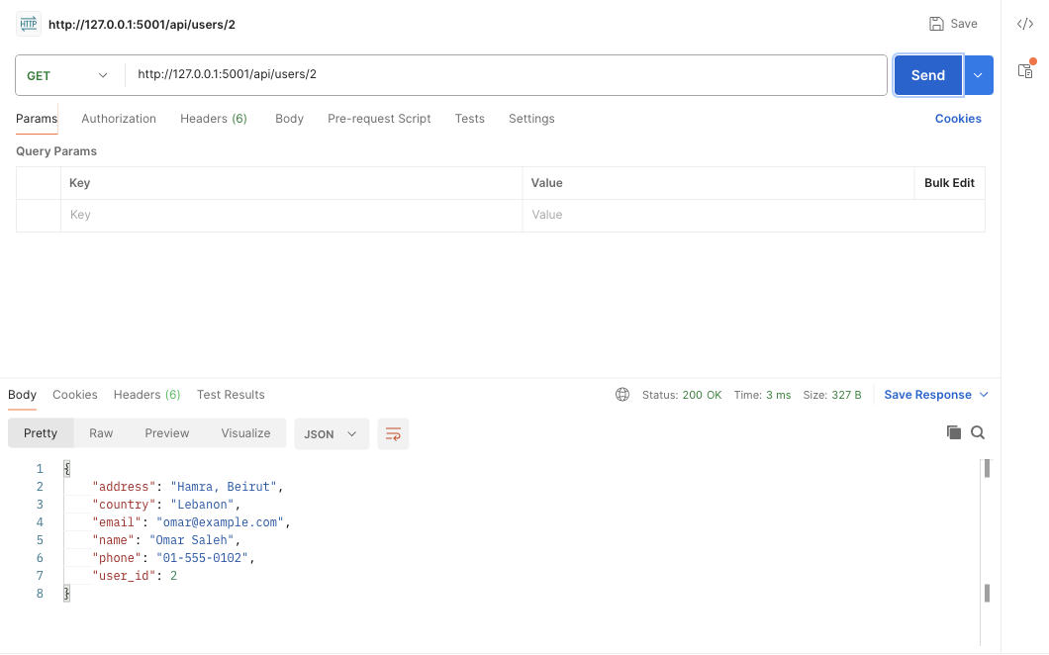
GET returns one user by ID.
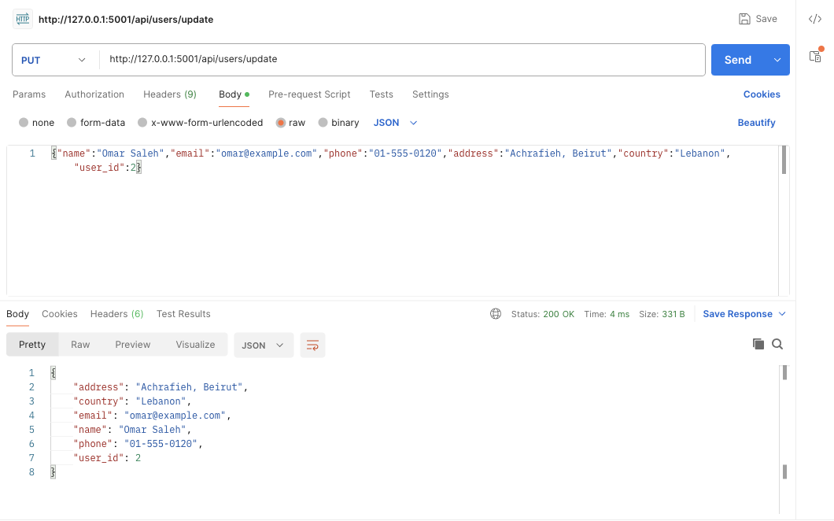
PUT changes the address and phone number.

Delete and confirm
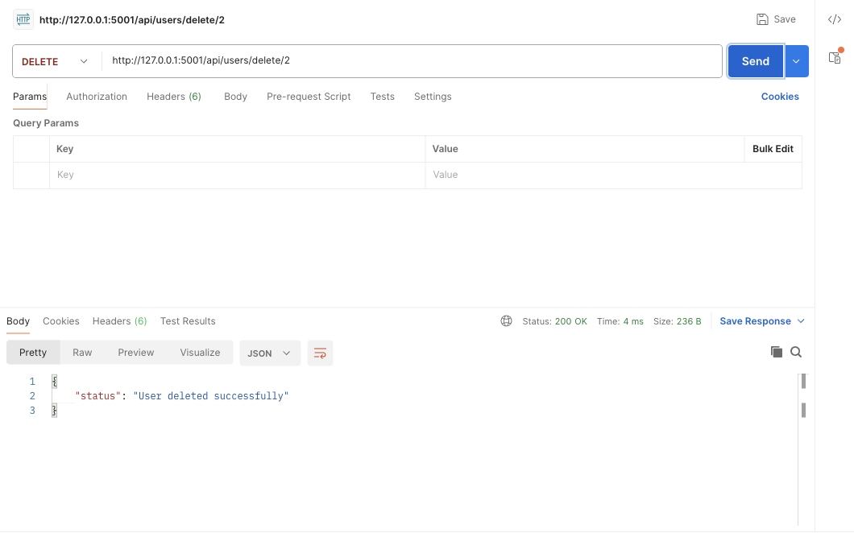
DELETE confirms removal of the selected user.
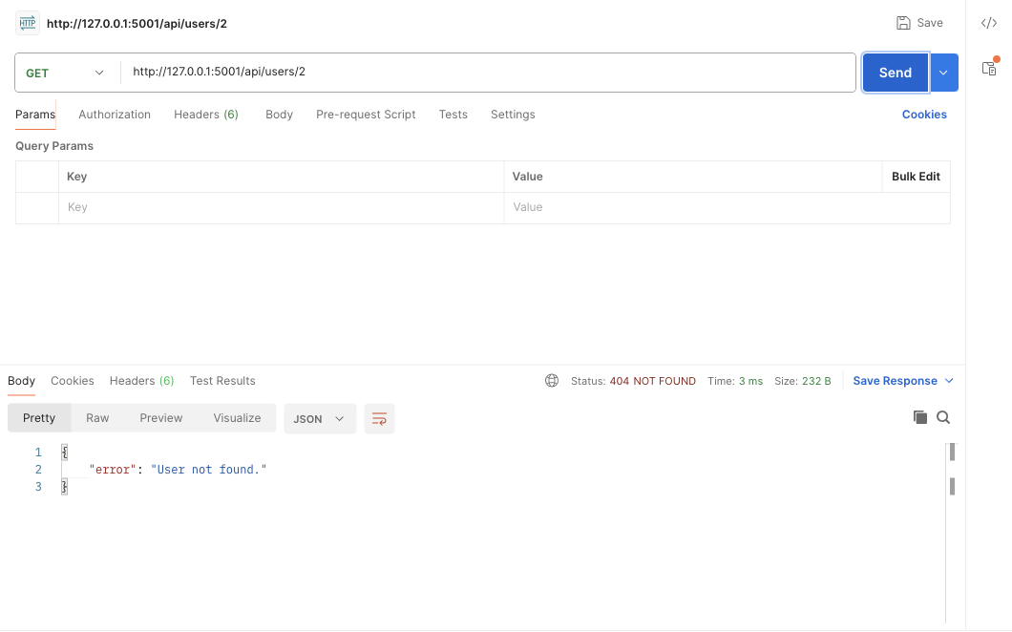
GET returns 404 for the deleted ID.

Collection run and environment
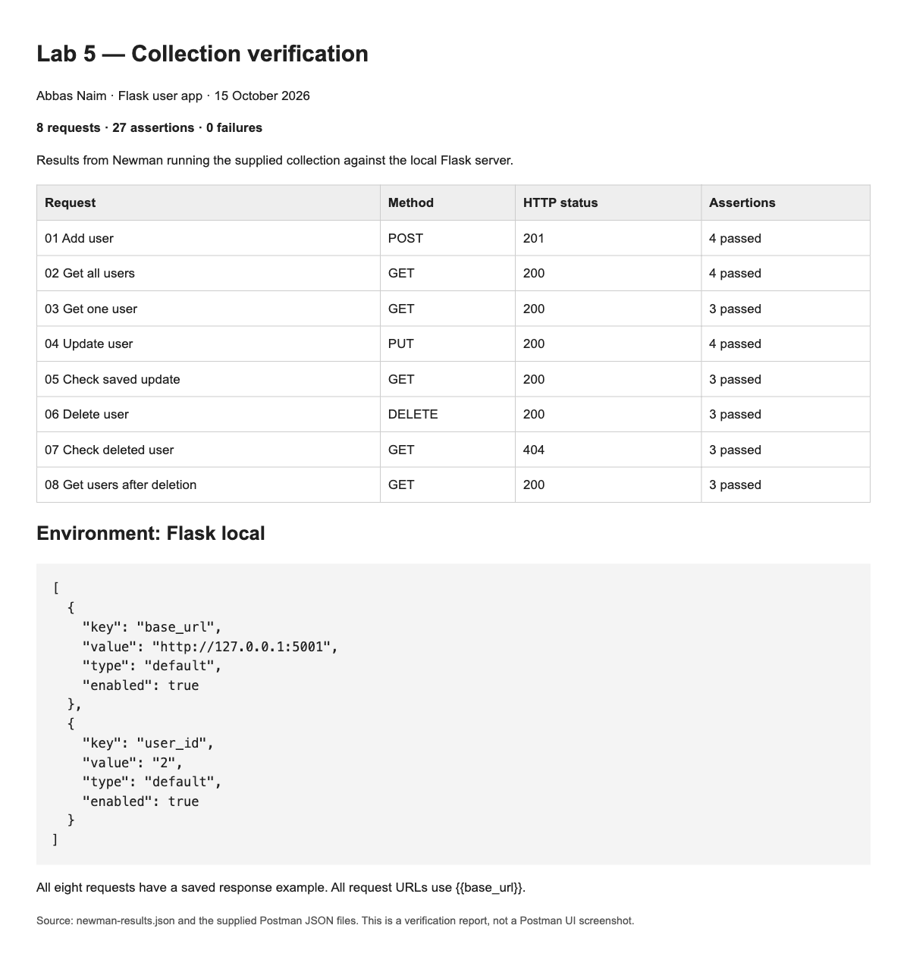
Newman results for the supplied collection and environment.

Browser GET checks
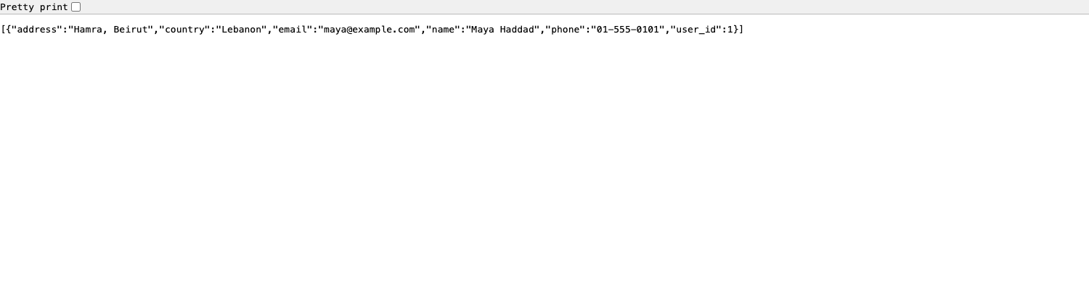
The list endpoint opened in Chrome.
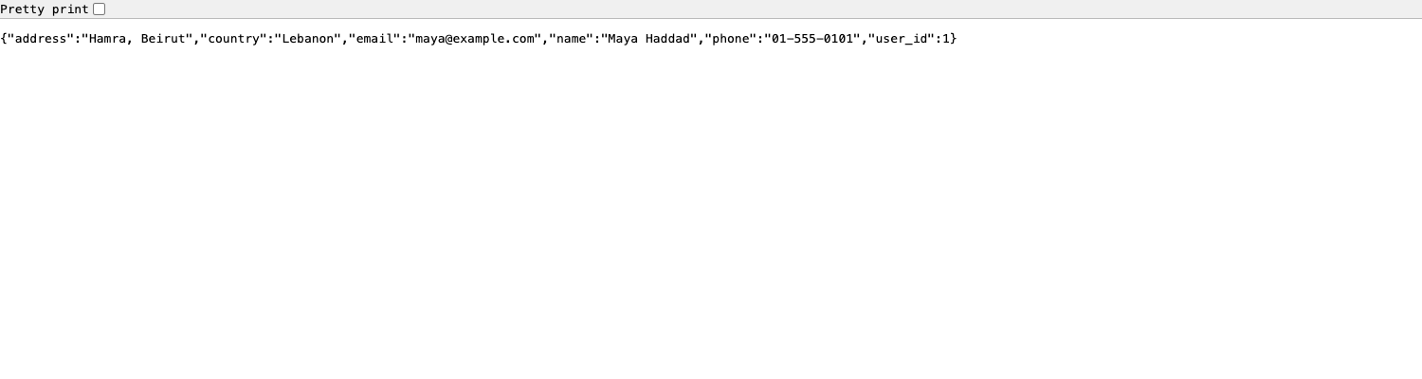
The single-user endpoint opened in Chrome.

