LAB 04 REPORT
Testing with Pytest: Fixtures, Parametrization, and Test Doubles
Student Name: | Zaeem Abbas Salim Abbas
Roll Number: | 2430-184
Program & Semester: | BS Software Engineering (Semester 5)
Course: | Software Construction and Design Lab
Repository Link: | https://github.com/abbaszaeem89-bit/gradebook-service.git

Task 1: Pytest Configuration (pytest.ini)
Configured pytest.ini at the project root directory. The setting pythonpath = . allows test files to import project modules (gradebook, models, errors) directly without manual sys.path manipulation, while testpaths = tests instructs pytest to discover tests inside the tests/ directory.
File: pytest.ini
[pytest]
pythonpath = .
testpaths = tests

Terminal Output Verification:
Terminal output verifying that pytest successfully loaded pytest.ini, located the tests directory, and passed all existing test suites.

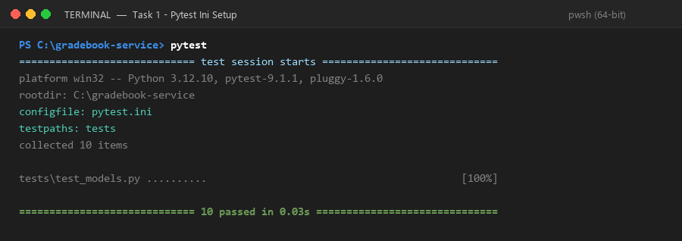

Task 2: Initial Tests for pct() using monkeypatch
Constructed tests/test_pct.py using the Arrange-Act-Assert pattern. Because pct() reads global STATE, monkeypatch.setattr is used to inject an isolated dictionary for each test and automatically revert state afterwards. Tested three scenarios: a student with no marks, standard weight percentage calculation (15/20 on weight 10 = 7.5%), and ignoring marks for unknown assessments.
File: tests/test_pct.py (Initial Version)
import gradebook
def test_student_with_no_marks_has_zero_percent(monkeypatch):
state = {
"students": {"S1": {"id": "S1", "name": "Ayesha"}},
"assessments": {"A1": {"id": "A1", "title": "Quiz 1", "weight": 10, "total": 20}},
"marks": [],
}
monkeypatch.setattr(gradebook, "STATE", state)
result = gradebook.pct("S1")
assert result == "0"
def test_mark_of_15_out_of_20_on_weight_10_gives_7_5(monkeypatch):
state = {
"students": {"S1": {"id": "S1", "name": "Ayesha"}},
"assessments": {"A1": {"id": "A1", "title": "Quiz 1", "weight": 10, "total": 20}},
"marks": [{"student": "S1", "assessment": "A1", "score": 15}],
}
monkeypatch.setattr(gradebook, "STATE", state)
result = gradebook.pct("S1")
assert result == "7.5"
def test_mark_for_unknown_assessment_is_ignored(monkeypatch):
state = {
"students": {"S1": {"id": "S1", "name": "Ayesha"}},
"assessments": {},
"marks": [{"student": "S1", "assessment": "GHOST", "score": 15}],
}
monkeypatch.setattr(gradebook, "STATE", state)
result = gradebook.pct("S1")
assert result == "0"

Terminal Output Verification:
Terminal output executing pytest tests/test_pct.py -v, confirming 3 passed tests.

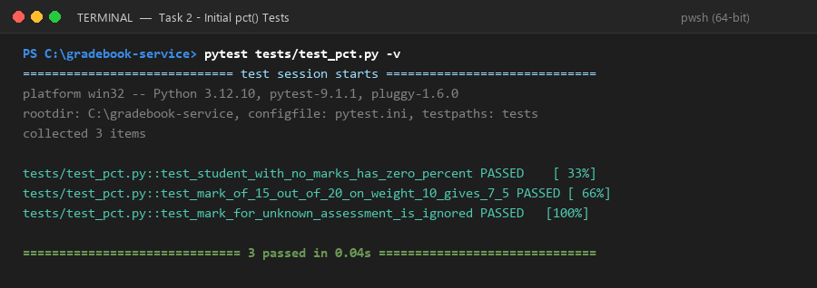

Task 3: Shared Fixtures in conftest.py
Extracted duplicated test setup into pytest fixtures inside tests/conftest.py. The state fixture builds a fresh mock gradebook dictionary, and the loaded fixture monkeypatches gradebook.STATE and returns it. Each test receives a clean, isolated copy, eliminating test pollution.
Files: tests/conftest.py & Refactored tests/test_pct.py
# tests/conftest.py
from typing import Any
import pytest
import gradebook
@pytest.fixture
def state() -> dict[str, Any]:
return {
"students": {"S1": {"id": "S1", "name": "Ayesha"}},
"assessments": {
"A1": {"id": "A1", "title": "Quiz 1", "weight": 10, "total": 20},
"A2": {"id": "A2", "title": "Midterm", "weight": 30, "total": 50},
},
"marks": [],
}
@pytest.fixture
def loaded(state: dict[str, Any], monkeypatch: pytest.MonkeyPatch) -> dict[str, Any]:
monkeypatch.setattr(gradebook, "STATE", state)
return state
# tests/test_pct.py (Refactored to use loaded fixture)
import gradebook
def test_student_with_no_marks_has_zero_percent(loaded):
result = gradebook.pct("S1")
assert result == "0"
def test_mark_of_15_out_of_20_on_weight_10_gives_7_5(loaded):
loaded["marks"].append({"student": "S1", "assessment": "A1", "score": 15})
result = gradebook.pct("S1")
assert result == "7.5"
def test_mark_for_unknown_assessment_is_ignored(loaded):
loaded["marks"].append({"student": "S1", "assessment": "GHOST", "score": 15})
result = gradebook.pct("S1")
assert result == "0"

Terminal Output Verification:
Terminal output verifying that tests/test_pct.py runs cleanly against the shared fixtures.

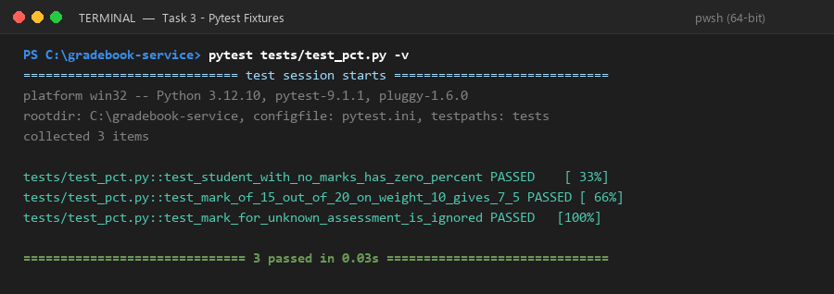

Task 4: Parametrizing Tests across Multiple Scenarios
Consolidated repetitive test cases into @pytest.mark.parametrize tables. In tests/test_pct.py, five score scenarios (no marks, partial quiz, full marks, zero score, two combined assessments) are tested in a single clean function. In tests/test_models.py, numeric parsing is parametrized into good numbers accepted and invalid types/tokens rejected.
Files: tests/test_pct.py & Parametrized tests/test_models.py
# tests/test_pct.py
import pytest
import gradebook
@pytest.mark.parametrize(
("scores", "expected"),
[
pytest.param({}, "0", id="no-marks"),
pytest.param({"A1": 15}, "7.5", id="quiz-15-of-20"),
pytest.param({"A1": 20}, "10.0", id="quiz-full-marks"),
pytest.param({"A1": 0}, "0.0", id="quiz-zero-score"),
pytest.param({"A1": 15, "A2": 40}, "31.5", id="two-assessments"),
],
)
def test_percentage_for_scores(loaded, scores, expected):
for assessment, score in scores.items():
loaded["marks"].append({"student": "S1", "assessment": assessment, "score": score})
result = gradebook.pct("S1")
assert result == expected
def test_mark_for_unknown_assessment_is_ignored(loaded):
loaded["marks"].append({"student": "S1", "assessment": "GHOST", "score": 15})
result = gradebook.pct("S1")
assert result == "0"
# tests/test_models.py (Parametrized Number Tests)
@pytest.mark.parametrize(
("raw", "expected"),
[
pytest.param("15", 15.0, id="numeric-string"),
pytest.param(15, 15.0, id="int"),
pytest.param("2.5", 2.5, id="decimal-string"),
],
)
def test_good_numbers_are_accepted(raw: object, expected: float) -> None:
assert parse_number(raw, "score") == expected
@pytest.mark.parametrize(
"raw",
[
pytest.param("abc", id="text"),
pytest.param(True, id="bool"),
pytest.param(None, id="none"),
pytest.param([], id="list"),
pytest.param("nan", id="nan"),
pytest.param("inf", id="inf"),
],
)
def test_bad_numbers_are_rejected(raw: object) -> None:
with pytest.raises(ValidationError, match="score"):
parse_number(raw, "score")

Terminal Output Verification:
Terminal output executing pytest -v, showing all 20 parametrized test cases passing.

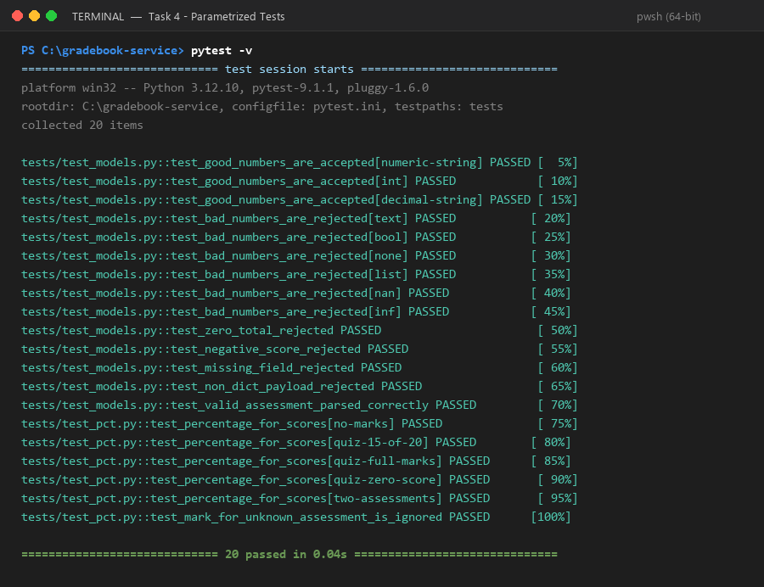

Task 5: Testing File Persistence with tmp_path
Created tests/test_storage.py to test load() and save() against real temporary files using pytest's built-in tmp_path fixture. Avoiding mocks ensures that actual disk I/O, serialization, missing-file defaults, and JSON corruption errors (json.JSONDecodeError) are genuinely verified.
File: tests/test_storage.py
import json
from pathlib import Path
from typing import Any
import pytest
import gradebook
@pytest.fixture
def data_file(tmp_path: Path, monkeypatch: pytest.MonkeyPatch) -> Path:
path = tmp_path / "gradebook.json"
monkeypatch.setattr(gradebook, "DATA", str(path))
return path
def test_saved_gradebook_loads_back_unchanged(data_file, state, monkeypatch):
monkeypatch.setattr(gradebook, "STATE", state)
gradebook.save()
monkeypatch.setattr(gradebook, "STATE", {})
gradebook.load()
assert gradebook.STATE == state
def test_missing_file_gives_an_empty_gradebook(data_file, monkeypatch):
monkeypatch.setattr(gradebook, "STATE", {})
gradebook.load()
assert gradebook.STATE == {"students": {}, "assessments": {}, "marks": []}
def test_corrupt_file_stops_loading_with_a_json_error(data_file):
data_file.write_text("{bad")
with pytest.raises(json.JSONDecodeError):
gradebook.load()

Terminal Output Verification:
Terminal output executing pytest tests/test_storage.py -v, showing all 3 storage tests passing (23 total).

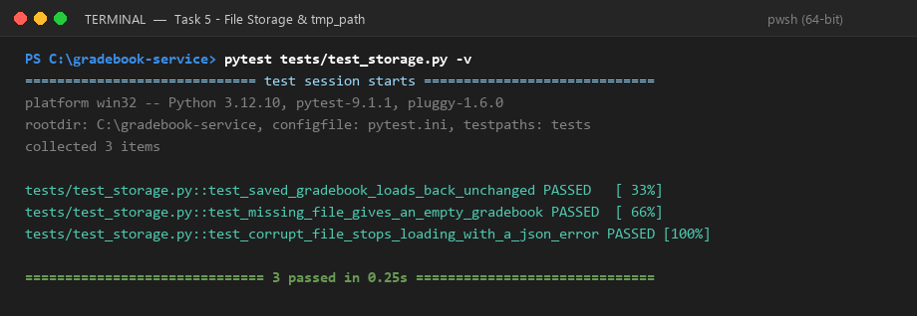

Task 6: Creating an Architectural Seam with add_mark()
Extracted mark validation, recording, timestamp generation, and persistence out of the HTTP handler into a pure domain function add_mark(state, mark, now, save). By passing now (clock) and save (persistence) as parameters, the function can be tested in complete isolation without launching an HTTP server.
File: gradebook.py (Seam Extraction)
def now() -> str:
return str(datetime.datetime.now(datetime.timezone.utc))
def add_mark(
state: dict[str, Any],
mark: Mark,
now: Callable[[], str],
save: Callable[[], None],
) -> None:
"""Check a mark against the gradebook, then record it and save."""
if mark.student not in state["students"]:
raise NotFoundError(f"no such student: {mark.student}")
assessment_row = state["assessments"].get(mark.assessment)
if assessment_row is None:
raise NotFoundError(f"no such assessment: {mark.assessment}")
if mark.score > assessment_row["total"]:
raise ValidationError("score exceeds assessment total")
state["marks"].append(
{
"student": mark.student,
"assessment": mark.assessment,
"score": mark.score,
"at": now(),
}
)
save()
# Handler integration inside do_POST:
if self.path == "/marks":
mark = parse_mark(payload)
add_mark(STATE, mark, now, save)
logger.info("recorded mark for %s score %s", mark.student, mark.score)
return 200, {"ok": True}

Terminal Output Verification:
Terminal output verifying ruff check ., mypy gradebook.py, and pytest with 0 issues.

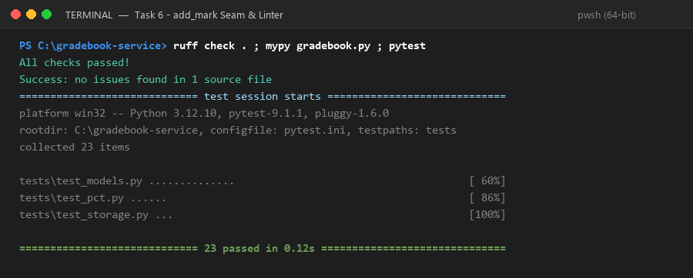

Task 7: Testing add_mark with Test Doubles (Stub, Fake, Mock)
Constructed tests/test_add_mark.py using three distinct test doubles: a Stub (fixed_now providing a deterministic ISO time string), a Fake (state fixture acting as in-memory storage), and a Mock (unittest.mock.Mock standing in for save to verify call counts). Verified that rejected marks leave state completely clean and never invoke save().
File: tests/test_add_mark.py
from typing import Any
from unittest.mock import Mock
import pytest
from errors import NotFoundError, ValidationError
from gradebook import add_mark
from models import Mark
def fixed_now() -> str:
return "2026-10-12 09:00:00"
def test_valid_mark_is_stored_with_the_time(state: dict[str, Any]) -> None:
save = Mock()
add_mark(state, Mark("S1", "A1", 15.0), fixed_now, save)
assert state["marks"] == [
{"student": "S1", "assessment": "A1", "score": 15.0, "at": "2026-10-12 09:00:00"}
]
def test_valid_mark_calls_save_once(state: dict[str, Any]) -> None:
save = Mock()
add_mark(state, Mark("S1", "A1", 15.0), fixed_now, save)
save.assert_called_once_with()
@pytest.mark.parametrize(
("mark", "error"),
[
pytest.param(Mark("NOPE", "A1", 5.0), NotFoundError, id="unknown-student"),
pytest.param(Mark("S1", "GHOST", 5.0), NotFoundError, id="unknown-assessment"),
pytest.param(Mark("S1", "A1", 21.0), ValidationError, id="score-above-total"),
],
)
def test_rejected_mark_changes_nothing(state: dict[str, Any], mark: Mark, error: type[Exception]) -> None:
save = Mock()
with pytest.raises(error):
add_mark(state, mark, fixed_now, save)
assert state["marks"] == []
save.assert_not_called()

Terminal Output Verification:
Terminal output executing pytest tests/test_add_mark.py -v, confirming 5 passed tests (28 passed in total).

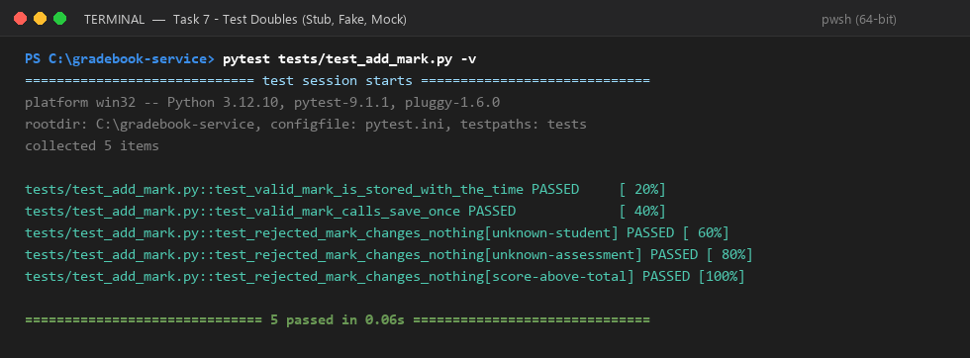

Task 8: Fault Injection & Proving Tests Can Fail
Conducted fault injection to prove test suite efficacy. Temporarily altered division (/) to multiplication (*) in pct(). Pytest immediately detected the flaw, resulting in '3 failed, 25 passed' across all non-zero percentage cases. After reverting the mutation, all 28 tests passed cleanly.
Mutation in gradebook.py & NOTES.md Section
# gradebook.py (Temporary Fault Injection)
# Original: got = got + float(m["score"]) * float(a["weight"]) / float(a["total"])
got = got + float(m["score"]) * float(a["weight"]) * float(a["total"]) # Broken on purpose
# Result: 3 failed, 25 passed
# After Reverting:
got = got + float(m["score"]) * float(a["weight"]) / float(a["total"]) # Clean
# Result: 28 passed
# NOTES.md (Excerpts):
# Which double is which:
# - Stub: fixed_now in tests/test_add_mark.py (deterministic return value)
# - Fake: state fixture in tests/conftest.py (working in-memory gradebook)
# - Mock: Mock() passed as save in tests/test_add_mark.py (records interactions)
#
# Why pct() and files were not mocked:
# - pct() is pure internal business logic; mocking it would bypass the calculation under test.
# - tmp_path provides a real, isolated file system to genuinely verify JSON disk read/write.

Terminal Output Verification:
Terminal output showing the fault injection failure (3 failed, 25 passed) followed by the successful re-run (28 passed).

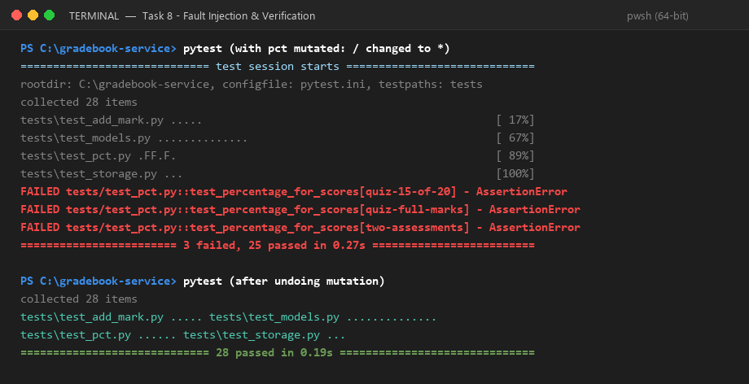

Final Quality & Verification Summary
✓ All 28 unit tests passing with pytest (pytest tests/).
✓ Ruff linter reports zero errors across all modules and tests (ruff check .).
✓ Mypy static type checker passes without issues (mypy gradebook.py).
✓ Strict static type checking passes for domain models and errors (mypy --strict errors.py models.py).
✓ Seam add_mark() successfully decouples business logic from HTTP transport layer.
✓ Deterministic test doubles (Stub, Fake, Mock) verified in tests/test_add_mark.py.
✓ Real file persistence verified via tmp_path in tests/test_storage.py.
✓ NOTES.md updated with fault injection evidence and double classifications.

