**Use Case Diagram**

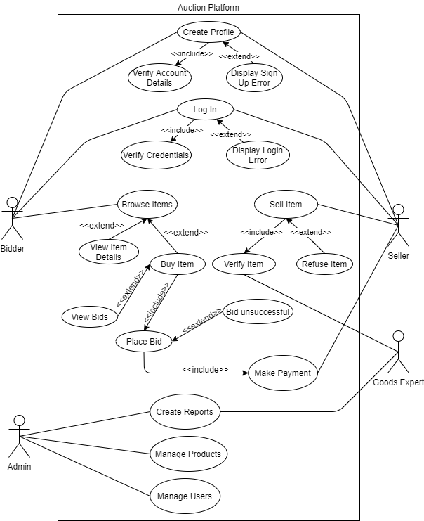

**Use Case Description**

|  |  |  |
| --- | --- | --- |
| **USE CASE 1** | Log In | |
| **Goal in Context** | User to login in successfully to their existing account to access the functionality of the system. | |
| **Scope & Level** | Summary | |
| **Preconditions** | User has created account and credentials are in database. | |
| **Success End Conditions** | User is logged into their account and main menu is displayed. | |
| **Failed End Condition** | User is not logged into their account. Attempt login again. | |
| **Primary, Secondary, Actors** | User (Buyers & Sellers), Goods Expert, Admin | |
| **Trigger** | User invokes ‘login’ option at homepage. | |
| **DESCRIPTION** | **Step** | **Action** |
|  | 1 | User enters credentials. (Username and password). |
|  | 2 | User credentials are validated. |
|  | 3 | User is allowed access to system |
| **EXTENSIONS** | **Step** | **Branching Action** |
|  | 2a | Invalid username  System shows error message |
|  | 2b | Invalid Password  System shows error message |

|  |  |  |
| --- | --- | --- |
| **USE CASE 2** | Sell Item | |
| **Goal in Context** | Enables user to put up an item for auction in order to sell. | |
| **Scope & Level** | Primary Task | |
| **Preconditions** | User has created or logged into their account. Has an item to sell. | |
| **Success End Conditions** | Item is verified by the goods expert and approved for auction. | |
| **Failed End Condition** | Item has been declined for auction by goods expert. | |
| **Primary, Secondary, Actors** | User (Seller), Goods Expert. | |
| **Trigger** | User opts to sell an item by clicking ‘sell’ on main menu. | |
| **DESCRIPTION** | **Step** | **Action** |
|  | 1 | User provides information about item to sell. |
|  | 2 | Item info is sent to goods expert for examination. |
|  | 3 | Item is verified by goods expert. |
|  | 4 | Seller receives update of status. |
|  | 5 | Item is put up for auction. |
| **EXTENSIONS** | **Step** | **Branching Action** |
|  | 3a | Item Approved  Item in question is approved for auction by goods expert. |
|  | 3b | Item Rejected  Item in question is denied/refused to put up for auction by goods expert. |

|  |  |  |
| --- | --- | --- |
| **USE CASE 3** | Place Bid | |
| **Goal in Context** | Enables user to submit a bid for an item on auction in order to buy it. | |
| **Scope & Level** | Subfunction | |
| **Preconditions** | User has created or logged into their account. Wants to buy an item. | |
| **Success End Conditions** | Bid is successful. Move onto final step - payment. | |
| **Failed End Condition** | Bid is unsuccessful. Submit higher bid or exit. | |
| **Primary, Secondary, Actors** | User (Buyer), Admin. | |
| **Trigger** | User chooses to submit a bid and clicks ‘place bid’. | |
| **DESCRIPTION** | **Step** | **Action** |
|  | 1 | Minimum price and related details are provided. |
|  | 2 | User chooses amount to bid. |
|  | 3 | User submits bid. |
|  | 4 | Bids are processed. |
|  | 5 | Bid result displayed. |
| **EXTENSIONS** | **Step** | **Branching Action** |
|  | 4a | Bid Successful.  Submitted bid was successful. Proceed to payment. |
|  | 4b | Bid Unsuccessful.  Submitted bid was unsuccessful. Return to step 3 and submit higher bid or exit. |